Free tier account - <https://aws.amazon.com/free/>

API Gateway, Lambda, ECS, Aurora,ALB

. Lambda, ALB, ECS, API Gateway

**Levels**

1) Certified cloud practitioner

2) Developer Associate

3) Solution Architect Associcate

4) Sysops Administrator Associate

5) Security Speciality

6) Big Data Speciality

7) Advanced Networking Speciality

8) Devops Pro

9) Solutions Architect Professional

**Easy to Hard**

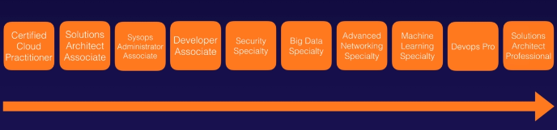

AWS week ---you will get the latest update on this

<https://aws.amazon.com/certification/beta-exam>

<http://jayendrapatil.com/aws-certification-exam-cheat-sheet/>

<https://www.whizlabs.com/learn/course/aws-csaa-practice-tests/>

youtube-watch?v=-xcby9k5OjU

**How to clear the AWS exam**

<https://javarevisited.blogspot.com/2019/08/how-to-crack-aws-certified-solution-architect-exam.html>

<https://acloud.guru/> -login using the linkedin

https://aws.amazon.com/documentation/

<http://www.aiotestkinguk.com/vendor/Amazon>

**Exam Registration**

<https://aws.amazon.com/certification/certified-solutions-architect-associate/>

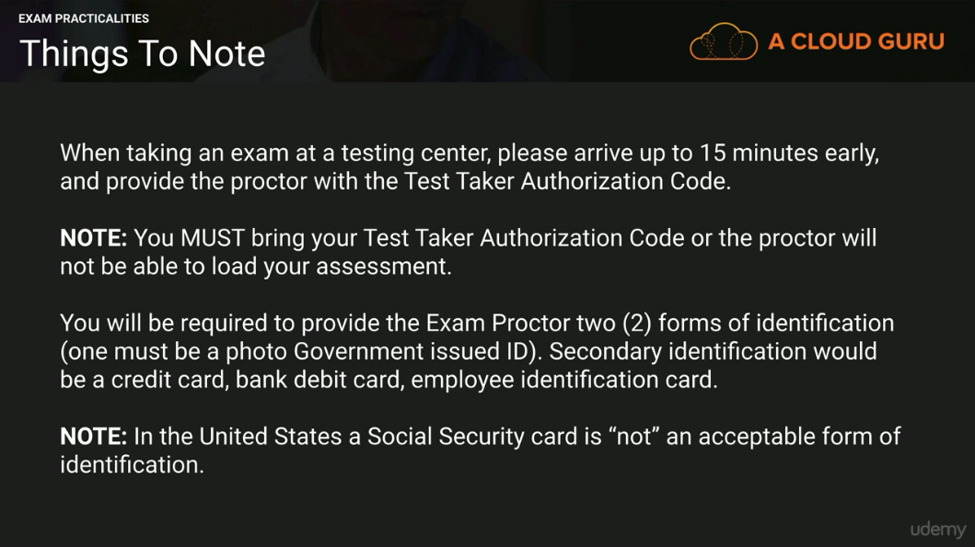

**Best Architecture which includes all the components**

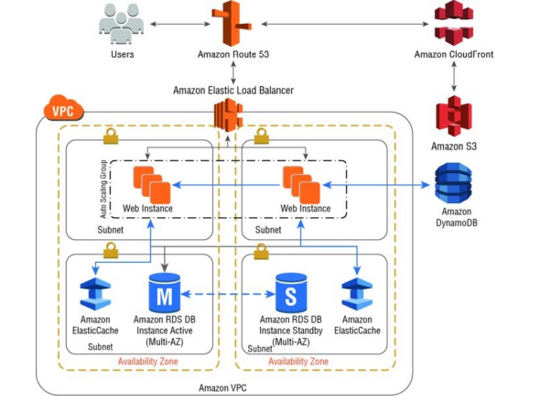

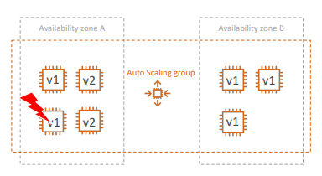

Perfect architecture with amazon S3 ,CloudFront and also with Elastic Cache and Dynamodb

In above diagram,

* session information for our sample web application can be moved to Amazon DynamoDB or even to Amazon ElastiCache. For our scenario, we will use Amazon DynamoDB to store the session information.
* By removing session state from our web tier, the web instances do not lose session information when horizontal scaling from Auto Scaling happens.
* Additionally, we will leverage Amazon ElastiCache to store common database query results, thereby taking the load off our database tier

As a Solutions Architect, you will ultimately come to a point where you need to decide and define what your storage requirements are for the data that you need to store on AWS. There are a variety of options to choose from depending on your needs, each with different attributes ranging from database storage, block storage, highly available object-based storage, and even cold archival storage. Ultimately, your workload requirements will dictate which storage option makes sense for your use case.

**WhatsTheTime.com**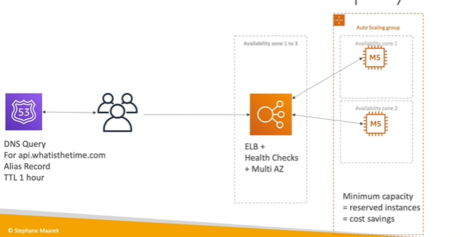

**MyClothes.Com**

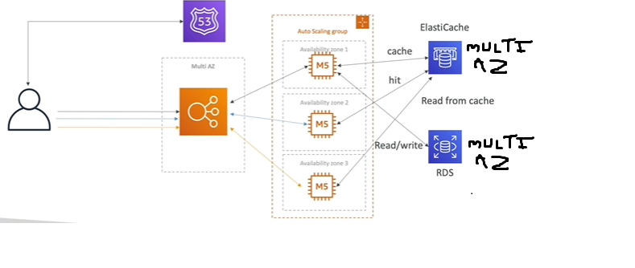

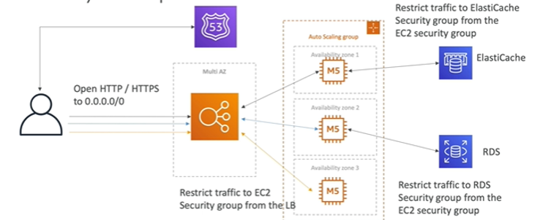

You can replace RDS with Aurora for default multiAZ feature

**MyClothes.Com (Image Store)**

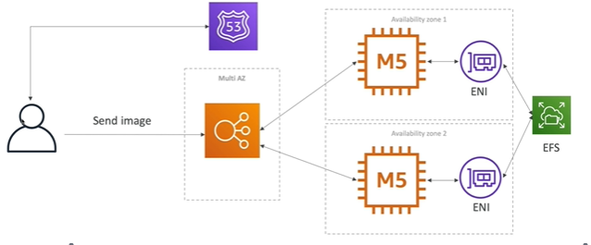

EFS-Elastic File System

ENI-Elastic Network Interface

**HA Architecture**

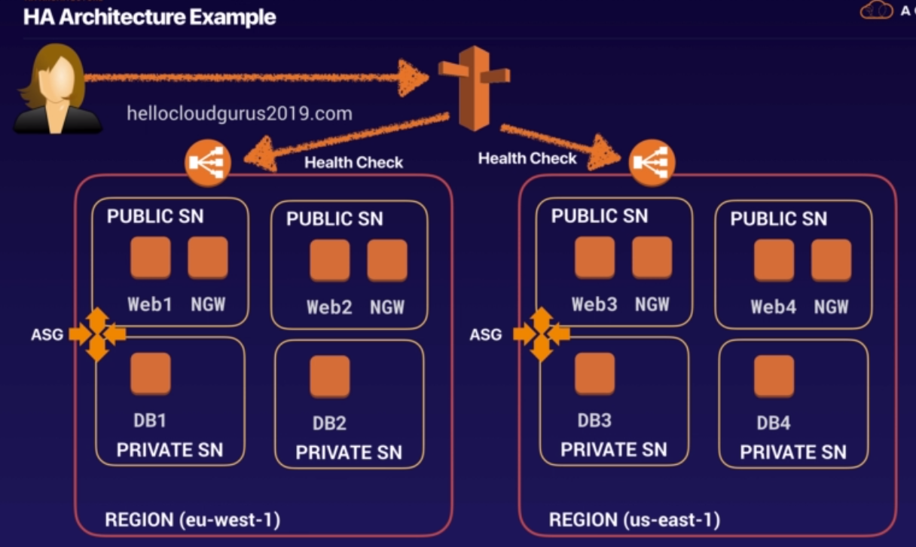

 In the above diagram the bar after “hellowcloudgurus2019.com” is route 53

-ELB

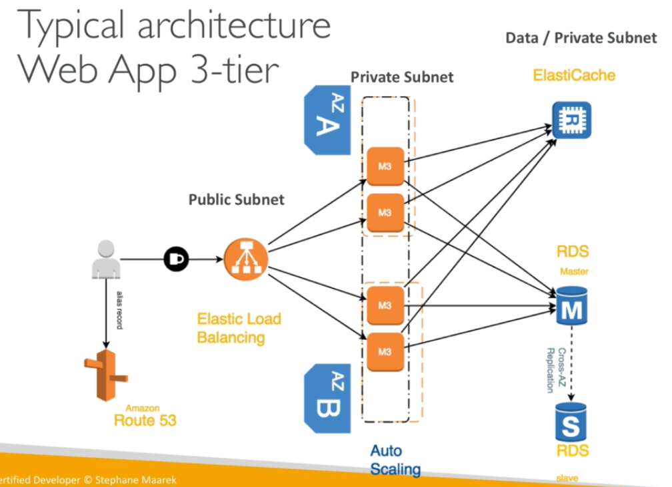

**Below is the Network diagram ( one of the best example for the word press site)**

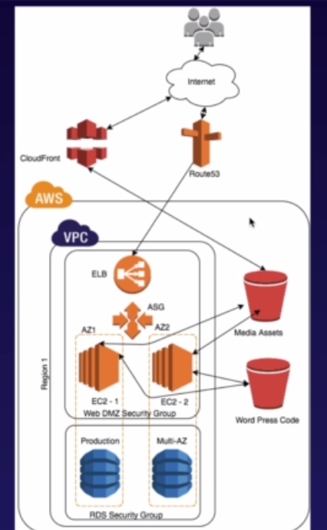

**Various Architectures**

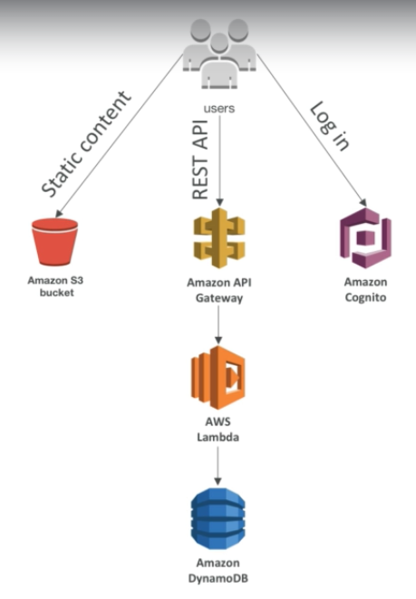

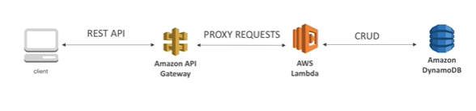

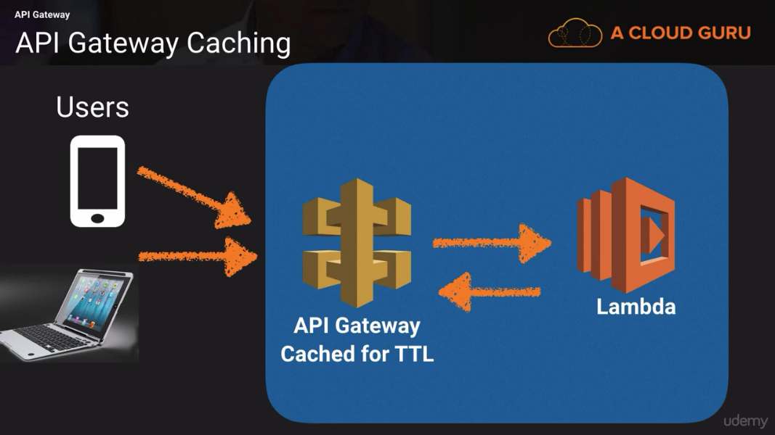

* **Mobile app:REST API layer Architecture**

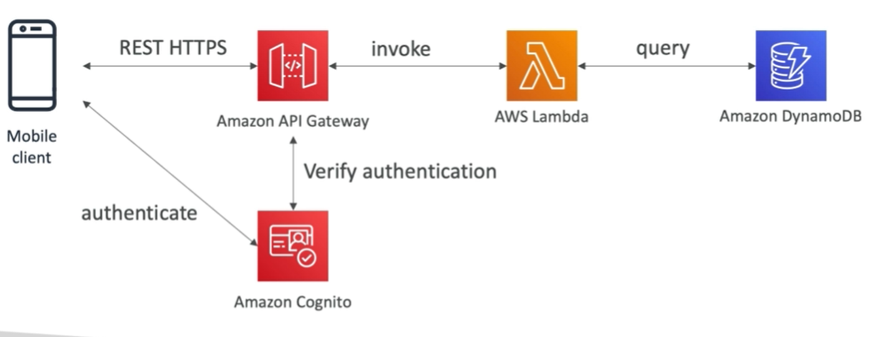

**Mobile app :high read throughput, static data architecture (Giving Users access to S3 architecture)**

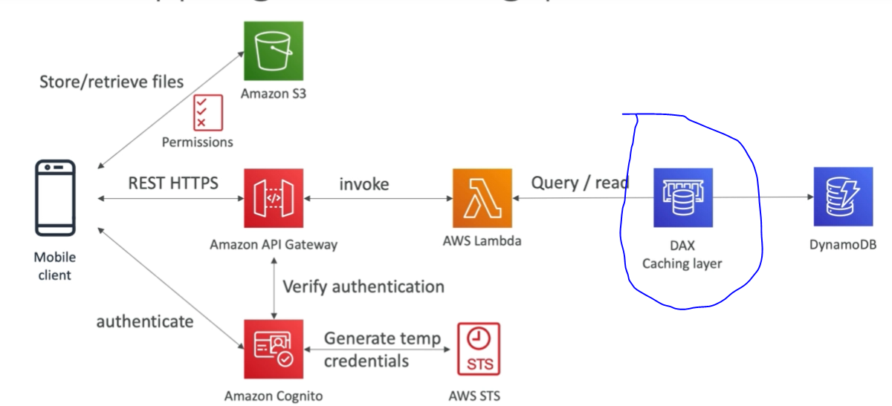

**Microservice architecture**

**Microservice Architecture (How we can do architecture for services in different way in one example)**

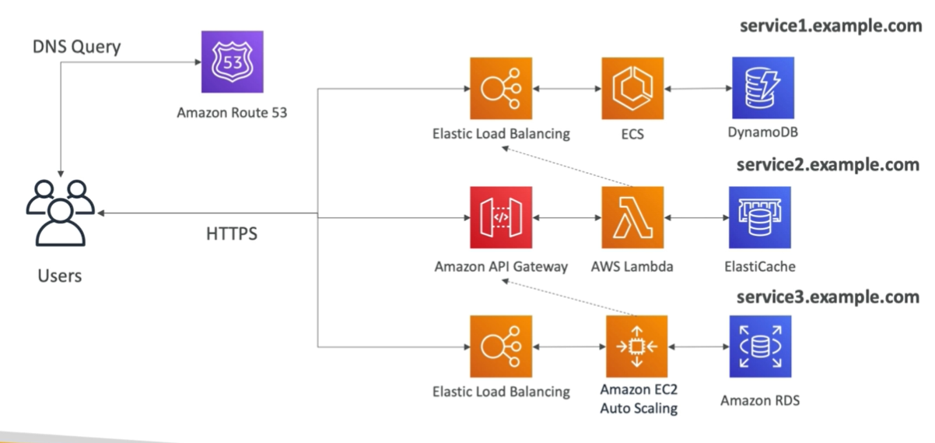

**Big Data Ingestion Pipeline Architecture:**

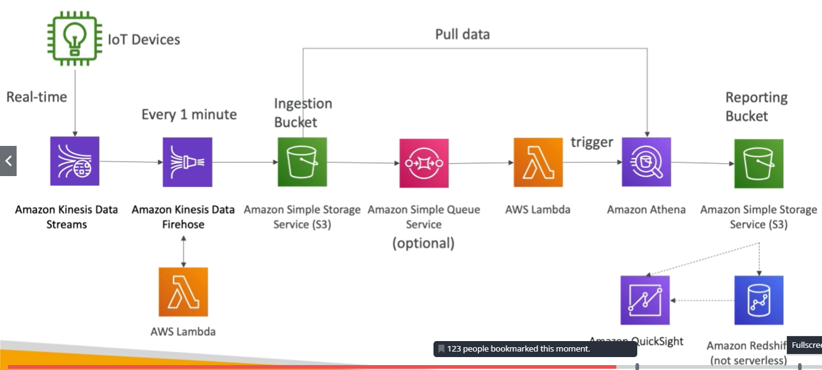

**Best Serverless architecture**

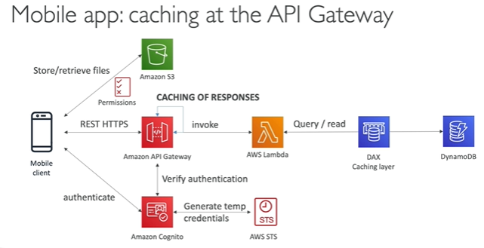

* + 1. **Myblog.com site (Step By Step)**

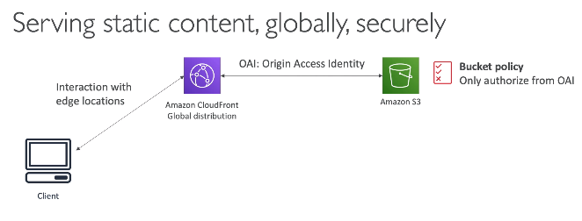

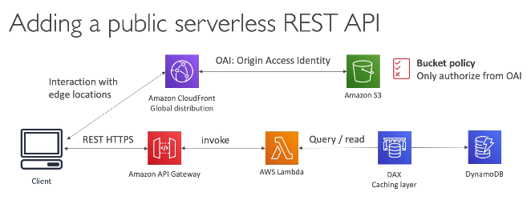

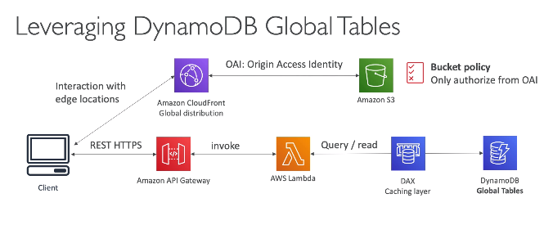

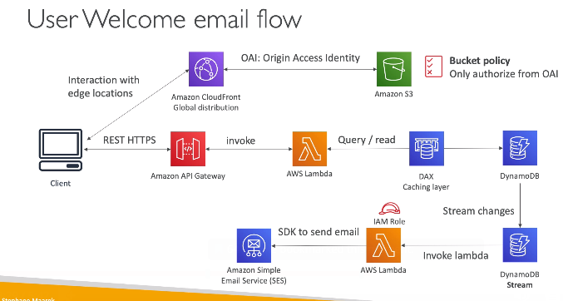

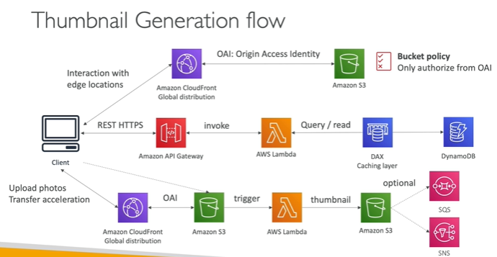

**One Liner**

**EC2**-Elastic Cloud Computing (Infrastructure as service)

**STS-**The AWS Security Token Service (STS) is a web service that enables you to request temporary, limited-privilege credentials for AWS Identity and Access Management (IAM) users or for users that you authenticate (federated users). This guide provides descriptions of the STS API

**ECS**-Ec2 container Service

ECS service creates the cluster of EC2 and deploy the container on the EC2 cluster instances (Run and manage container at scale)

• ECS is complicated, and made of:

• “ECS Core”: Running ECS on user-provisioned EC2 instances • Fargate: Running ECS tasks on AWS-provisioned compute (serverless)

• EKS: Running ECS on AWS-powered Kubernetes (running on EC2)

• ECR: Docker Container Registry hosted by AWS

**Lambda** -Serverless offering, suppose you provide the application code and say that its .net application code then lambda service automatically deploy code on virtual machine

AWS Lambda lets you run code without provisioning or managing servers.

e.g-Convert the image from high resolution to low resolution in S3 bucket using the Code

**S3** -Simple Storage Service

**EFS**-Elastic File system, Same as shared network drive.

**EBS**-its like hard disk attached to computer

**S3Bucket** -to store the data

ELB -Within Availability Zone

=================================

**Database**

**RDS**-Relational Database Service

**Dynamodb**-No SQL

**Elastic Cache (**This service can create cluster of below DB)

1. Redis
2. Memcached

**RedShift**-Data Warehouse

========================================

**VPC** -Virtual Private Cloud

**SES-**Simple email service

**SQS-**Simple Queue Service

**SNS** –Simple Notification Service

**SWF-**Simple workflow Service-Order placed on amazon

**Rout53** -Global Service-Amazon DNS Server-Creating your domain

**CloudFront**-Amazon CDN

**Direct Connect**-Dedicated line

**CloudWatch** Alarm-filtering the log pattern. We create instances and if you wanted to know about the instance resources such CPU,RAM so all this information made available to you by graphical format by service CloudWatch

Amazon CloudWatch can monitor AWS resources such as Amazon EC2 instances, Amazon DynamoDB tables, and Amazon RDS DB instances, as well as custom metrics generated by your applications and services, and any log files your applications generate

**CloudTrail**-Logs changes to AWS environment (User Activities). It keeps all the record.

it captures every single info occurring on AWS

**Cloud Formation**-It’s web scripting infrastructure. Infrastructure as code.

e.g if you want to create two tier application such webserver and DB

So, if you want to create dynamically then cloud formation service is used.

The input to this service is template file (json file) in which you can write the steps to create Webserver and DB…(using Stack and template)

You can create the many instances at a time after writing it to the CloudFormation file

When you use AWS CloudFormation, you manage related resources as a single unit called a stack. You create, update, and delete a collection of resources by creating, updating, and deleting stacks. All the resources in a stack are defined by the stack’s AWS CloudFormation template.

CloudFormation template sections

AWSTemplateFormatVersion:

"version date"

Description:

Metadata:

Parameters:

Mappings:

Conditions:

Transform:

Resources:

Outputs:

**Elastic Beanstalk** same as Ec2 but it deploys the code. (EC2+deploy application code)

Elastic beanstalk-platform as service (PAAS) and EC2 is infrastructure as service(IAAS)

It is useful for the developer who don’t have idea about the aws. They simply load the code, other services get automatically used for the developer. Elastic beanstalk automatically handles the details of capacity provisioning, load balancing, scaling and application heath monitoring.

Elastic beanstalk uses “*Cloud Formation”*for instance creation in behind

*You can simply upload your code and Elastic Beanstalk automatically handles the deployment, from capacity provisioning, load balancing, auto-scaling to application health monitoring. At the same time, you retain full control over the AWS resources powering your application and can access the underlying resources at any time.*

**AWS config**-Gives history about the configuration which made earlier. If you want to go previous config…compare the two config file..you can revert it to old config

AWS Config provides a detailed view of the configuration of AWS resources in your AWS account. This includes how the resources are related and how they were configured in the past so that you can see how the configurations and relationships change over time.

**Amazon Cognito**

For mobile applications, the use of Amazon Cognito allows client devices to get controlled access to AWS resources via temporary tokens.

**federated access**

For AWS Management Console users, you can similarly provide federated access through temporary tokens instead of creating IAM users in your AWS account. In that way, an employee who leaves your organization and is removed from your organization’s identity directory will also lose access to your AWS account.

**OpsWork**-You can create/write the script file (Ruby) and this script file u can execute on VM by using this service for automation task(Chef Recipes).you can do installation of software/configuration of software, set up directory structure using the OpsWork

AWS OpsWorks is a configuration management service that uses Chef, an automation platform that treats server configurations as code. OpsWorks uses Chef to automate how servers are configured, deployed, and managed across your EC2 instances or on-premises compute environments. OpsWorks has two offerings, AWS OpsWorks for Chef Automate and AWS OpsWorks Stacks.

**Trusted Advisor**-Gives advice to lower the cost of account to reduce the monthly cost.

AWS Trusted Advisor inspects your AWS environment and makes recommendations when opportunities exist to save money, improve system availability and performance, or help close security gaps. You can view the overall status of your AWS resources and savings estimations on the AWS Trusted Advisor dashboard.

AWS Trusted Advisor is accessed in the AWS Management Console. Additionally, programmatic access to AWS Trusted Advisor is available with the AWS Support API.

**AWS** **WAF-**Web application firewall. . Services like AWS Web Application Firewall (AWS WAF) can help protect your web applications from SQL injection and other vulnerabilities in your application code

**Service Catalog**-You can create the profile predefined particular catalog(template) or a particular configuration so that user can create the instance using this config.This is mainly use for the compliance.

**Amazon Lex-**

Amazon Lex is a service for building conversational interfaces into any application using voice and text. Lex provides the advanced deep learning functionalities of automatic speech recognition (ASR) for converting speech to text, and natural language understanding (NLU) to recognize the intent of the text, to enable you to build applications with highly engaging user experiences and lifelike conversational interactions. With Amazon Lex, the same deep learning technologies that power Amazon Alexa are now available to any developer, enabling you to quickly and easily build sophisticated, natural language, conversational bots (“chatbots”). Speech recognition and natural language understanding are some of the most challenging problems to solve in computer science, requiring sophisticated deep learning algorithms to be trained on massive amounts of data and infrastructure. Amazon Lex democratizes these deep learning technologies by putting the power of Alexa within reach of all developers. Harnessing these technologies, Amazon Lex enables you to define entirely new categories of products made possible through conversational interfaces.

**Amazon Polly-**Speech enable product. Convert text into speech.

 allowing you to create applications that talk, and build entirely new categories of speech-enabled products

**Amazon Rekognition**

Its same as image Rekognition i.e it recognise image from video.(you can called it as video recognition as well)

Amazon Rekognition makes it easy to add image and video analysis to your applications. You just provide an image or video to the Rekognition API, and the service can identify the objects, people, text, scenes, and activities, as well as detect any inappropriate content. Amazon Rekognition also provides highly accurate facial analysis and facial recognition. You can detect, analyze, and compare faces for a wide variety of user verification, cataloging, people counting, and public safety use cases.

Amazon Rekognition is based on the same proven, highly scalable, deep learning technology developed by Amazon’s computer vision scientists to analyze billions of images and videos daily, and requires no machine learning expertise to use. Amazon Rekognition is a simple and easy to use API that can quickly analyze any image or video file stored in Amazon S3. Amazon Rekognition is always learning from new data, and we are continually adding new labels and facial recognition features to the service.

**CloudSearch-**This is AWS own technology to search the data

**Transcoder-**Convert the file format

**AML-**Amazon Machine Learning

**Amazon API Gateway –**

API gateway-way of creating own API to talk to other services

Amazon API Gateway provides a way to expose well-defined interfaces. Amazon API Gateway is a fully managed service that makes it easy for developers to create, publish, maintain, monitor, and secure APIs at any scale. It handles all of the tasks involved in accepting and processing up to hundreds of thousands of concurrent API calls, including traffic management, authorization and access control, monitoring, and API version management.

**AWS Glue-**AWS Glue is a fully managed ETL service that makes it easy to move data between your data stores. AWS Glue is integrated with Amazon S3 (p. 14), Amazon RDS (p. 17), and Amazon Redshift (p. 30), and can connect to any Java Database Connectivity (JDBC)-compliant data store.

**Amazon Athena**

Amazon Athena is an interactive query service that makes it easy to analyze data in Amazon S3 using standard SQL. Serverless service to perform analytics directly against S3 files

• Exam Tip: Analyze data directly on S3 => use Athena

Athena is serverless, so there is no infrastructure to manage, and you pay only for the queries that you run.

Athena is easy to use. Simply point to your data in Amazon S3, define the schema, and start querying using standard SQL. Most results are delivered within seconds. With Athena, there’s no need for complex ETL jobs to prepare your data for analysis. This makes it easy for anyone with SQL skills to quickly analyze large-scale datasets.

Athena is out-of-the-box integrated with [AWS Glue](https://aws.amazon.com/glue/) Data Catalog, allowing you to create a unified metadata repository across various services, crawl data sources to discover schemas and populate your Catalog with new and modified table and partition definitions, and maintain schema versioning. You can also use Glue’s fully-managed ETL capabilities to transform data or convert it into columnar formats to optimize cost and improve performance.

**Database Migration Service**

Easy way to migrate the databases to AWS and keep the track of migration

**AWS Storage Gateway**

AWS Storage Gateway is a service connecting an on-premises software appliance with cloud- based storage to provide seamless and secure integration between an organization’s onpremises IT environment and AWS storage infrastructure. The service enables you to store data securely on the AWS cloud in a scalable and cost-effective manner. AWS Storage Gateway supports industry-standard storage protocols that work with your existing applications. It provides low-latency performance by caching frequently accessed data onpremises while encrypting and storing all of your data in Amazon S3 or Amazon Glacier.

There are three configurations for AWS Storage Gateway: Gateway-Cached volumes, Gateway-Stored volumes, and Gateway-Virtual Tape Libraries (VTL).

1. Gateway-Cached Volumes

Gateway-Cached volumes allow you to expand your local storage capacity into Amazon S3. All data stored on a Gateway-Cached volume is moved to Amazon S3, while recently read data is retained in local storage to provide low-latency access.

1. Gateway-Stored Volumes Gateway-

Stored volumes allow you to store your data on your on-premises storage and asynchronously back up that data to Amazon S3.

1. Gateway Virtual Tape Libraries (VTL)

Gateway-VTL offers a durable, cost-effective solution to archive your data on the AWS cloud. The VTL interface lets you leverage your existing tape-based backup application infrastructure to store data on virtual tape cartridges that you create on your Gateway-VTL.

Use Cases

There are several use cases where AWS Storage Gateway is an excellent choice, including, but not limited to:

1. Gateway-Cached volumes enable you to expand local storage hardware to Amazon S3, allowing you to store much more data without drastically increasing your storage hardware or changing your storage processes.
2. Gateway-Stored volumes provide seamless, asynchronous, and secure backup of your onpremises storage without new processes or hardware.
3. Gateway-VTLs enable you to keep your current tape backup software and processes while storing your data more cost-effectively and simply on the cloud.

**AWS Key Management Service (KMS) and AWS CloudHSM**

Key management is the management of cryptographic keys within a cryptosystem. This includes dealing with the generation, exchange, storage, use, and replacement of keys

AWS offers two services that provide you with the ability to manage your own symmetric or asymmetric cryptographic keys:

1. AWS KMS: A service enabling you to generate, store, enable/disable, and delete symmetric keys
2. AWS CloudHSM: A service providing you with secure cryptographic key

**Amazon Lightsail** Amazon Lightsail is designed to be the easiest way to launch and manage a virtual private server with AWS. Lightsail plans include everything you need to jumpstart your project – a virtual machine, SSDbased storage, data transfer, DNS management, and a static IP address – for a low, predictable price.

Here's a quick cheat-sheet to remember all these services:

**CICD**- 1) Github🡪CodeCommit

2) Jenkin -🡪CodeBuild

3) Deploy -> CodeDeploy

4) Code Pipeline

CodeCommit: service where you can store your code. Similar service is GitHub

CodeBuild: build and testing service in your CICD pipelines

CodeDeploy: deploy the packaged code onto EC2 and AWS Lambda

**CodePipeline**: orchestrate the actions of your CICD pipelines (build stages, manual approvals, many deploys, etc)

**CloudFormation**: Infrastructure as Code for AWS. Declarative way to manage, create and update resources.

**ECS** (Elastic Container Service): Docker container management system on AWS. Helps with creating micro-services.

**ECR** (Elastic Container Registry): Docker images repository on AWS. Docker Images can be pushed and pulled from there

**Step Functions**: Orchestrate / Coordinate Lambda functions and ECS containers into a workflow

**SWF** (Simple Workflow Service): Old way of orchestrating a big workflow.

**EMR** (Elastic Map Reduce): Big Data / Hadoop / Spark clusters on AWS, deployed on EC2 for you

**Glue**: ETL (Extract Transform Load) service on AWS

**OpsWorks**: managed Chef & Puppet on AWS

**ElasticTranscoder**: managed media (video, music) converter service into various optimized formats

**Organizations**: hierarchy and centralized management of multiple AWS accounts

**Workspaces**: Virtual Desktop on Demand in the Cloud. Replaces traditional on-premise VDI infrastructure

**AppSync**: GraphQL as a service on AWS

**SSO** (Single Sign On): One login managed by AWS to log in to various business SAML 2.0-compa

**Introduction to the Course**

# **What is Cloud Computing?**

Cloud computing is the on-demand delivery of compute power, database storage, applications, and other IT resources through a cloud services platform via the internet with pay-as-you-go pricing.

## **How Does Cloud Computing Work?**

Cloud computing provides a simple way to access servers, storage, databases and a broad set of application services over the Internet. A Cloud services platform such as Amazon Web Services owns and maintains the network-connected hardware required for these application services, while you provision and use what you need via a web application.

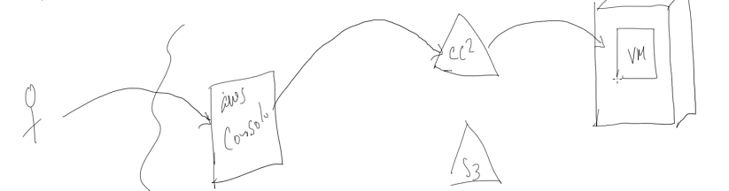

[**Features of Cloud Computing**](https://aws.amazon.com/types-of-cloud-computing/)

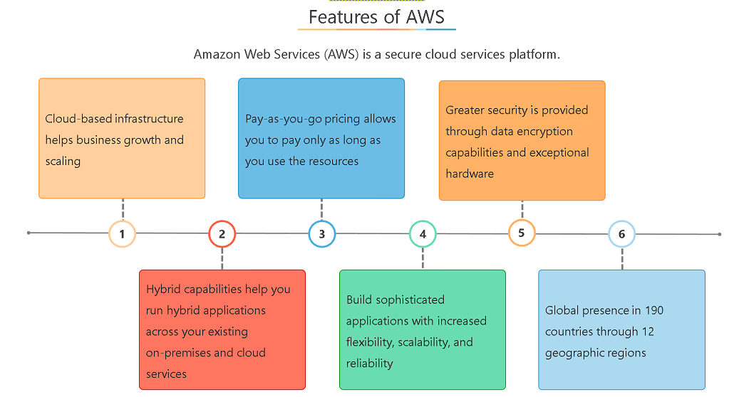



[**Types of Cloud Computing**](https://aws.amazon.com/types-of-cloud-computing/)

Cloud computing has three main types that are commonly referred to as Infrastructure as a Service (IaaS), Platform as a Service (PaaS), and Software as a Service (SaaS).

### Infrastructure as a Service (IaaS):

Infrastructure as a Service, sometimes abbreviated as IaaS, contains the basic building blocks for cloud IT and typically provide access to networking features, computers (virtual or on dedicated hardware), and data storage space. Infrastructure as a Service provides you with the highest level of flexibility and management control over your IT resources and is most similar to existing IT resources that many IT departments and developers are familiar with today.

### Platform as a Service (PaaS):

Platforms as a service remove the need for organizations to manage the underlying infrastructure (usually hardware and operating systems) and allow you to focus on the deployment and management of your applications. This helps you be more efficient as you don’t need to worry about resource procurement, capacity planning, software maintenance, patching, or any of the other undifferentiated heavy lifting involved in running your application.

### Software as a Service (SaaS):

Software as a Service provides you with a completed product that is run and managed by the service provider. In most cases, people referring to Software as a Service are referring to end-user applications. With a SaaS offering you do not have to think about how the service is maintained or how the underlying infrastructure is managed; you only need to think about how you will use that particular piece software. A common example of a SaaS application is web-based email where you can send and receive email without having to manage feature additions to the email product or maintaining the servers and operating systems that the email program is running on.

Bread and butter for exam

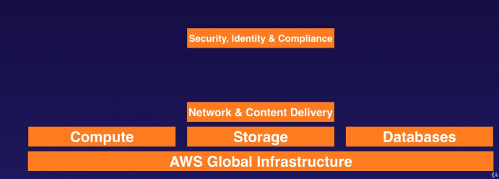

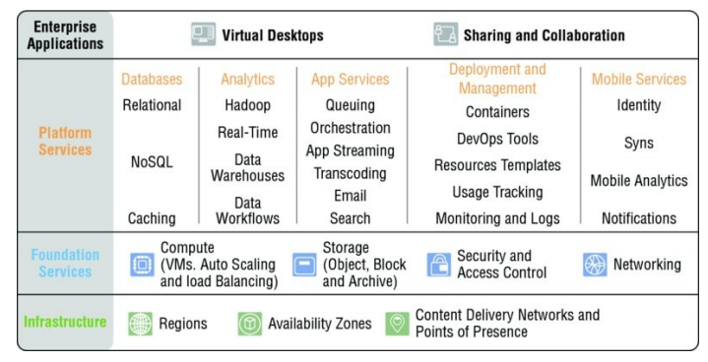

**AWS Cloud computing platform**

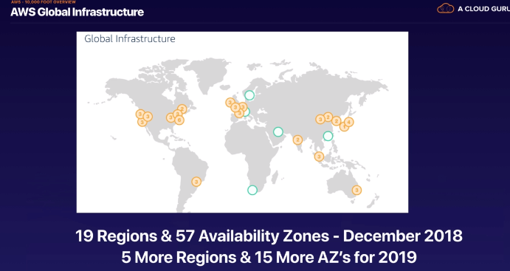

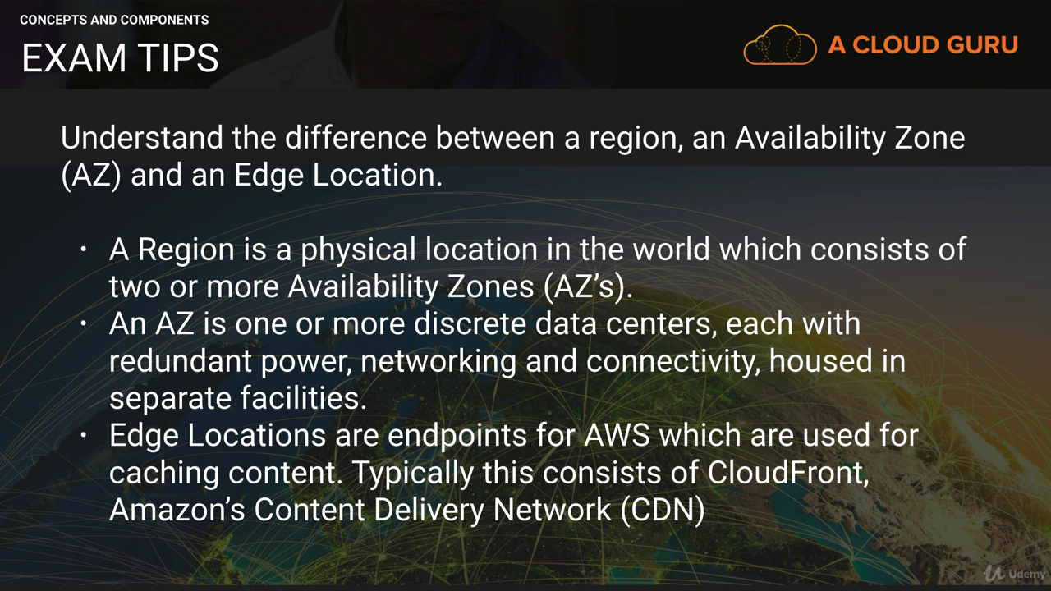

# **Simple Storage Service**

**S3 is object-based storage based so it is not suitable to install an operating system on Blocked based storage. you can install it on the blocked base storage**

Object based -store videos,movies,pictures

Blocked based Storage-OS

Files stored in buckets (Folders)

Amazon S3 is cloud object storage. **Instead of being closely associated with a server, Amazon S3 storage is independent of a server and is accessed over the Internet**

Objects reside in containers called buckets, and each object is identified by a unique user-specified key (filename)

* you cannot have a sub-bucket within a bucket. Each bucket can hold an unlimited number of objects.
* If you need traditional block or file storage in addition to Amazon S3 storage, AWS provides options. The Amazon **EBS service provides block level storage** for Amazon Elastic Compute Cloud (Amazon EC2) instances. A**mazon Elastic File System (AWS EFS) provides network-attached shared file storage (NAS storage) using the NFS v4 protocol.**
* Bucket names can contain up to 63 lowercase letters, numbers, hyphens, and periods
* You can create and use multiple buckets; you can have up to 100 per account by default.
* Objects can range in size from 0 bytes up to 5TB
* Performance-Your applications can easily achieve thousands of transactions per second in request performance when uploading and retrieving storage from Amazon S3. Amazon S3 automatically scales to high request rates. For example, your application can achieve at least 3,500 PUT/COPY/POST/DELETE and 5,500 GET/HEAD requests per second per prefix in a bucket. There are no limits to the number of prefixes in a bucket. You can increase your read or write performance by parallelizing reads. For example, if you create 10 prefixes in an Amazon S3 bucket to parallelize reads, you could scale your read performance to 55,000 read requests per second.

**Keys**

Every object stored in an S3 bucket is identified by a unique identifier called a key. You can think of the key as a filename. A key can be up to 1024 bytes of Unicode UTF-8 characters, including embedded slashes, backslashes, dots, and dashes. Keys must be unique within a single bucket, but different buckets can contain objects with the same key. The combination of bucket, key, and optional version ID uniquely identifies an Amazon S3 object

**Object URL**

<http://mybucket.s3.amazonaws.com/jack.doc>

**REST Interface**

The native interface for Amazon S3 is a REST (Representational State Transfer) API. With the REST interface, you use standard HTTP or HTTPS requests to create and delete buckets, list keys, and read and write objects. REST maps standard HTTP “verbs” (HTTP methods) to the familiar CRUD (Create, Read, Update, Delete) operations. Create is HTTP PUT (and sometimes POST); read is HTTP GET; delete is HTTP DELETE; and update is HTTP POST (or sometimes PUT).

Always use HTTPS for Amazon S3 API requests to ensure that your requests and data are secure.

Amazon S3 originally supported a SOAP (Simple Object Access Protocol) API in addition to the REST API, but you should use the REST API. The legacy HTTPS endpoint is still available, but new features are not supported.

**When u create the bucket, u must select the Region**. When you upload the file in bucket, then 6 copies are created in multiple AZ zones. When you upload files to S3 then be default permission to that file becomes private i.e it will be available to owners only. You can host your bucket with static website.

### Various Storage Types

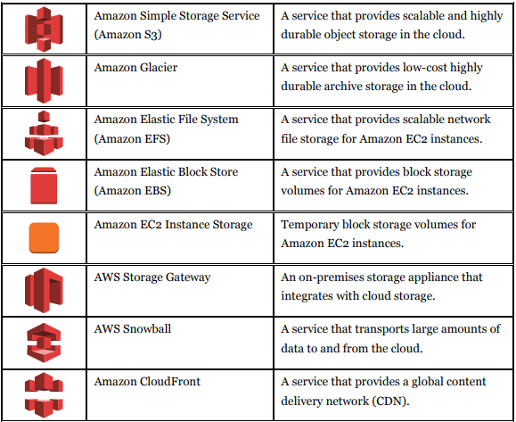

**Step 1: Create an Amazon S3 Bucket**

1. Sign in to the preview version of the **AWS** Management Console.
2. Under Storage & Content Delivery, choose **S3** to open the Amazon **S3** console. ...
3. From the Amazon **S3** console dashboard, choose **Create Bucket**.
4. In **Create** a **Bucket**, type a **bucket** name in **Bucket** Name. ...
5. In Region, choose Oregon.
6. Choose **Create**.

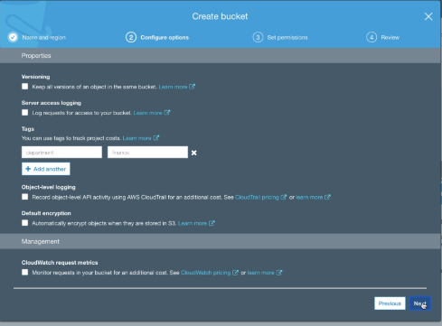

**Properties of bucket**

1. Versioning
2. Server access logging
3. Static website hosting
4. Object level logging
5. Default encryption

**Advanced Setting**

1. Object lock
2. Tags
3. Transfer acceleration
4. Events
5. Requester pays

**Permission**

1. Public access setting
2. Access Control List
3. Permission
4. CORS

**Management**

1. Life Cycle Management
2. Replication
3. Analytics
4. Metrics
5. Inventory

**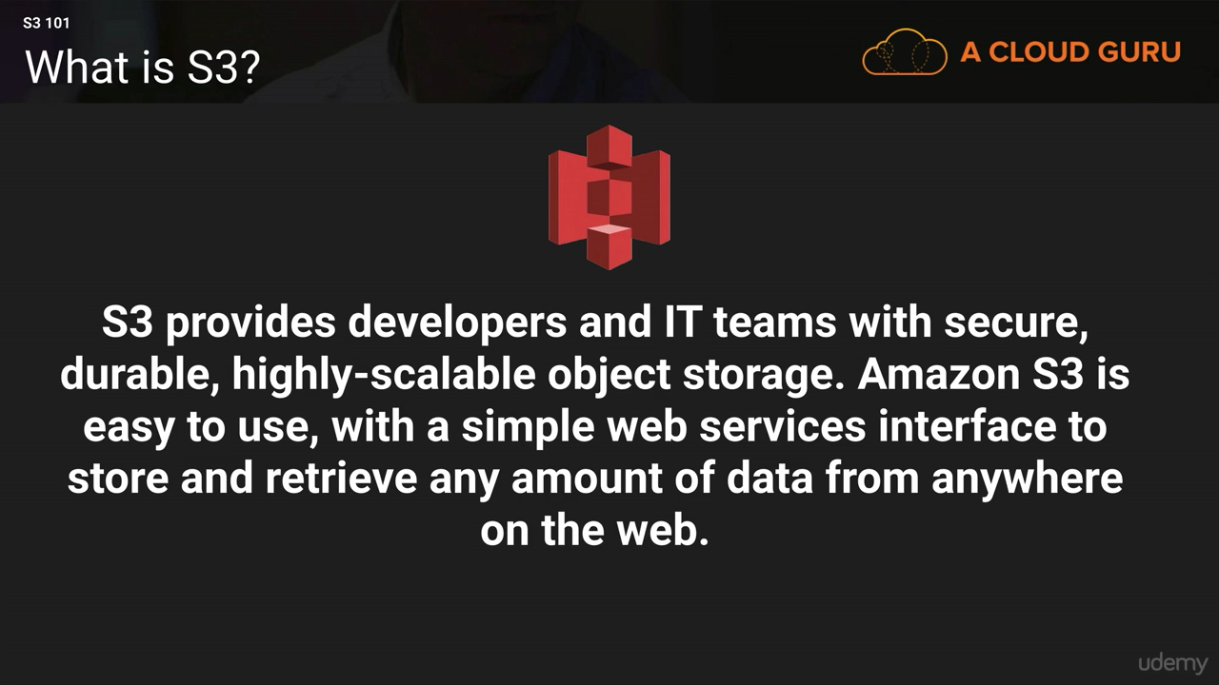**

**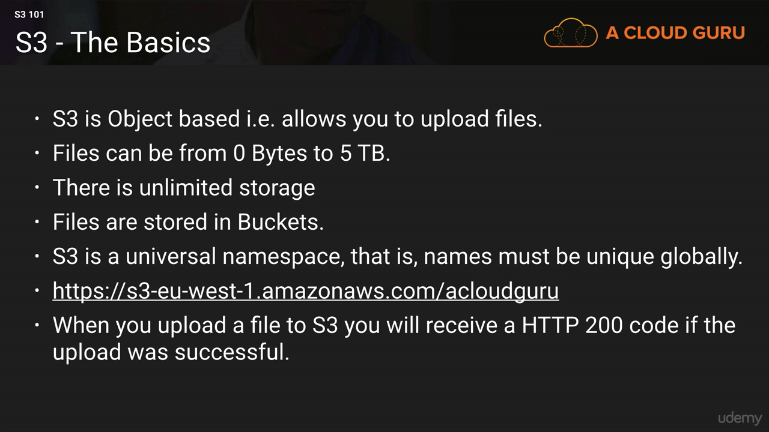**

**You can not run application and database on S3 as it is object based**

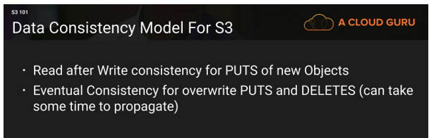

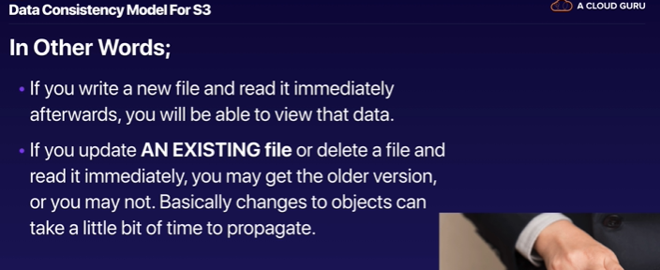

Amazon S3 is an eventually consistent system. Because your data is automatically replicated across multiple servers and locations within a region, changes in your data may take some time to propagate to all locations. As a result, there are some situations where information that you read immediately after an update may return stale data. For PUTs to new objects, this is not a concern—in this case, Amazon S3 provides read-afterwrite consistency. However, for PUTs to existing objects (object overwrite to an existing key) and for object DELETEs, Amazon S3 provides eventual consistency. Eventual consistency means that if you PUT new data to an existing key, a subsequent GET might return the old data. Similarly, if you DELETE an object, a subsequent GET for that object might still read the deleted object. In all cases, updates to a single key are atomic—for eventually-consistent reads,

**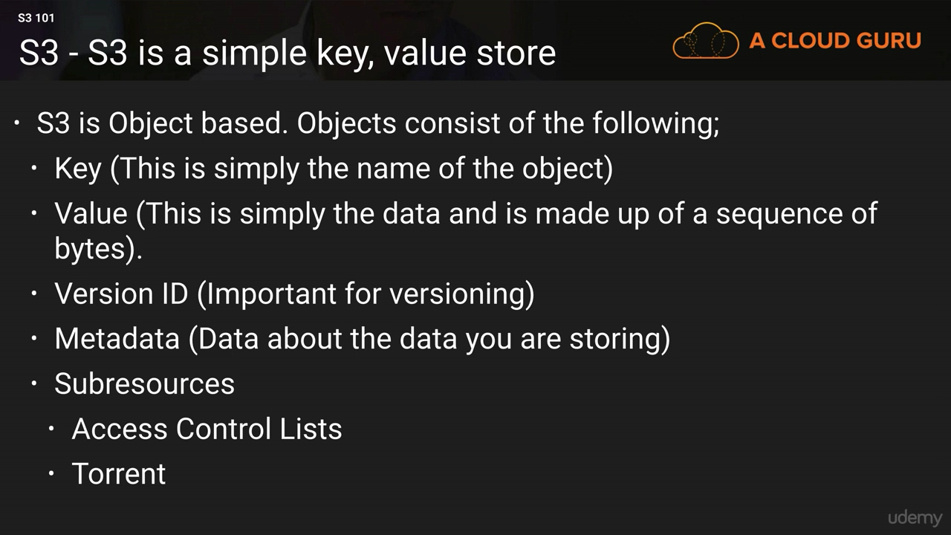**

**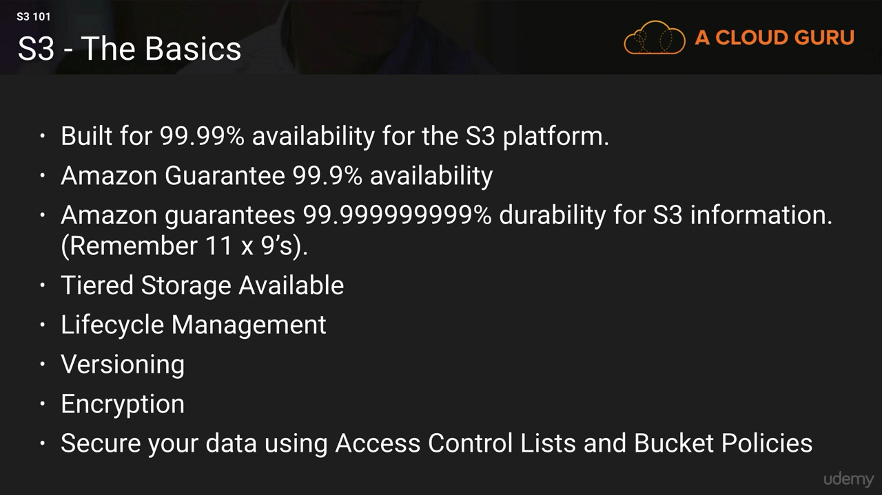**

Durability-Don’t lose the file

Lifecycle management -After few days the data will be sit in other storage tier i.e data archival process (move to other storage tier)

Question will be asked-Best mechanism to store u r data

### Storage Classes

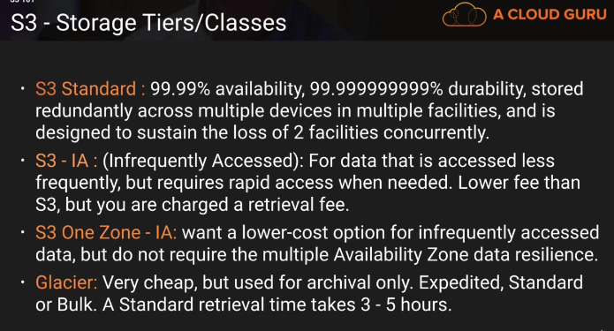

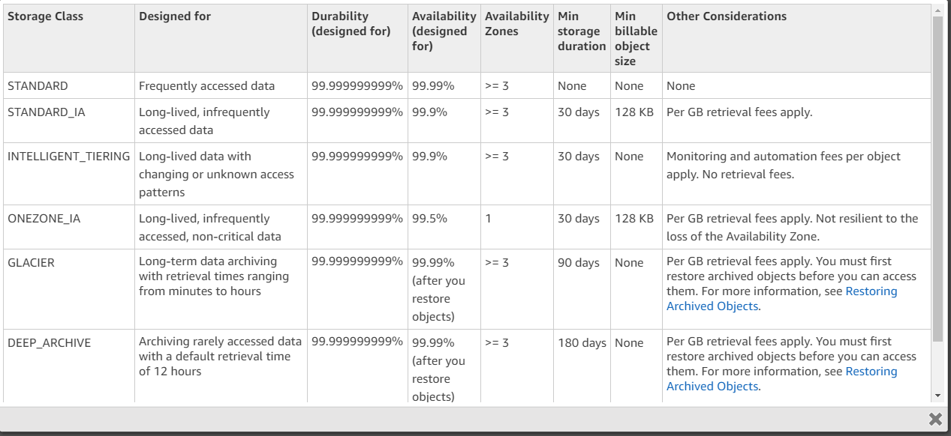

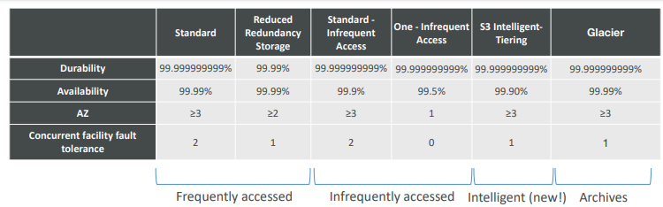

Using **standard** storage class S3 create 6 backup copies of your file and apply the cost as per the number of copies but if you don’t want 6 copies to reduce cost then select **reduced redundancy** storage class then only 3 copies will be created.

**Standard infrequent access**-There will be also 6 copies created ..in this case only you will access the storage infrequently so the cost will be reduced.

**Glacier**-same 6 copies, storage cost is very low as data is archive data. retrieval is very slow so u can store old data only not rapid access.

**Glacier**

**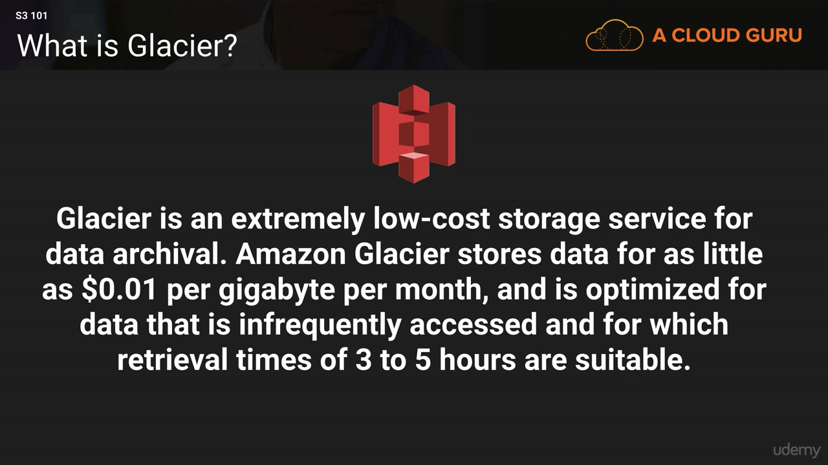**

**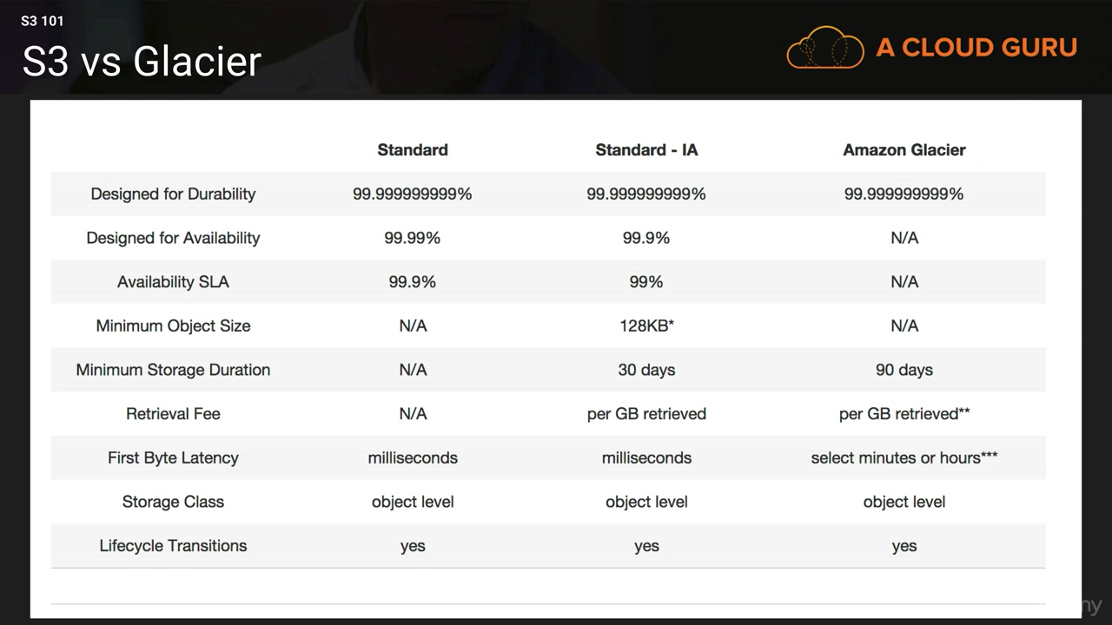**

**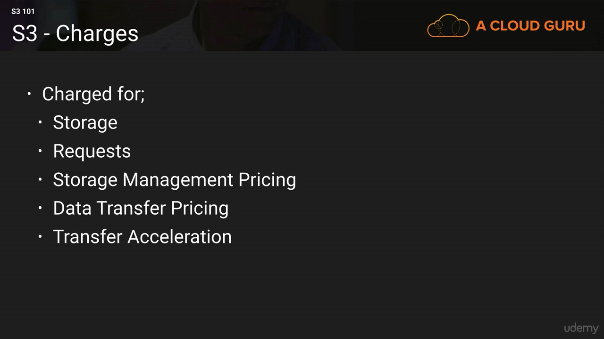**

### Transfer Acceleration

**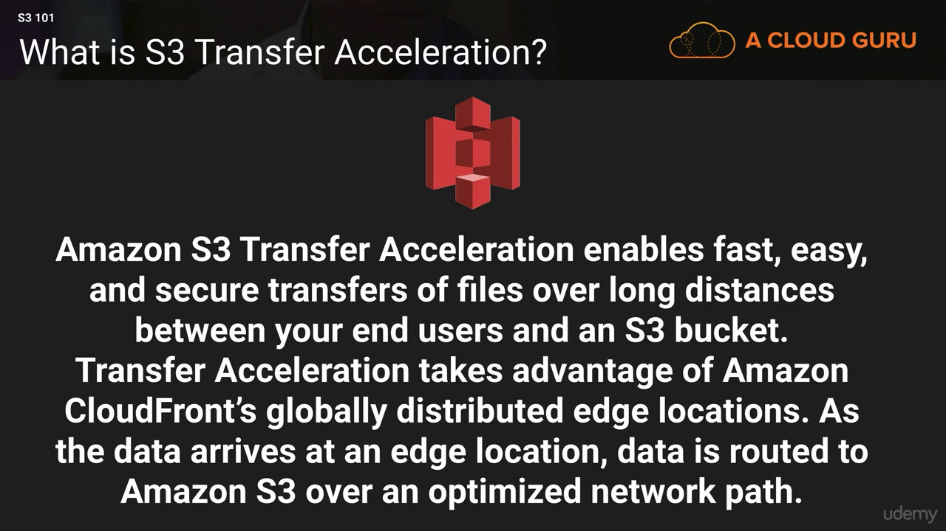**

People from other region can upload the fastly.it speed ups the upload for another region

**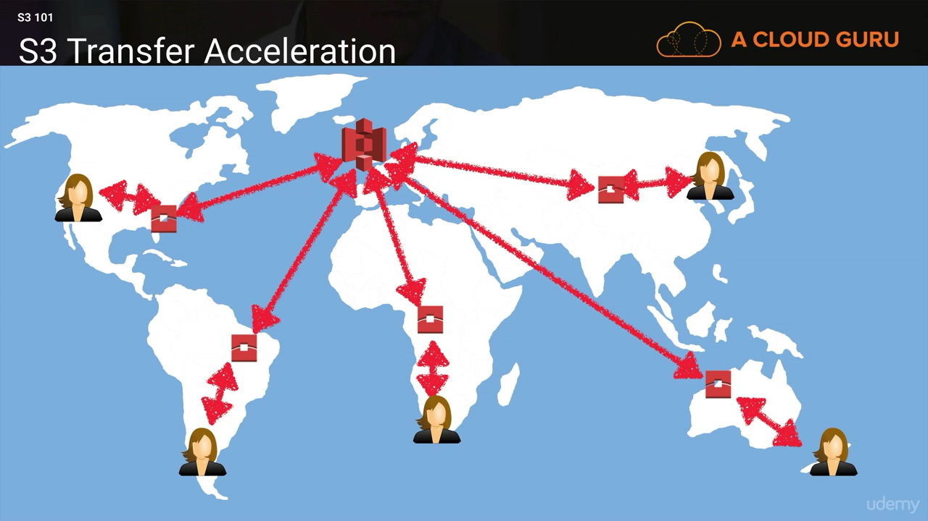**

**First transfer to edge location**

**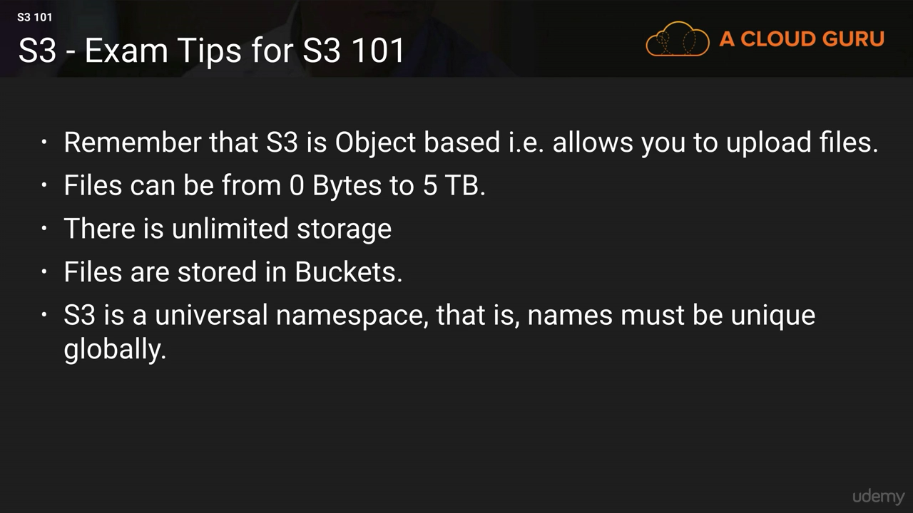**

**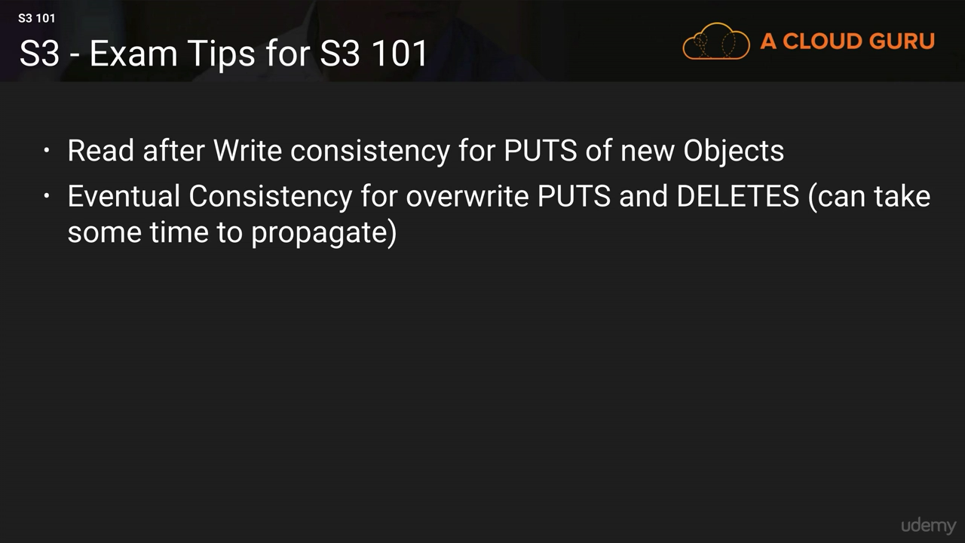**

Q: What data consistency model does Amazon S3 employ?

Amazon S3 buckets in all Regions provide read-after-write consistency for PUTS of new objects and eventual consistency for overwrite PUTS and DELETES.

**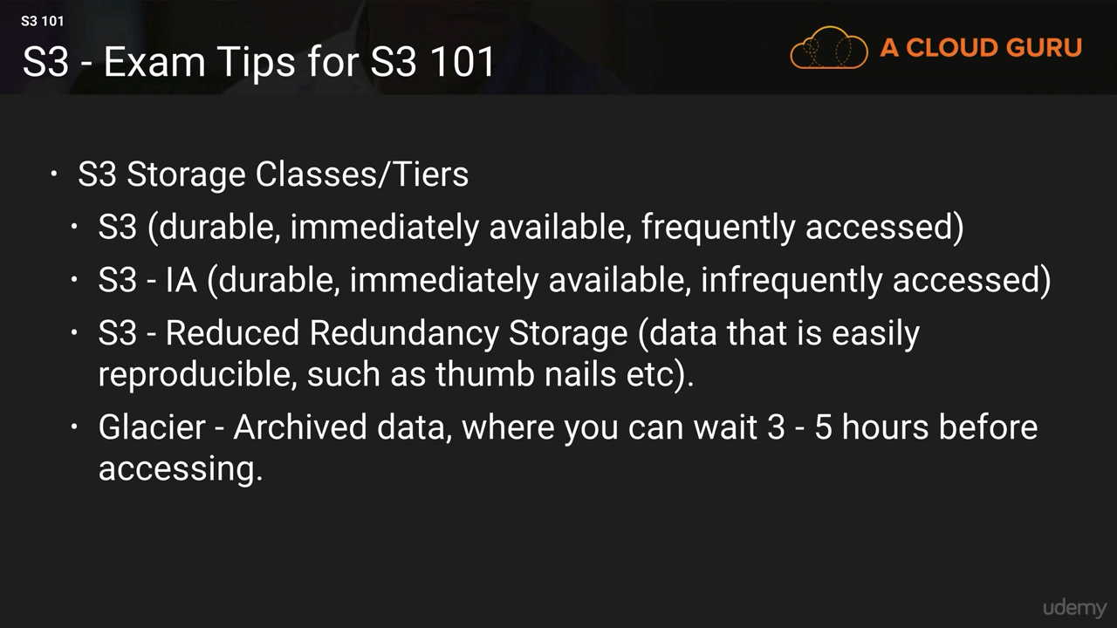**

**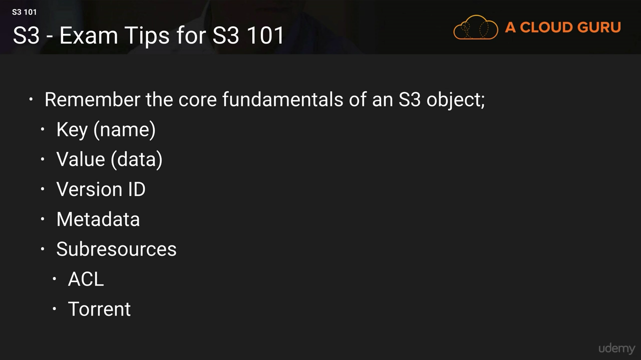**

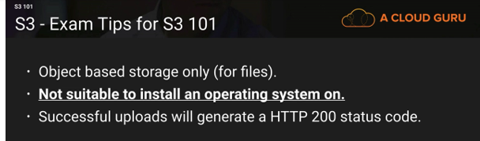

**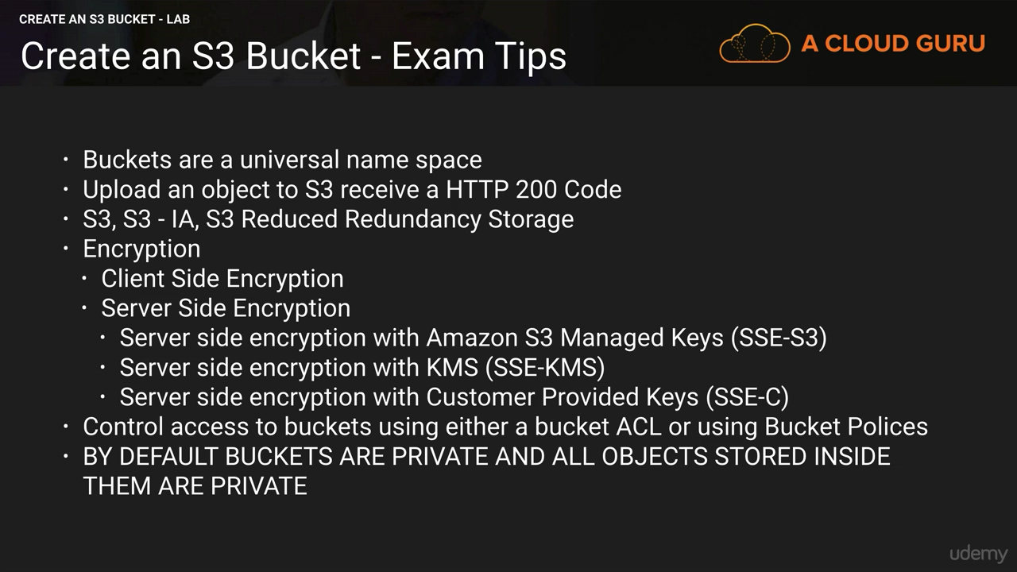**

### S3-Security and Encryption

**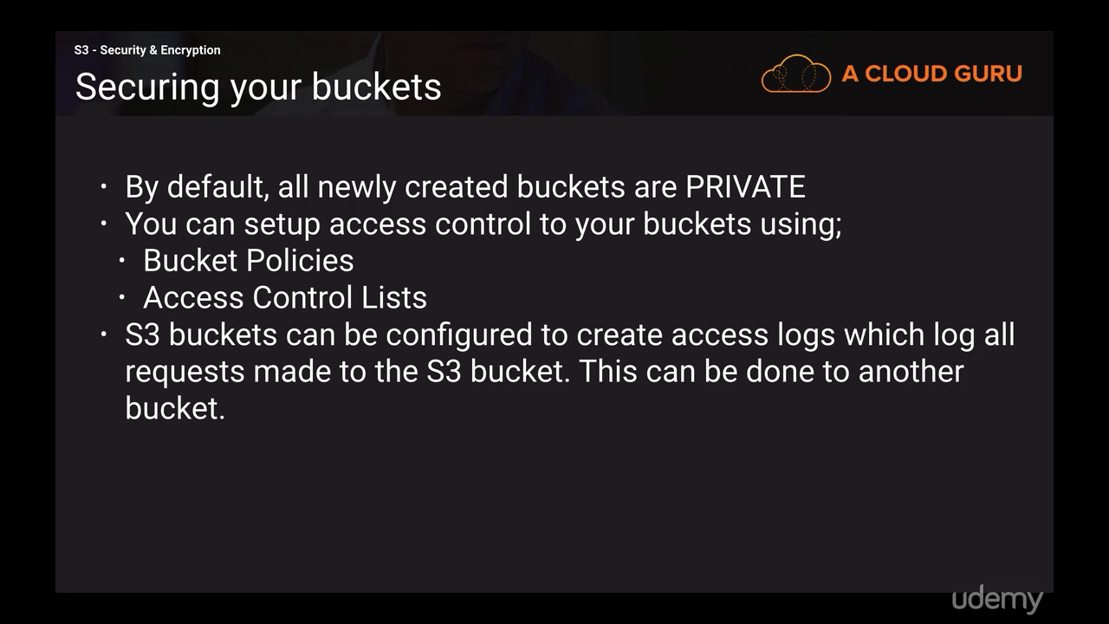**

### Bucket Policy Generator

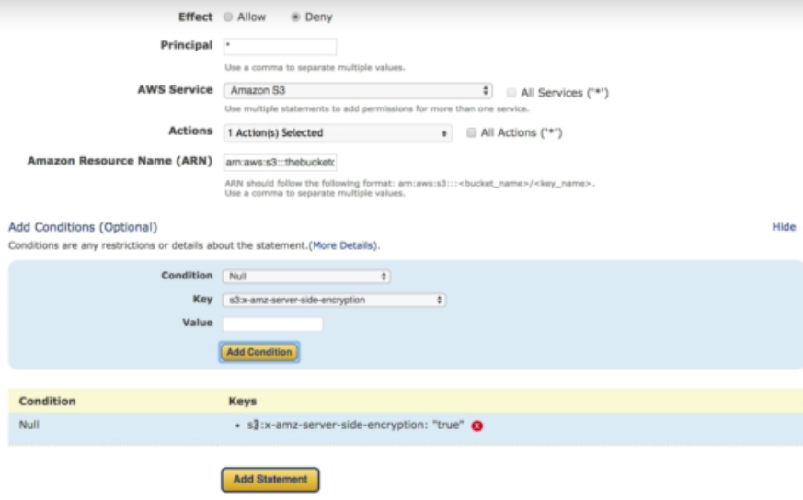

### S3 Encryption

**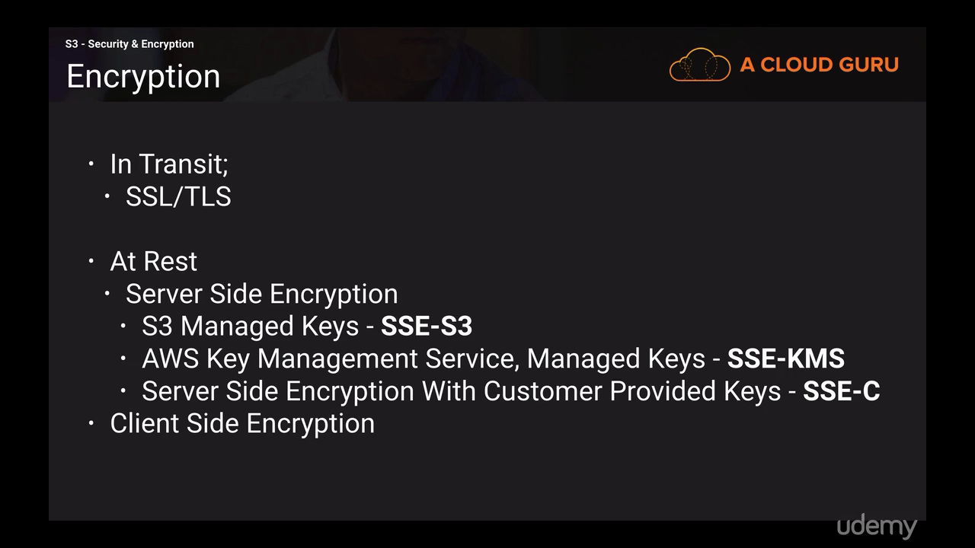**

In transit-When you are sending information to and from your bucket which is secured using SSL/TLS(accessing it via https)

At Rest- to encrypt your Amazon S3 data at rest, you can use several variations of Server-Side Encryption (SSE) . All SSE performed by Amazon S3 and AWS Key Management Service (Amazon KMS) uses the 256-bit Advanced Encryption Standard (AES) .

You can also encrypt your Amazon S3 data at rest using Client-Side Encryption, encrypting your data on the client before sending it to Amazon S3.

**SSE-S3 (AWS-Managed Keys)** This is a fully integrated “check-box-style” encryption solution where AWS handles the key management and key protection for Amazon S3. Every object is encrypted with a unique key. The actual object key itself is then further encrypted by a separate master key. A new master key is issued at least monthly, with AWS rotating the keys. Encrypted data, encryption keys, and master keys are all stored separately on secure hosts, further enhancing protection.

**SSE-KMS (AWS KMS Keys)** This is a fully integrated solution where Amazon handles your key management and protection for Amazon S3, but where you manage the keys. SSE-KMS offers several additional benefits compared to SSE-S3. Using SSE-KMS, there are separate permissions for using the master key, which provide protection against unauthorized access to your objects stored in Amazon S3 and an additional layer of control. AWS KMS also provides auditing, so you can see who used your key to access which object and when they tried to access this object. AWS KMS also allows you to view any failed attempts to access data from users who did not have permission to decrypt the data.

**SSE-C (Customer-Provided Keys)** This is used when you want to maintain your own encryption keys but don’t want to manage or implement your own client-side encryption library. With SSE-C, AWS will do the encryption/decryption of your objects while you maintain full control of the keys used to encrypt/decrypt the objects in Amazon S3.

**Client-Side Encryption** Client-side encryption refers to encrypting data on the client side of your application before sending it to Amazon S3.

For maximum simplicity and ease of use, use server-side encryption with AWSmanaged keys (SSE-S3 or SSE-KMS).

With SSE-KMS you let AWS manage the encryption keys but you have full control of the key rotation policy

With Client Side Encryption you perform the encryption yourself and send the encrypted data to AWS directly. AWS does not know your encryption keys and cannot decrypt your data.

### S3-Versioning

**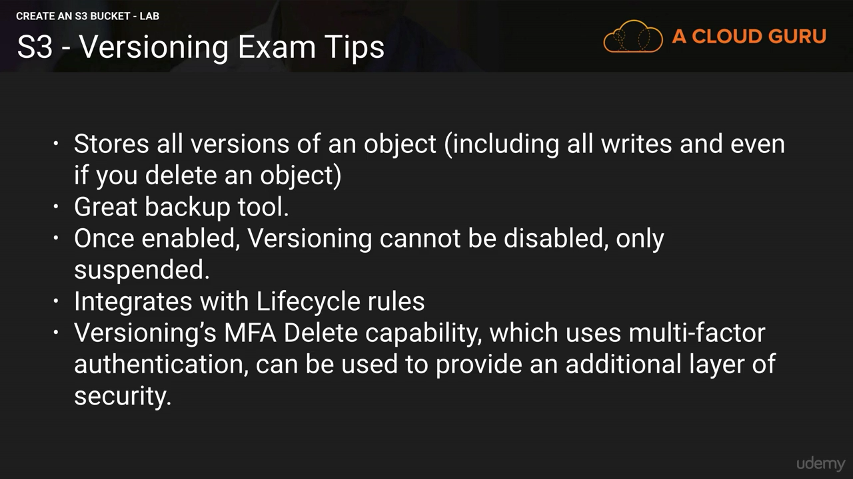**

1. You can also create MFA delete for S3
2. When you upload same file in bucket after making changes (version 2) then that file wont be accessible to public though the version 1 was accessible .Older version always be accessible if you mark it to pubic
3. If you delete that file from bucket then it won’t be appear in bucket but you will see in version tab, that older version and delete marker are available. If you want to restore the file, then just delete that delete marked and file will get automatically restored.

You can also delete the older version of the file from version tab.

1. To delete a bucket, you need to remove all the file versions within it

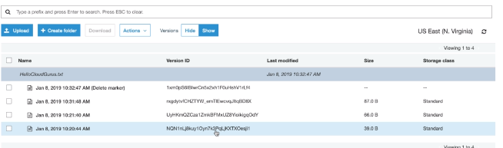

**MFA Delete**

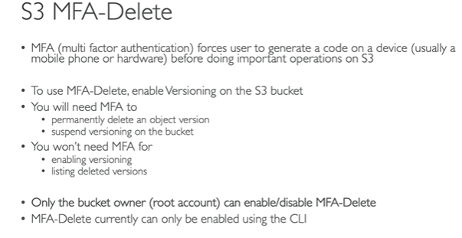

### Cross Region Replication

**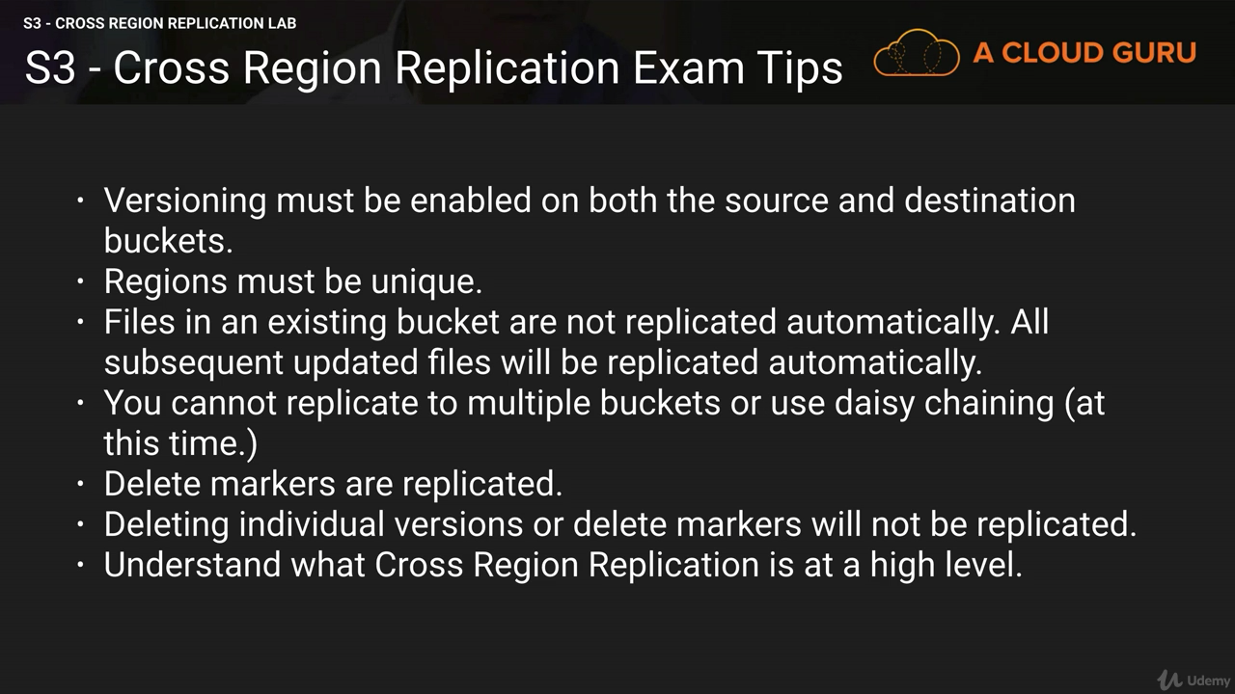**

Cross-region replication is a feature of Amazon S3 that allows you to asynchronously replicate all new objects in the source bucket in one AWS region to a target bucket in another region.

Any metadata and ACLs associated with the object are also part of the replication

Versioning must be enabled. Only new files will get replicated after enabling the cross-region replication. You will not see older files in destination bucket. For one account u can only create 100 buckets and can’t transfer the ownership and can’t create bucket within bucket. **Delete marker will not be get replicated** in destination bucket

Use Cases-Compliance, Lower Latency access, replication across accounts

### S3 CORS (Cross Origin Resource Sharing)

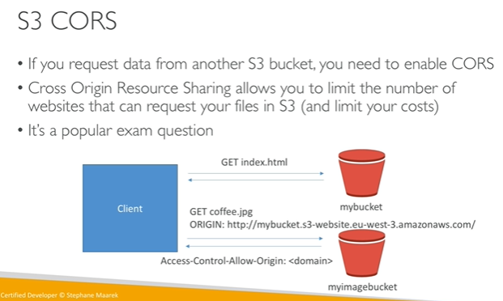

### CloudFront (CDN)

**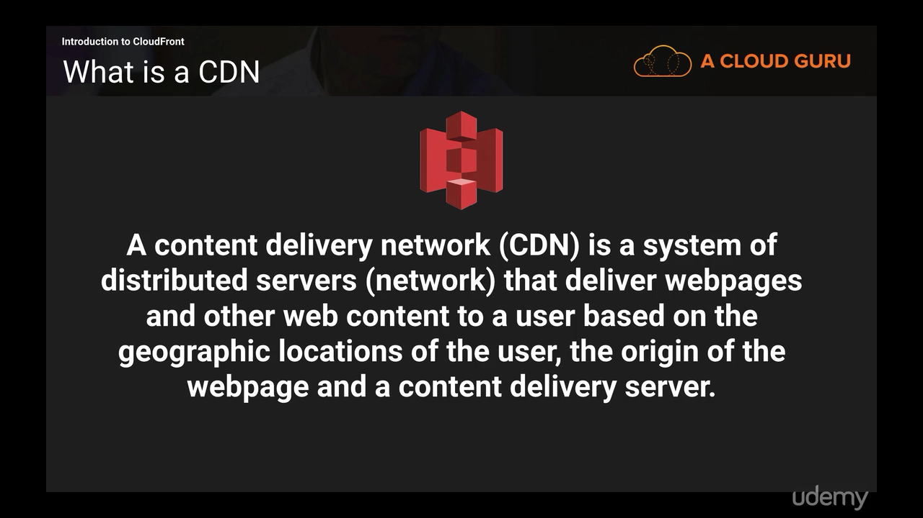**

**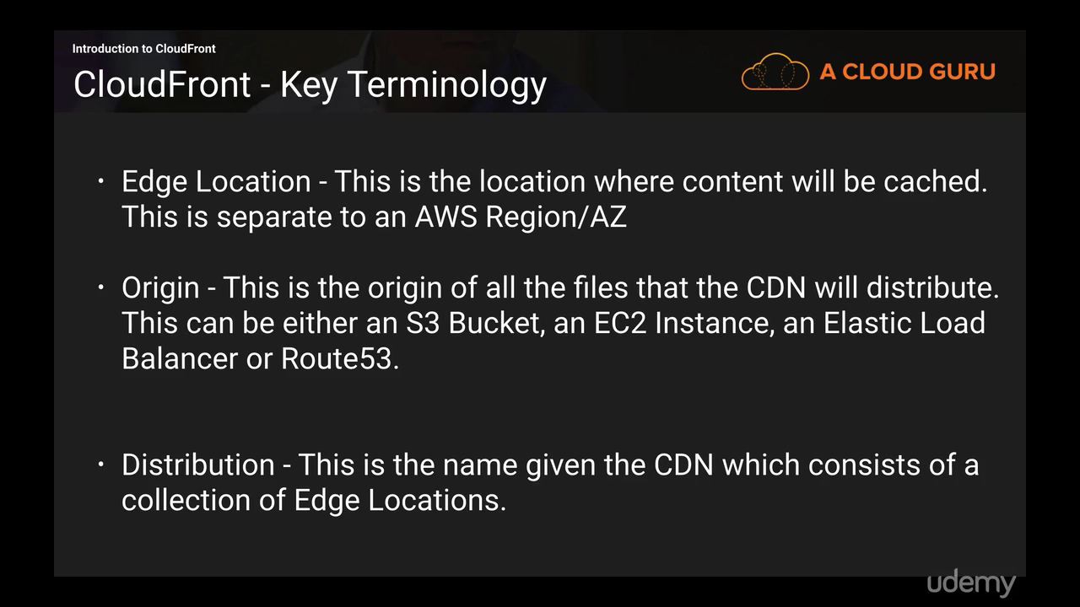**

**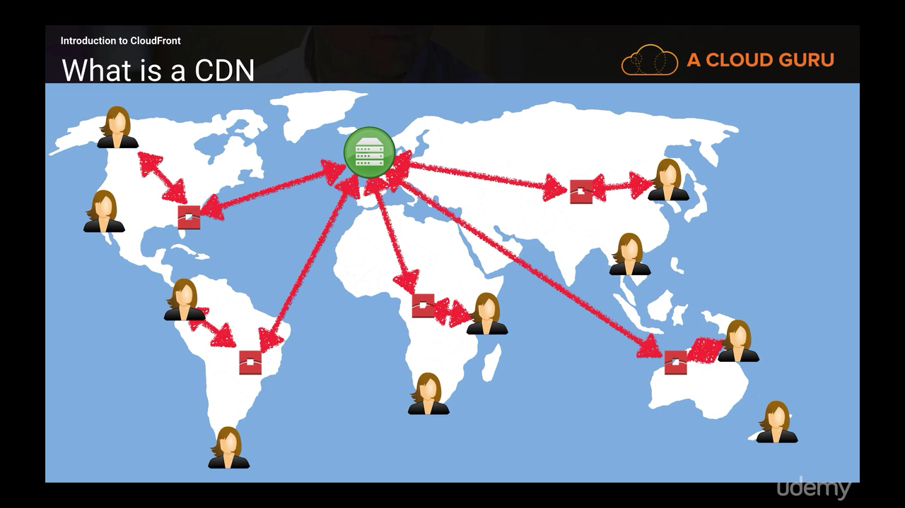**

**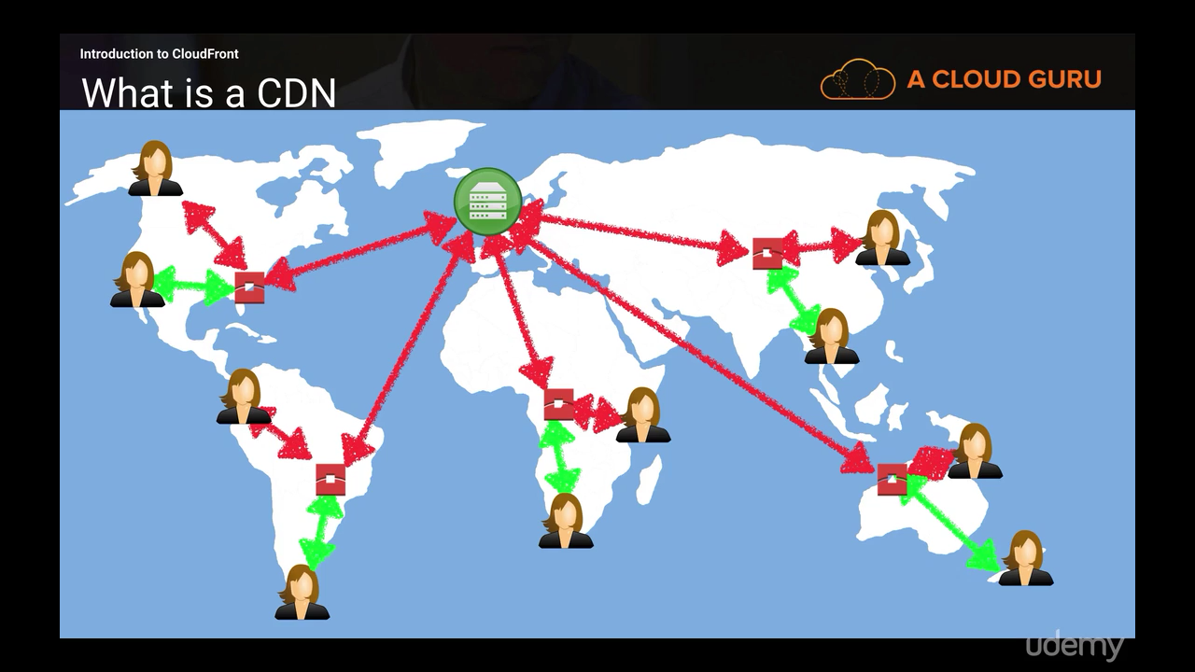**

**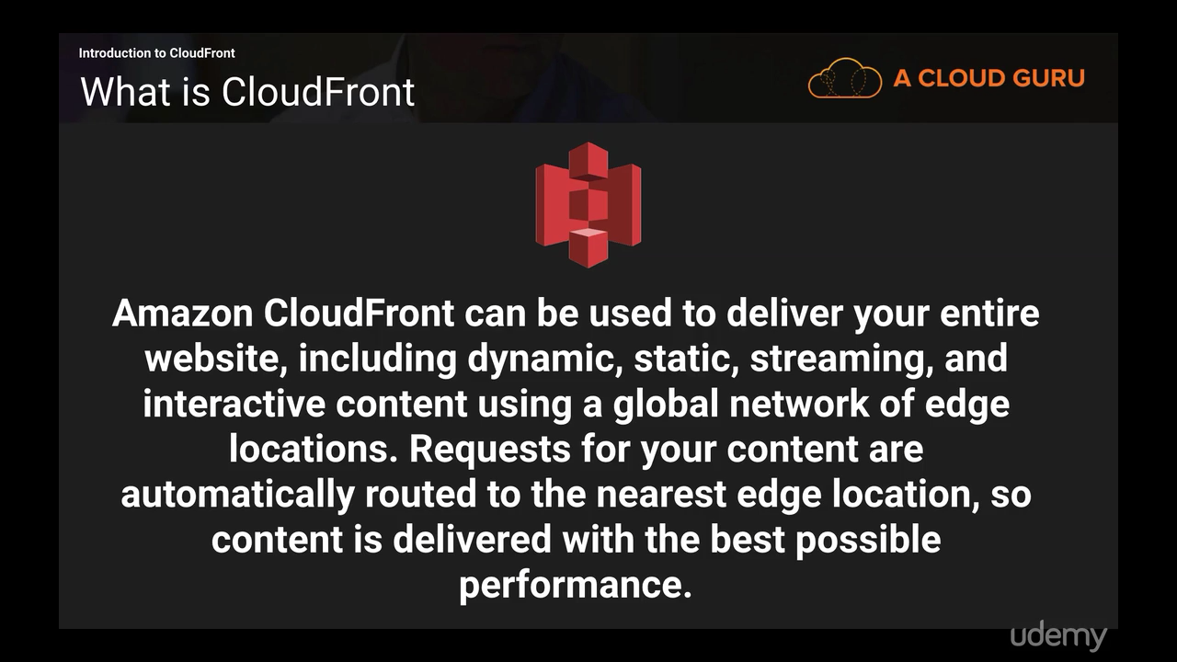**

**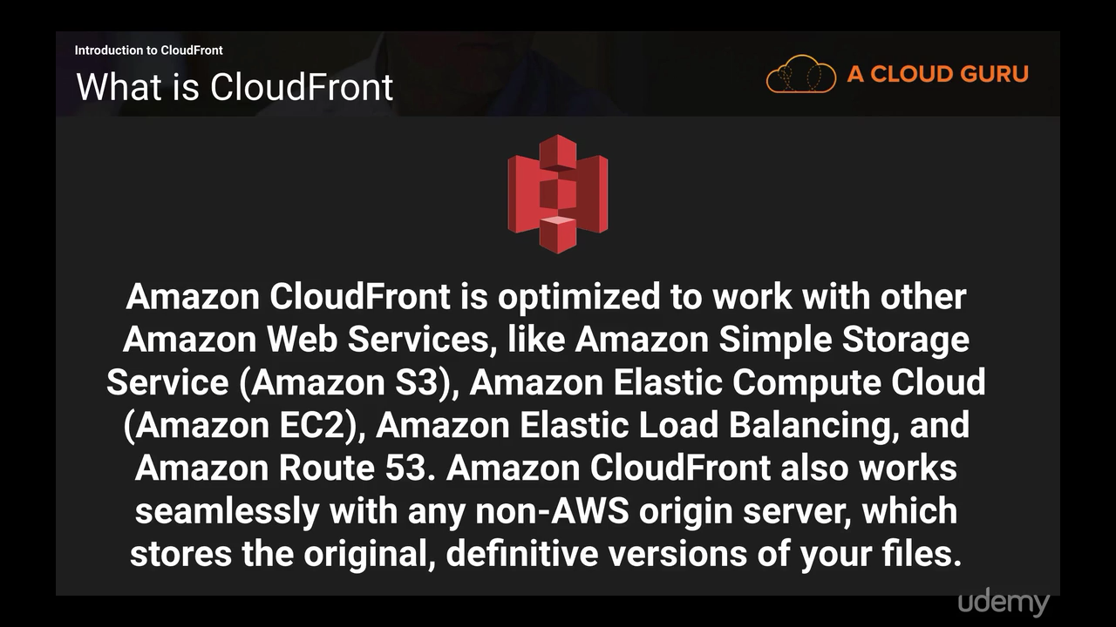**

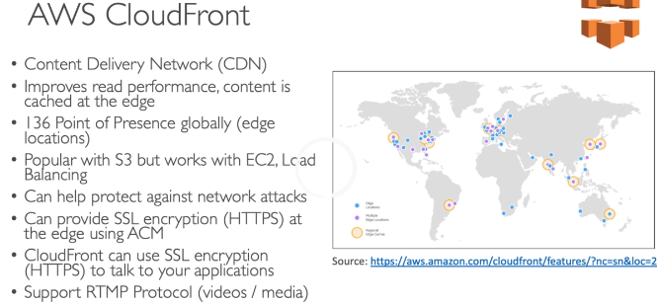

**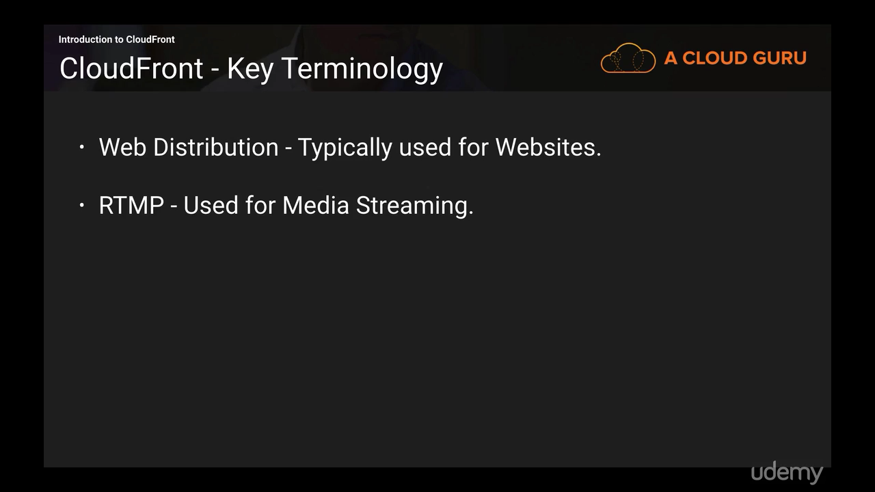**

**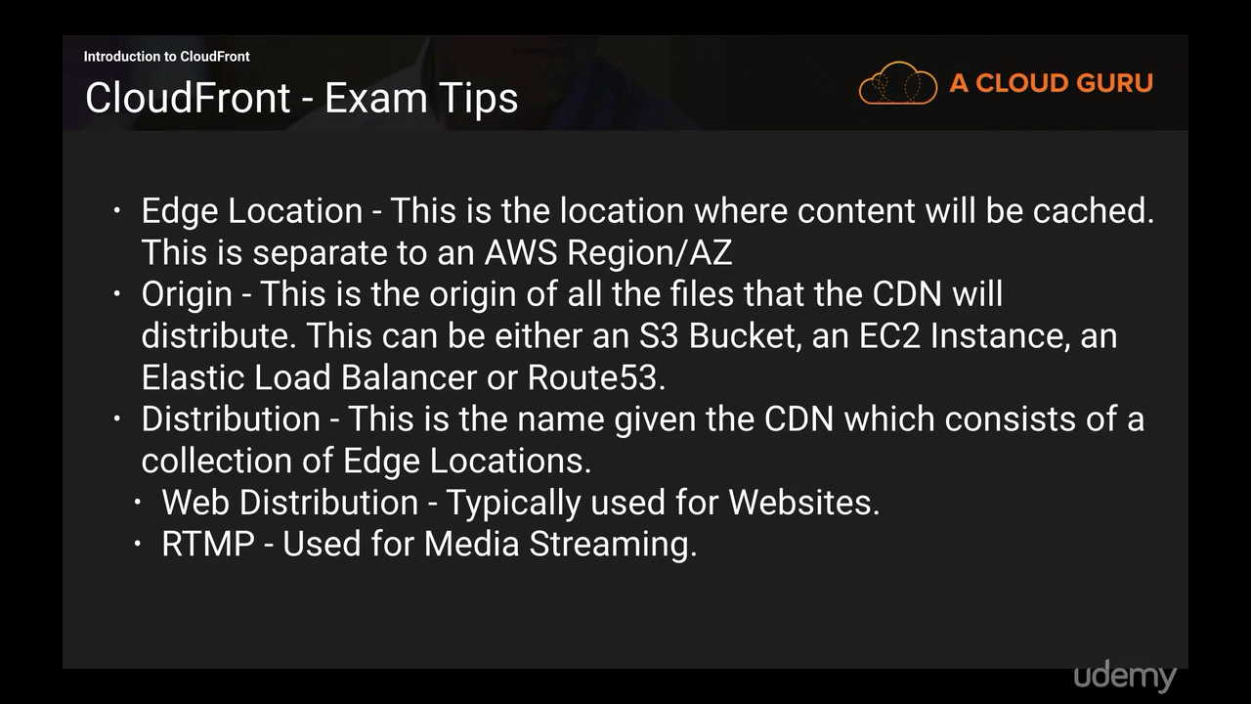**

There can be Multiple origins in same distribution

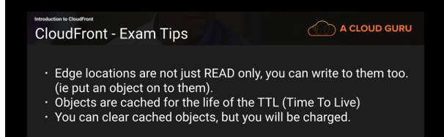

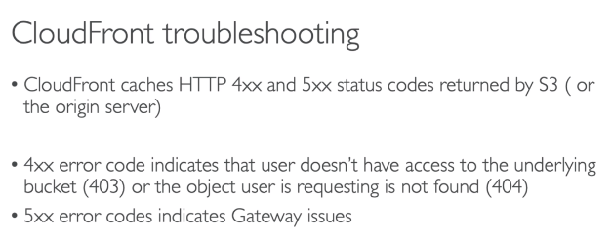

**CloudFront vs S3 Cross Region Replication**

CloudFront:

• Global Edge network

• Files are cached for a TTL (maybe a day)

• “*Great for static content that must be available everywhere”*

S3 Cross Region Replication:

• Must be setup for each region you want replication to happen

• Files are updated in near real-time

• Read only

• *“Great for dynamic content that needs to be available at low-latency in few regions”*

S3-Lifecycle Management**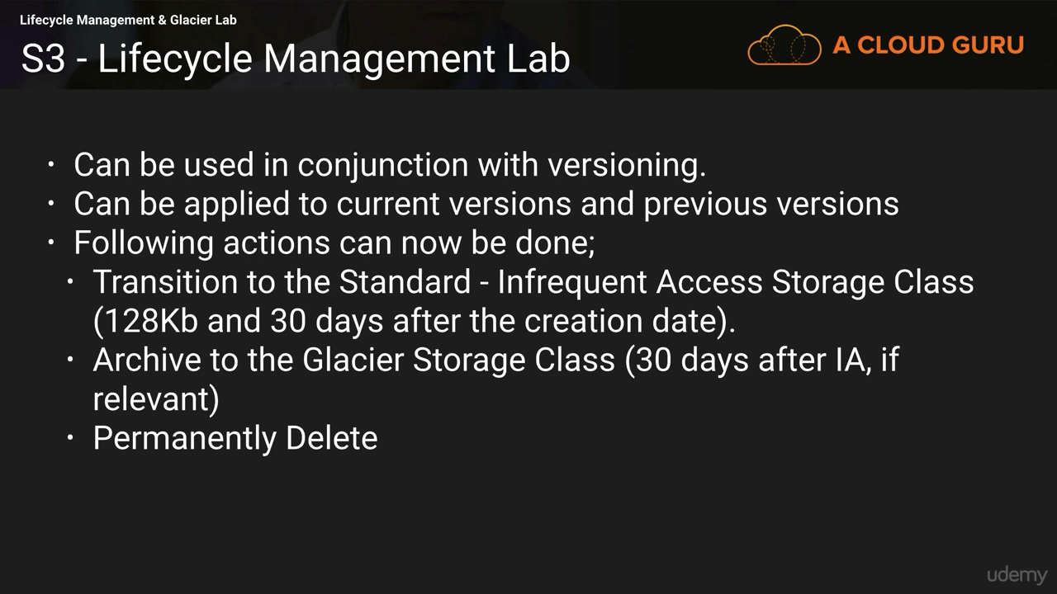**

You can set up lifecycle management such as Changes to the storage classes i.e. move file from one storage class to other storage class as per requirement for the file.

e.g. Delete the file after some days or archive the older files.

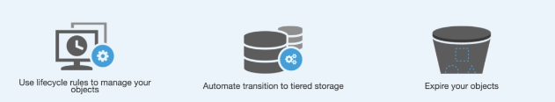

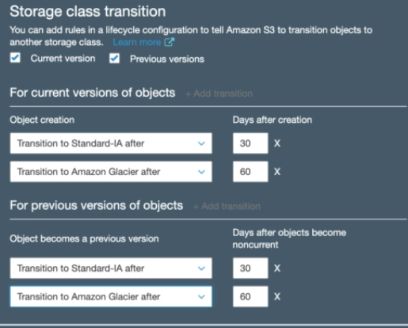

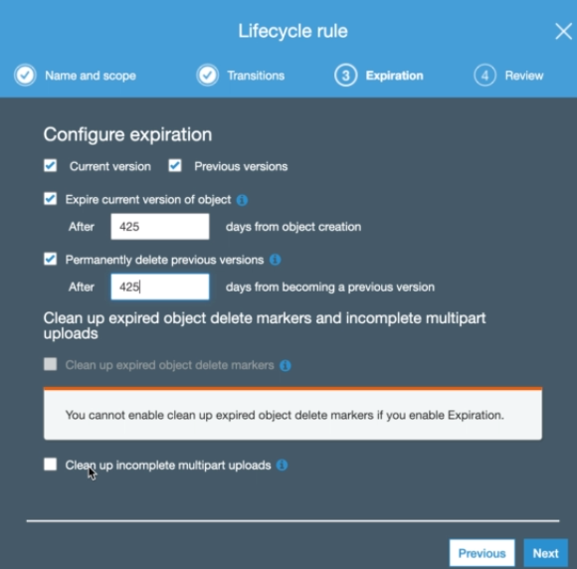

**Pre-Signed URLs**

All Amazon S3 objects by default are private, meaning that only the owner has access. However, the object owner can optionally share objects with others by creating a pre-signed URL, using their own security credentials to grant time-limited permission to download the objects. When you create a pre-signed URL for your object, you must provide your security credentials and specify a bucket name, an object key, the HTTP method (GET to download the object), and an expiration date and time. The pre-signed URLs are valid only for the specified duration. This is particularly useful to protect against “content scraping” of web content such as media files stored in Amazon S3.

**Multipart Upload**

To better support uploading or copying of large objects, Amazon S3 provides the Multipart Upload API. This allows you to upload large objects as a set of parts, which generally gives better network utilization (through parallel transfers), the ability to pause and resume, and the ability to upload objects where the size is initially unknown.

**Range GETs**

It is possible to download (GET) only a portion of an object in both Amazon S3 and Amazon Glacier by using something called a Range GET. Using the Range HTTP header in the GET request or equivalent parameters in one of the SDK wrapper libraries, you specify a range of bytes of the object. This can be useful in dealing with large objects when you have poor connectivity or to download only a known portion of a large Amazon Glacier backup.

**Event Notifications**

Amazon S3 event notifications can be sent in response to actions taken on objects uploaded or stored in Amazon S3. Notification messages can be sent through either Amazon Simple Notification Service (Amazon SNS) or Amazon Simple Queue Service (Amazon SQS) or delivered directly to AWS Lambda to invoke AWS Lambda functions.

**Archives**

In Amazon Glacier, data is stored in archives. An archive can contain up to 40TB of data, and you can have an unlimited number of archives. Each archive is assigned a unique archive ID at the time of creation. (Unlike an Amazon S3 object key, you cannot specify a user-friendly archive name.) All archives are automatically encrypted, and archives are immutable—after an archive is created, it cannot be modified.

**Vaults** Vaults are containers for archives. Each AWS account can have up to 1,000 vaults. You can control access to your vaults and the actions allowed using IAM policies or vault access policies.

### Storage Gateway

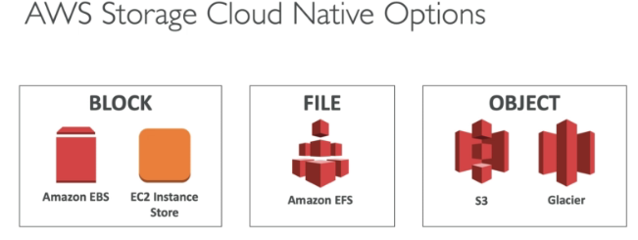

• Bridge between on-premise data and cloud data in S3

• Use cases: disaster recovery, backup & restore, tiered storage

**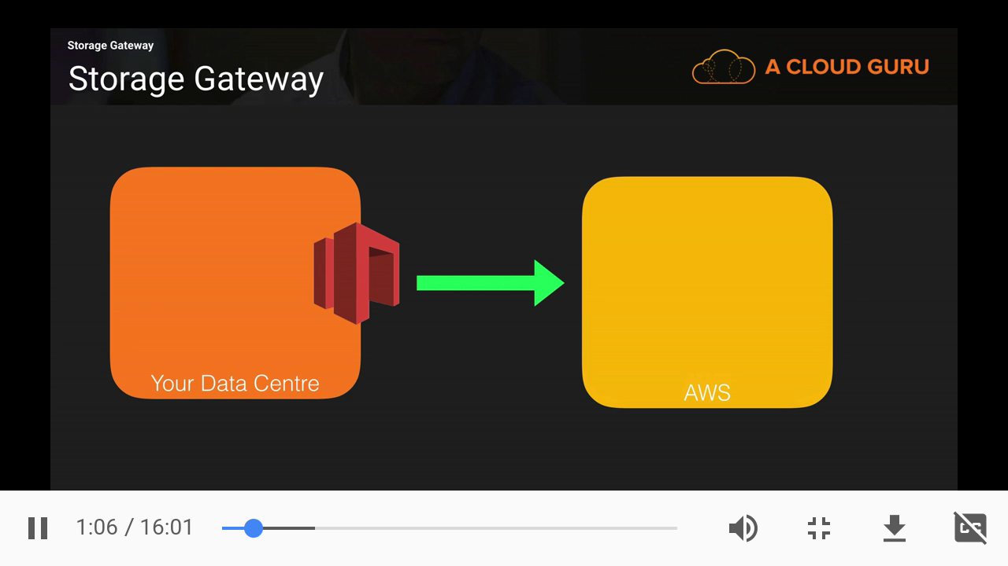**

**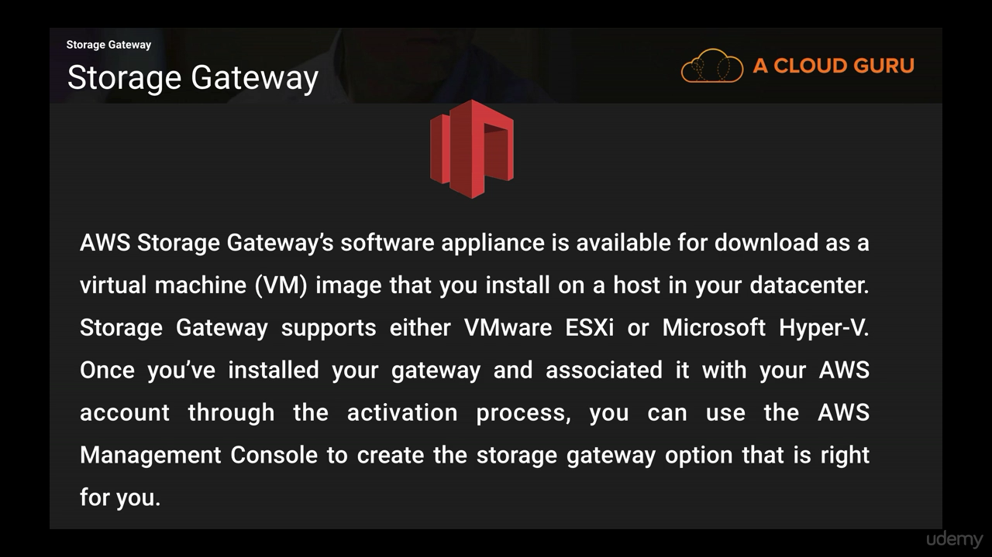**

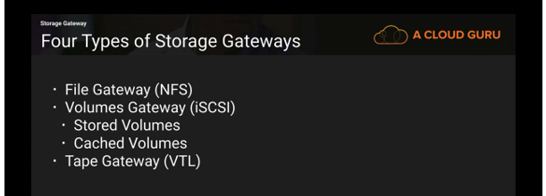

3 types of Storage Gateway:

• File Gateway

• Volume Gateway

• Tape Gateway

**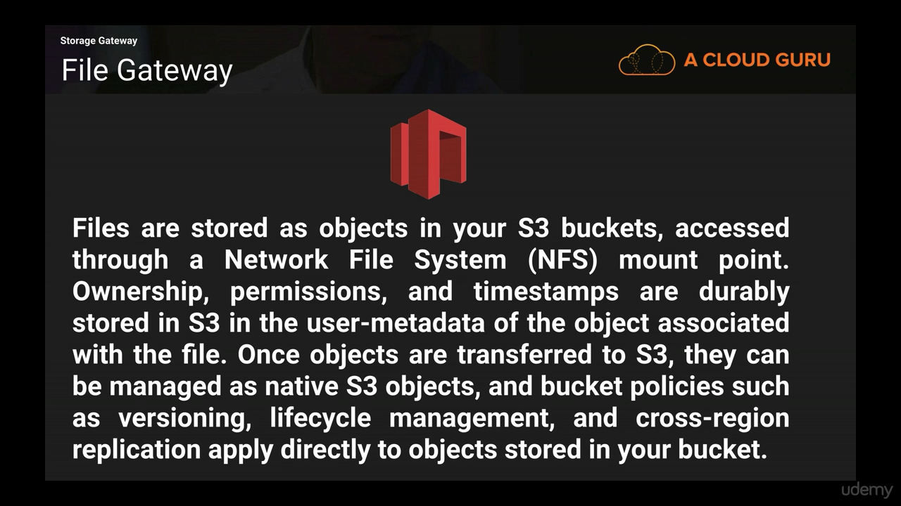**

**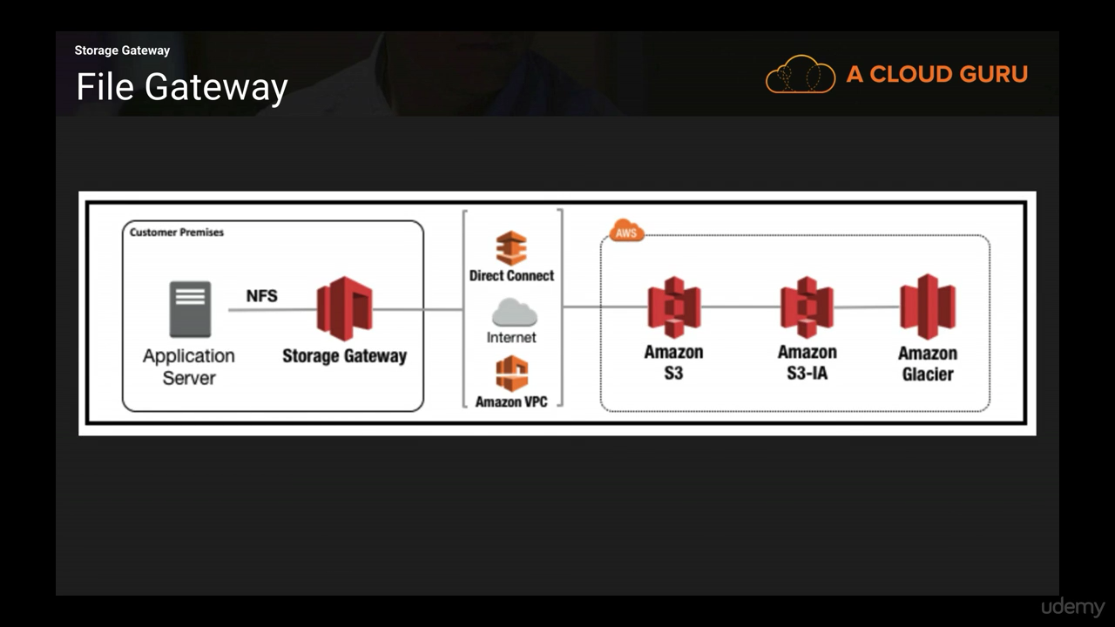**

**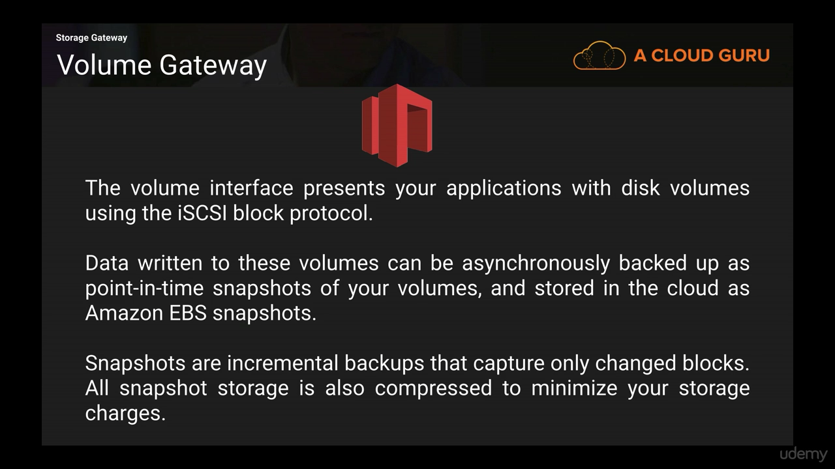**

**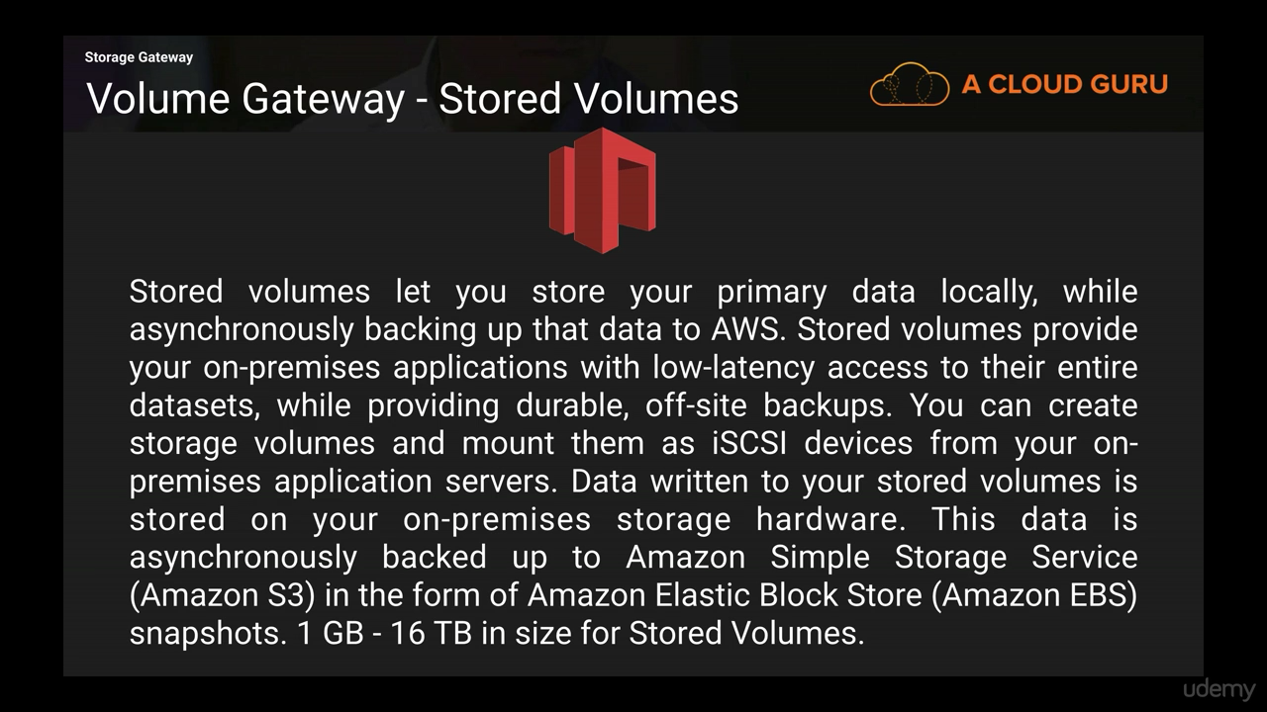**

**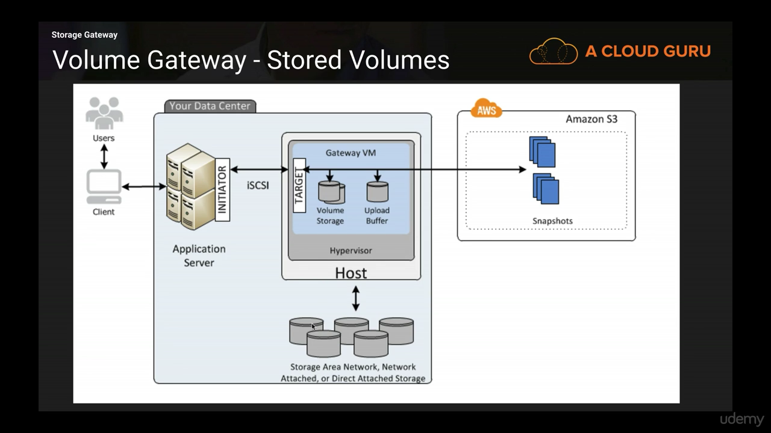**

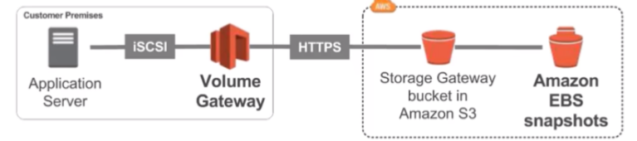

**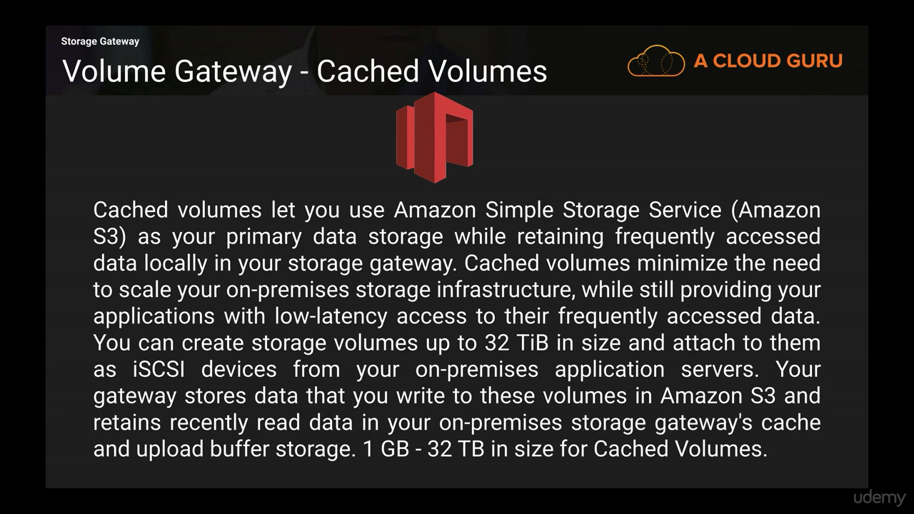**

**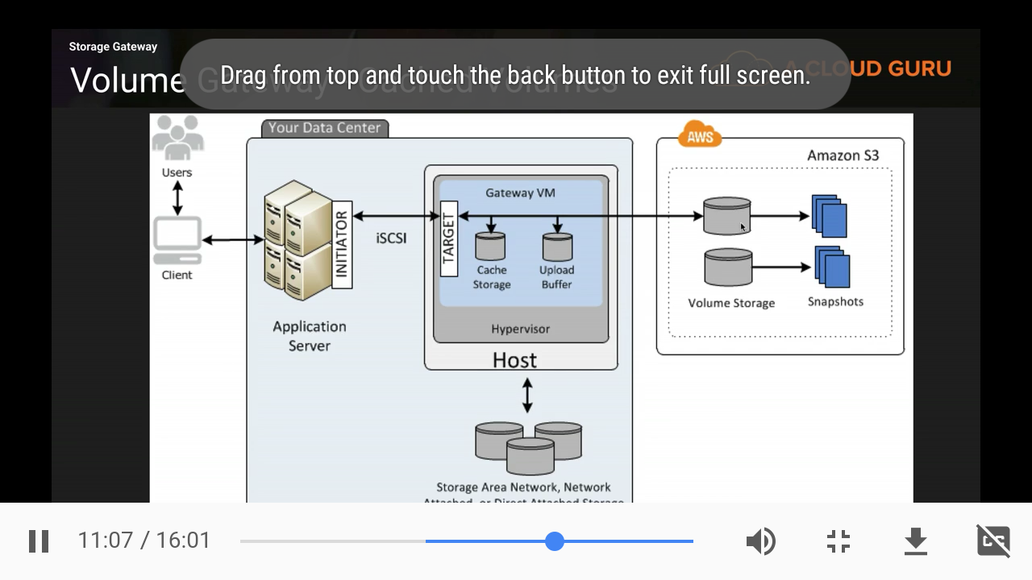**

**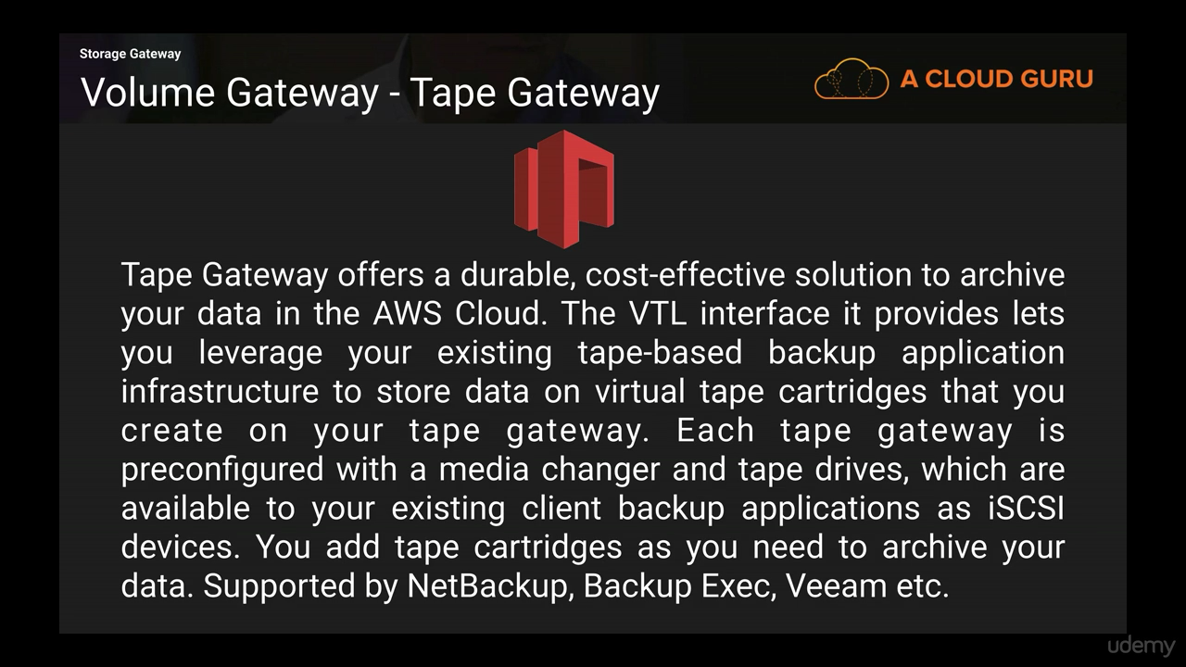**

**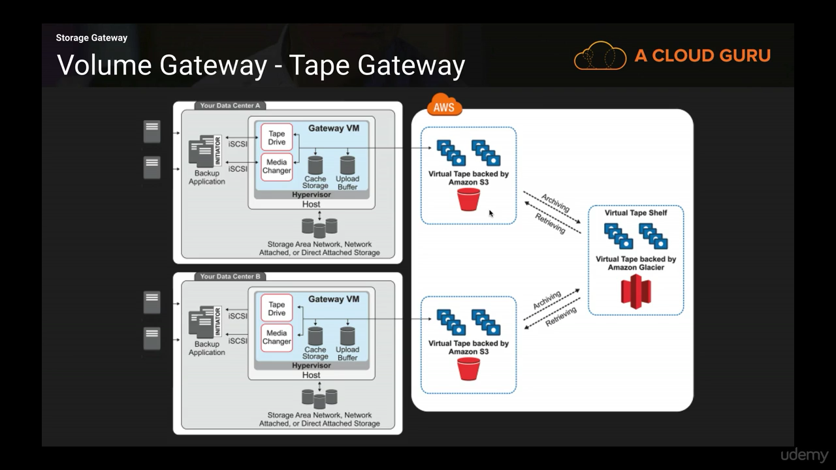**

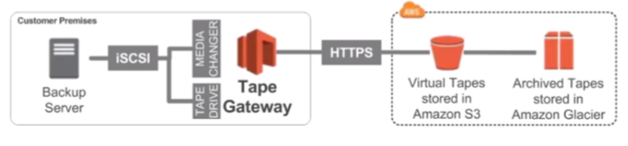

**AWS Storage Gateway Summary**

• Exam tip: Read the question well, it will hint at which gateway to use

• On premise data to the cloud => Storage Gateway

• File access / NFS => File Gateway (backed by S3)

• Volumes / Block Storage / iSCSI => Volume gateway (backed by S3 with EBS snapshots)

• VTL Tape solution / Backup with iSCSI = > Tape Gateway (backed by S3 and Glacier)

**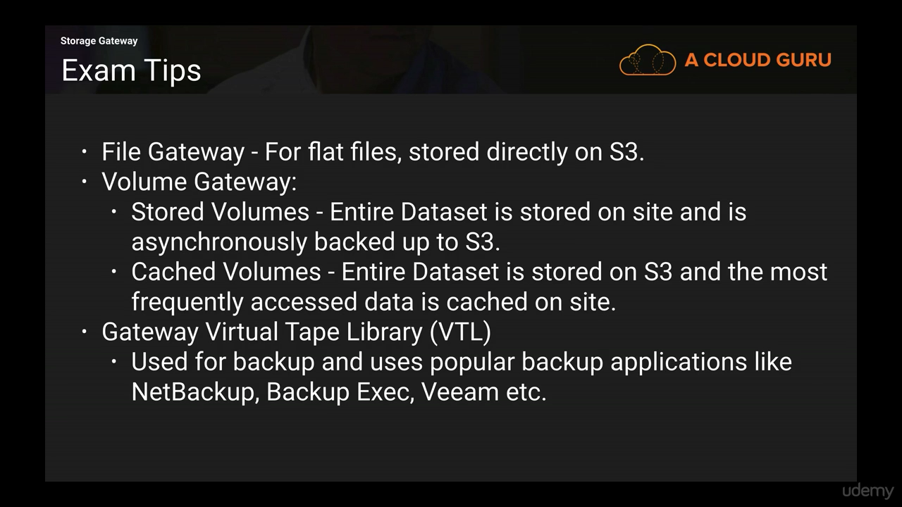**

### Snowball

**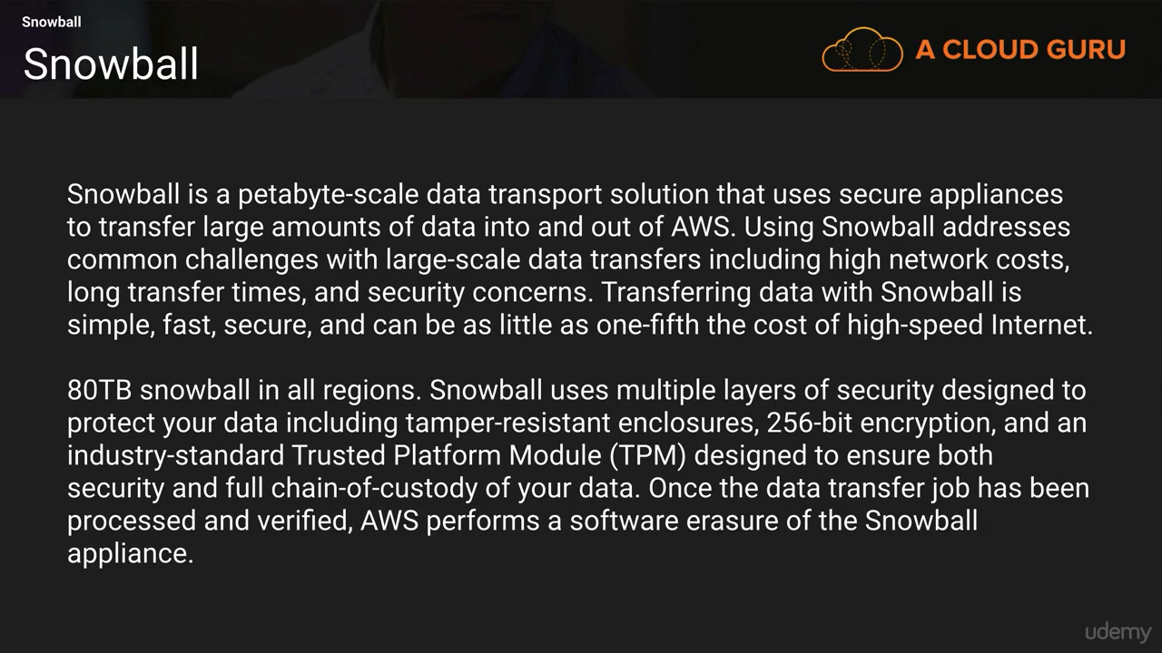**

**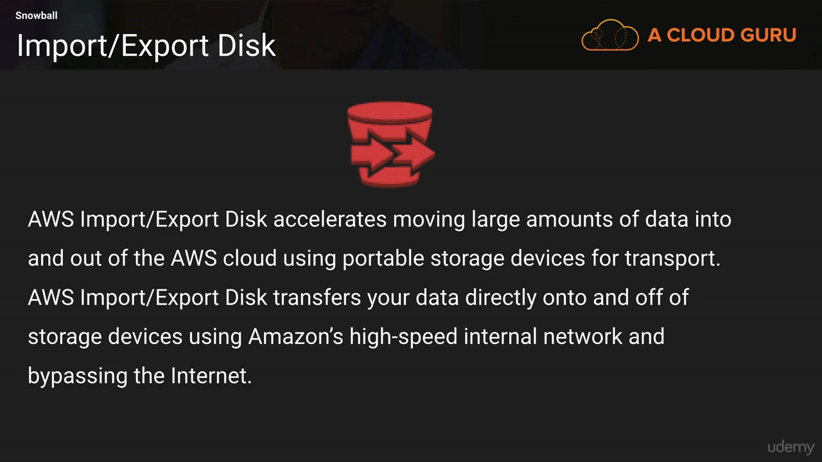**

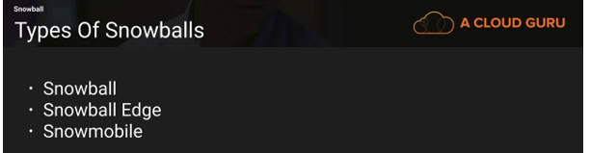

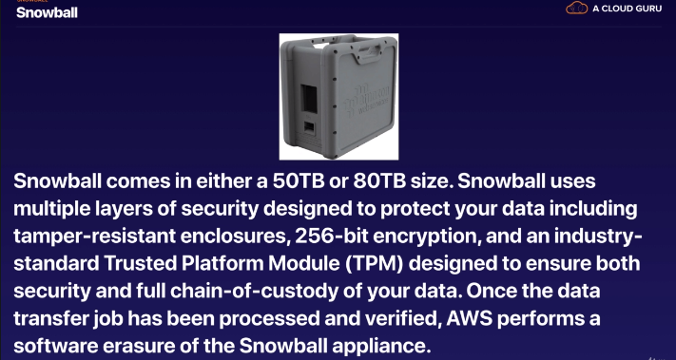

**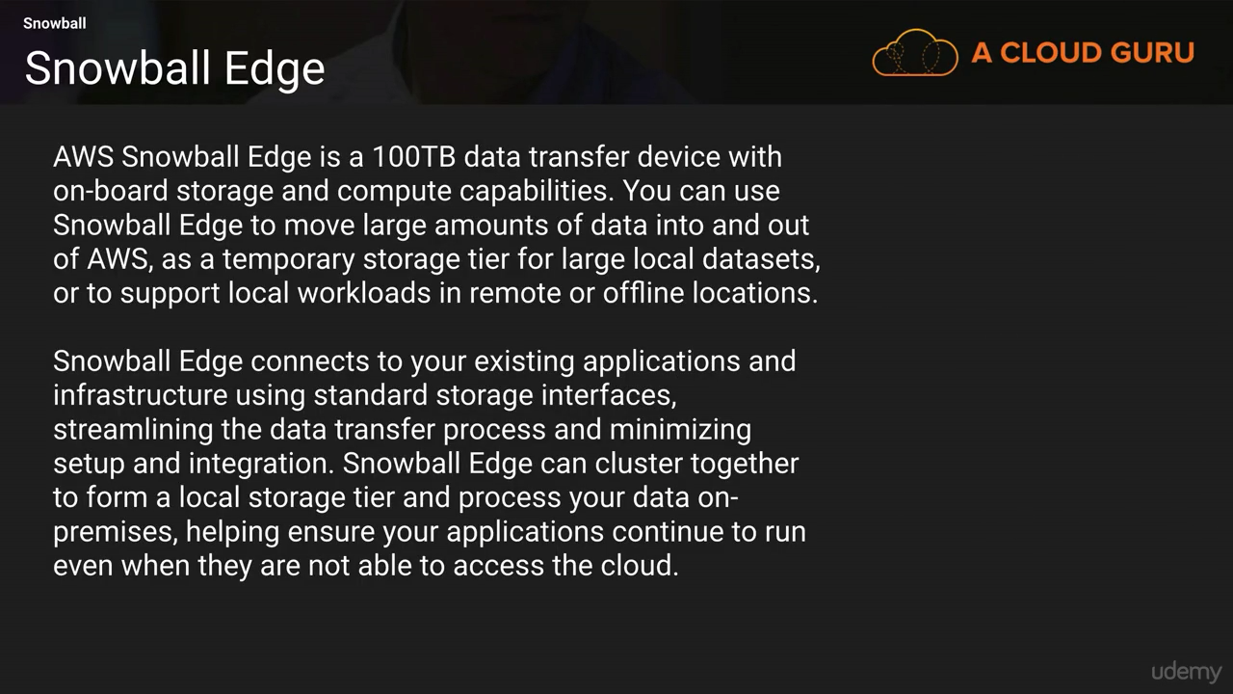**

Support 100 TB

**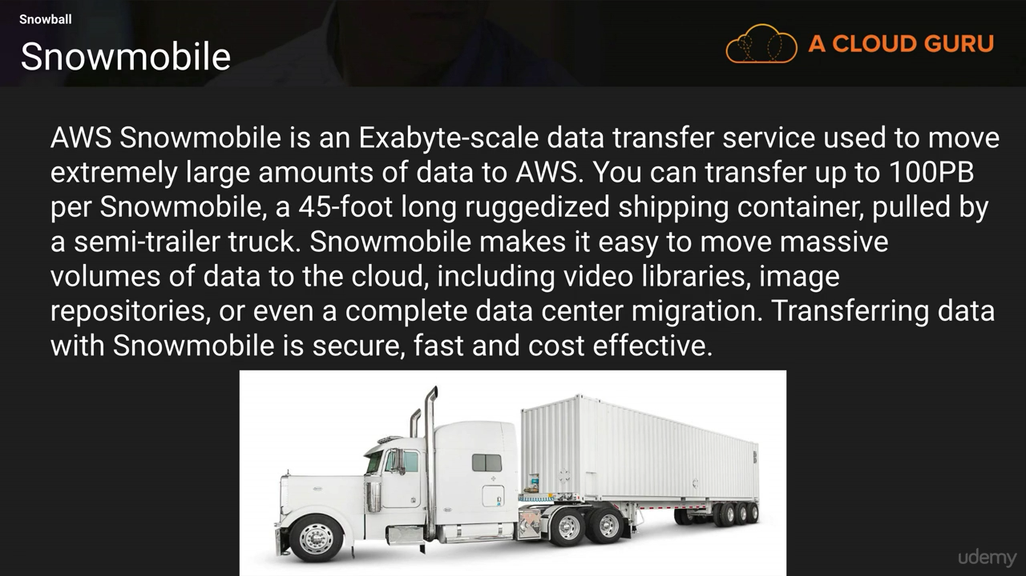**

Support 100PB

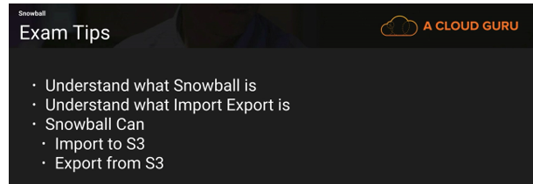

**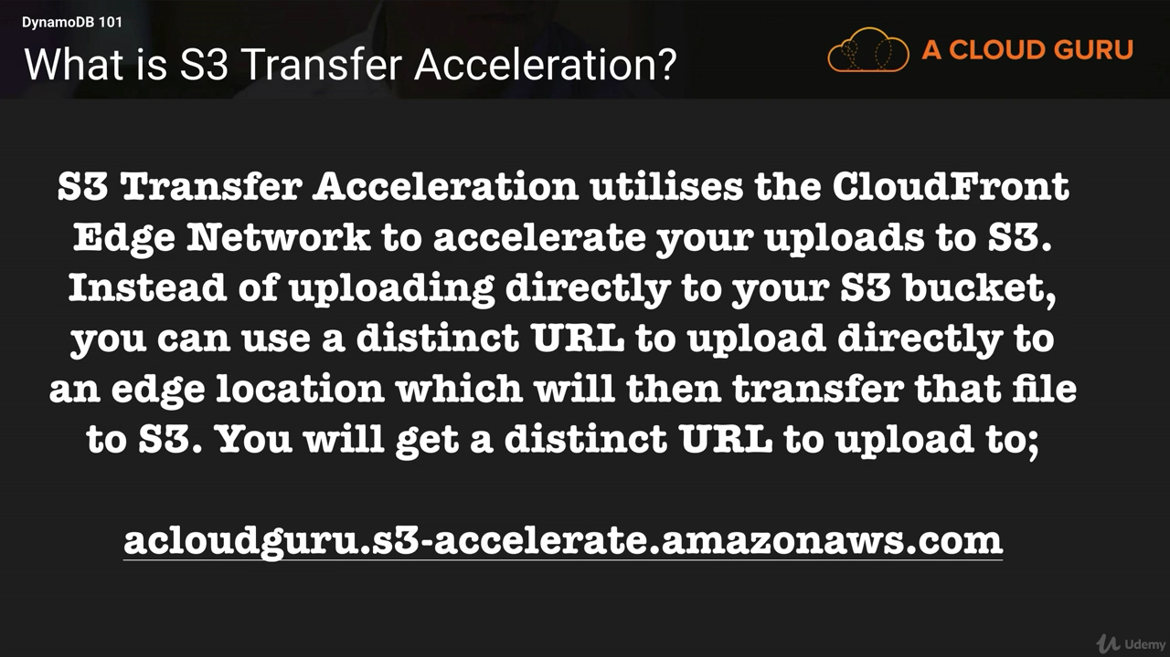**

**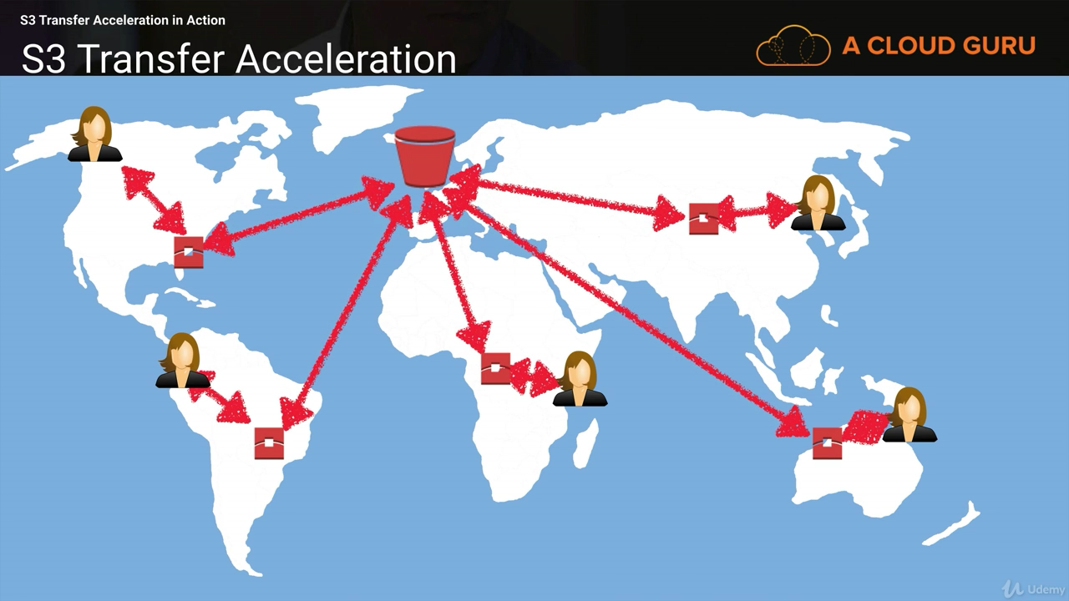**

For creating static website using S3. The domain name and bucket name should be same..

---Url for the static website on S3-----

http:*//bucketname.s3-website-us-east-1.amazonaws.com/photo.jpg*

# **EC2 (Elastic Compute Cloud)**

To launch a new EC2 instance from an Amazon Machine Image (AMI), do the following:

1. Open the [EC2 console](https://console.aws.amazon.com/ec2/).  
   Note: Be sure to [select the AWS region](https://docs.aws.amazon.com/awsconsolehelpdocs/latest/gsg/getting-started.html#select-region) you want to launch the instance in.
2. From the navigation bar, choose AMIs.
3. Find the AMI you want to use to launch a new instance. To begin, open the menu next to the search bar, and then choose one of the following:  
   If the AMI you’re using is one that you created, select Owned by me.  
   If the AMI you’re using is a public AMI, select Public images.  
   If the AMI you’re using is a private image that someone else shared with you, select Private images.  
   Note: The search bar automatically provides filtering options, as well as automatically matching AMI IDs.
4. Select the AMI, and then choose Launch.
5. Choose an instance type(t2 micro), and then choose Next: Configure Instance Details.
6. Review the Instance Details, and then choose Review and Launch.
7. Choose your preferred boot volume, choose Next, and then choose Launch.
8. Select an existing key pair or create a new key pair, select the acknowledge agreement box, and then choose Launch Instances.
9. Choose View Instances to check the status of your instance.

**Launching Instance**

**1)**

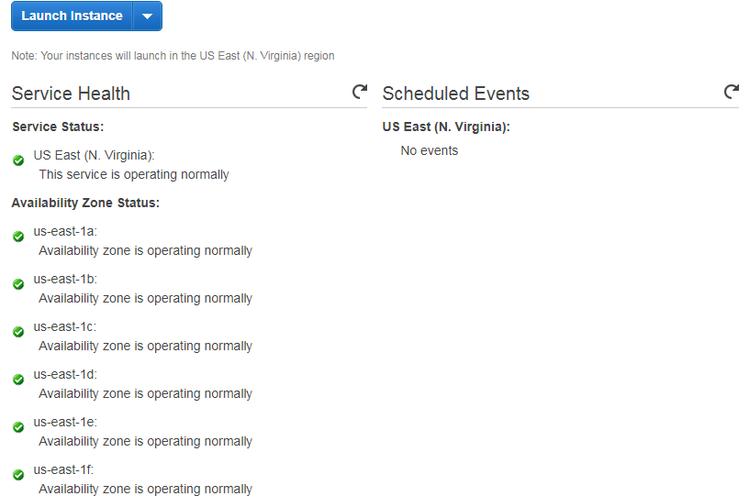

2)

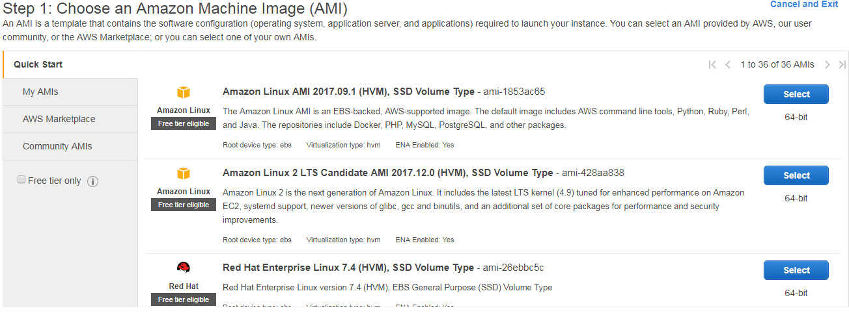

1. Choose instance type on the basis of Dr mac GIFT PX

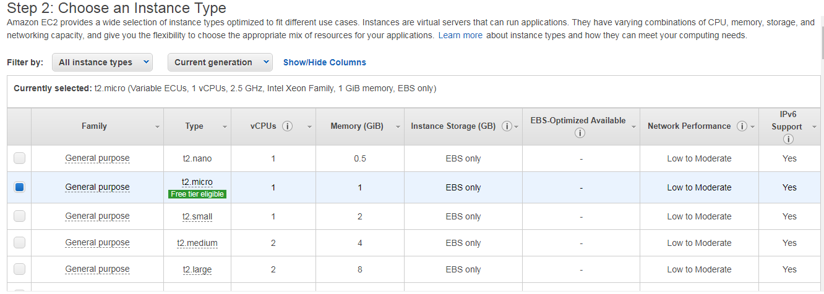

4)

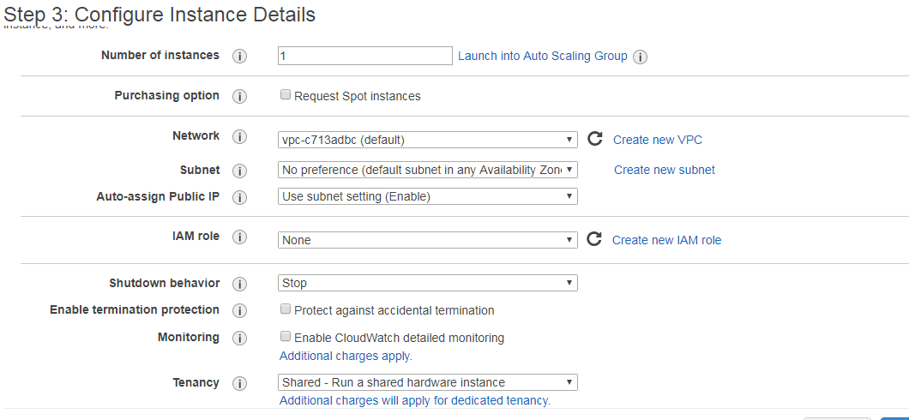

Tenancy - 1) Dedicated -

2) Dedicated Host – Own Physical machine so no other VMs will be there

3) Shared -In Physical machines VM’s are mix (can have VM’s of other user in physical Machine)

5)

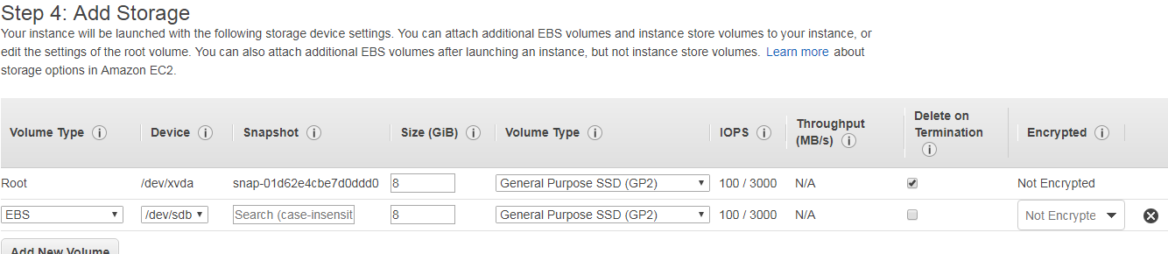

6)

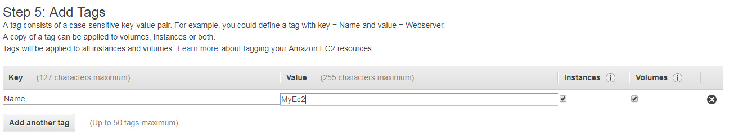

7)

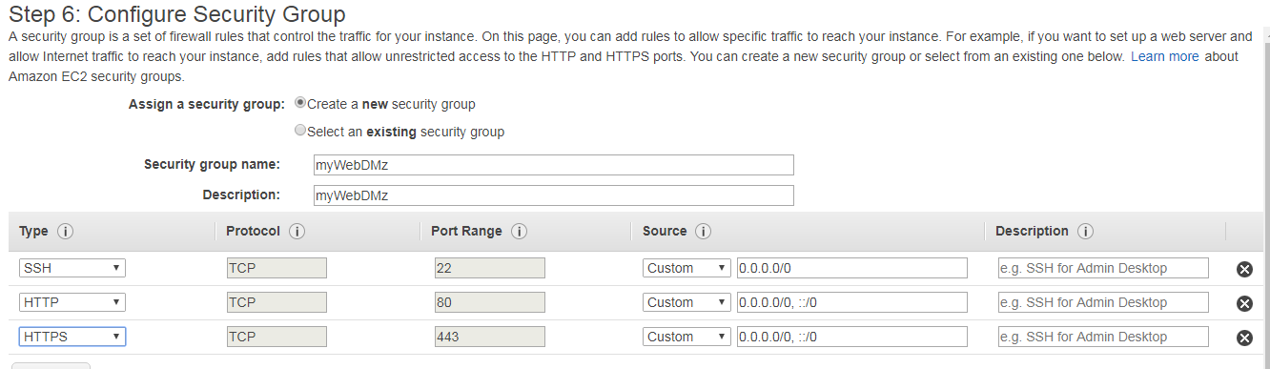

**Initial Access**

Amazon EC2 uses public-key cryptography to encrypt and decrypt login information. Publickey cryptography uses a public key to encrypt a piece of data and an associated private key to decrypt the data. These two keys together are called a key pair.

**Virtual Firewall Protection**

Every instance must have at least one security group but can have more.

**A security group is default deny;**

**Security Group**

• If your application is not accessible (time out), then it’s a security group issue

• If your application gives a “connection refused“ error, then it’s an application error or it’s not launched

• All inbound traffic is blocked by default

• All outbound traffic is authorised by default

**Launching**

One of the parameters when an instance is launched is a string value called UserData.

UserData is stored with the instance and is not encrypted,

**Instance Metadata**

http://169.254.169.254/latest/meta-data/

**Modifying an Instance**

If an instance is running in an Amazon VPC ,you can change which security groups are associated with an instance while the instance is running. For instances outside of an Amazon VPC (called EC2-Classic), the association of the security groups cannot be changed after launch

**Termination Protection**

Instance will not terminate if Termination Protection is enabled but this just protects from termination calls from the AWS Management Console, CLI, or API. It does not prevent termination triggered by an OS shutdown command, termination from an Auto Scaling group or termination of a Spot Instance due to Spot price changes

**Tenancy Options**

Shared Tenancy Shared tenancy is the default tenancy model for all Amazon EC2 instances,

1) Dedicated Instances-

Dedicated Instances run on hardware that’s dedicated to a single customer. As a customer runs more Dedicated Instances, more underlying hardware may be dedicated to their account.

2) Dedicated Host – Own Physical machine so no other VMs will be there

3) Shared - Shared Tenancy Shared tenancy is the default tenancy model for all Amazon EC2 instances In Physical machines, VM’s are mix (can have VM’s of other user in physical Machine)

### On Demand, Reserved, Spot instance

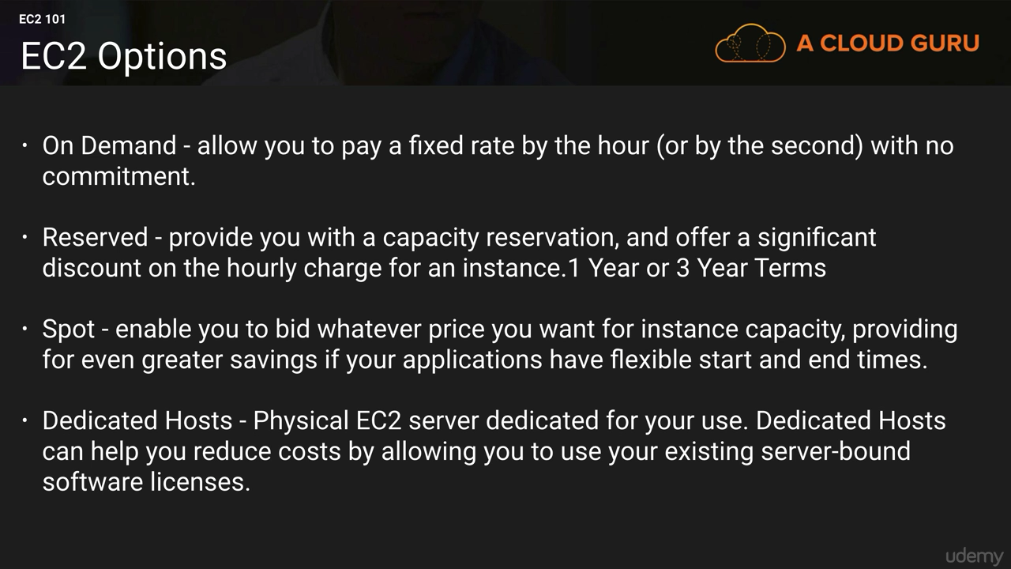

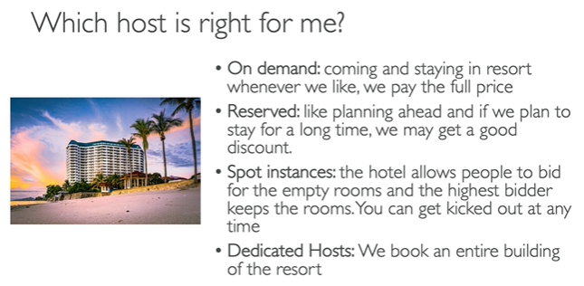

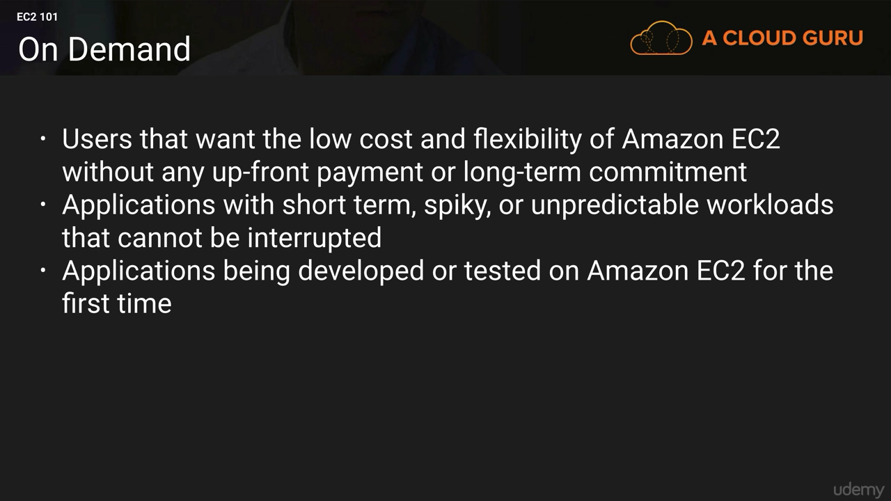

On Demand- The price per hour for each instance type published on the AWS website represents the price for On-Demand Instances. This is the most flexible pricing option, as it requires no up-front commitment, and the customer has control over when the instance is launched and when it is terminated. It is the least cost effective of the three pricing options per compute hour, but its flexibility allows customers to save by provisioning a variable level of compute for unpredictable workloads

• Pay for what you use (billing per second, after the first minute)

• Has the highest cost but no upfront payment

• No long term commitment

• Recommended for short-term and un-interrupted workloads, where you can't predict how the application will behave.

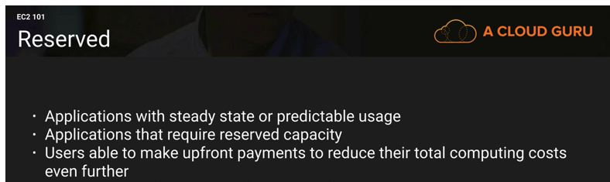

Reserved- customers can save up to 75 percent over the on-demand hourly rate.

An additional benefit is that capacity in the AWS data centers is reserved for that customer. There are two factors that determine the cost of the reservation: the term commitment and the payment option. The term commitment is the duration of the reservation and can be either one or three years. The longer the commitment, the bigger the discount

* + 1. Convertible Reserved Instance
* can change the EC2 instance type
* Up to 54% discount
  + 1. Scheduled Reserved Instances

• launch within time window you reserve

• When you require a fraction of day / week / month

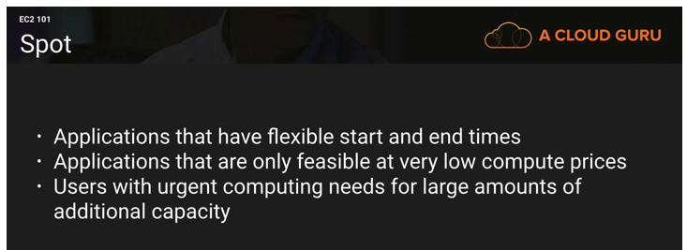

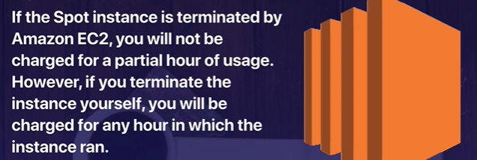

Spot- For workloads that are not time critical and are tolerant of interruption, Spot Instances offer the greatest discount. With Spot Instances, customers specify the price they are willing to pay for a certain instance

• Used for batch jobs, Big Data analysis, or workloads that are resilient to failures.

• Not great for critical jobs or databases

• Spot instances are reclaimed with a 2-minute notification warning when the spot price goes above your bid.

**EC2 Dedicated Hosts**

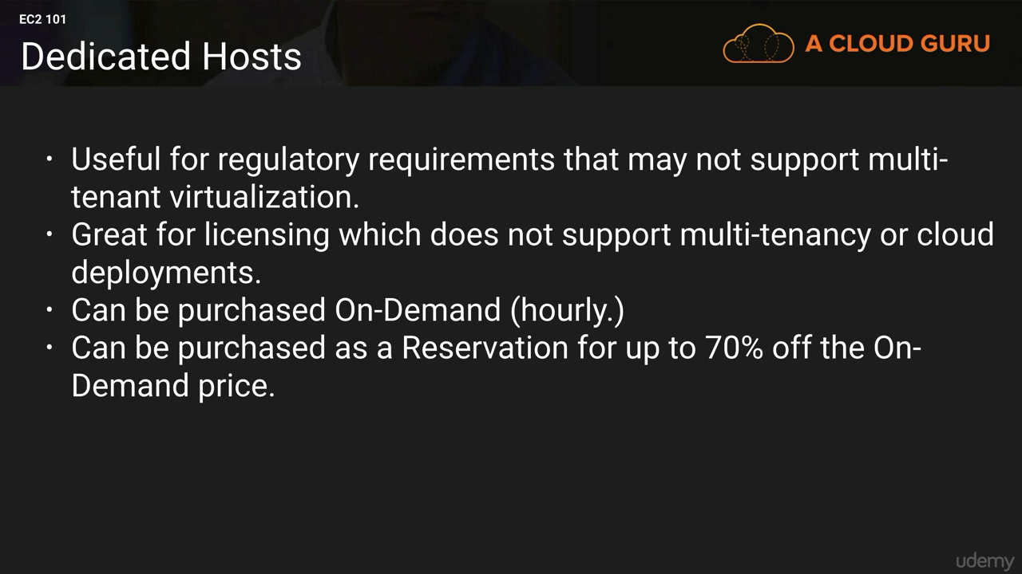

• Physical dedicated EC2 server for your use

• Full control of EC2 Instance placement

• Visibility into the underlying sockets / physical cores of the hardware

• Allocated for your account for a 3 year period reservation

• More expensive

• Useful for software that have complicated licensing model (BYOL – Bring Your Own License)

• Or for companies that have strong regulatory or compliance needs

**EC2 Dedicated Instances**

• Instances running on hardware that’s dedicated to you

• May share hardware with other instances in same account

• No control over instance placement (can move hardware after Stop / Start)

### EC2 Instance Types – Main ones

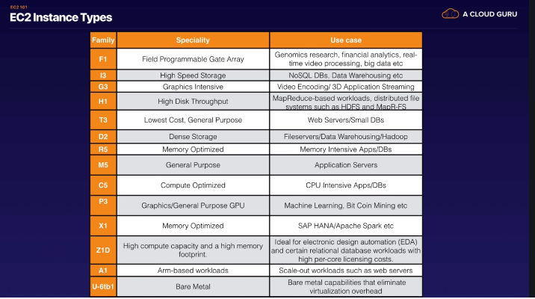

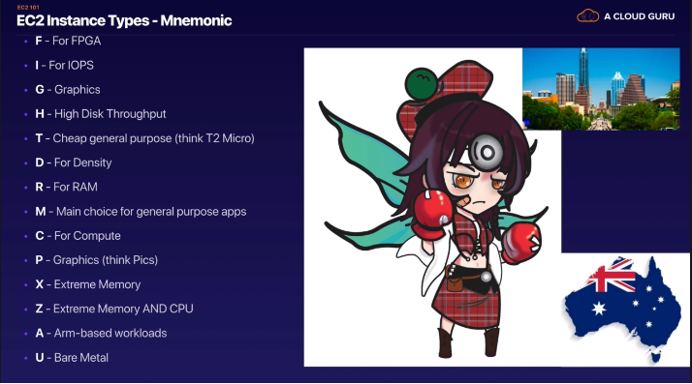

FIGHT DR MC-PXZ AU(Australia)

### EC2 Placement Groups

A placement group is a logical grouping of instances within a single Availability Zone. Placement groups enable applications to participate in a low-latency, 10 Gbps network.

Types

* Cluster- clusters instances into a low-latency group in a single Availability Zone (10GBPS)
* Spread (Across availability zone)- —spreads instances across underlying hardware (max 7 instances per group per AZ)
* Partitioned- spreads instances across many different partitions.7 Partition per AZ and upto 100 of EC2 instances

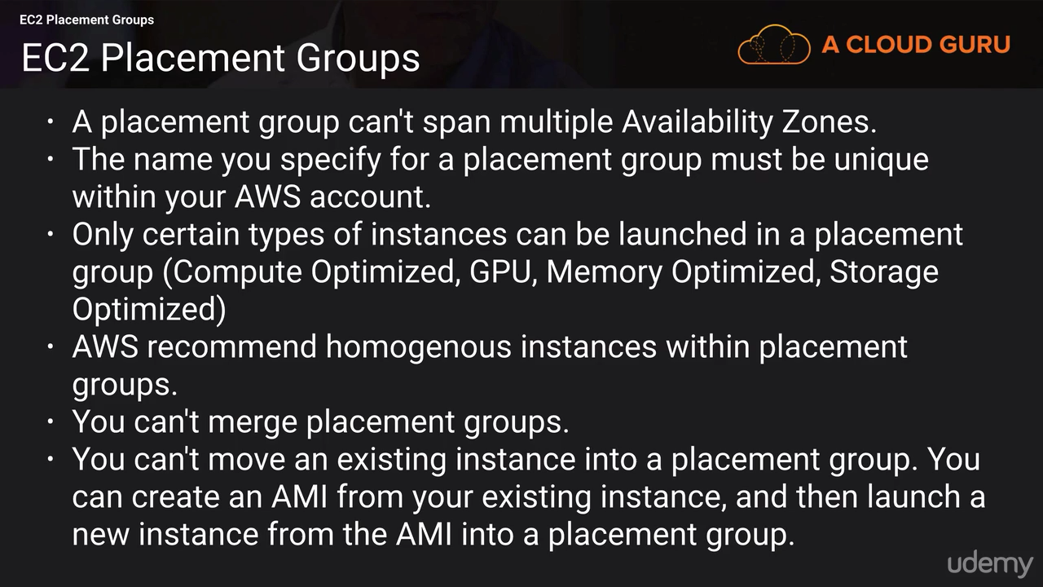

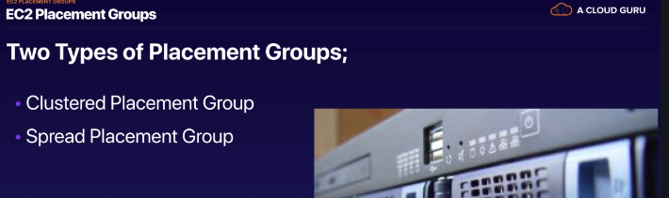

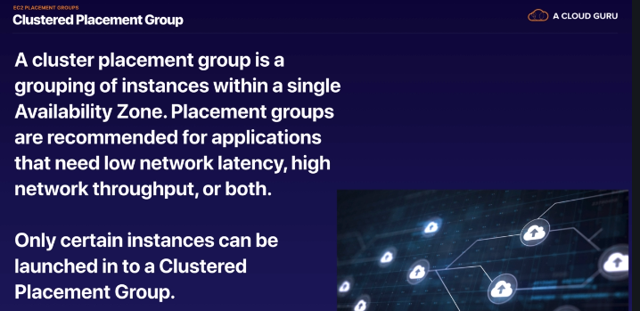

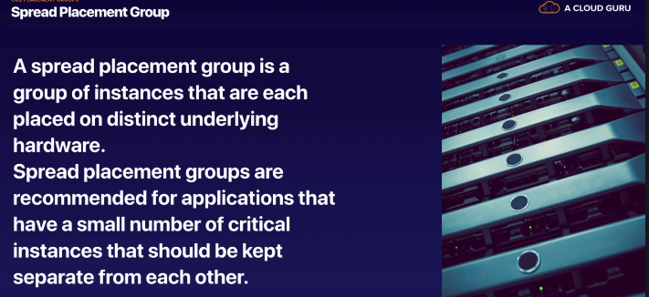

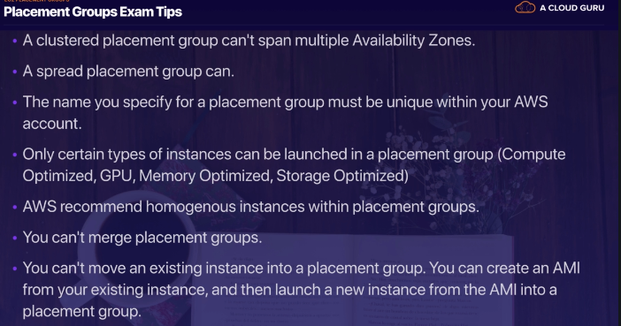

### EC2 Storage-EBS, EFS and Instance Store

#### **Instance Stores**

An instance store (sometimes referred to as ephemeral storage) provides temporary block level storage for your instance. This storage is located on disks that are physically attached to the host computer.

An instance store is ideal for temporary storage of information that changes frequently.

The key aspect of instance stores is that they are temporary.

Data in the instance store is lost when:

* The underlying disk drive fails.
* The instance stops (the data will persist if an instance reboots).
* The instance terminates.

#### **EBS**

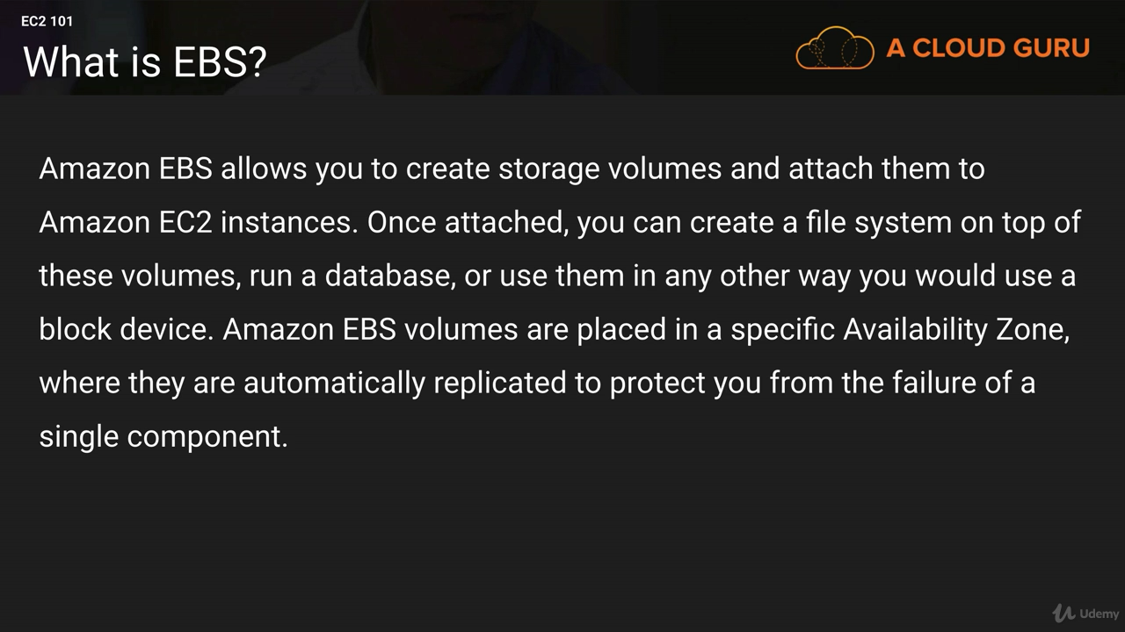

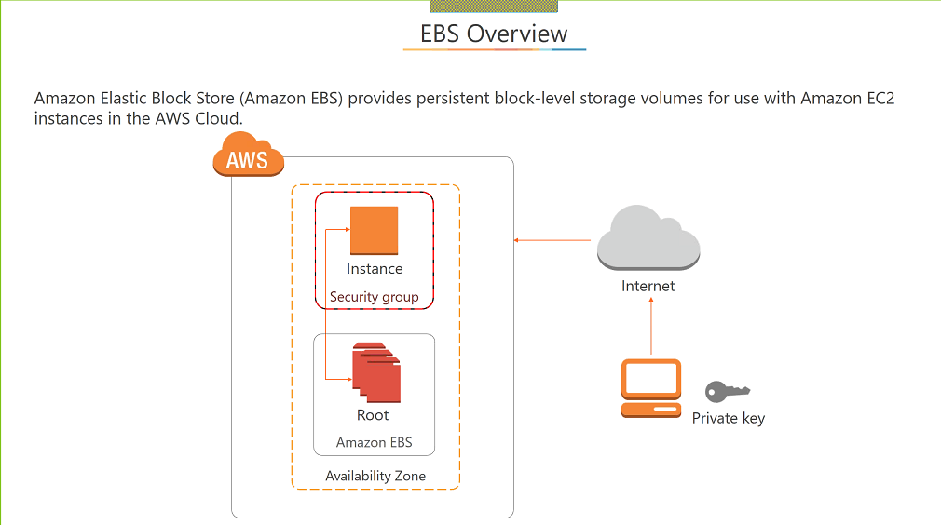

EBS is virtual disk which u can attached to your Ec2 instances. It is Block-based storage and can install database, Install os and applications.

EC2 instance and EBS Volume are always in one Availability zone. You cannot run Ec2 instance if EBS volume is mounted in different AZ.(hard disk drive always near to motherboard).

Question-We have Ec2 instance in eu-west1-a and wanted to create the Ec2 instance and volume in eu-west-b how do we go ahead.

🡪first take the snapshot of volume and create new volume for new AZ .

• Amazon EBS provides persistent block-level storage volumes for use with Amazon EC2 instances.

• An EC2 machine loses its root volume (main drive) when it is manually terminated.

• Unexpected terminations might happen from time to time (AWS would email you)

• Sometimes, you need a way to store your instance data somewhere

• An EBS (Elastic Block Store) Volume is a network drive you can attach to your instances while they run

• It allows your instances to persist data

• Multiple Amazon EBS volumes can be attached to a single Amazon EC2 instance, although a volume can only be attached to a single instance at a time.

EBS Volume

• It’s a network drive (i.e. not a physical drive)

• It can be detached from an EC2 instance and attached to another one quickly

• It’s locked to an Availability Zone (AZ)

• An EBS Volume in us-east-1a cannot be attached to us-east-1b (it is scope to specific AZ)

• To move a volume across, you first need to snapshot it

• Have a provisioned capacity (size in GBs, and IOPS)

• You get billed for all the provisioned capacity

• You can increase the capacity of the drive over time

**Protecting Data**

• You can back up the data on your Amazon EBS volumes, regardless of volume type, by taking point-in-time snapshots.

• Snapshots are incremental backups, which means that only the blocks on the device that have changed since your most recent snapshot are saved.

• EBS Volumes are only locked to a specific AZ

• To migrate it to a different AZ (or region)

• Snapshot the volume

• (optional) Copy the volume to a different region

• Create a volume from the snapshot in the AZ of your choice

EBS Migration Steps

EBS Volume🡪 SNAPSHOT🡪VOLUME

Taking Snapshots

• Data for the snapshot is stored using Amazon S3 technology. They are stored in AWS-controlled storage and not in your account’s Amazon S3 buckets.

• The action of taking a snapshot is free. You pay only the storage costs for the snapshot data.

• Snapshots are constrained to the region in which they are created, meaning you can use them to create new volumes only in the same region. If you need to restore a snapshot in a different region, you can copy a snapshot to another region.

• Not necessary to detach volume to do snapshot, but recommended

• Max 100,000 snapshots

• Can copy snapshots across AZ or Region

• Can make Image (AMI) from Snapshot

Creating a Volume from a Snapshot

To use a snapshot, you create a new Amazon EBS volume from the snapshot. When you do this, the volume is created immediately but the data is loaded lazily

Recovering Volumes

Because Amazon EBS volumes persist beyond the lifetime of an instance, it is possible to recover data if an instance fails. If an Amazon EBS-backed instance fails and there is data on the boot drive, it is relatively straightforward to detach the volume from the instance. Unless the DeleteOnTermination flag for the volume has been set to false, the volume should be detached before the instance is terminated. The volume can then be attached as a data volume to another instance and the data read and recovered.

EBS Encryption

• When you create an encrypted EBS volume, you get the following:

• Data at rest is encrypted inside the volume

• All the data in flight moving between the instance and the volume is encrypted

• All snapshots are encrypted

• All volumes created from the snapshot

• Encryption and decryption are handled transparently (you have nothing to do)

• Encryption has a minimal impact on latency

• EBS Encryption leverages keys from KMS (AES-256)

• Copying an unencrypted snapshot allows encryption

• Snapshots of encrypted volumes are encrypted

Encryption: encrypt an unencrypted EBS volume

• Create an EBS snapshot of the volume

• Encrypt the EBS snapshot ( using copy )

• Create new ebs volume from the snapshot ( the volume will also be encrypted )

• Now you can attach the encrypted volume to the original instance

**Amazon EBS Features**

• High Performance Volumes: Choose between solid-state disk (SSD)-backed or hard disk drive (HDD)- backed volumes that can deliver the performance you need for your most demanding applications.

• Availability: Each Amazon EBS volume is designed for 99.999% availability and automatically replicates within its Availability Zone to protect your applications from component failure.

• Encryption: Amazon EBS encryption provides seamless support for data-at-rest and data-in-transit between EC2 instances and EBS volumes.

• Access Management: Amazon’s flexible access control policies allow you to specify who can access which EBS volumes ensuring secure access to your data.

• Snapshots: Protect your data by creating point-in-time snapshots of EBS volumes, which are backed up to Amazon S3 for long-term durability

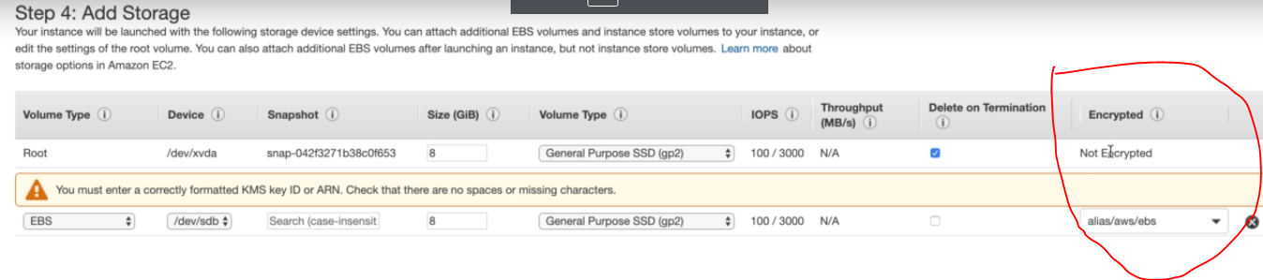

Root volume can’t be encrypted at launch but EBS volume can be encrypted at first launch

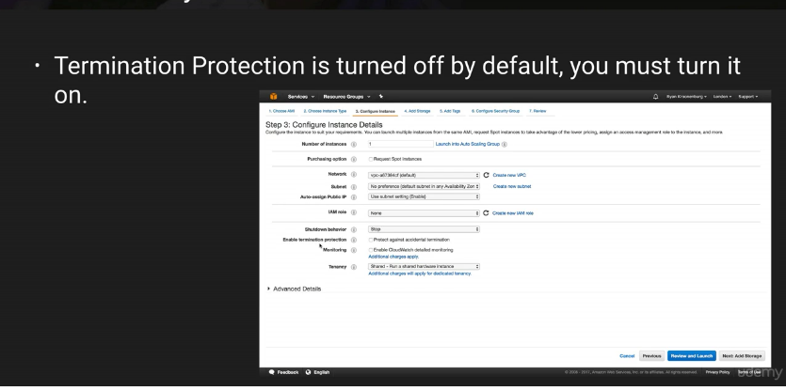

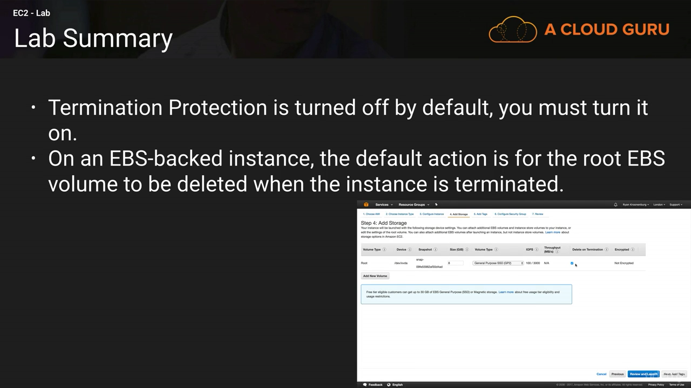

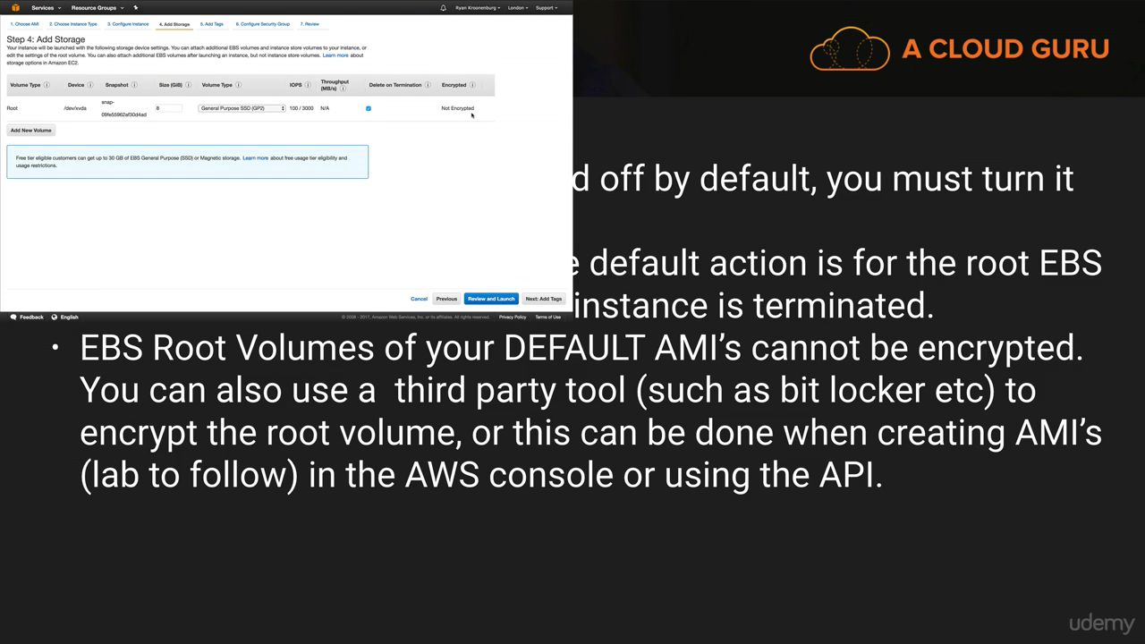

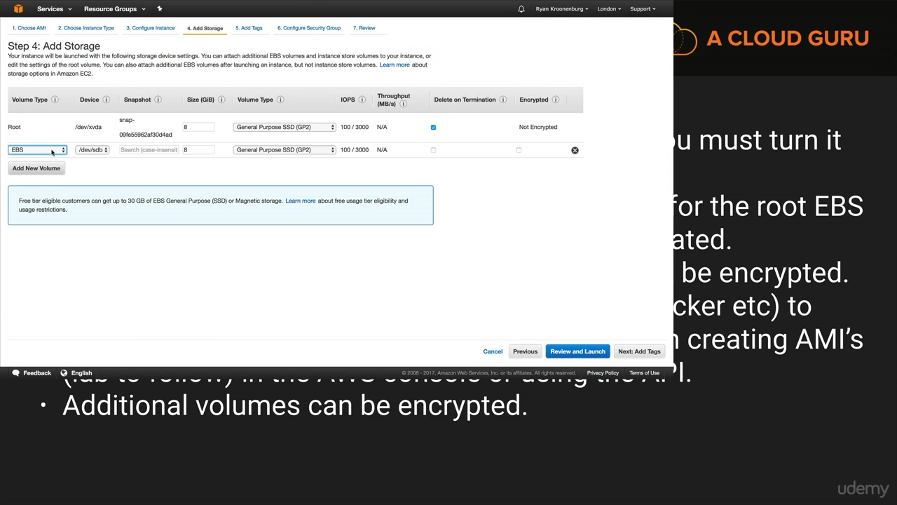

#### **EBS Storage Types**

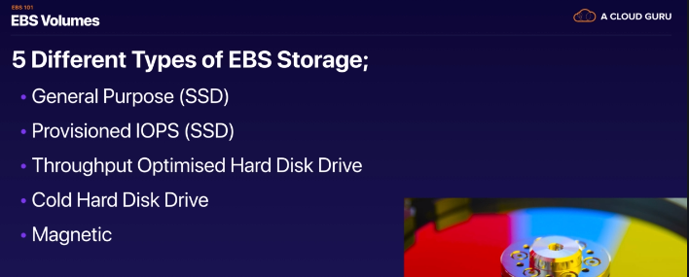

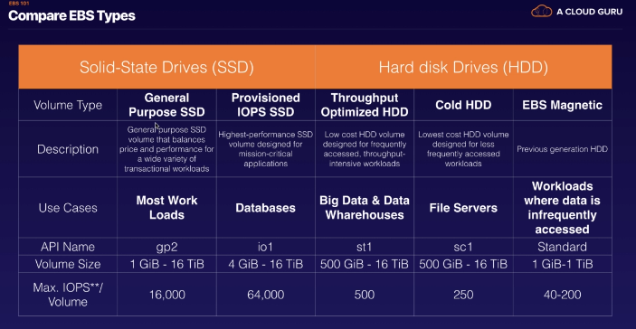

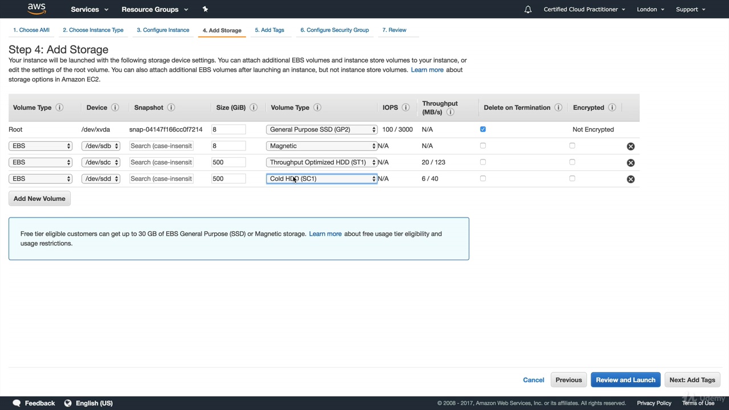

*• Only GP2 and IO1 can be used as boot volumes*

**EBS Volumes types**

• GP2 (SSD): General purpose SSD volume that balances price and performance for a wide variety of workloads also for Development and test environments

• IO1 (SSD): Highest-performance SSD volume for mission-critical low-latency or high- throughput workloads. Large database workloads, such as: MongoDB, Cassandra, Microsoft SQL Server, MySQL, PostgreSQL, Oracle

• ST1 (HDD): Low cost HDD volume designed for frequently accessed, throughput- intensive workloads. Big data, Data warehouses, Log processing i.e Apache Kafka

• SC1 (HDD): Lowest cost HDD volume designed for less frequently accessed workloads

**RAID (It is used if you want to increase the performance more than 64,000)**

Used only RAID 0 and RAID 1

1. RAID 0 for performance but not fault tolerance
2. It is fault tolerant

• EBS is already redundant storage (replicated within an AZ)

• But what if you want to increase IOPS to say 100 000 IOPS?

• What if you want to mirror your EBS volumes?

• You would mount volumes in parallel in RAID settings! • RAID is possible as long as your OS supports it

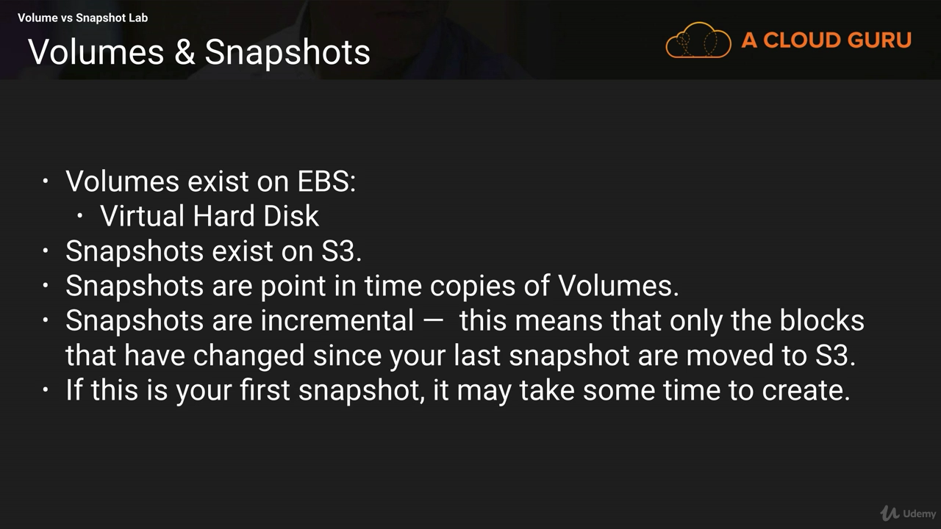

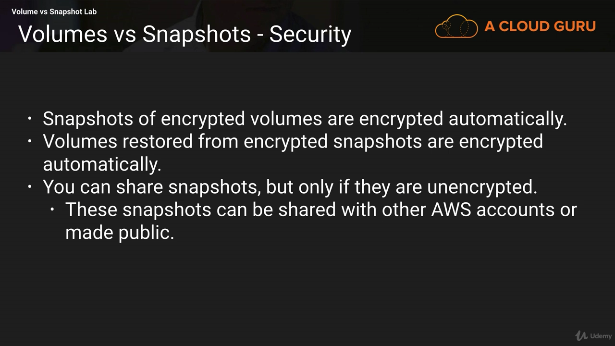

**Snapshot of root Device Volume**

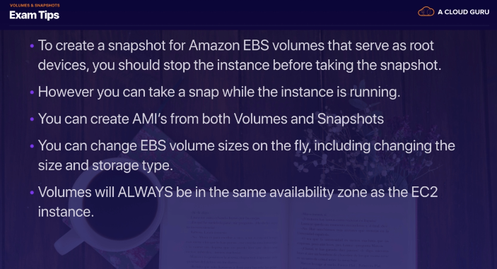

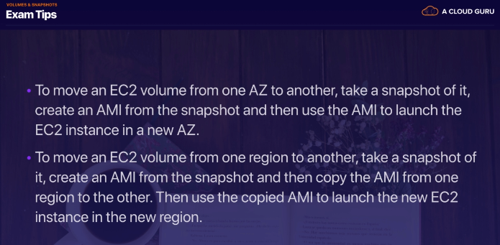

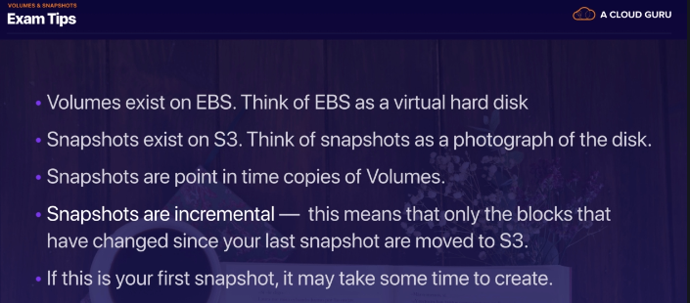

#### **Elastic File System**

**EFS (Elastic File System)**

• Managed NFS (network file system) that can be mounted on many EC2

• EFS works with EC2 instances in multi-AZ

• Highly available, scalable, expensive (3x gp2), pay per use

• Use cases: content management, web serving, data sharing, Wordpress

• Uses NFSv4.1 protocol

• Uses security group to control access to EFS

• Compatible with Linux based AMI (not Windows)

• Performance mode:

• General purpose (default)

• Max I/O – used when thousands of EC2 are using the EFS

• EFS file sync to sync from on-premise file system to EFS

• Backup EFS-to-EFS (incremental – can choose frequency)

• Encryption at rest using KMS

Shared the volume across multiple instances. Using EBS you can attach the volume (storage) to only one instance/machine but using EFS you can share the volume across many instances

EBS-you can attach VM to multiple EBS volume but if you have two VM’s then same EBS volume cannot be attached

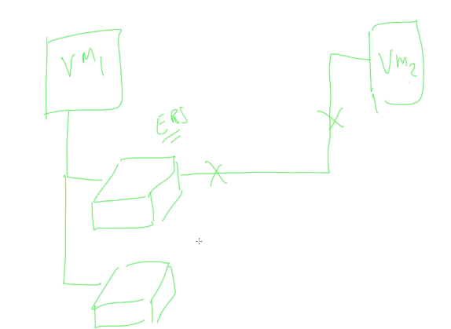

This can be done using EFS(Shared network folder)

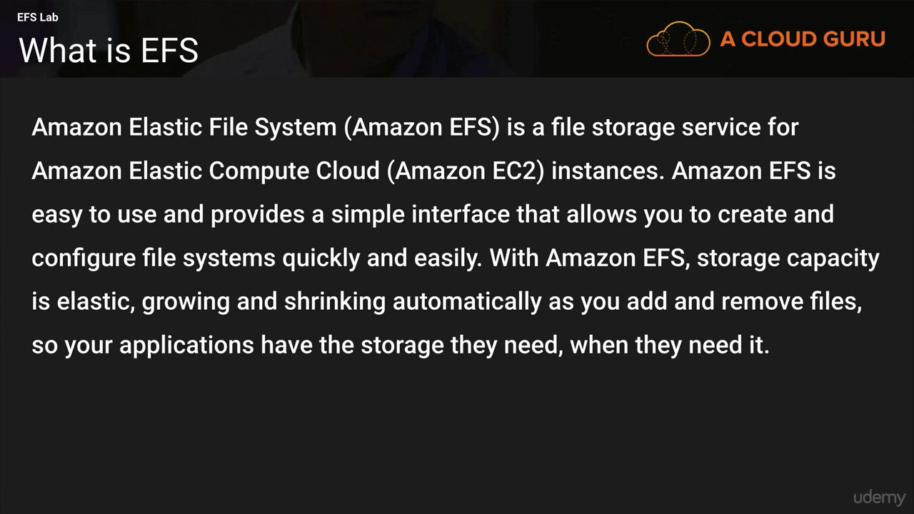

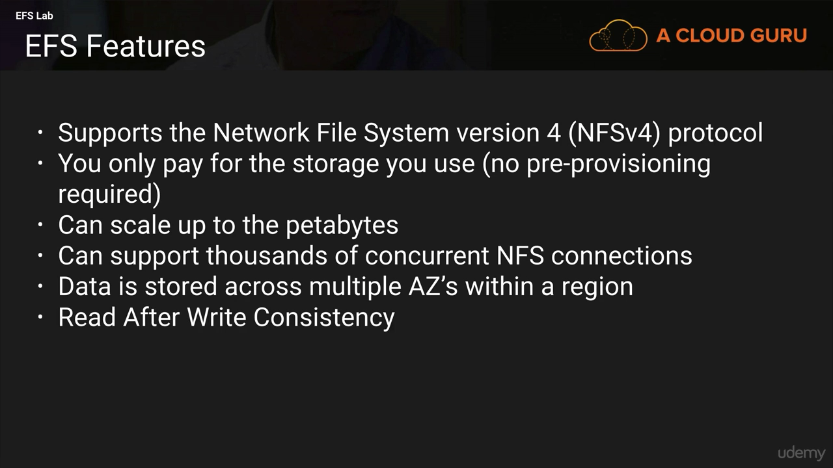

Diagram for the EFS

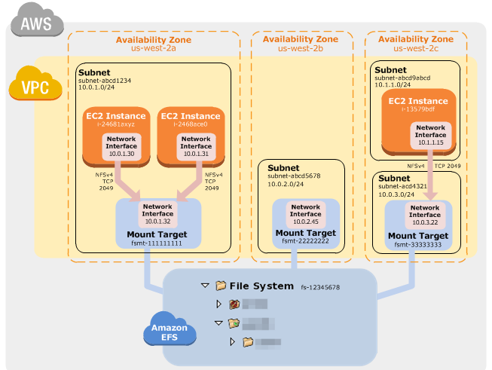

**Difference Between EBS, EFS and Instance store**

• EBS volumes can be attached to only one instance at a time

• EBS volumes are locked at the AZ level

• Migrating an EBS volume across AZ means first backing it up (snapshot), then recreating it in the other AZ

• EBS backups use IO and you shouldn’t run them while your application is handling a lot of traffic

• Root EBS Volumes of instances get terminated by default if the EC2 instance gets terminated. (you can disable that)

• Disk IO is high => Increase EBS volume size (for gp2)

• EFS mounting 100s of instances

• EFS share website files

• EBS gp2, optimize on cost

• Custom AMI for faster deploy on ASG

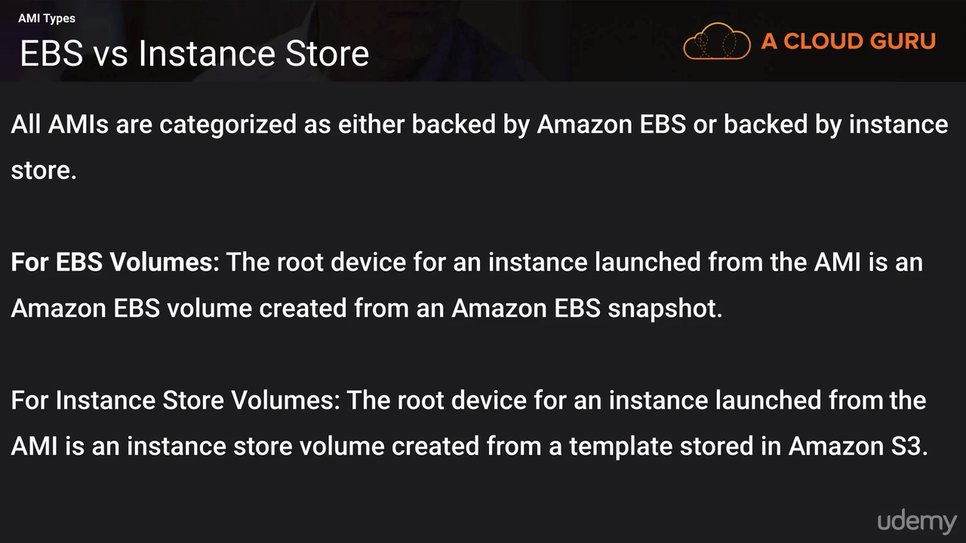

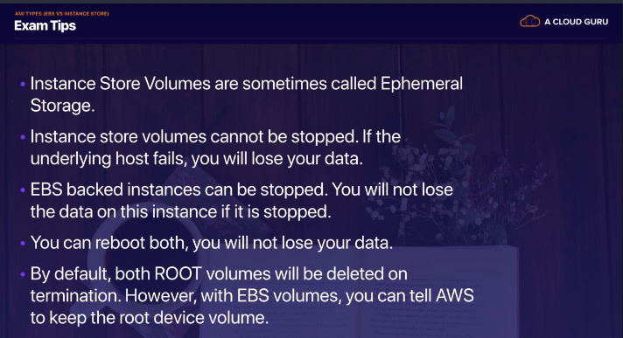

Ephermal -temporary

**Instance Store(Ephermal Storage)**-Internal storage of physical machine(Server) for your VM i.e S3

**EBS**-External Storage for your VM (such as external hard disk) ..Data in EBS volume is always preserved

### AMI (Amazon Machine Image)

**AMI**

• AMI are built for a specific AWS region (!)

* AMI are built for specific AWS region and same ID cannot used across region
* AMI take space and they store in Amazon S3
* You can share an AMI with another AWS account.
* Sharing an AMI does not affect the ownership of the AMI.
* If you copy an AMI that has been shared with your account, you are the owner of the target AMI in your account.
* To copy an AMI that was shared with you from another account, the owner of the source AMI must grant you read permissions for the storage that backs the AMI, either the associated EBS snapshot (for an Amazon EBS-backed AMI) or an associated S3 bucket (for an instance store-backed AMI).
* By default, your AMIs are private, and locked for your account / region

Limits:

* You can't copy an encrypted AMI that was shared with you from another account. Instead, if the underlying snapshot and encryption key were shared with you, you can copy the snapshot while re- encrypting it with a key of your own. You own the copied snapshot, and can register it as a new AMI.
* You can't copy an AMI with an associated billingProduct code that was shared with you from another account. This includes Windows AMIs and AMIs from the AWS Marketplace. To copy a shared AMI with a billingProduct code, launch an EC2 instance in your account using the shared AMI and then create an AMI from the instance.

You can create the private AMI and stored inn s3 as a snapshot (See below Diagram)

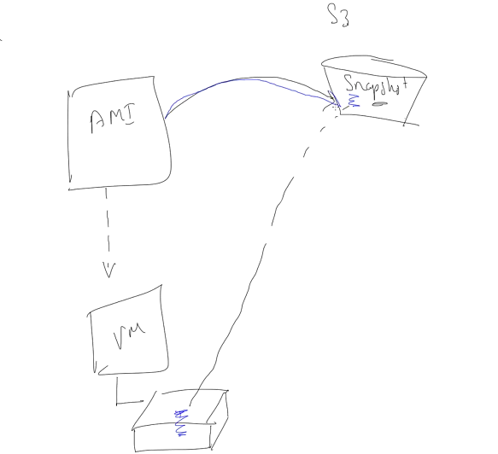

### Security Group

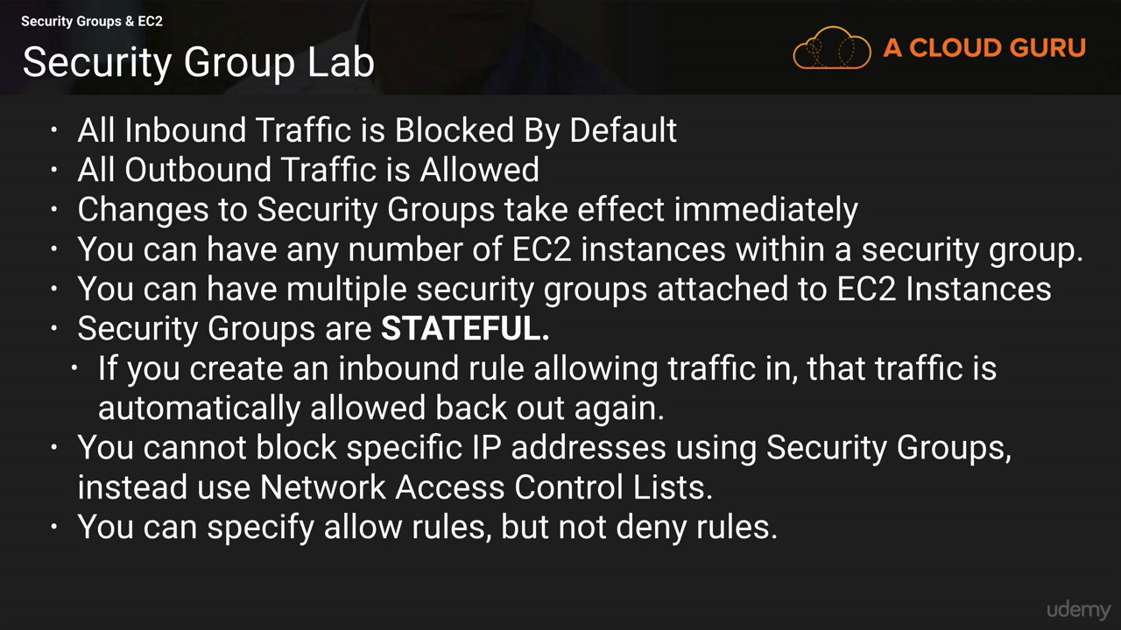

* The default security group allows communication between all resources within the security group, allows all outbound traffic, and denies all other traffic.
* You may change the rules for the default security group, but you may not delete the default security group.
* You can create up to 500 security groups for each Amazon VPC.
* You can add up to 50 inbound and 50 outbound rules to each security group.
* If you need to apply more than 100 rules to an instance, you can associate up to five security groups with each network interface.
* You can specify allow rules, but not deny rules. This is an important difference between security groups and ACLs.
* You can specify separate rules for inbound and outbound traffic.
* By default, no inbound traffic is allowed until you add inbound rules to the security group.
* By default, new security groups have an outbound rule that allows all outbound traffic. You can remove the rule and add outbound rules that allow specific outbound traffic only.
* Security groups are stateful. This means that responses to allowed inbound traffic are allowed to flow outbound regardless of outbound rules and vice versa. This is an important difference between security groups and network ACLs.
* Instances associated with the same security group can’t talk to each other unless you add rules allowing it (with the exception being the default security group).
* You can change the security groups with which an instance is associated after launch, and the changes will take effect immediately.
* If your application is not accessible (time out), then it’s a security group issue
* If your application gives a “connection refused“ error, then it’s an application error or it’s not launched
* All inbound traffic is blocked by default
* All outbound traffic is authorised by default

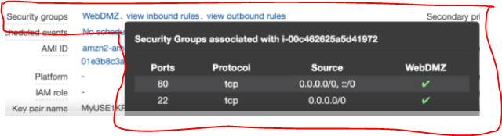

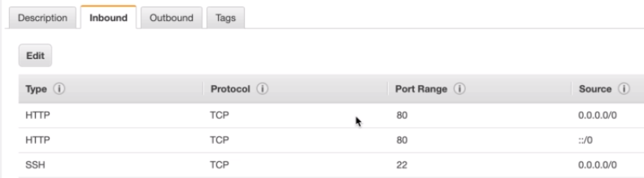

If you delete http from the inbound rule then immediately you don’t able access the page

If in inbound rules http is added and not added in outbound rule, then also you will able to see the web page

If you create inbound rule then outbound rules are created automatically

**Security groups are stateful. Mean outbound traffic is dependent on inbound….**

.

Security group is to give access not for blocking ….it is done by Network ACL

**Network ACL’s are stateless**

# **ELB (High Availability(HA) Architecture)**

**Load balancer balance the load across the webservers**

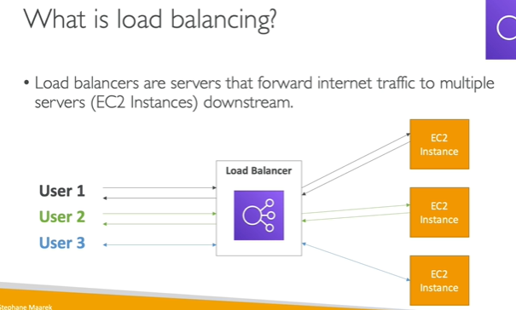

Best practice is always to reference a load balance by its DNS name, instead of by IP address of the load balancer in order to provide a single, stable entry point.

It also has security group and mapped with Ec2 security group

* ELB is highly available service (Within Availability Zone)
* Distributed traffic across Ec2 instances in one or more availability zone (Within Region)
* Supports routing and load balancing of http, https, TCP and SSL traffic to Ec2 instances
* Provides a stable, single Canonical Name Record (CNAME) entry point for DNS configuration
* Provide SSL termination (HTTPS) for your websites
* The health check is done on a port and a route (/health is common)
* Supports both internet facing and internal application facing load balancer
* Supports health checks for amazon EC2 instances and ensures that traffic is not routed to unhealthy instances
* Integrates with Auto Scaling Service to automatically scale the Ec2 instances behind the load balancer
* Internet facing load balancer (Public) while internal facing is private
* **ELB in amazon VPC supports IPV4 address only, while in EC2 classic supports both IPV4 and IPV6**
* Listener must be configured on an ELB to accept incoming traffic

=====================================

### Type of load Balancer

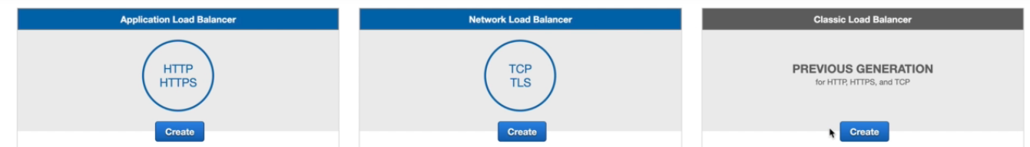

1. **Application (Layer 7)**

• Load balancing to multiple HTTP applications across machines (target groups)

ALB support **HTTP/HTTPS** & **Websockets** protocols

• Load balancing to multiple applications on the same machine (ex: containers)

• Load balancing based on route in URL

• Load balancing based on hostname in URL

• Stickiness can be enabled at the target group level

• Same request goes to the same instance

• Stickiness is directly generated by the ALB (not the application)

• The application servers don’t see the IP of the client directly

• The true IP of the client is inserted in the header X-Forwarded-For

• We can also get Port (X-Forwarded-Port) and proto (X-Forwarded-Proto)

• Basically, they’re awesome for micro services & container-based application (example: Docker & Amazon ECS)

• Has a port mapping feature to redirect to a dynamic port

• Support dynamic host port mapping with ECS

1. **Network (Layer 4)**

• Forward TCP traffic to your instances

• Handle millions of request per seconds

• Support for static IP or elastic IP

• Less latency ~100 ms (vs 400 ms for ALB)

• Network Load Balancers are mostly used for extreme performance

• NLB directly see the client IP

• Public facing: must attach Elastic IP – can help whitelist by clients

• Private facing: will get random private IP based on free ones at time of creation

• Has cross zone balancing

• Has SSL termination (Jan 2019)

1. **Classic (Layer 7)**

• Can load balance http/https applications

===========================================

* **Few Concepts**

1)Internet facing load balancer -request from customer

2)internal facing load balancer -You can use internal load balancer to route traffic to your amazon Ec2 instances in VPC with private subnet

3) Https load balancer –

You can create LB that uses SSL/TLS protocol for encrypted connections (also known as SSL offload). This feature enable traffic encryption between your load balancer and the client that initiate Https session. In order to use SSL, you must install SSL certificate on the LB that it uses to terminate the connection and then decrypt request from client before sending request Ec2 instances

If you want to host multiple websites on a fleet of amazon Ec2 instance behind the ELB with single SSL cert,then you will need to add SAN(Subject Alternative Name) for each website

Listeners

Every load balancer must have one or more listeners configures

**Configuring Elastic Load balancing**

* Idle connection timeout –

Load balance maintains two connections, one with client and other with Ec2 instances

By Default, ELB sets the idle timeout to 60 seconds for both connection

* Cross Zone Load Balancing-

Within availability zone

* Connection Draining-

It Ensure that LB stops sending request to instances that are unhealthy

* Sticky Session

Users request will send to instance

* Health Checks

Check the health checks to test the status of Ec2 instances behind ELB

**Load Balancer Good to Know**

• Classic Load Balancers are Deprecated

• Application Load Balancers for HTTP / HTTPs & Websocket

• Network Load Balancer for TCP

• CLB, ALB & NLB support SSL certificates and provide SSL termination

• All Load Balancers have health check capability

• ALB can route on based on hostname / path

• ALB is a great fit with ECS (Docker)

• Any Load Balancer (CLB, ALB, NLB) has a static host name. Do not resolve and use underlying IP

• LBs can scale but not instantaneously – contact AWS for a “warm-up”

• NLB directly see the client IP

• 4xx errors are client induced errors

• 5xx errors are application induced errors

• Load Balancer Errors 503 means at capacity or no registered target

• If the LB can’t connect to your application, check your security group

•Network Load Balancers expose a public static IP, whereas an Application or Classic Load Balancer exposes a static DNS (URL)

**EC2 for Solutions Architects**

• EC2 instances are billed by the second, t2.micro is free tier

• On Linux / Mac we use SSH, on Windows we use Putty

• SSH is on port 22, lock down the security group to your IP

• Timeout issues => Security groups issues

• Permission issues on the SSH key => run “chmod 0400”

• Security Groups can reference other Security Groups instead of IP ranges (very popular exam question)

• You can customize an EC2 instance at boot time using EC2 User Data

• AMI can be copied across regions and

Q. Your application load balancer is hosting 3 target groups with hostnames being users.example.com, api.external.example.com and checkout.example.com. You would like to expose HTTPS traffic for each of these hostnames. How do you configure your ALB SSL certificates to make this work?

🡪Use ANI

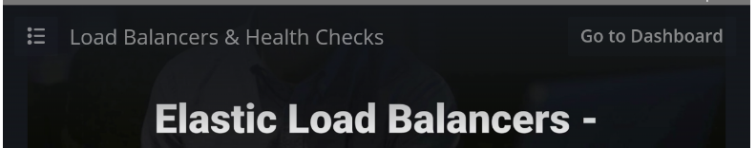

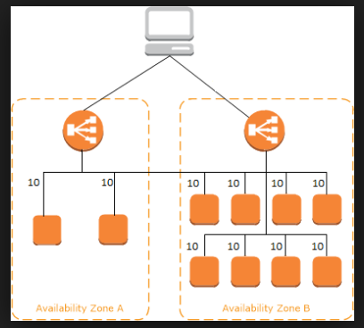

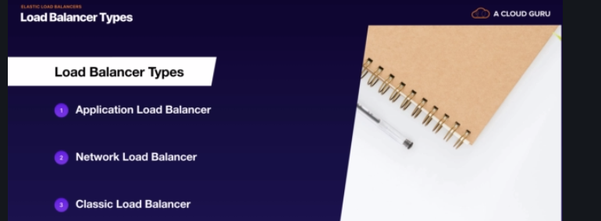

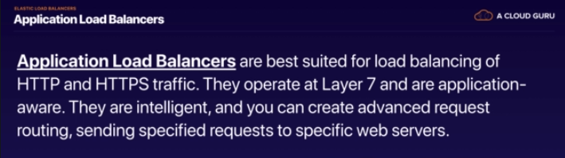

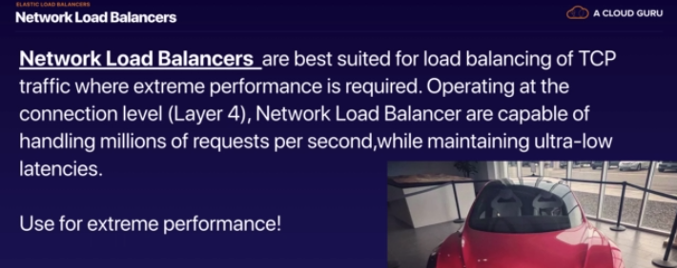

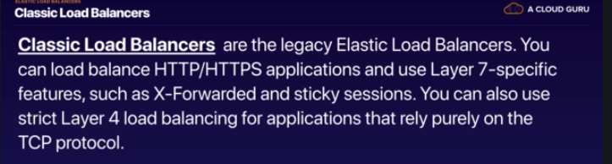

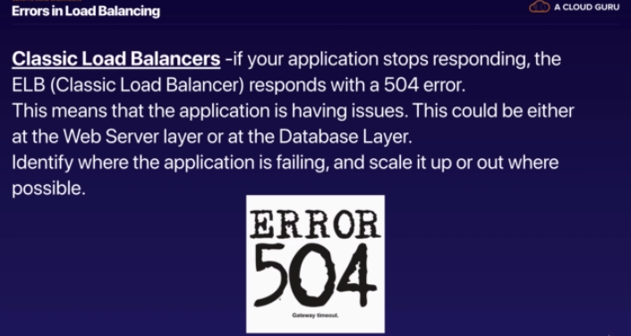

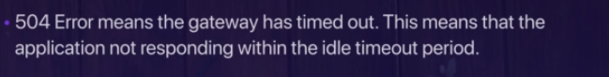

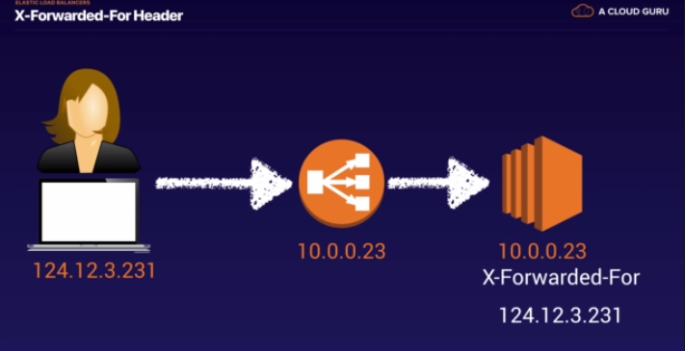





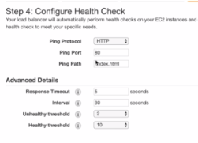

**Classic load balancer** is very easy.

--First create the two instances in different availability zone

-- Then create load balancer and select both the instances in ELB

**Application load balancer** is little bit difficult and more intelligence

--Before creating the application load balancer, you have to create the “target group” and add the target as your “EC2 instances” and click on “Add to registered” and save

--Then create load balancer

-- Select application load balancer

---Targets are behind the application load balancer

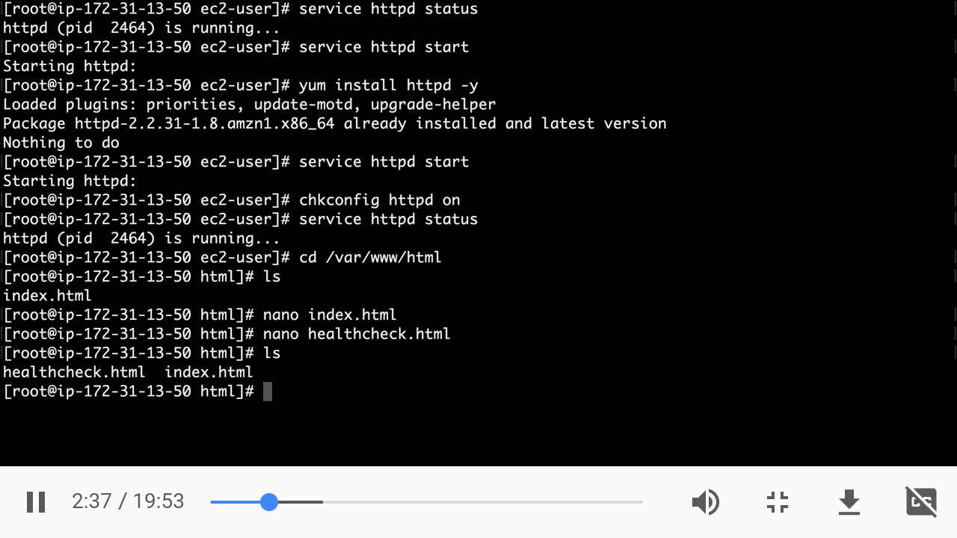

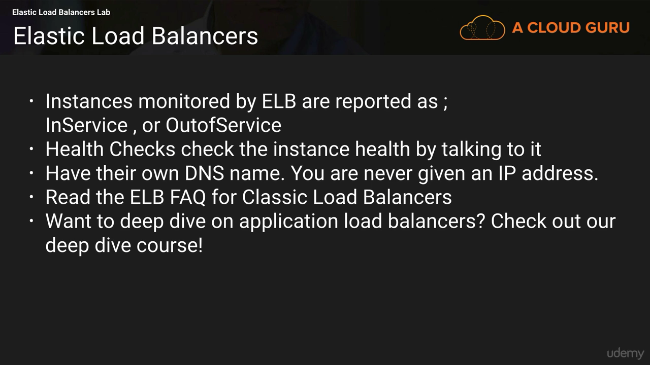

**Advanced Load balancer Theory**

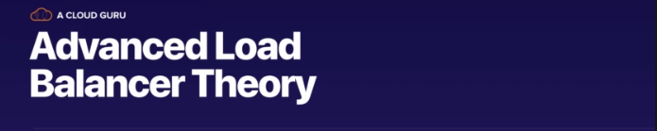

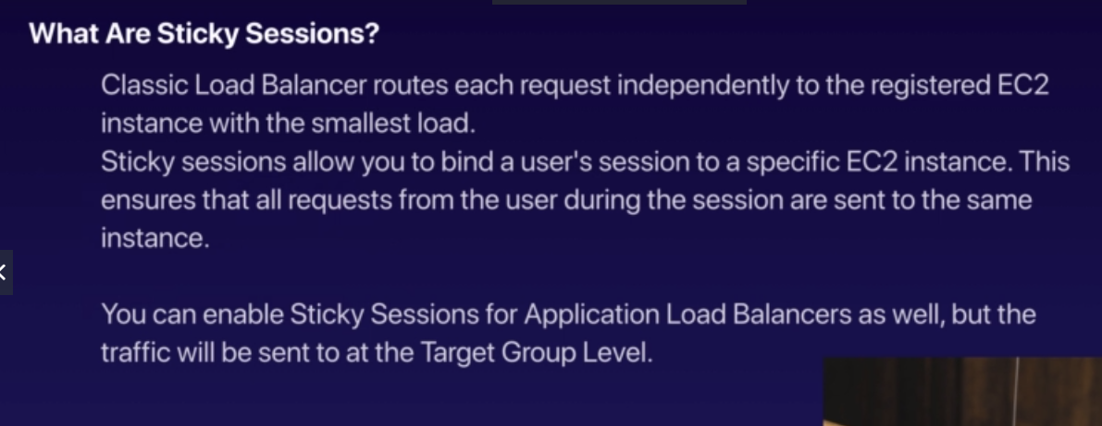

**This comes in exam-**Sticky sessions mean bind user’s session to specific EC2 instance. The cookie used for stickiness has an expiration date you control (Make sure user doesn’t lose his session data).

Stickiness Enabled in the target group for particular time

**Example**

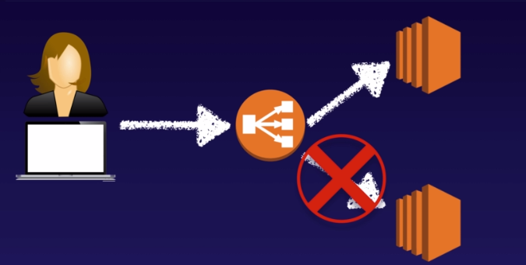

**Cross Zone Load Balancing**

Load is balance in different availability zone is cross zone

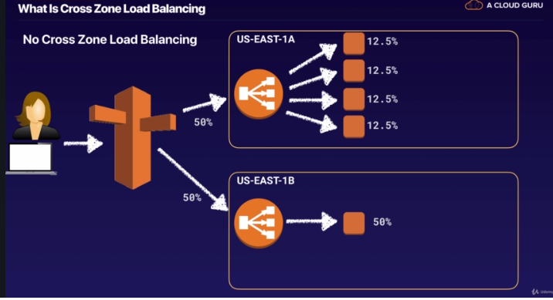

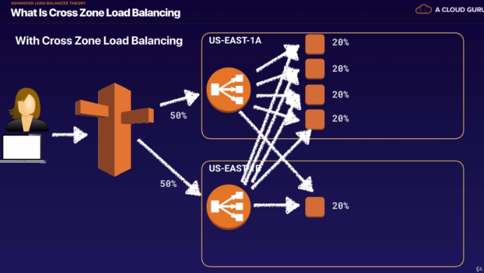

Path pattern

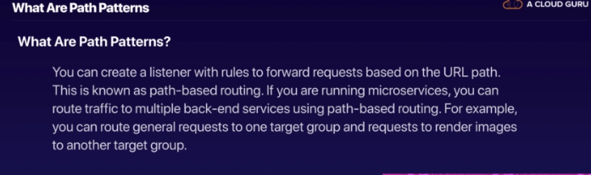

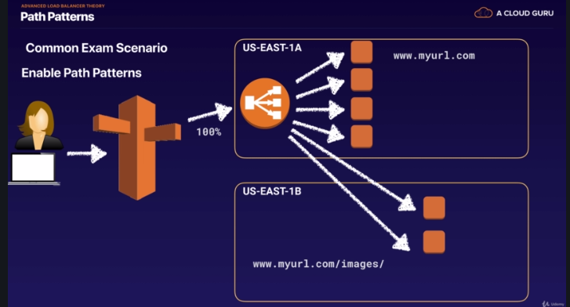

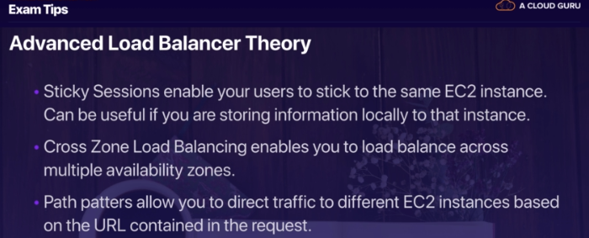

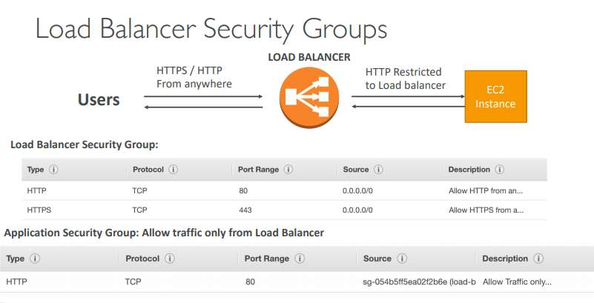

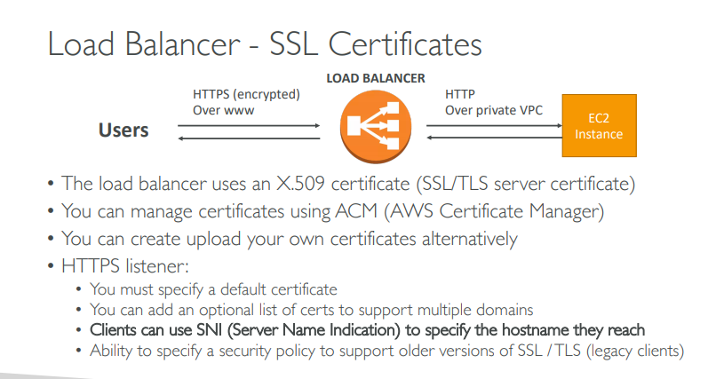

### Auto Scaling

**Launch Configuration and Autoscaling Group**

* In order to create the autoscaling group first we must create launch configuration
* It is like creation of the Ec2 instance but don’t create the Ec2 instance
* Now we can create the autoscaling group using the launch configuration
* You don’t need to create the Ec2 instances separately they are getting created while autoscaling group
* For autoscaling mostly On Demand and On Spot instances are used but On Demand is default.
* On Spot instances used only when you are hosting sites where you want additional compute capacity but are price constrained
* ASG can terminate instances marked as unhealthy by a LB (and hence replace them)
* **Auto Scaling Components**

1. Launch Configuration –

**- Default limit for launch configuration is 100 per region**

**-20 instances can launch within region**

2) Auto Scaling Group

3) Scaling Policy

Cloudwatch alarm sends a message to the Auto Scaling group,

Auto Scaling executes the associative policy to scale up your group

* **Autoscaling plans**

1. Manual Scaling -This is useful for the infrequent events

Ex.If There is event, such as release of new game that will available for download and registration

1. Scheduled Scaling-

Predictable schedules includes periodic events such end-of-month,end-of-year sale and also recurring events

1. Dynamic Scaling-

As per the network bandwidth reaches to certain threshold

* **Scaling Cooldowns for Amazon EC2 Auto Scaling**

The cooldown period helps to ensure that your Auto Scaling group doesn't launch or terminate additional instances before the previous scaling activity takes effect. You can configure the length of time based on your instance warmup period or other application needs,default cooldown period of 300 seconds is too long

**ASG Brain Dump**

• Scaling policies can be on CPU, Network… and can even be on custom metrics or based on a schedule (if you know your visitors patterns)

• ASGs use Launch configurations and you update an ASG by providing a new launch configuration

• IAM roles attached to an ASG will get assigned to EC2 instances

• ASG are free. You pay for the underlying resources being launched

• Having instances under an ASG means that if they get terminated for whatever reason, the ASG will restart them. Extra safety!

• ASG can terminate instances marked as unhealthy by an LB (and hence replace them)

**ASG for Solutions Architects**

• ASG Default Termination Policy (simplified version):

1. Find the AZ which has the most number of instances

2. If there are multiple instances in the AZ to choose from, delete the one with the oldest launch configuration

Scaling Cooldowns

* The cooldown period helps to ensure that your Auto Scaling group doesn't launch or terminate additional instances before the previous scaling activity takes effect.
* In addition to default cooldown for Auto Scaling group, we can create cooldowns that apply to a specific simple scaling policy
* A scaling-specific cooldown period overrides the default cooldown period.
* One common use for scaling-specific cooldowns is with a scale-in policy—a policy that terminates instances based on a specific criteria or metric. Because this policy terminates instances, Amazon EC2 Auto Scaling needs less time to determine whether to terminate additional instances.
* If the default cooldown period of 300 seconds is too long—you can reduce costs by applying a scaling-specific cooldown period of 180 seconds to the scale-in policy.
* If your application is scaling up and down multiple times each hour, modify the Auto Scaling Groups cool-down timers and the CloudWatch Alarm Period that

**CLOUDWATCH**

* It supports multiple types of actions such as sending notification to and SNS tpic or executing and Auto Scaling Policy
* It offers either basic or detailed monitoring

Basic monitoring sends data points to CloudWatch every 5 min (No Charge)

Details monitoring sends data points to CloudWatch every min (Charge)

* Metrics can be retrieved by performing a GET request
* It does not aggregate data across region but can aggregate across AZ within a region
* Memory is not directly monitored, for that you can use custom metrics
* Logs are also monitored by CloudWatch
* Each amazon account is limited to 5000 alarms per account and metrics data is retained for 2 weeks by default

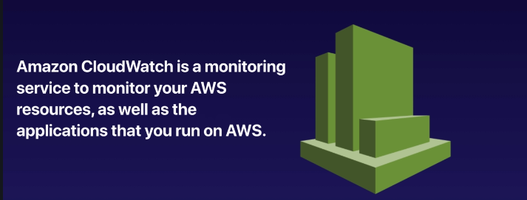

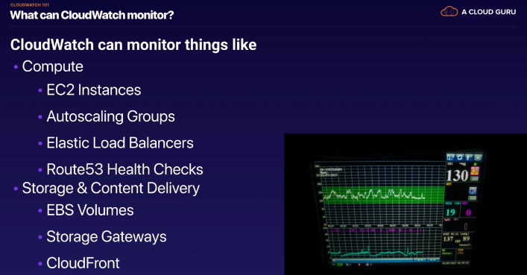

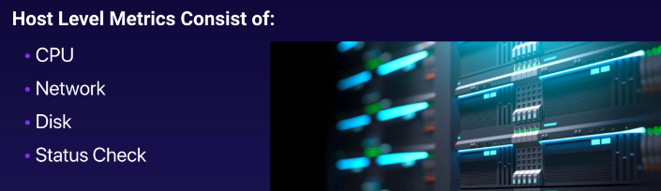

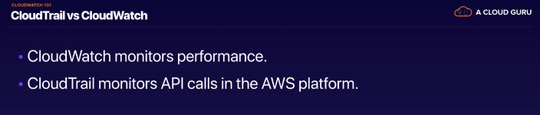

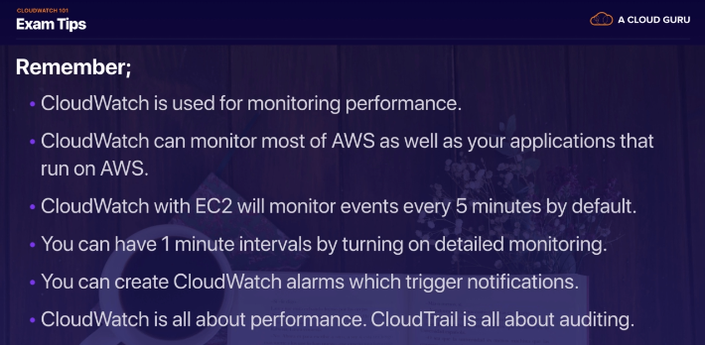

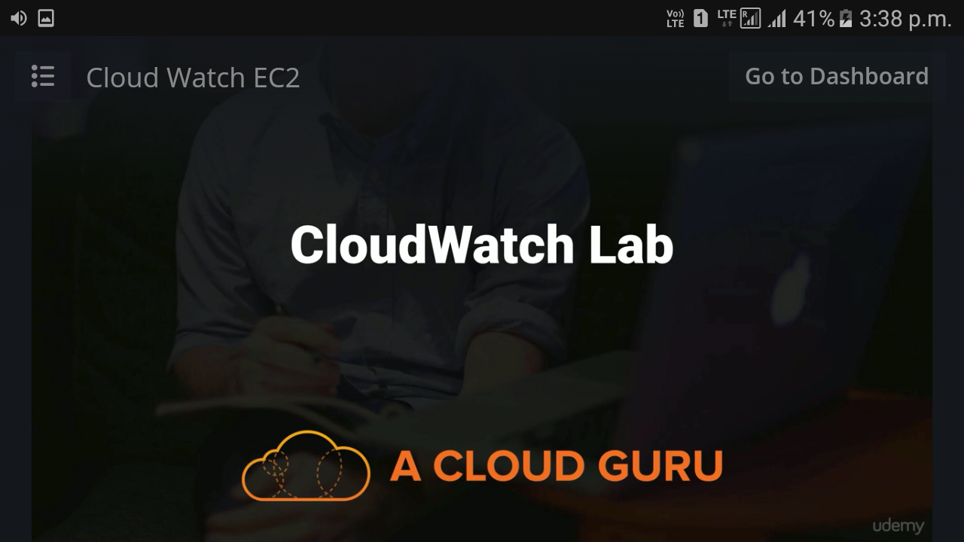

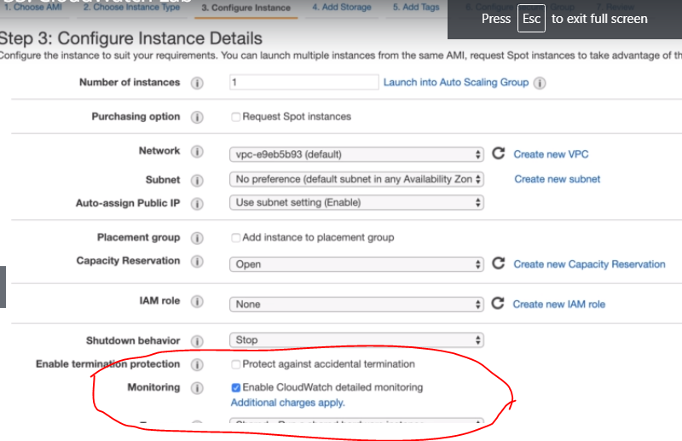

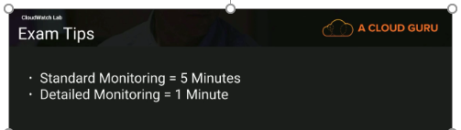

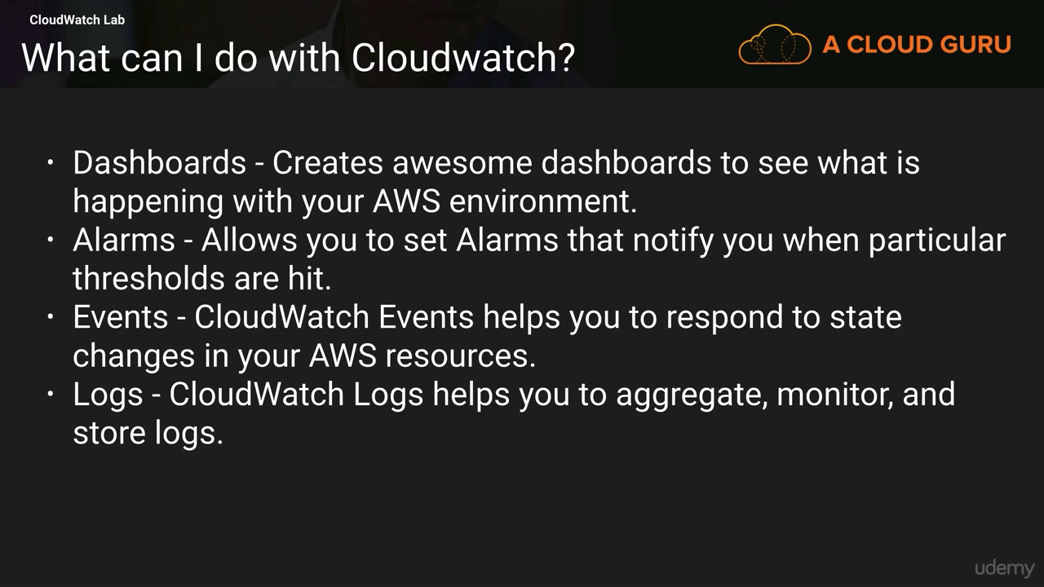

**AWS Command Line(CLI) Lab**

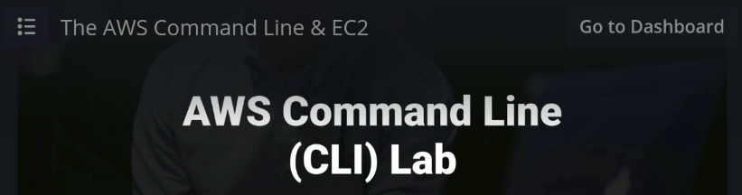

**Create User**

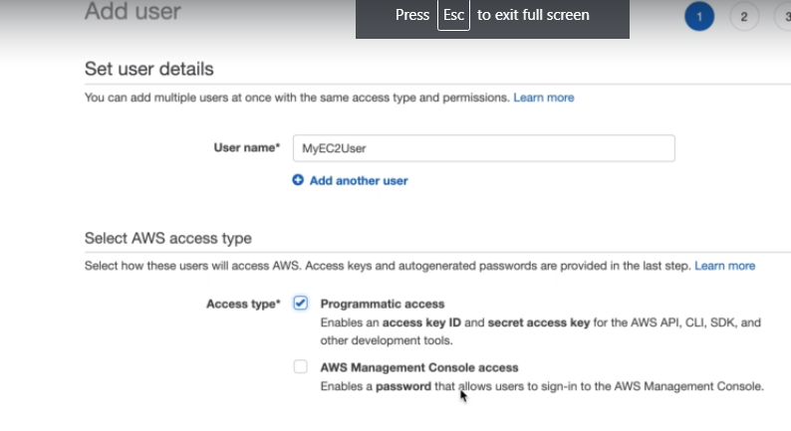

**Add him in admin group**

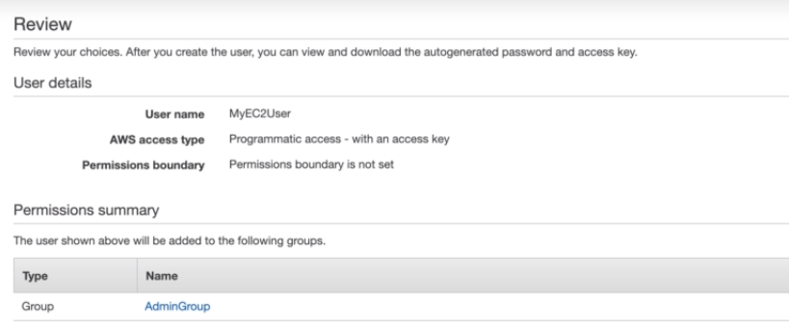

**Download Keys and create instance**

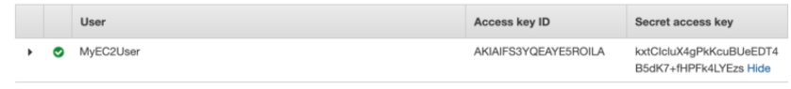

**Create S3 folder using CLI**

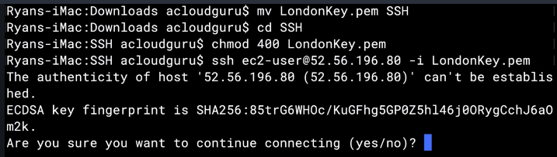

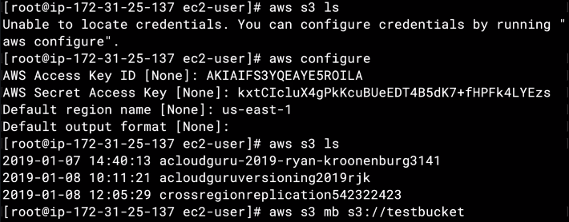

Where are the credentials Saved on server.

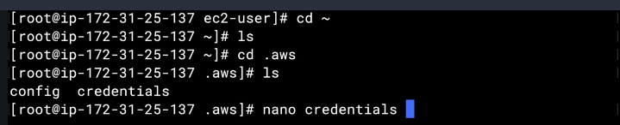

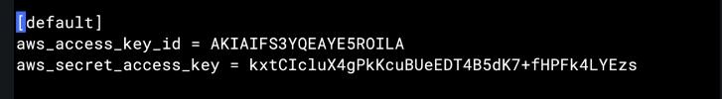

This is actual risky anybody can use this and login to instance so best way delete this and try to access using the role….please check next in IAM(How to create role and attach it to instance)

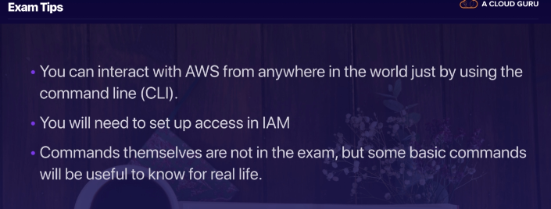

**Key Takeaways From EC2**

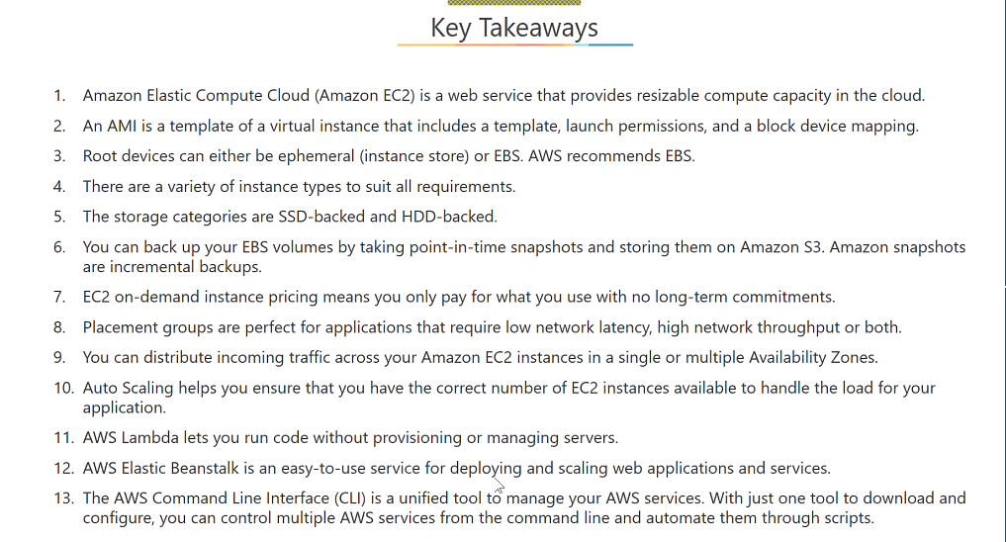

# **IAM (Identity access Management)**

What Does IAM give you

**IAM** -AWS Identity and Access Management (IAM) is a web service that helps you securely control access to AWS resources for your users.

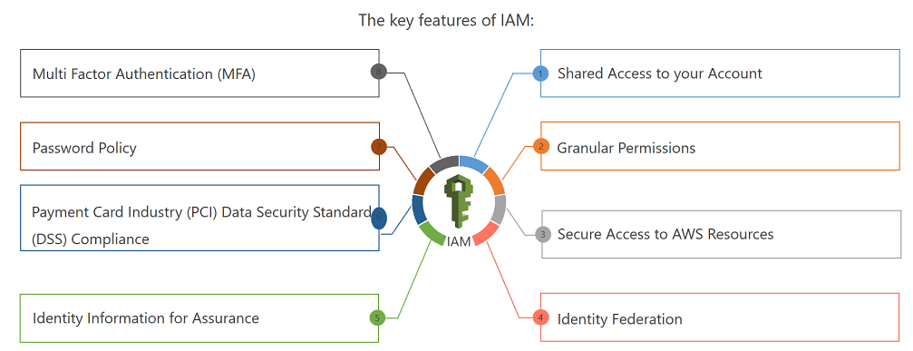

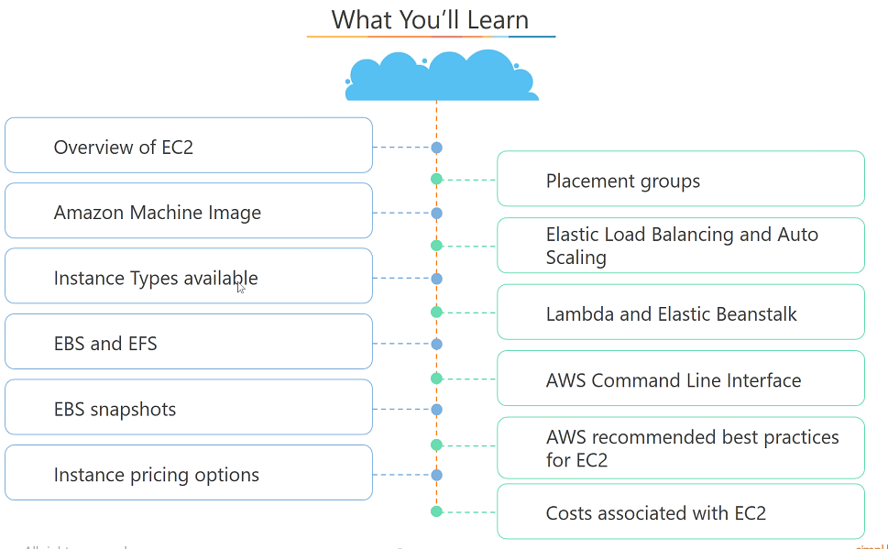

Using IAM -🡪We create user-🡪 We then give permission (using Policy)

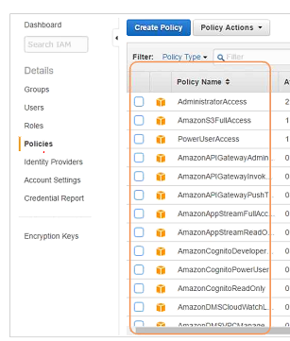

**Users** -End Users

**Groups**- A collection of users under one set of permission

**Policies**-Document that defines one or more permission (We can give permissions to Users or Groups)

**Roles**-You create roles and then assign them to AWS resources

Users is going to be for a physical person and roles is going to be for a machine.

U can assign policies to user, group and roles

IAM is global i.e region is global …users,groups,users are global

-Activate MFA on root account

-If you don’t want to root account to your employee then set up MFA

Two devices for MFA

1. A virtual MFA
2. Hardware MFA
3. U2F security key

When you create user and groups in IAM then **Secret access ID key ,access id** and password created for users and groups which is used when you want to programmatically interact with AWS services not for the console

IAM is **PCI(payment card industry) DSS(Data Security standard)** compliant i.e actually u can deploy u r application which are accepting credit card payment in AWS

If your application identities are based on Active Directory, your on-premises Active Directory can be extended into the cloud to continue to fill that need. A great solution for using Active Directory in the cloud is AWS Directory Service, which is an Active Directory-compatible directory service that can work on its own or integrate with your on-premises Active Directory.

It is important to note that when an IAM user is created, it has neither an access key nor a password, and the IAM administrator can set up either or both. This adds an extra layer of security in that console users cannot use their credentials to run a program that accesses your AWS infrastructure

**Roles/Temporary Security** Tokens Roles and temporary security tokens are very important for advanced IAM usage, but many AWS users find them confusing. Roles are used to grant specific privileges to specific actors for a set duration of time. These actors can be authenticated by AWS or some trusted external system. When one of these actors assumes a role, AWS provides the actor with a temporary security token from the AWS Security Token Service (STS) that the actor can use to access AWS Cloud services. Requesting a temporary security token requires specifying how long the token will exist before it expires. The range of a temporary security token lifetime is 15 minutes to 36 hours. Roles and temporary security tokens enable a number of use cases: Amazon EC2 Roles—Granting permissions to applications running on an Amazon EC2 instance. Cross-Account Access—Granting permissions to users from other AWS accounts, whether you control those accounts or not. Federation—Granting permissions to users authenticated by a trusted external system.

**Policies**

A policy is a JSON document that fully defines a set of permissions to access and manipulate AWS resources.

Policy documents contain one or more permissions, with each permission defining:

Effect—A single word: Allow or Deny.

Service—For what service does this permission apply? Most AWS Cloud services support granting access through IAM, including IAM itself.

Resource—The resource value specifies the specific AWS infrastructure for which this permission applies. This is specified as an Amazon Resource Name (ARN). The format for an ARN varies slightly between services, but the basic format is:

IAM Federation

• Big enterprises usually integrate their own repository of users with IAM

• This way, one can login into AWS using their company credentials

• Identity Federation uses the SAML standard (Active Directory)

**Associating Policies with Principals**

There are several ways to associate a policy with an IAM user; this section will only cover the most common. A policy can be associated directly with an IAM user in one of two ways:

User Policy—These policies exist only in the context of the user to which they are attached. In the console, a user policy is entered the user interface on the IAM user page.

Managed Policies—These policies are created in the Policies tab on the IAM page (or through the CLI, and so forth) and exist independently of any individual user. In this way, the same policy can be associated with many users or groups of users. The other common method for associating policies with users is with the IAM groups feature. Groups simplify managing permissions for large numbers of users.

Two ways a policy can be associated with an IAM group:

Group Policy—These policies exist only in the context of the group to which they are attached. In the AWS Management Console, a group policy is entered into the user interface on the IAM Group page. Managed Policies—In the same way that managed policies (discussed in the “Authorization” section) can be associated with IAM users, they can also be associated with IAM groups.

*“A good first step is to use the root user to create a new IAM group called “IAM Administrators” and assign the managed policy, “IAMFullAccess.” Then create a new IAM user called “Administrator,” assign a password, and add it to the IAM Administrators group. At this point, you can log off as the root user and perform all further administration with the IAM user account.”*

**what are IAM roles?**

IAM roles are a secure way to grant permissions to entities that you trust. Examples of entities include the following:

* IAM user in another account
* Application code running on an EC2 instance that needs to perform actions on AWS resources
* An AWS service that needs to act on resources in your account to provide its features
* Users from a corporate directory who use identity federation with SAML

IAM roles issue keys that are valid for short durations, making them a more secure way to grant access.

**IAM Federation**

• Big enterprises usually integrate their own repository of users with IAM

• This way, one can login into AWS using their company credentials

• Identity Federation uses the SAML standard (Active Directory)

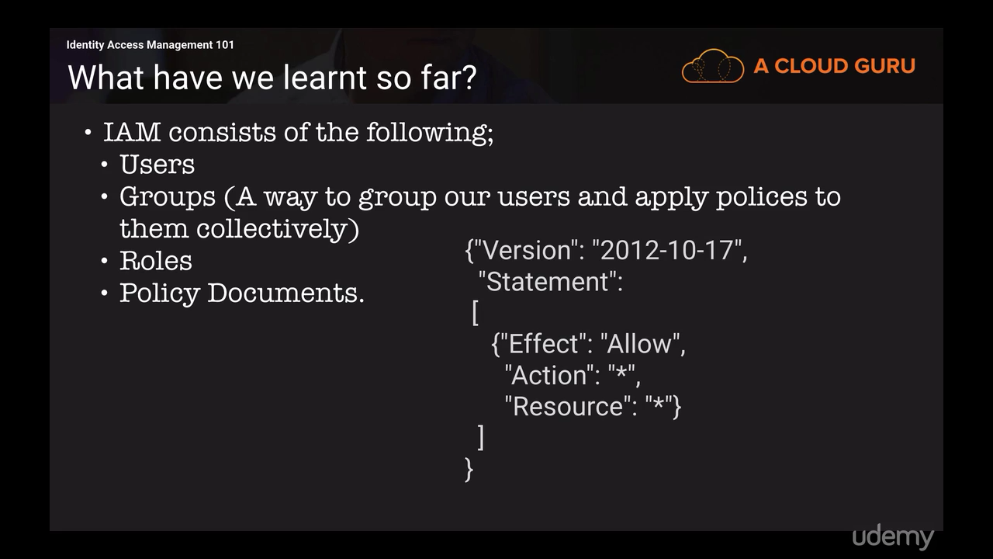

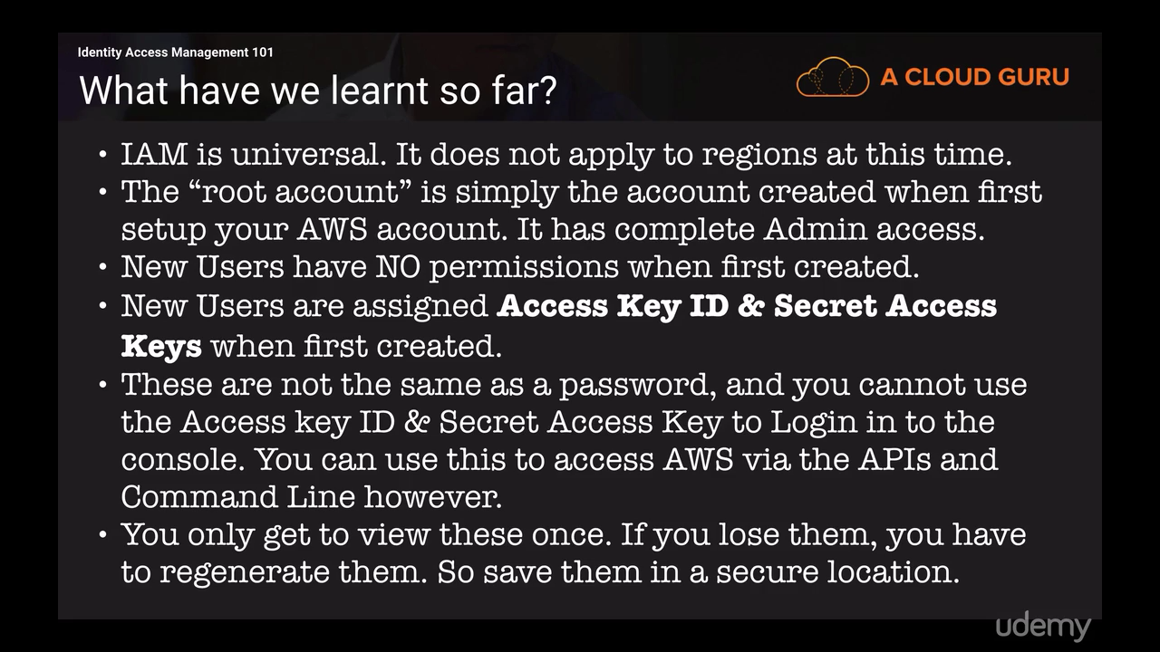

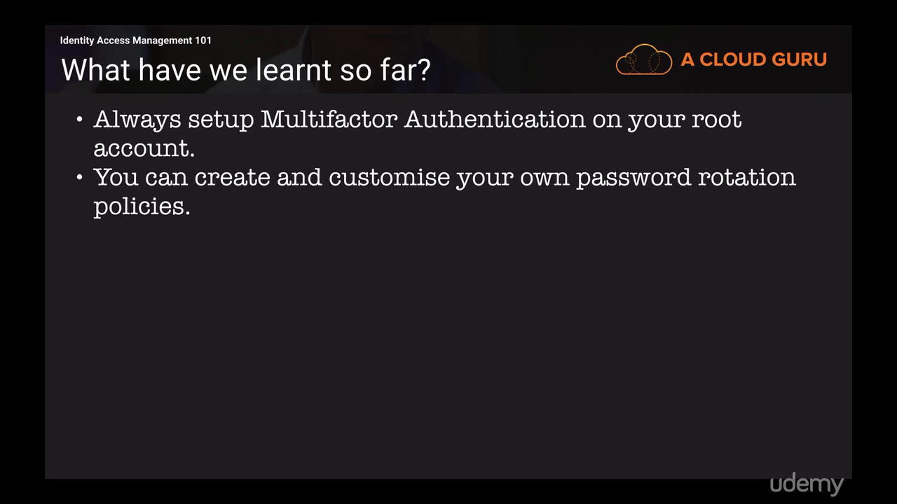

***Access Using CLI***

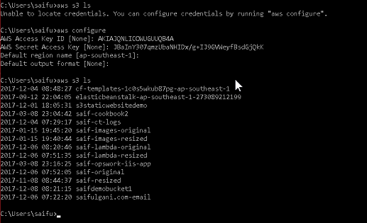s

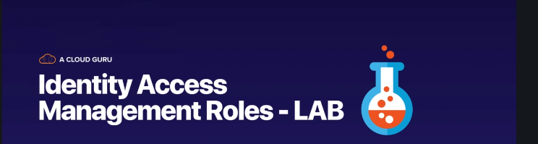

You can not access S3 bucket from CLI if you delete config file but you can access it after attaching role

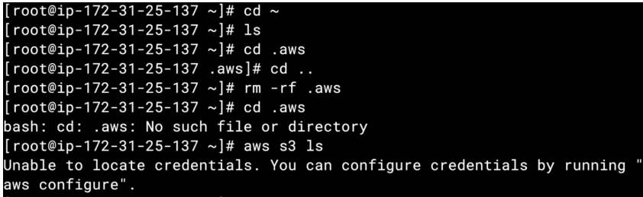

Add Role to EC2 instance

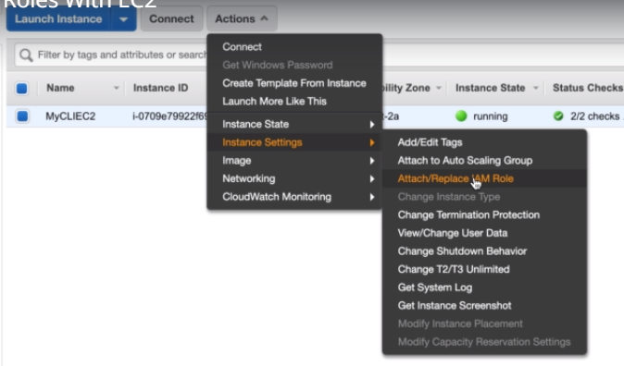

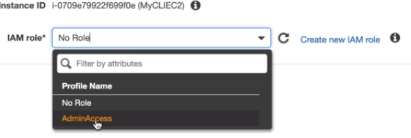

Now you can access it via CLI after adding role

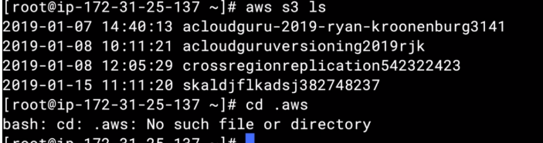

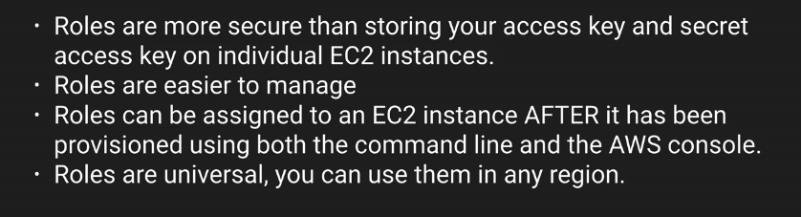

**EC2 Instance Meta Data**

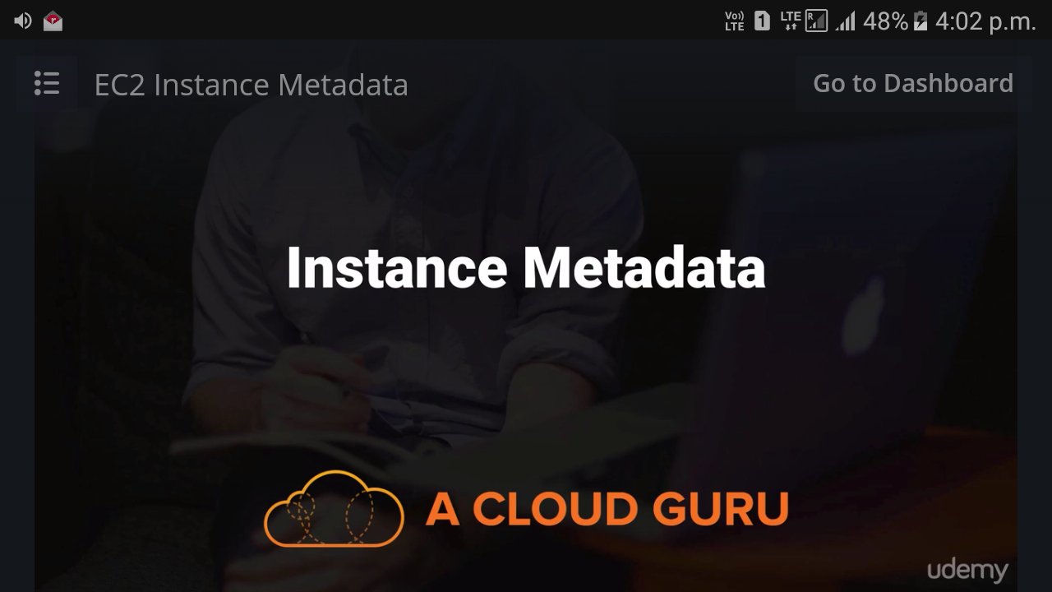

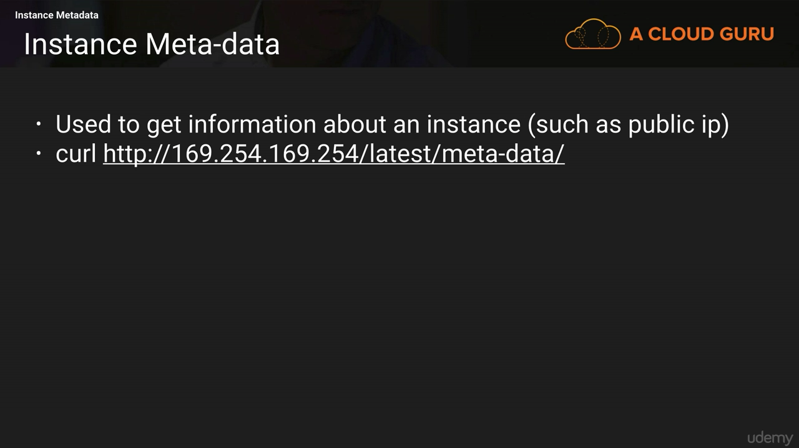

**You need to know both the private IP address and public IP address of your EC2 instance. You should**



# **ROUTE53 (DNS)**

It is global policy not the regional one

TLD -Top level Domain

SLD-Second Level Domain

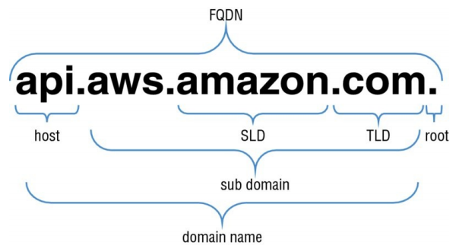

**C:\Users\pawar_ka\Desktop\Image004.tif**

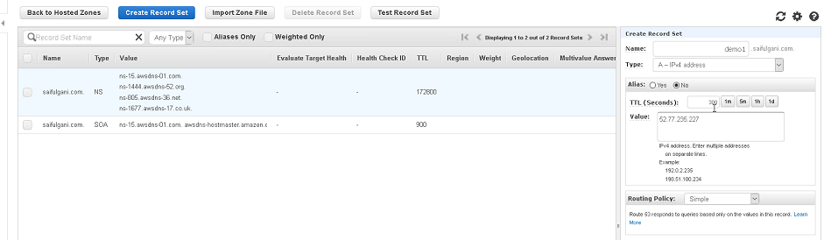 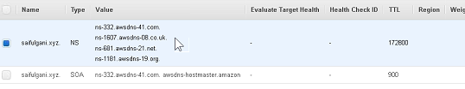

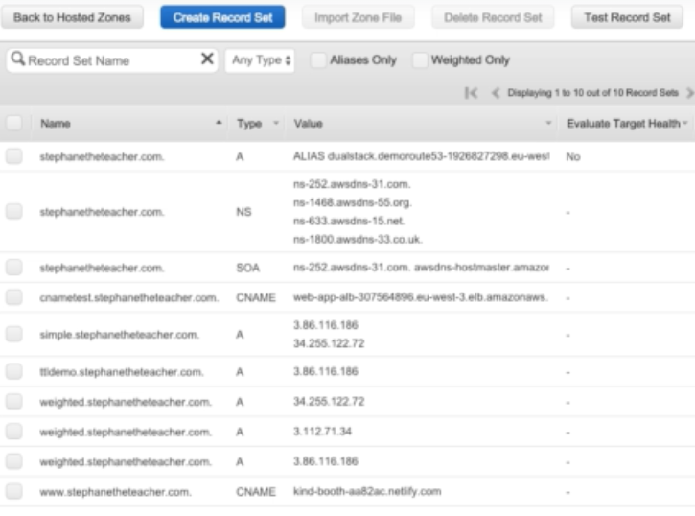

DNS uses port number 53 to serve requests

* Route53 is a Managed DNS (Domain Name System)
* DNS is a collection of rules and records which helps clients understand how to reach a server through URLs.

### Common DNS Types

* In AWS Route53, the most common records are:
  + A: URL to IPv4
  + AAAA: URL to IPv6
  + NS (Named Server) -Another registrar to Route53
  + CNAME: URL to URL (It points to ELB instead before Ec2 instance i.e host to host)
  + Alias: URL to AWS resource. (choose Alias record over CNAME)
  + Pointer (PTR) - reverse of an A record
  + DNS record - transmission of email to your intended mail server?
  + MX Record -DNS records are commonly used to stop email spoofing and spam?
  + SPF records-store human-readable information about a server, network, and other accounting data with a host?
  + TXT Record-DNS primarily uses UDP to serve requests. The TCP protocol is used by DNS server when the response data size exceeds 512 bytes or for tasks such as zone transfers.

### Name Servers

3rd Party Registrar with AWS Route 53

• If you buy your domain on 3rd party website, you can still use Route53.

• 1) Create a Hosted Zone in Route 53

• 2) Update NS Records on 3rd party website to use Route 53 name servers

Map Third party domain (From other Registrar godaddy )with Route 53 From other Registrar …e.g GoDaddy --AWS

A name server is a computer designated to translate domain names into IP addresses. Name Server (NS) records are used by TLD servers to direct traffic to the DNS server that contains the authoritative DNS records. (From other Registrar …e.g GoDaddy)

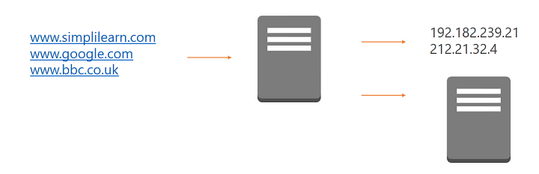

### Zone Files

Zone files reside in name servers and it is a simple text file that contains the mappings between domain names and IP addresses.

This is how a DNS server finally identifies which IP address should be contacted when a user requests a certain domain name.

Zone files reside in name servers and generally define the resources available under a specific domain, or the place where one can go to get that information.

Zone files are the way that name servers store information about the domains they know. The more zone files that a name server has, the more requests it will be able to answer authoritatively. Most requests to the average name server, however, are for domains that are not in the local zone file

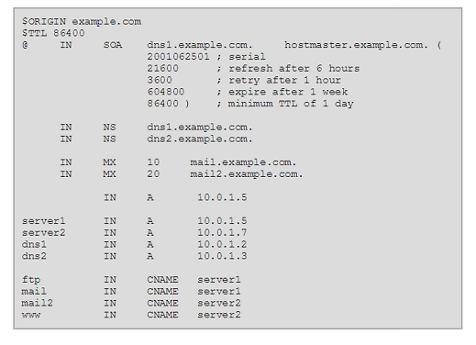

**Record Types**

Each zone file contains records. In its simplest form, a record is a single mapping between a resource and a name. These can map a domain name to an IP address or define resources for the domain, such as name servers or mail servers. This section describes each record type in detail.

There are four record types

1. A Record
2. CNAME
3. NS Record
4. Alias Record

**Start of Authority (SOA) Record**

A Start of Authority (SOA) record is mandatory in all zone files, and it identifies the base DNS information about the domain. Each zone contains a single SOA record.

The SOA record stores information about the following:

* The name of the DNS server for that zone
* The administrator of the zone
* The current version of the data file
* The number of seconds that a secondary name server should wait before checking for updates
* The number of seconds that a secondary name server should wait before retrying a failed zone transfer
* The maximum number of seconds that a secondary name server can use data before it must either be refreshed or expire
* The default TTL value (in seconds) for resource records in the zone

**A and AAAA**

Both types of address records map a host to an IP address.

The A record is used to map a host to an IPv4 address,

while AAAA records are used to map a host to an IPv6 address.

**Pointer (PTR)**

A Pointer (PTR) record is essentially the reverse of an A record. PTR records map an IP address to a DNS name, and they are mainly used to check if the server name is associated with the IP address from where the connection was initiated.

**Alias Record**

It points to ELB instead before Ec2 instance i.e host to host

We use Alias to create mappings to devices that have constantly changing IP address like ELB S3 and so on

Alias is similar term like CNAME but Alias is internal to AWS and CNAME is general term for DNS.

**Canonical Name (CNAME)**

A Canonical Name (CNAME) record is a type of resource record in the DNS that defines an alias for the CNAME for your server

resolve a domain name to another domain i.e CNAME is used to map a host to host address,

e.g Suppose there is ticketing website and same website is accessible by multiple domain

Ticket.com, Ticket1.com, ticketing.com

All of the above will map to one domain i.e ticket.com

Always use alias record over CNAME for the cost purpose

**CNAME vs Alias**

* AWS Resources (Load Balancer, CloudFront, etc…) expose an AWS URL: lb1-1234.us-east-2.elb.amazonaws.com and you want it to be myapp.mydomain.com
* CNAME:
  + Points a URL to any other URL. (app.mydomain.com => blabla.anything.com)
  + ONLY FOR NON ROOT DOMAIN (aka. something.mydomain.com)
* Alias:
  + Points a URL to an AWS Resource (app.mydomain.com => blabla.amazonaws.com)
  + Works for ROOT DOMAIN and NON ROOT DOMAIN (aka mydomain.com) • Free of charge • Native health check

**Amazon Route 53 Overview**

Amazon Route 53 performs three main functions

1. Domain Registration
2. DNS Service
3. Health checking

DNS record should you use to configure the transmission of email to your intended mail server?

* MX Record

DNS records are commonly used to stop email spoofing and spam?

* SPF records

DNS record can be used to store human-readable information about a server, network, and other accounting data with a host?

* TXT Record

DNS primarily uses UDP to serve requests. The TCP protocol is used by DNS server when the response data size exceeds 512 bytes or for tasks such as zone transfers.

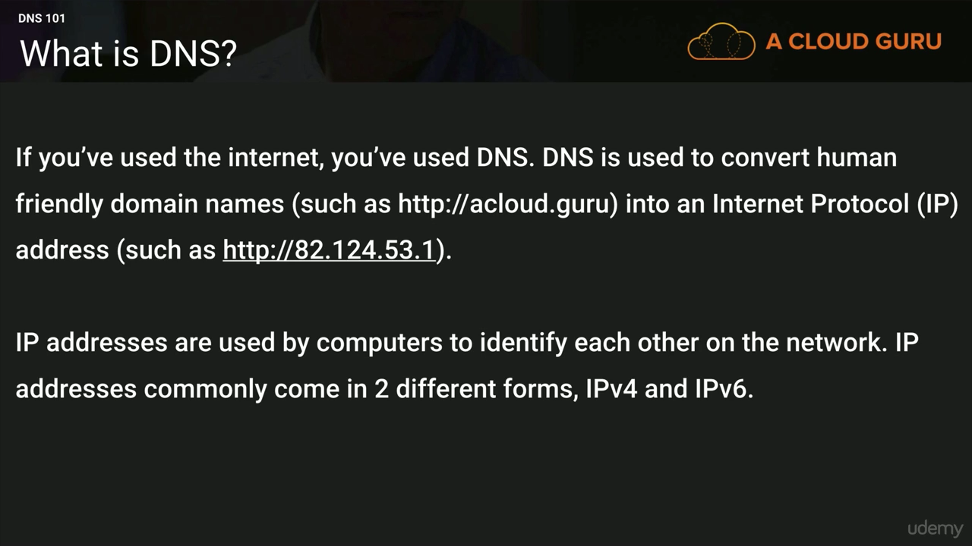

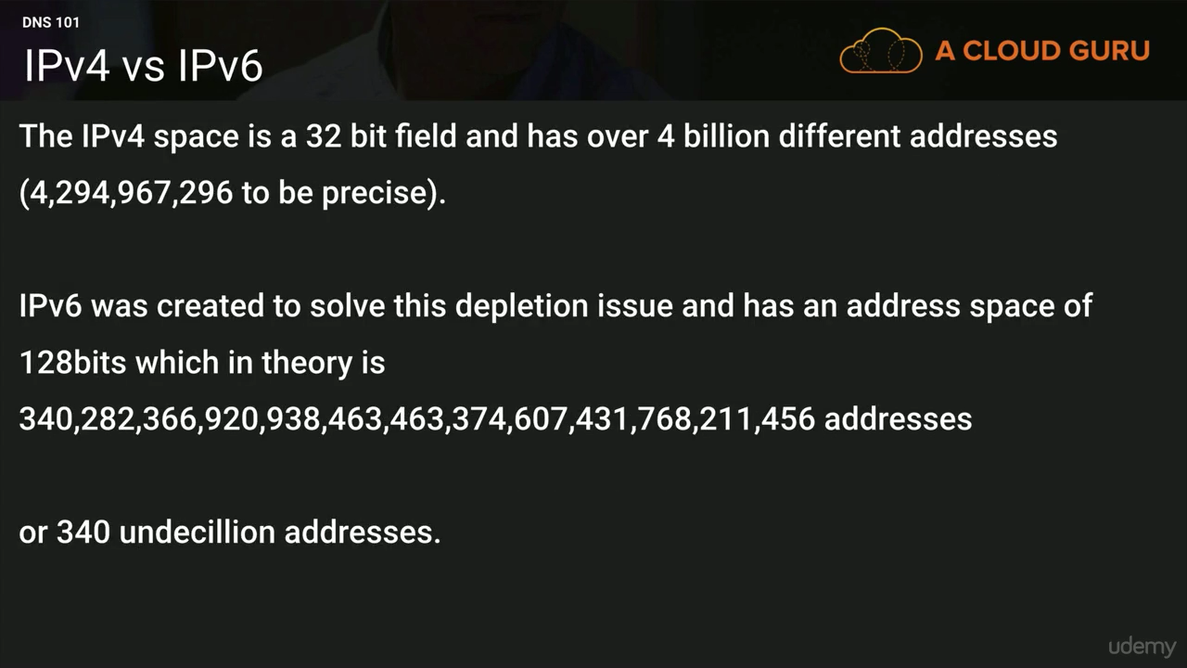

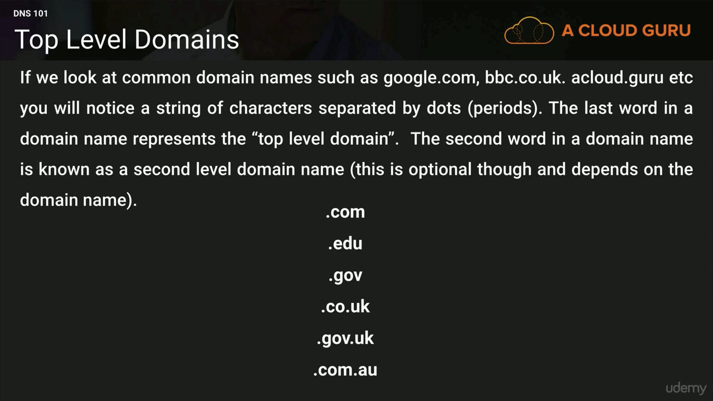

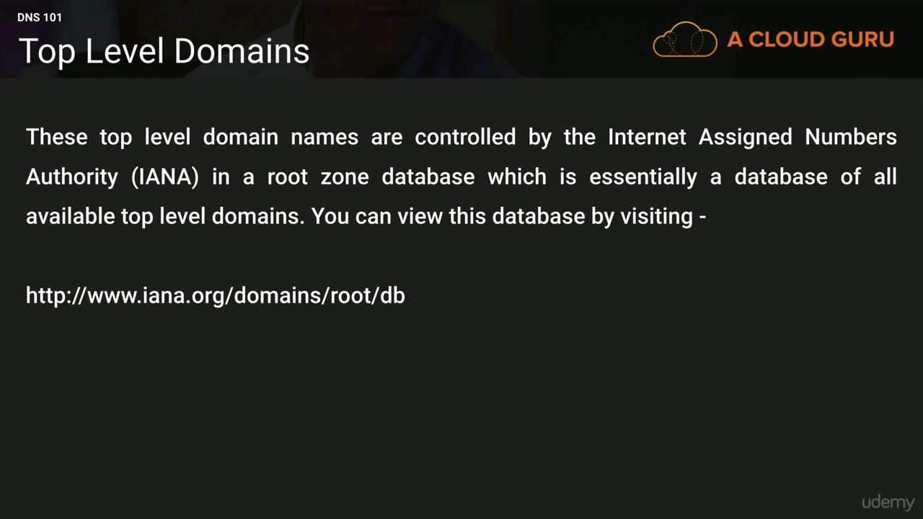

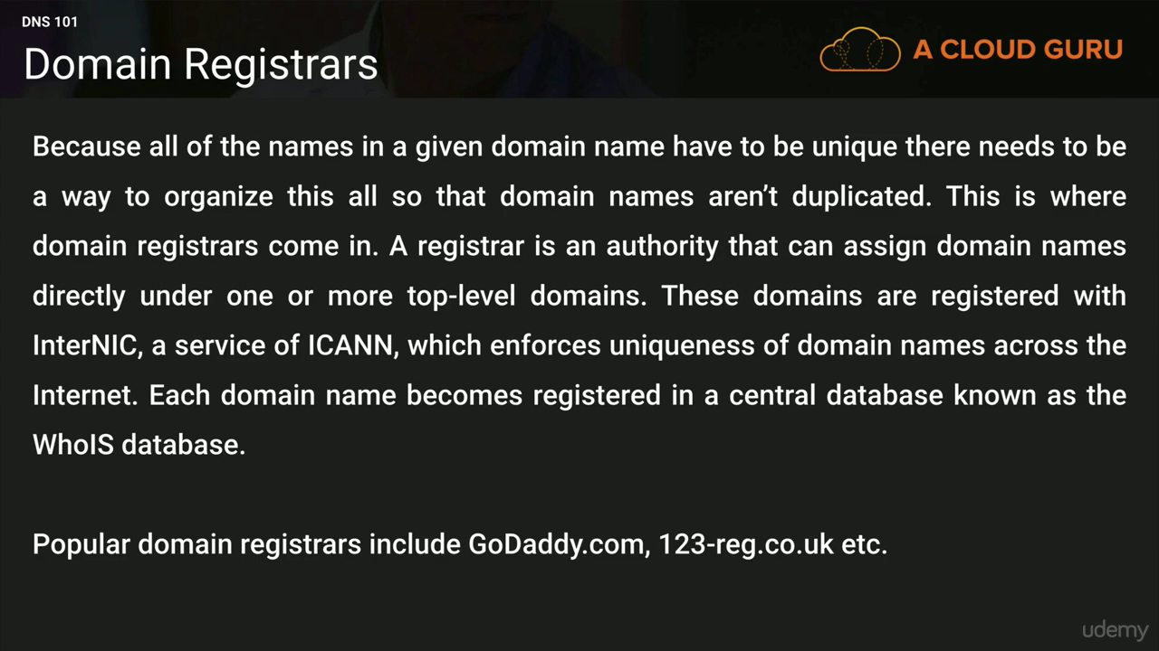

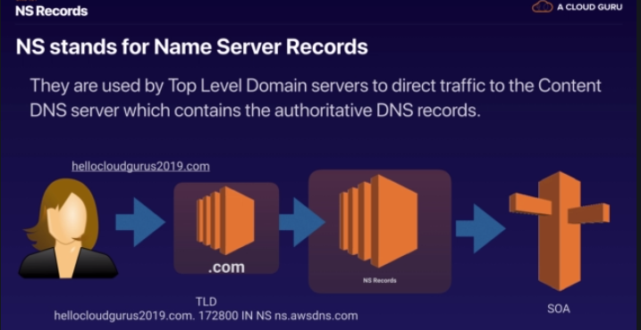

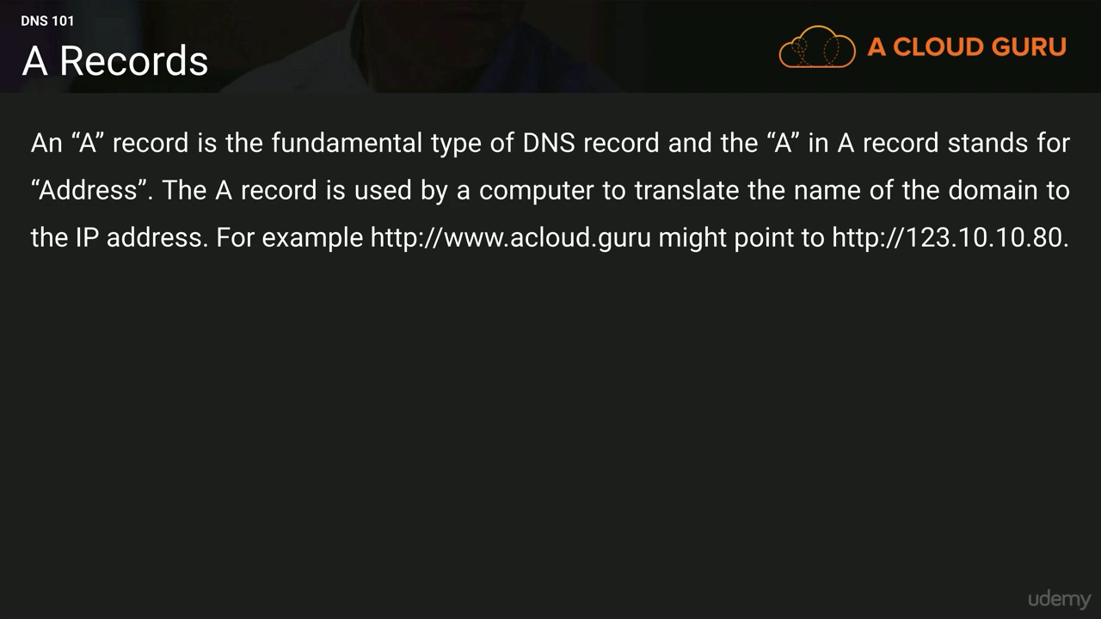

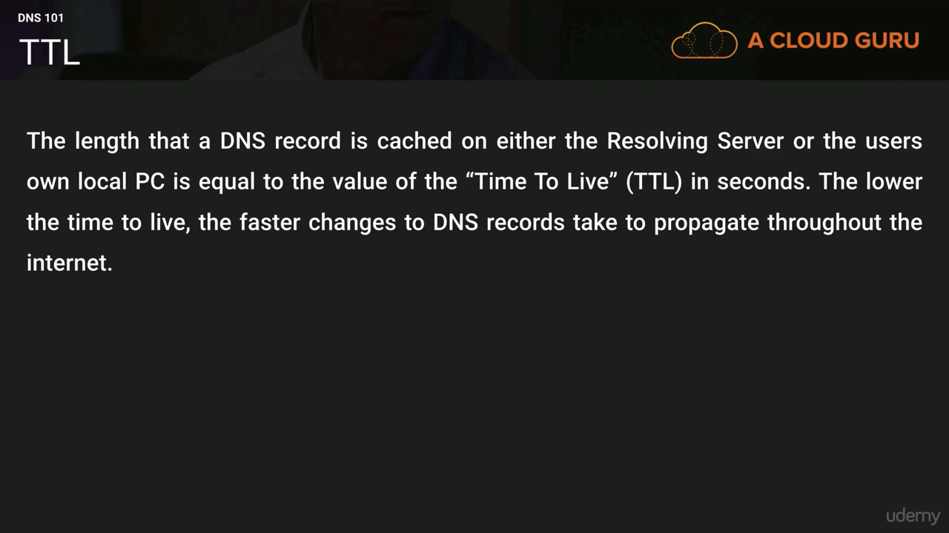

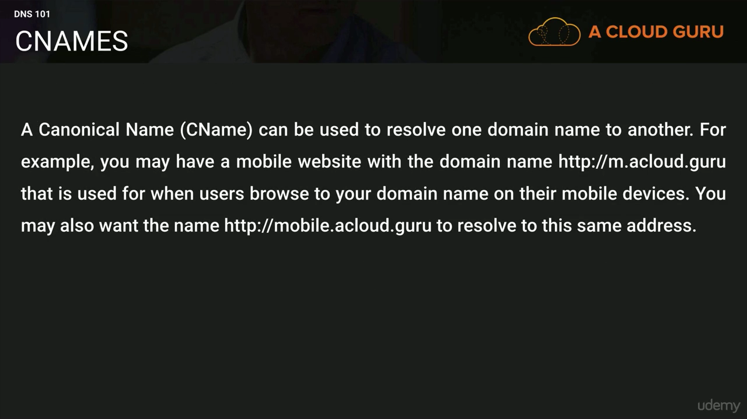

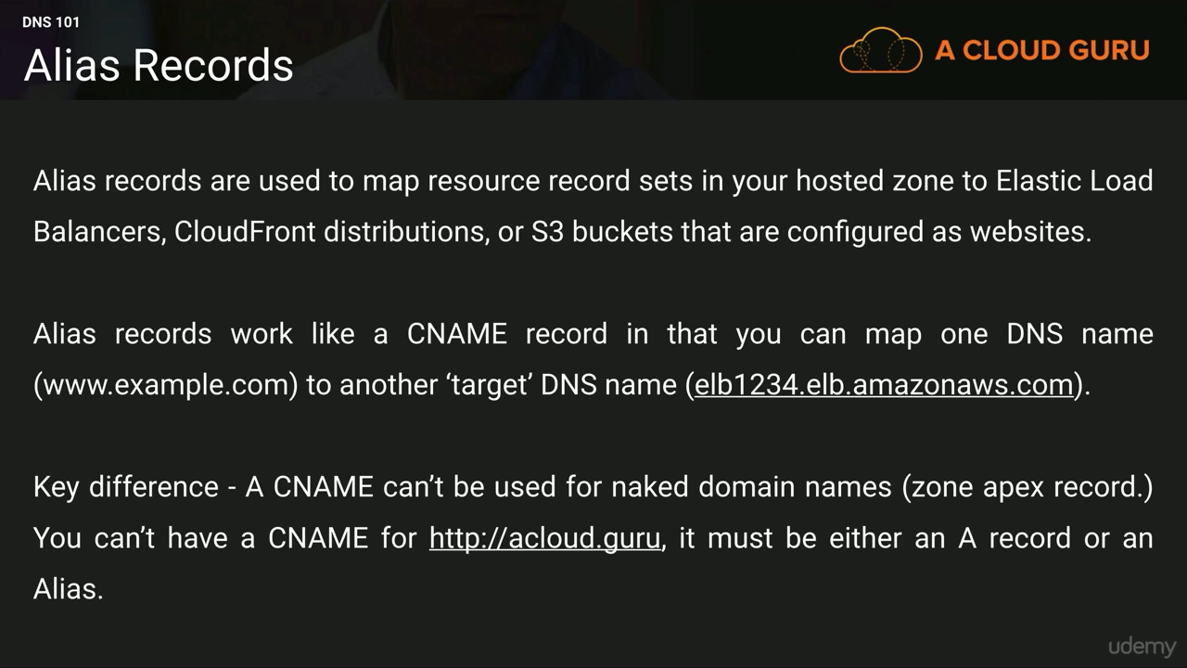

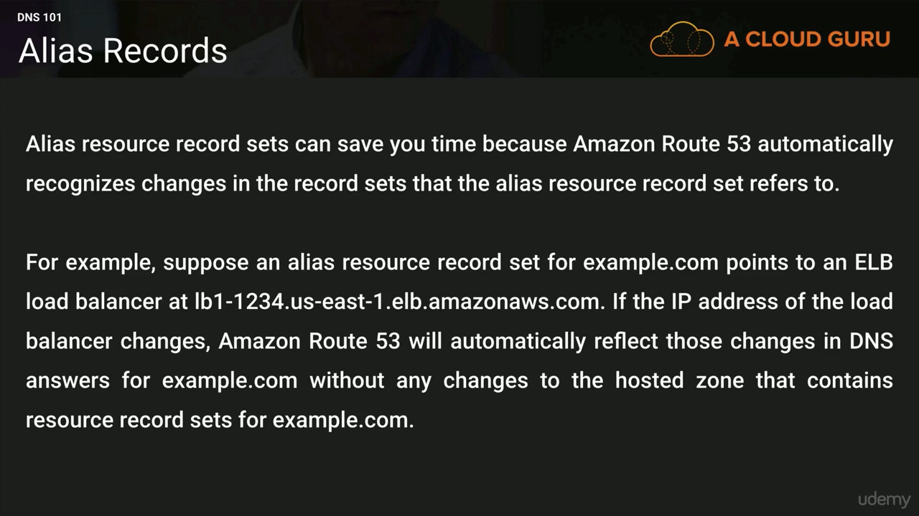

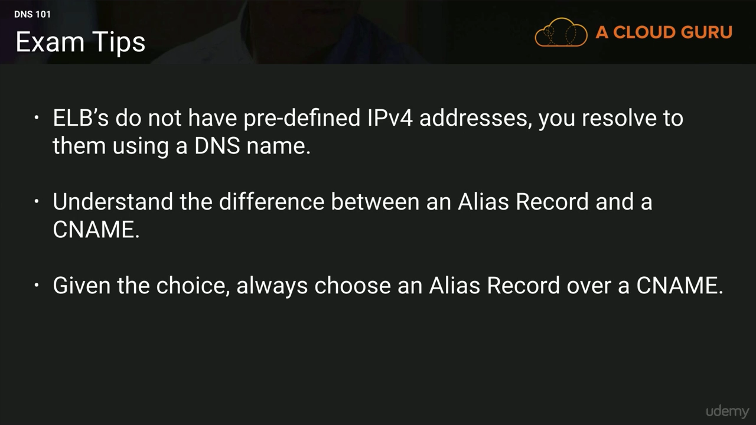

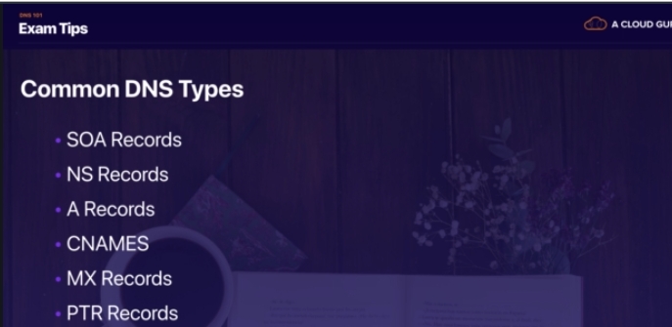

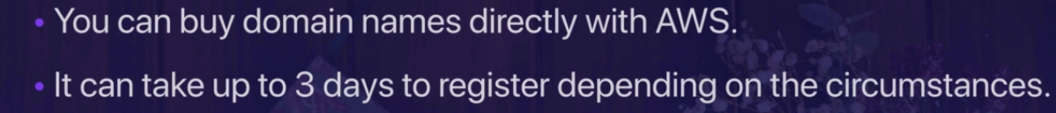

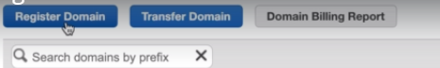

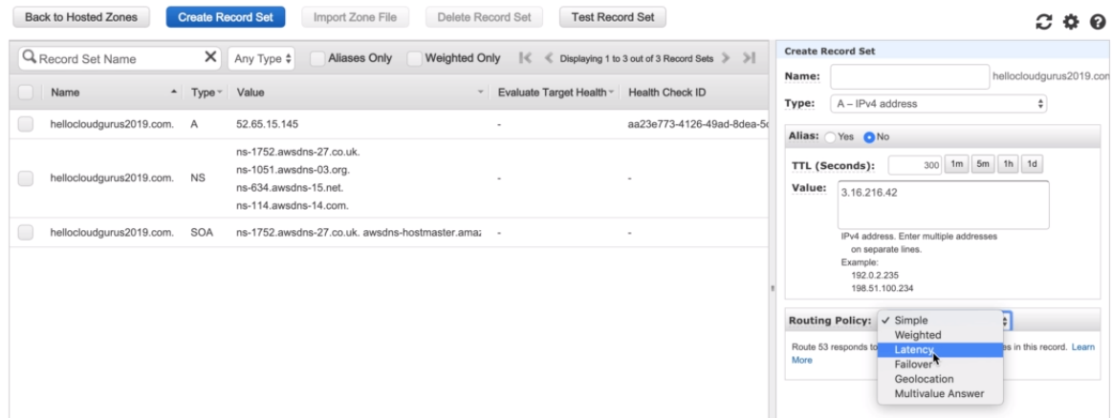

### Routing Policies Available On AWS (Route 53)

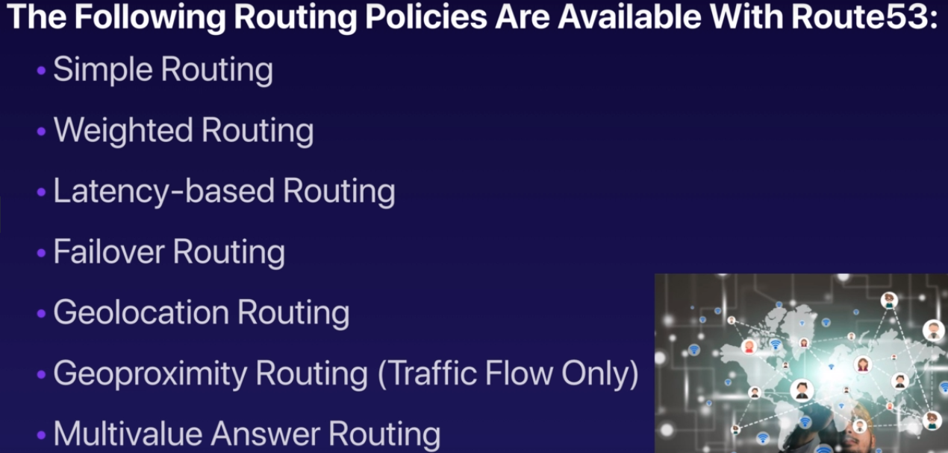

**Simple Routing Policy**

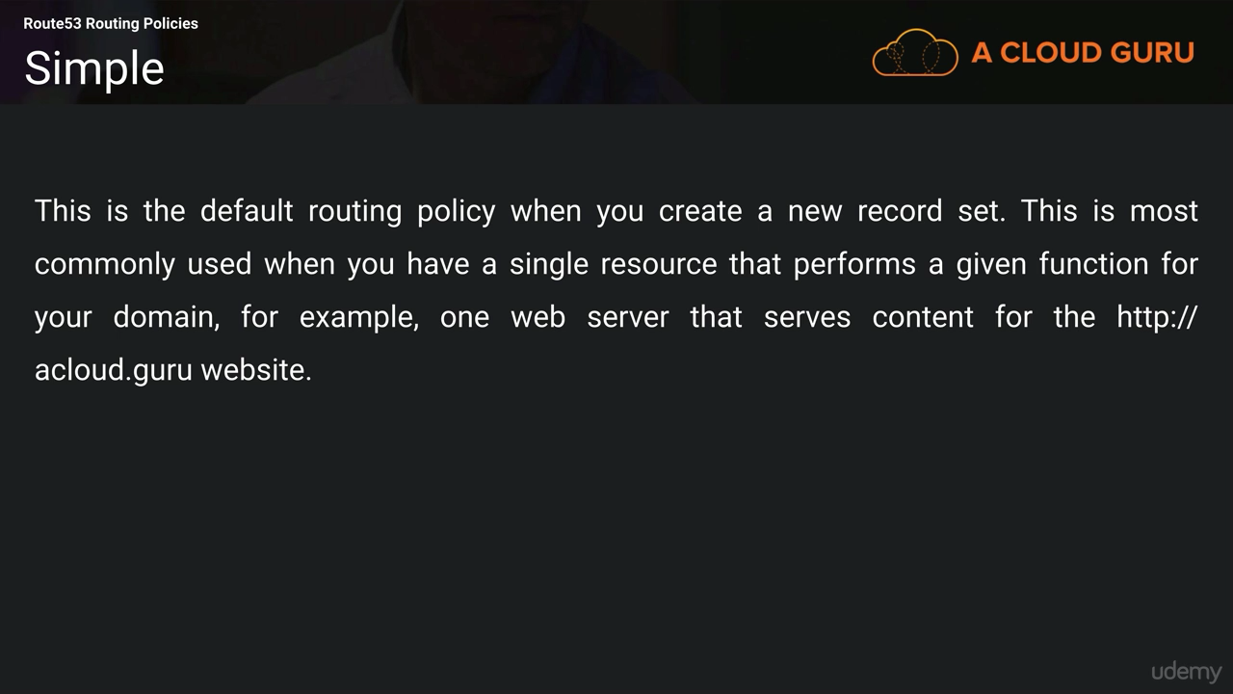

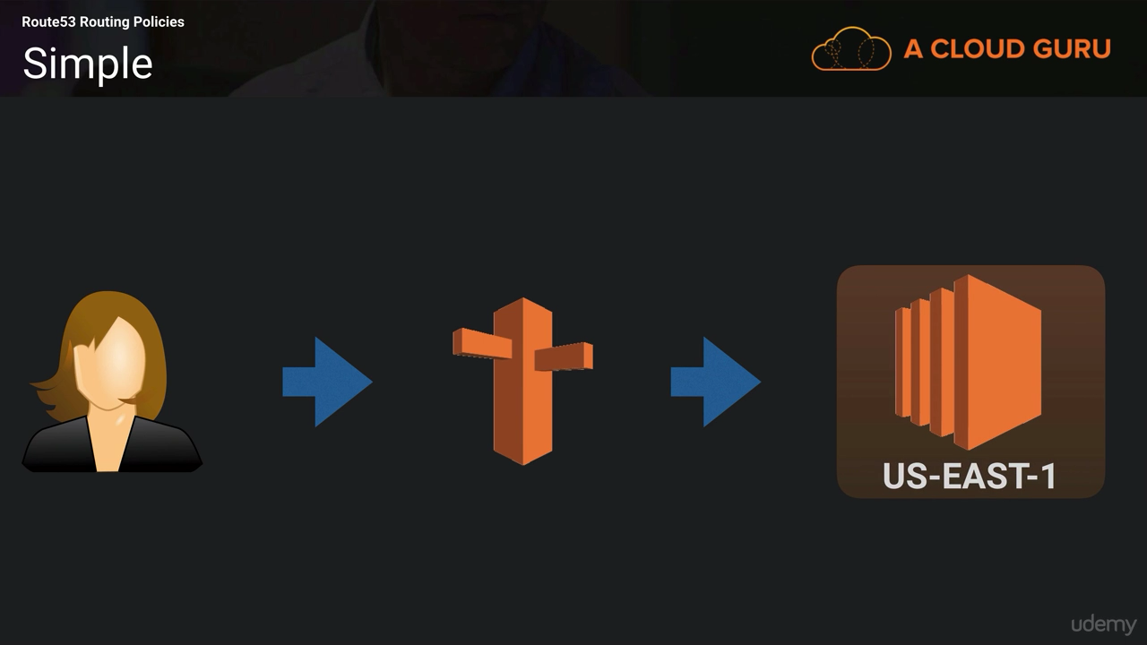

**Weighted Rounting Policy**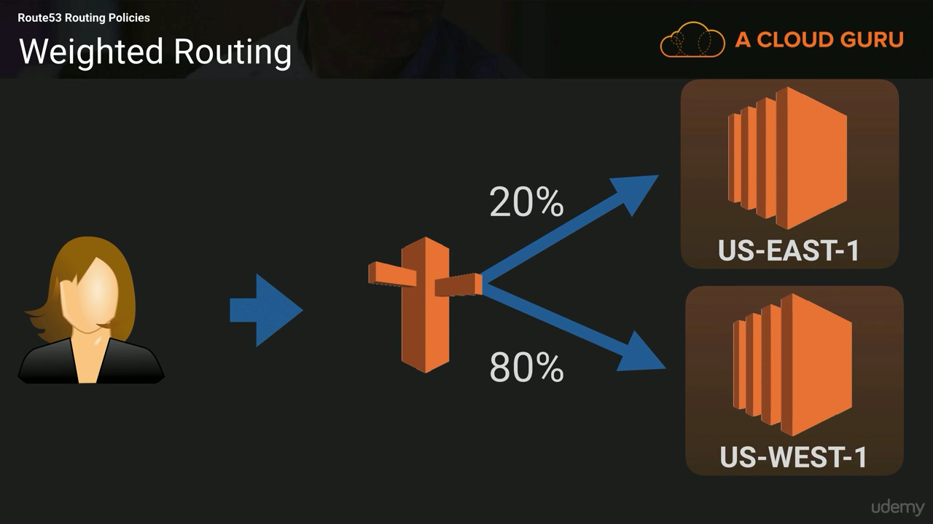

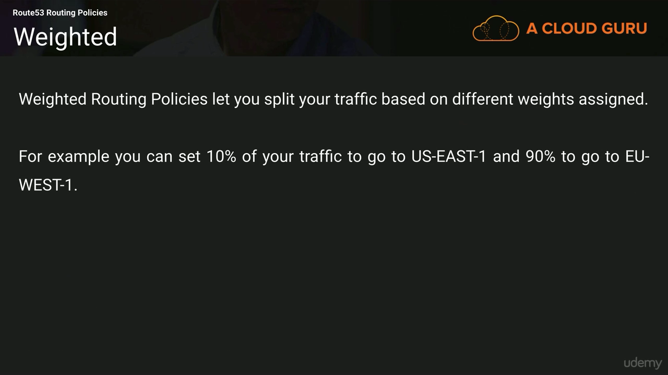

**Latency Based Routing Policy**

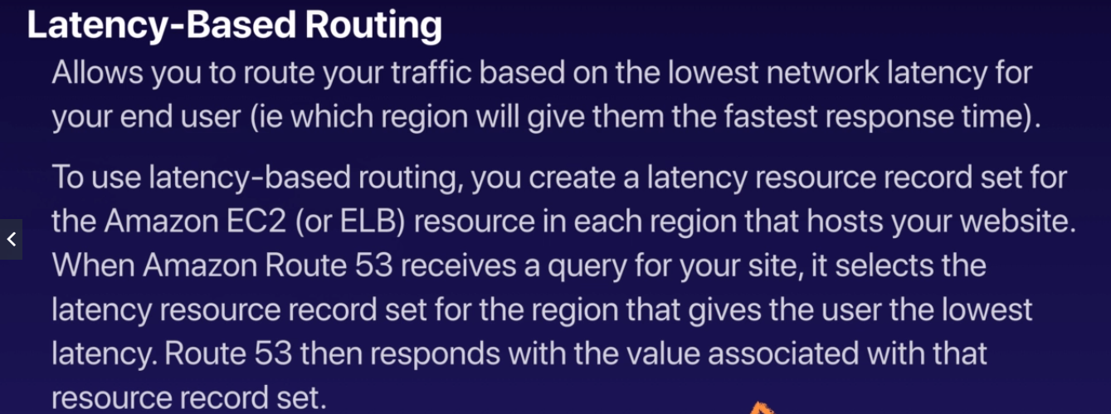

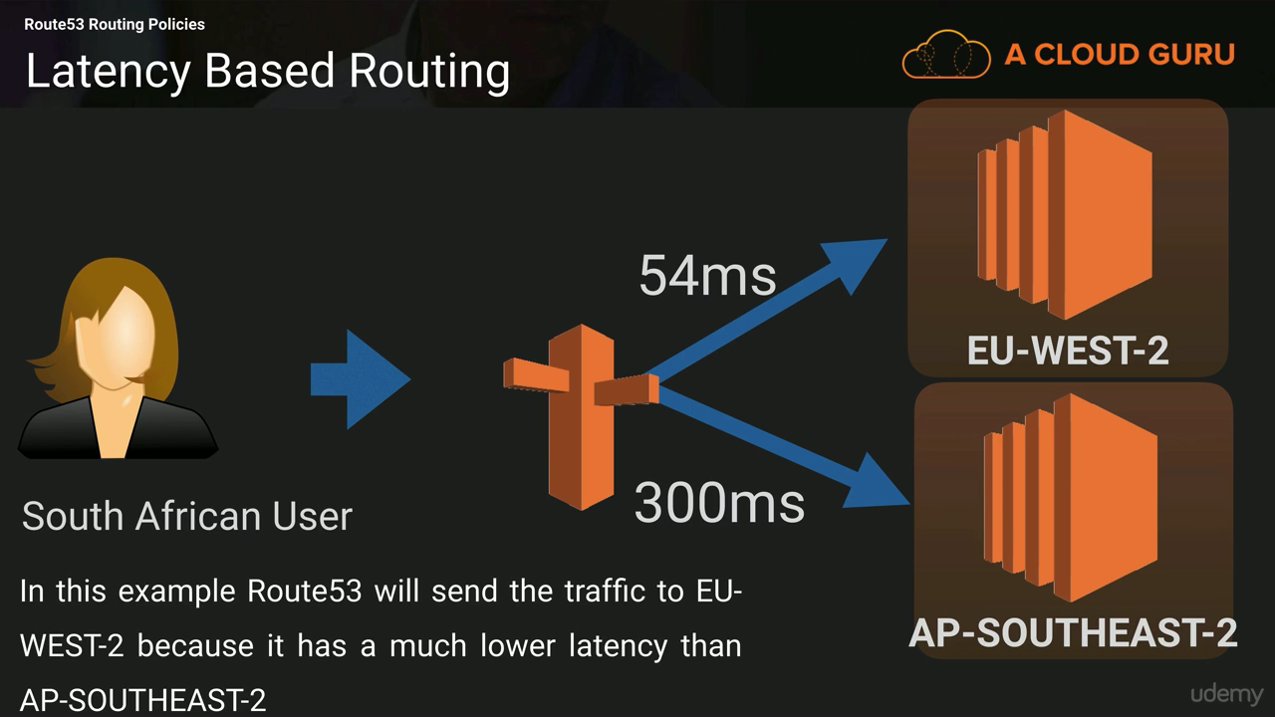

**Failover Routing Policy**

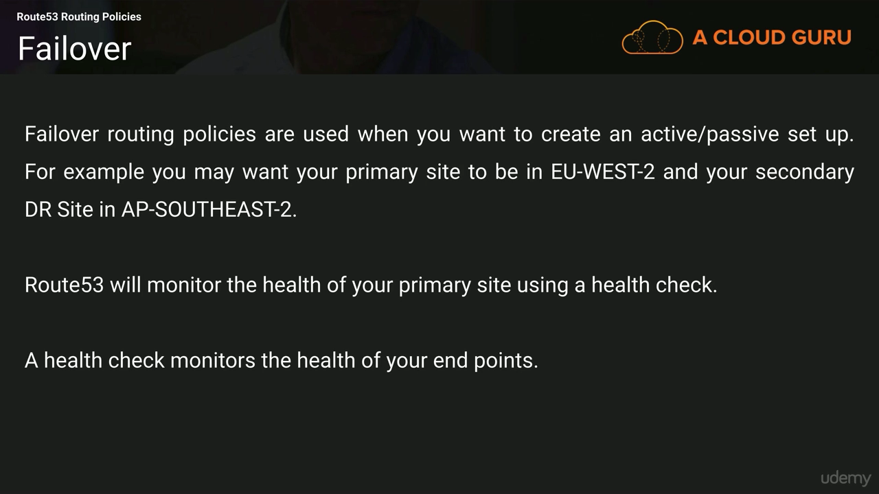

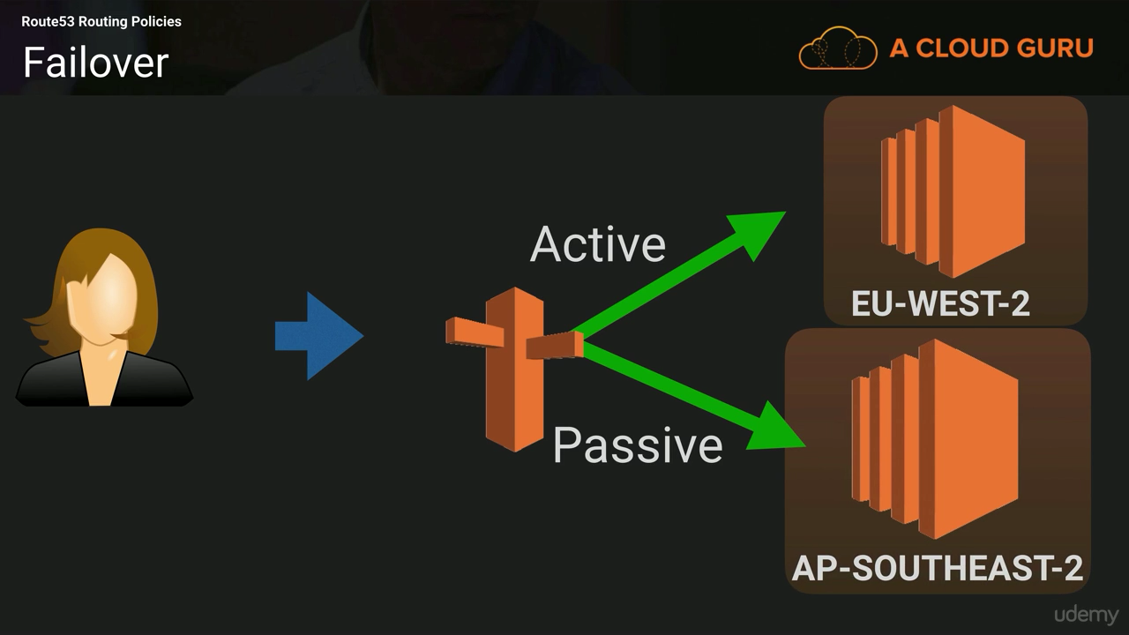

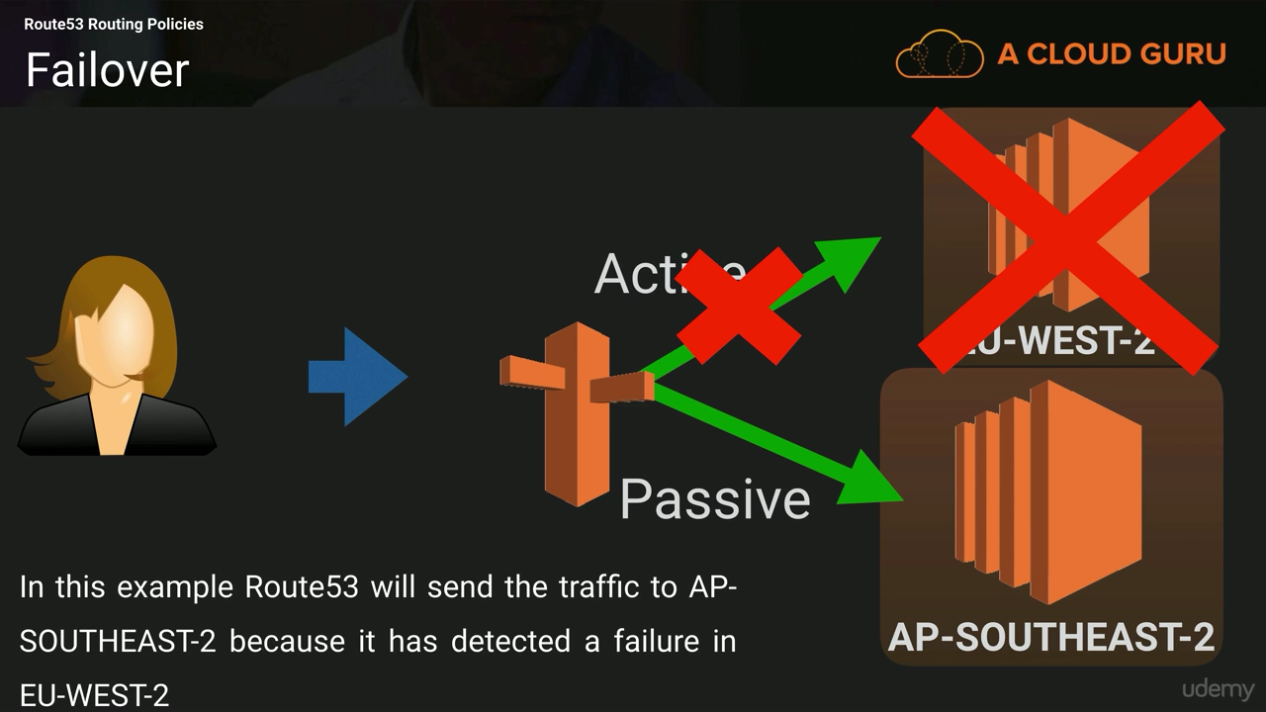

**Geolocation Routing Policy**

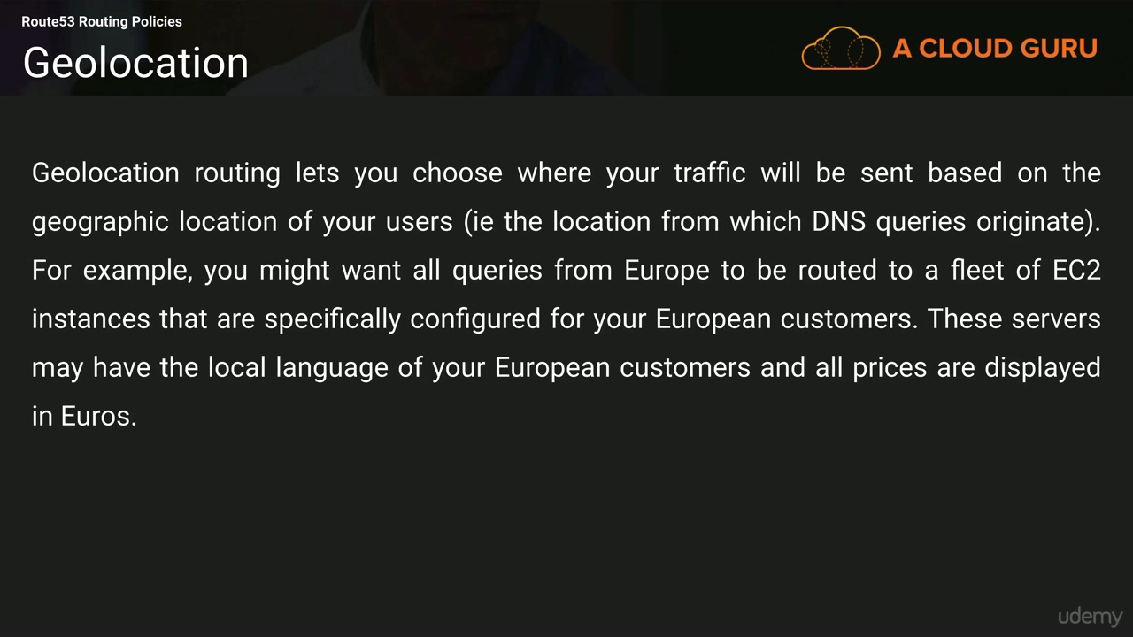

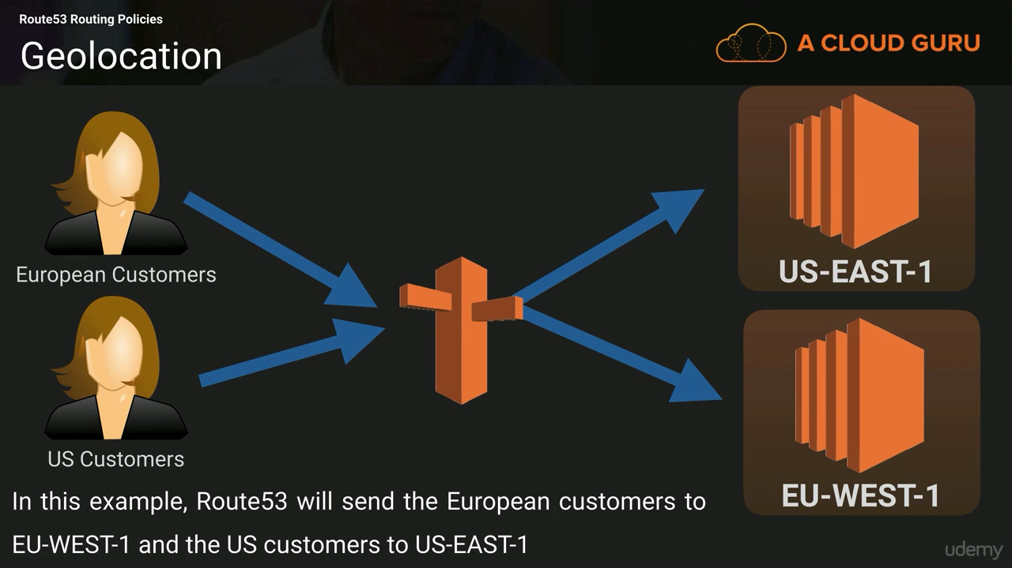

**GeoProximity Routing (not for exam)**

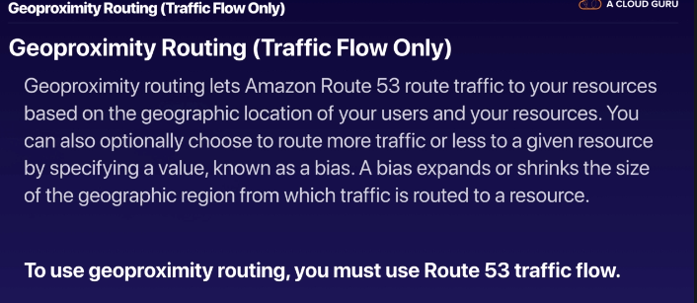

**Multivalue Answer Policy(not for exam)**

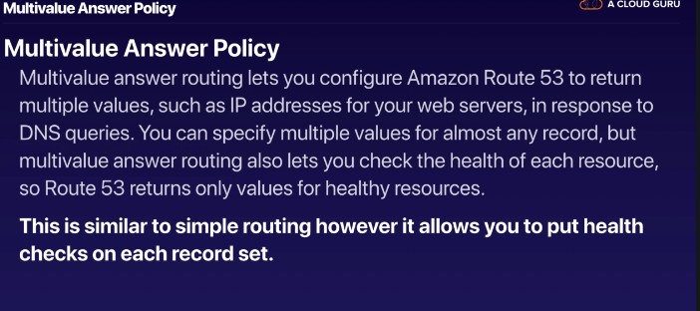

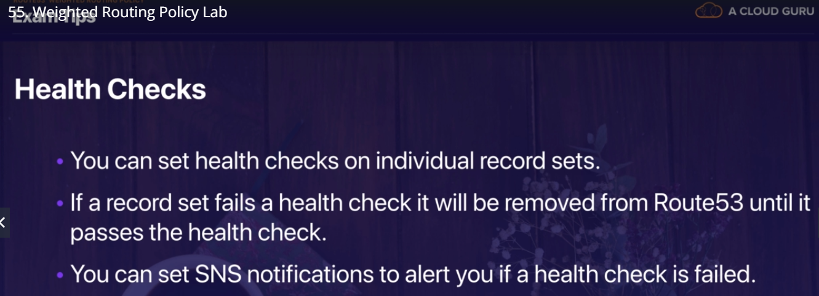



# **DATABASE**

### AWS Database Types

**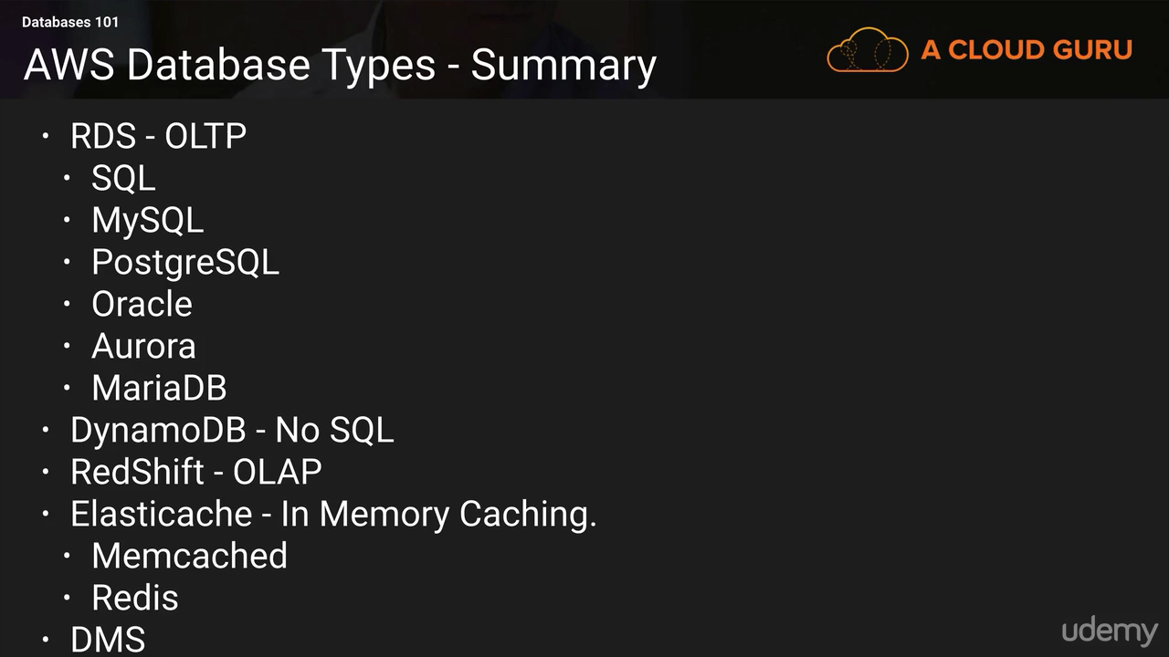**

* RDBMS (= SQL / OLTP) 🡪 RDS, Aurora – great for joins
* NoSQL database 🡪 DynamoDB (~JSON), ElastiCache (key / value pairs), Neptune (graphs) – no joins, no SQL
* Object Store 🡪S3 (for big objects) / Glacier (for backups / archives)
* Data Warehouse (= SQL Analytics / BI) 🡪Redshift (OLAP), Athena
* Search🡪 ElasticSearch (JSON) – free text, unstructured searches
* Graphs: Neptune – displays relationships between data

**Create RDS Instance and connect to EC2**

1. Sign in to the AWS Management Console and open the Amazon RDS console at<https://console.aws.amazon.com/rds/>.
2. In the top-right corner of the AWS Management Console, choose the AWS Region in which you want to create the DB instance. This example uses the US West (Oregon) region.
3. In the navigation pane, choose **Databases**.

If the navigation pane is closed, choose the menu icon at the top left to open it.

1. Choose **Create database** to open the **Select engine** page.
2. On the **Select engine** page, shown following, choose **MySQL**, and then choose **Next**.
3. On the **Choose use case** page, choose **Dev/Test – MySQL**, and then choose **Next**.
4. On the **Specify DB details** page, shown following, set these values:
   1. **License model:** Use the default value.
   2. **DB engine version:** Use the default value.
   3. **DB instance class:** db.t2.small
   4. **Multi-AZ deployment:** No
   5. **Storage type:** General Purpose (SSD)
   6. **Allocated storage:** 20 GiB
   7. **DB instance identifier:** tutorial-db-instance
   8. **Master username:** tutorial\_user
   9. **Master password:** Choose a password.
   10. **Confirm password:** Retype the password.
5. Choose **Next** and set the following values in the **Configure advanced settings** page:

* **Virtual Private Cloud (VPC):** Choose an existing VPC with both public and private subnets, such as the tutorial-vpc (vpc-*identifier*) created in [Create a VPC with Private and Public Subnets](https://docs.aws.amazon.com/AmazonRDS/latest/UserGuide/CHAP_Tutorials.WebServerDB.CreateVPC.html#CHAP_Tutorials.WebServerDB.CreateVPC.VPCAndSubnets)

**Note**

The VPC must have subnets in different Availability Zones.

* **Subnet group:** The DB subnet group for the VPC, such as the tutorial-db-subnet-group created in [Create a DB Subnet Group](https://docs.aws.amazon.com/AmazonRDS/latest/UserGuide/CHAP_Tutorials.WebServerDB.CreateVPC.html#CHAP_Tutorials.WebServerDB.CreateVPC.DBSubnetGroup)
* **Public accessibility:** **No**
* **Availability zone:** **No Preference**
* **VPC security groups:** Choose an existing VPC security group that is configured for private access, such as the tutorial-db-securitygroup created in [Create a VPC Security Group for a Private DB Instance](https://docs.aws.amazon.com/AmazonRDS/latest/UserGuide/CHAP_Tutorials.WebServerDB.CreateVPC.html#CHAP_Tutorials.WebServerDB.CreateVPC.SecurityGroupDB).

Remove other security groups, such as the default security group, by choosing the **X**associated with each.

* **Database name:** sample

1. To create your Amazon RDS MySQL DB instance, choose **Create database**.
2. On the next page, choose **View DB instances details** to view your RDS MySQL DB instance.
3. Wait for the **DB instance status** of your new DB instance to show as **available**. Then scroll to the **Connect** section, shown following.

… Make note of the endpoint and port for your DB instance. You will use this information to connect your web server to your RDS DB instance.

(When you create the RDS instance and create the EC2 instance then for the connectivity there should inbound rule for RDS(security group) present which should pointing to EC2 security group i.e it should point to WebDMZ in below examples)

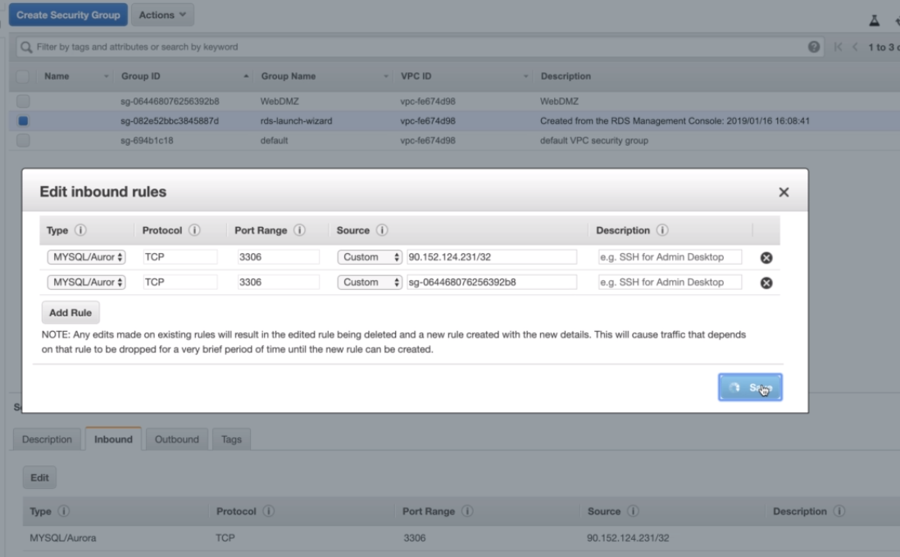

### RDS

• The Amazon RDS service itself provides an Application Programming Interface (API) that lets you create and manage one or more DB Instances.

• You can launch a new DB Instance by calling the CreateDBInstance API or by using the AWS Management Console. Existing DB Instances can be changed or resized using the **ModifyDBInstance** API.

Existing databases can be migrated to Amazon RDS using native tools and techniques that vary depending on the engine. For example with MySQL, you can export a backup using mysqldump and import the file into Amazon RDS MySQL. You can also use the AWS Database Migration Service, which gives you a graphical interface that simplifies the migration of both schema and data between databases. AWS Database Migration Service also helps convert databases from one database engine to another.

* Continuous backups and restore to specific timestamp (Point in Time Restore)!
* Monitoring dashboards
* Read replicas for improved read performance
* Multi AZ setup for DR (Disaster Recovery)
* Maintenance windows for upgrades
* Scaling capability (vertical and horizontal)
* BUT you can’t SSH into your instances
* Up to 5 Read Replicas within AZ, Cross AZ or Cross Region and Replication is ASYNC, so reads are eventually consistent

**RDS Multi AZ (Disaster Recovery)**

* SYNC replication
* One DNS name – automatic app failover to standby
* Increase availability
* Failover in case of loss of AZ, loss of network, instance or storage failure
* No manual intervention in apps
* Not used for scaling

**RDS Backups**

* Backups are automatically enabled in RDS
* Automated backups:
  + Daily full snapshot of the database
  + Capture transaction logs in real time
  + 7 days retention (can be increased to 35 days)
* • DB Snapshots:
  + Manually triggered by the user
  + Retention of backup for as long as you want

**RDS Encryption**

* Encryption at rest capability with AWS KMS - AES-256 encryption
* SSL certificates to encrypt data to RDS in flight
* To enforce SSL:
  + PostgreSQL: rds.force\_ssl=1 in the AWS RDS Console (Paratemer Groups)
  + MySQL: Within the DB: GRANT USAGE ON \*.\* TO 'mysqluser'@'%' REQUIRE SSL;
* To connect using SSL
  + Provide the SSL Trust certificate (can be download from AWS)
  + Provide SSL options when connecting to database

**Licensing**

Amazon RDS Oracle and Microsoft SQL Server are commercial software products that require appropriate licenses to operate in the cloud. AWS offers two licensing models: License Included and Bring Your Own License (BYOL).

1. License Included

In the License Included model, the license is held by AWS and is included in the Amazon RDS instance price. For Oracle, License Included provides licensing for Standard Edition One. For SQL Server, License Included provides licensing for SQL Server Express Edition, Web Edition, and Standard Edition.

1. Bring Your Own License (BYOL) In the BYOL model, you provide your own license. For Oracle, you must have the appropriate Oracle Database license for the DB Instance class and Oracle Database edition you want to run. You can bring over Standard Edition One, Standard Edition, and Enterprise Edition. For SQL Server, you provide your own license under the Microsoft License Mobility program. You can bring over Microsoft SQL Standard Edition and also Enterprise Edition. You are responsible for tracking and managing how licenses are allocated.

**Storage Options**

Amazon RDS is built using Amazon Elastic Block Store (Amazon EBS) and allows you to select the right storage option based on your performance and cost requirements

Storage Types

1. Magnetic

Magnetic storage, also called standard storage, offers cost-effective storage that is ideal for applications with light I/O requirements.

1. General Purpose (SSD)

General purpose (SSD)-backed storage, also called gp2, can provide faster access than magnetic storage. This storage type can provide burst performance to meet spikes and is excellent for small- to medium-sized databases.

1. Provisioned IOPS (SSD) Provisioned IOPS (SSD) storage is designed to meet the needs of I/O-intensive workloads, particularly database workloads

For most applications, General Purpose (SSD) is the best option and provides a good mix of lower-cost and higher-performance characteristics

**Backup and Recovery**

Amazon RDS provides two mechanisms for backing up the database: automated backups and manual snapshots

Each organization typically will define a Recovery Point Objective (RPO) and Recovery Time Objective (RTO) for important applications based on the criticality of the application and the expectations of the users. It’s common for enterprise systems to have an RPO measured in minutes and an RTO measured in hours or even days, while some critical applications may have much lower tolerances

1. Automated backups

One day of backups will be retained by default, but you can modify the retention period up to a maximum of 35 days. Keep in mind that when you delete a DB Instance, all automated backup snapshots are deleted and cannot be recovered. Manual snapshots, however, are not deleted.

1. Manual DB Snapshots

DB snapshots can be created with the Amazon RDS console or the CreateDBSnapshot action. Unlike automated snapshots that are deleted after the retention period, manual DB snapshots are kept until you explicitly delete them with the Amazon RDS console or the DeleteDBSnapshot

**Recovery**

You cannot restore from a DB snapshot to an existing DB Instance; a new DB Instance is created when you restore. When you restore a DB Instance, only the default DB parameter and security groups are associated with the restored instance.

When using automated backups, Amazon RDS combines the daily backups performed during your predefined maintenance window in conjunction with transaction logs to enable you to restore your DB Instance to any point during your retention period, typically up to the last five minutes.

**High Availability with Multi-AZ**

Multi-AZ allows you to place a secondary copy of your database in another Availability Zone for disaster recovery purposes. Multi-AZ deployments are available for all types of Amazon RDS database engines. When you create a Multi-AZ DB Instance, a primary instance is created in one Availability Zone and a secondary instance is created in another Availability Zone. You are assigned a database instance endpoint such as the following:

my\_app\_db.ch6fe7ykq1zd.us-west-2.rds.amazonaws.com

This endpoint is a Domain Name System (DNS) name that AWS takes responsibility for resolving to a specific IP address. You use this DNS name when creating the connection to your database.

Amazon RDS will automatically fail over to the standby instance without user intervention. The DNS name remains the same, but the Amazon RDS service changes the CNAME to point to the standby.

It is important to remember that Multi-AZ deployments are for disaster recovery only; they are not meant to enhance database performance. The standby DB Instance is not available to offline queries from the primary master DB Instance. To improve database performance using multiple DB Instances, use read replicas or other DB caching technologies such as Amazon ElastiCache.

**Scaling Up and Out**

Amazon RDS allows you to scale compute and storage vertically, and for some DB engines, you can scale horizontally.

**Vertical Scalability**

Each database instance can scale from 5GB up to 6TB in provisioned storage depending on the storage type and engine. Storage for Amazon RDS can be increased over time as needs grow with minimal impact to the running database. Storage expansion is supported for all of the database engines except for SQL Server.

**Horizontal Scalability with Partitioning**

A relational database can be scaled vertically only so much before you reach the maximum instance size. Partitioning a large relational database into multiple instances or shards is a common technique for handling more requests beyond the capabilities of a single instance.

Partitioning, or sharding, allows you to scale horizontally to handle more users and requests but requires additional logic in the application layer.

**Horizontal Scalability with Read Replicas**

Amazon RDS supports read replicas that allow you to scale out elastically beyond the capacity constraints of a single DB Instance for read-heavy database workloads.

To enhance your disaster recovery capabilities or reduce global latencies, you can use cross-region read replicas to serve read traffic from a region closest to your global users or migrate your databases across AWS Regions

**RDS Security**

* RDS databases are usually deployed within a private subnet, not in a public one
* RDS Security works by leveraging security groups (the same concept as for EC2 instances) – it controls who can communicate with RDS
* IAM policies help control who can manage AWS RDS
* Traditional Username and Password can be used to login to the database
* IAM users can now be used too (for MySQL / Aurora – NEW!)

Another security best practice is to deploy your Amazon RDS DB Instances into a private subnet within an Amazon Virtual Private Cloud (Amazon VPC) that limits network access to the DB Instance. Before you can deploy into an Amazon VPC, you must first create a DB subnet group that predefines which subnets are available for Amazon RDS deployments. Further, restrict network access using network Access Control Lists (ACLs) and security groups to limit inbound traffic to a short list of source IP addresses.

At the database level, you will also need to create users and grant them permissions to read and write to your databases. Access to the database is controlled using the database engine specific access control and user management mechanisms. Create users at the database level with strong passwords that you rotate frequently.

Finally, protect the confidentiality of your data in transit and at rest with multiple encryption capabilities provided with Amazon RDS. Security features vary slightly from one engine to another, but all engines support some form of in-transit encryption and also at-rest encryption.

You can securely connect a client to a running DB Instance using Secure Sockets Layer (SSL) to protect data in transit.

Encryption at rest is possible for all engines using the Amazon Key Management Service (KMS) or Transparent Data Encryption (TDE). All logs, backups, and snapshots are encrypted for an encrypted Amazon RDS instance.

**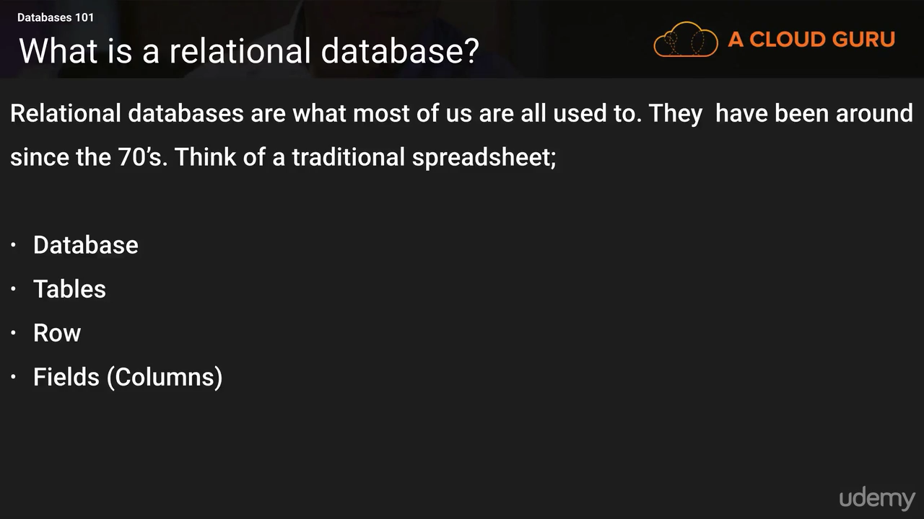**

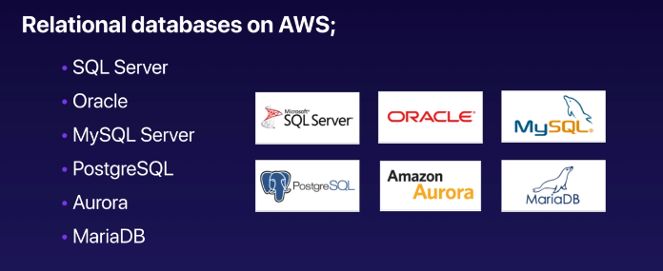

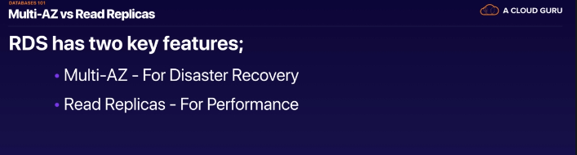

**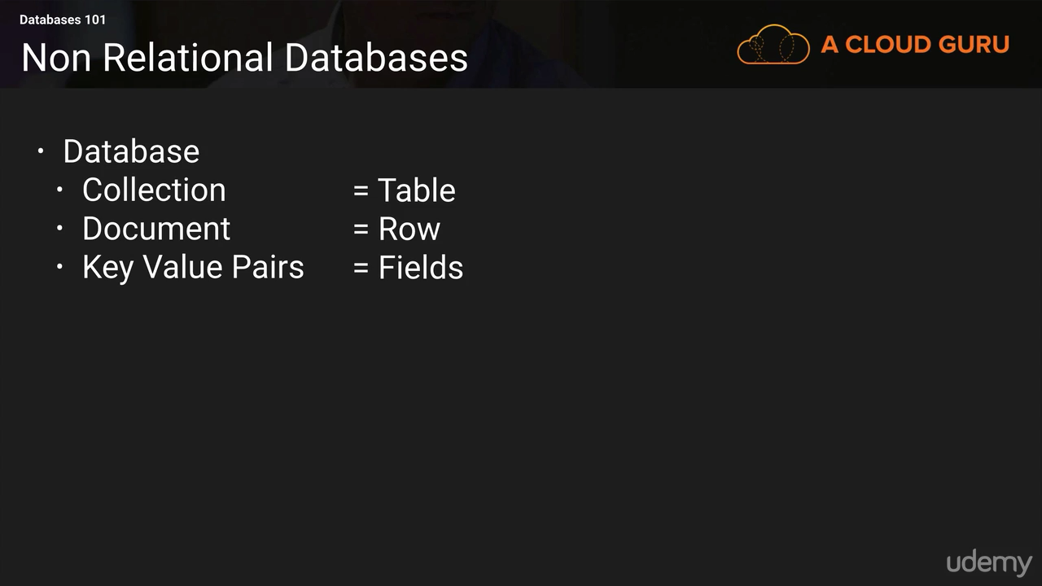**

**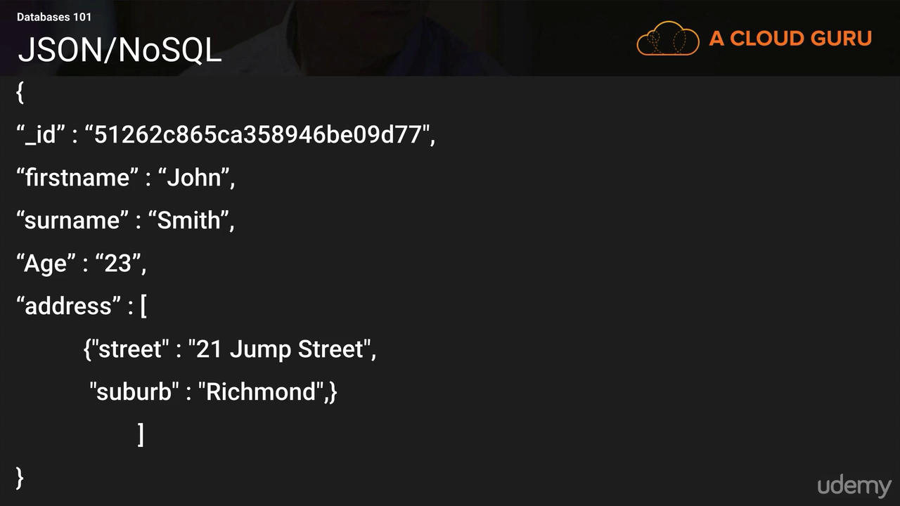**

### Data Warehousing

**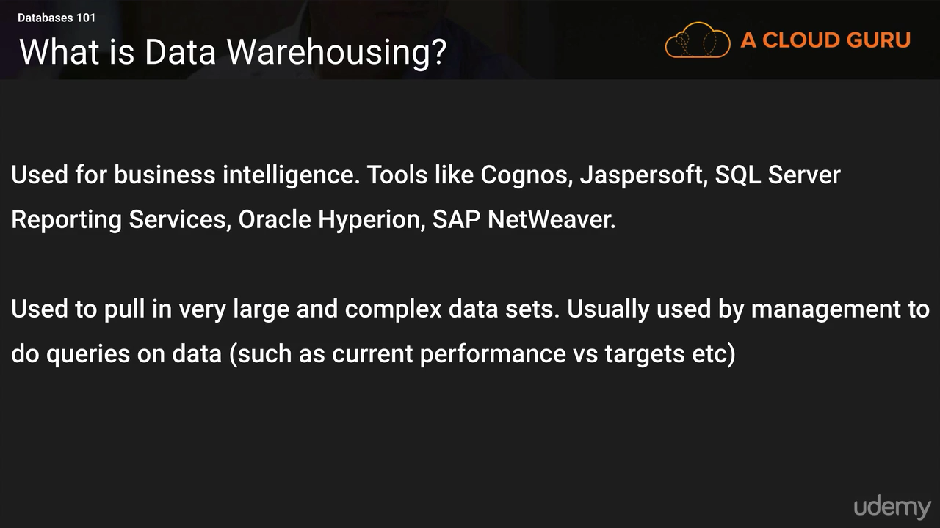**

A data warehouse stores data from multiple sources for analytical purposes

**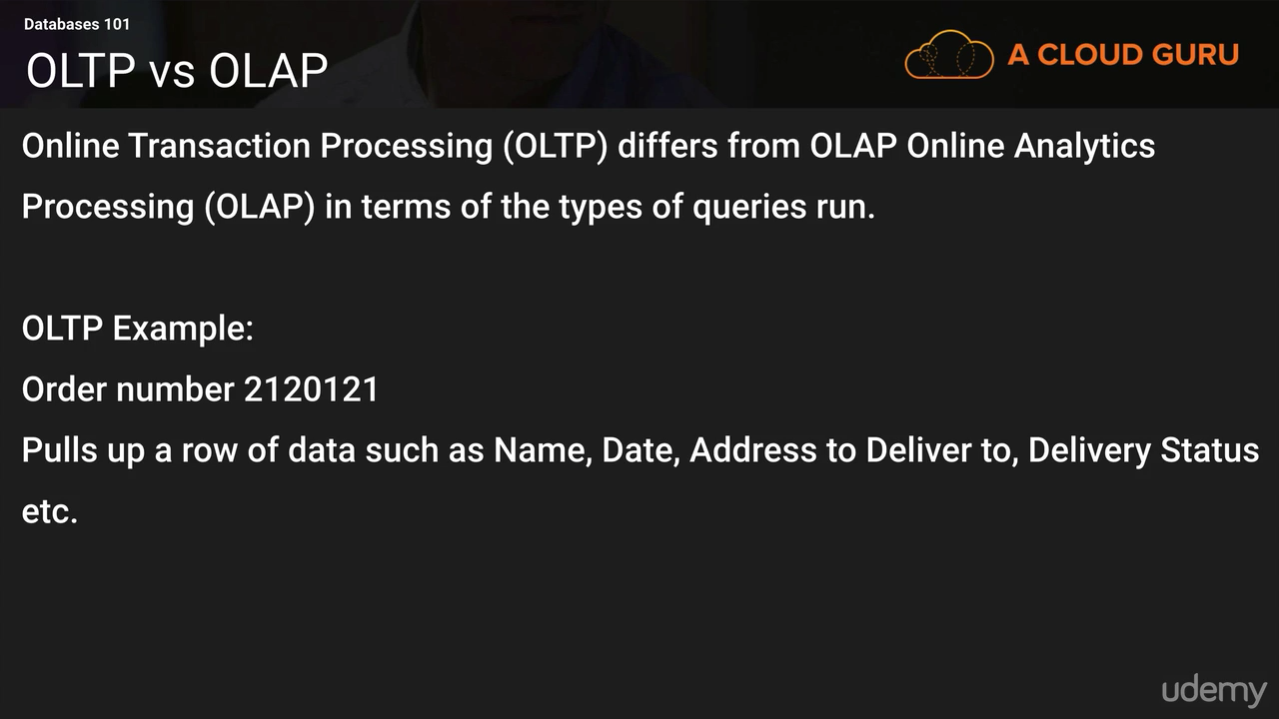**

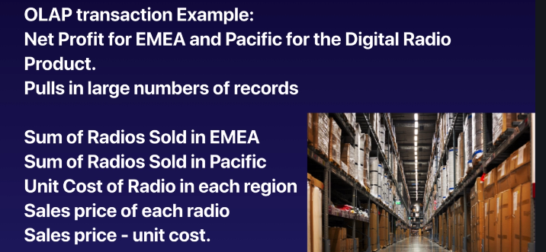

Run on column e,g find me avg of sell of all order from India region

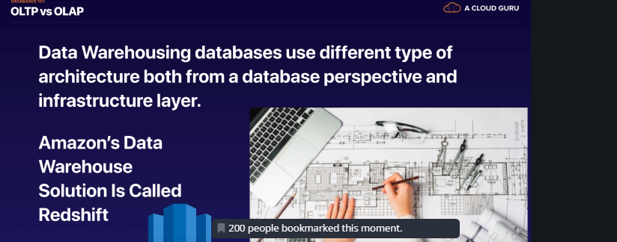

### DMS(Data Migration Service)

**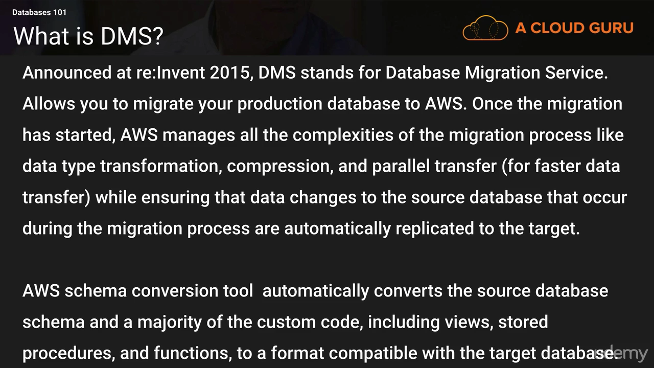**

===========================================================================

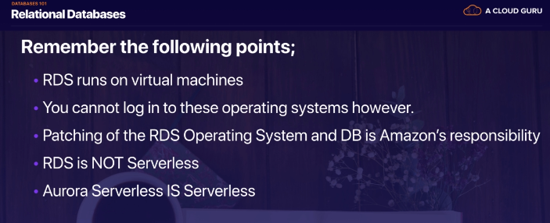

RDS runs on virtual machines,you cant do ssh on that machines

**RDS- Backups, Multi-AZ & Read Replicas**

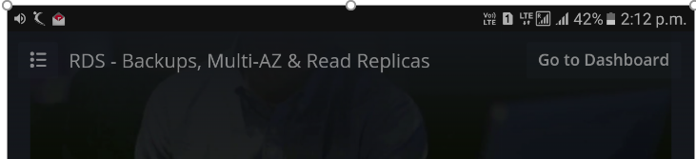

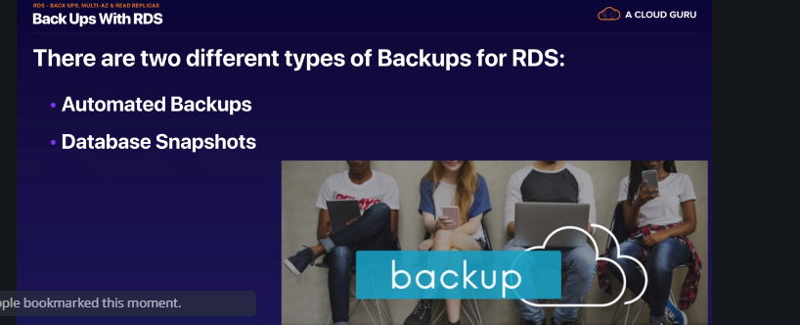

**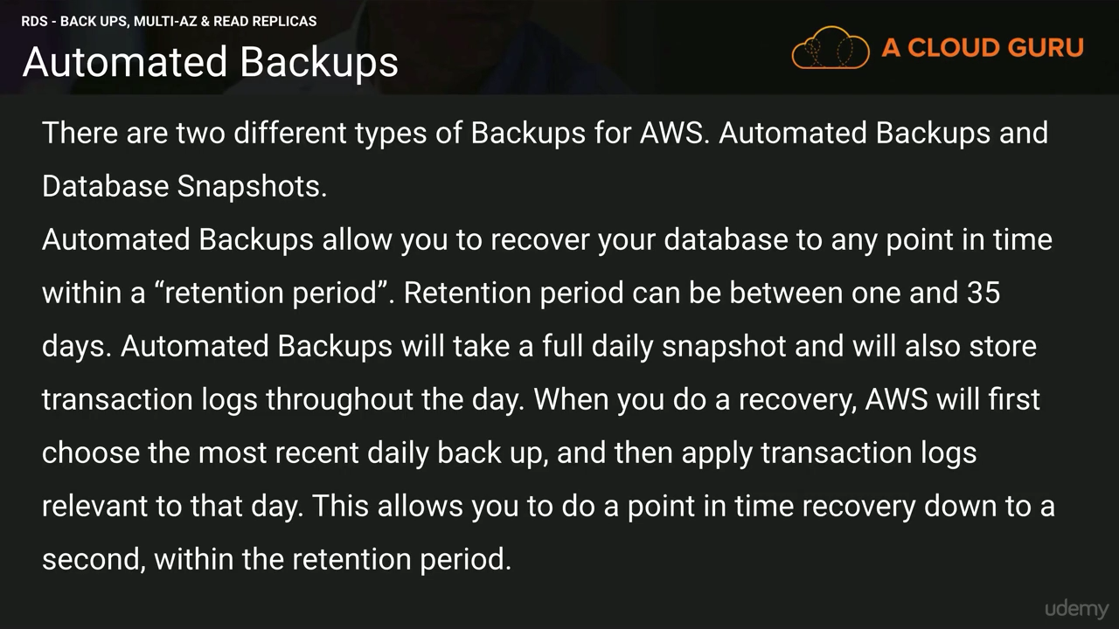**

**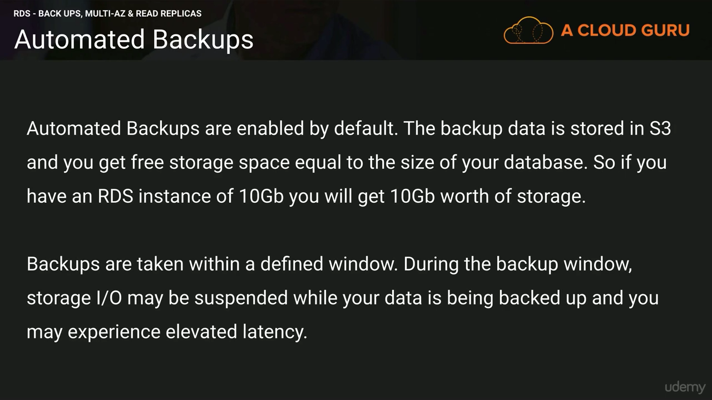**

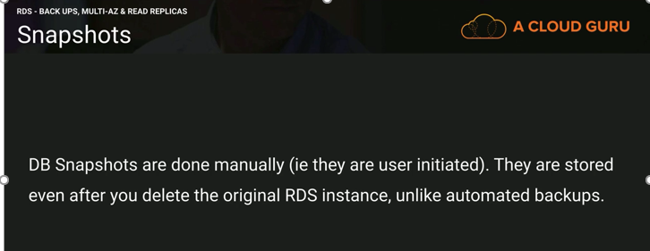

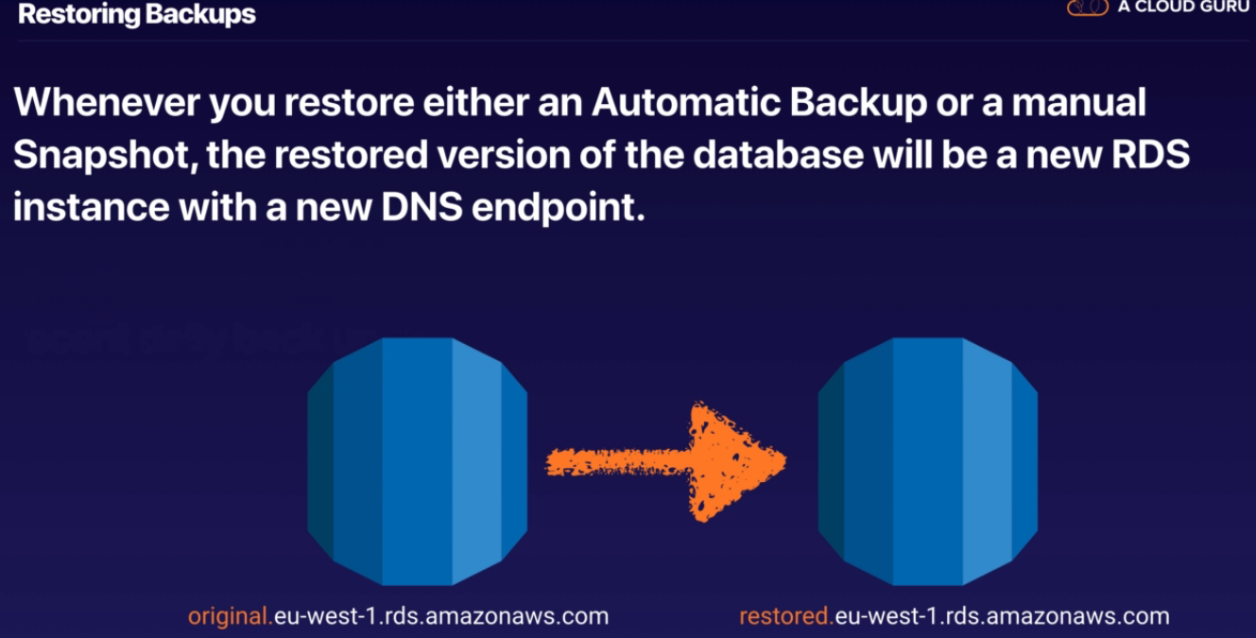

**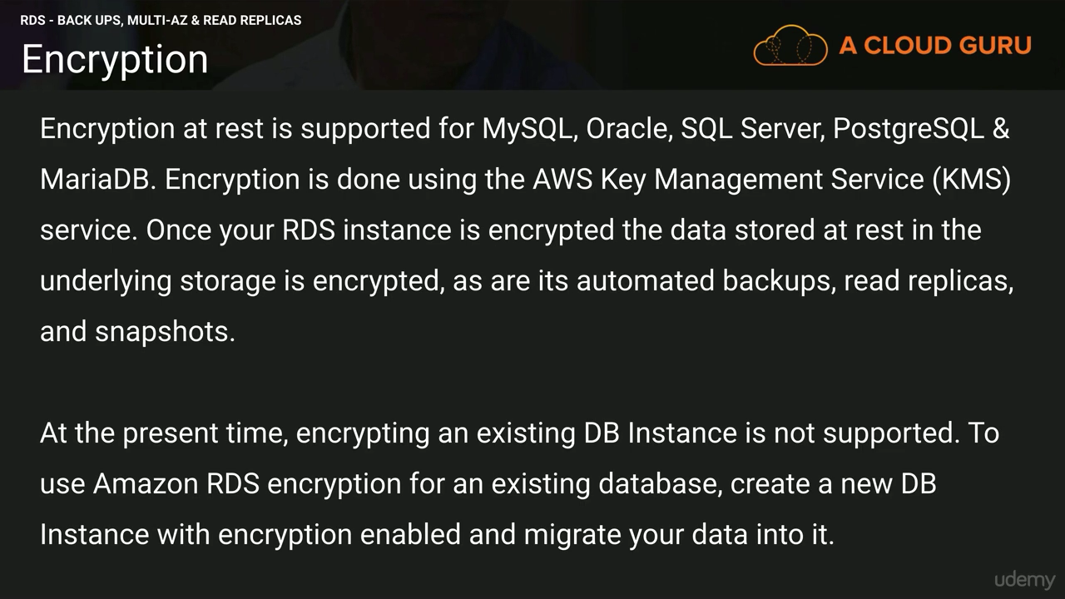**

**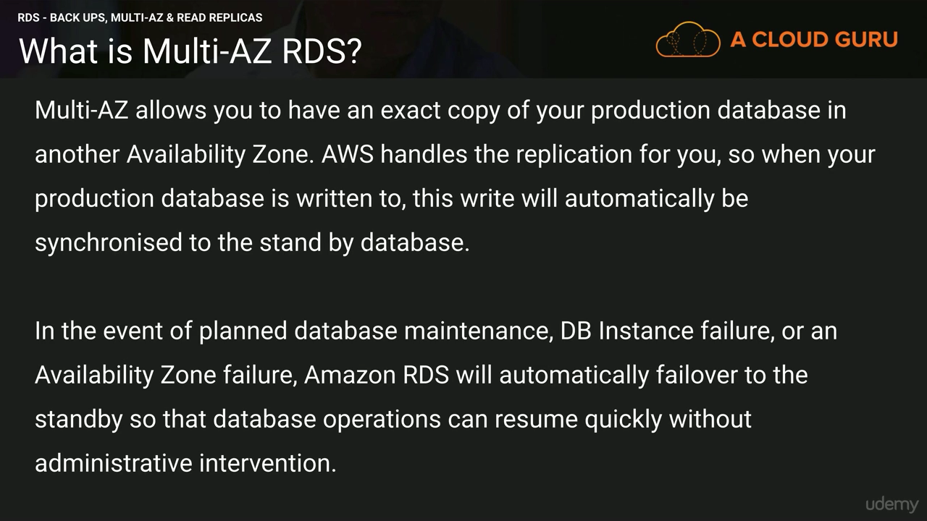**

**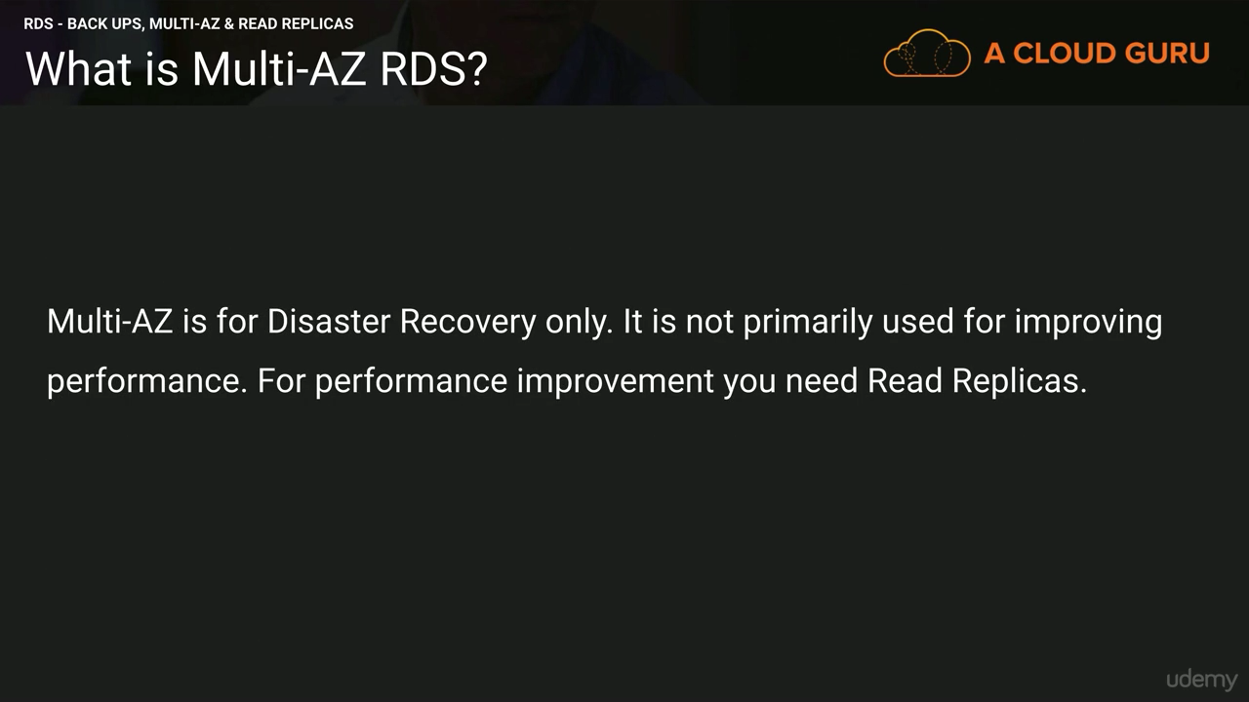**

**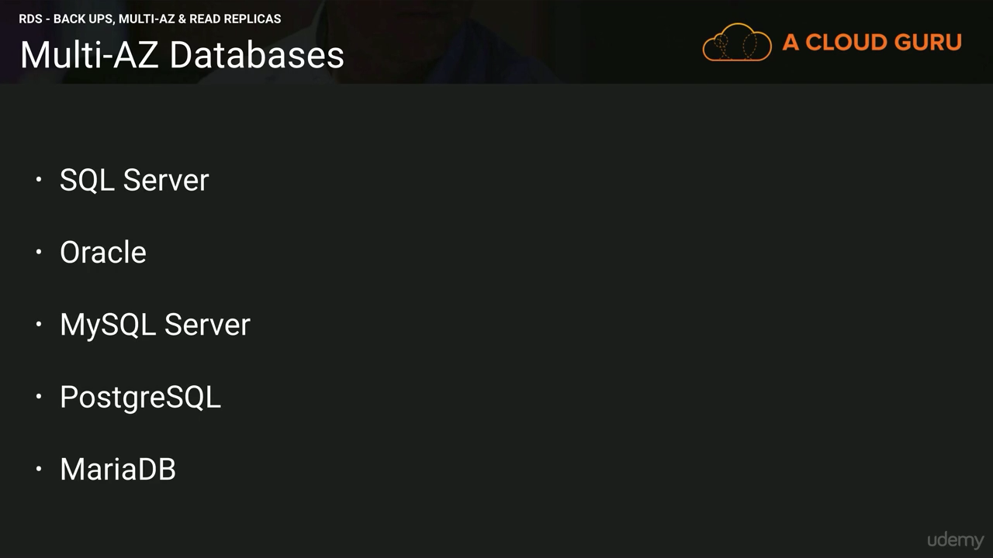**

**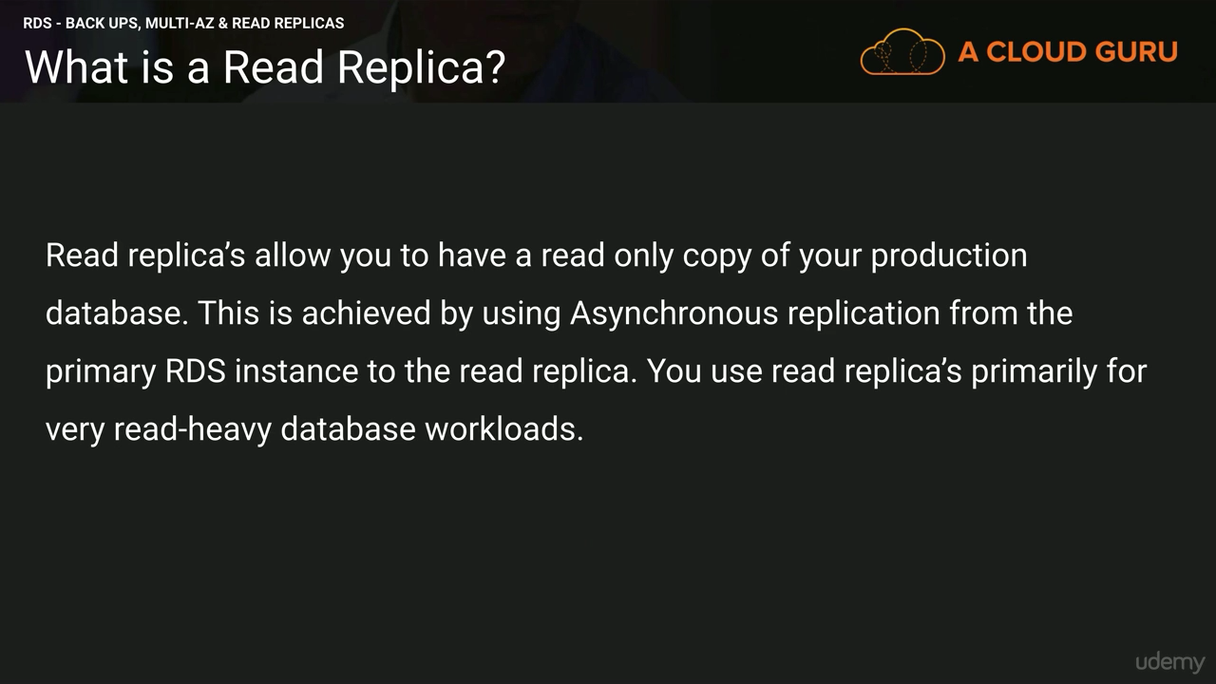**

Asynchronous replication.to make read replica active then backup should be turn on.

**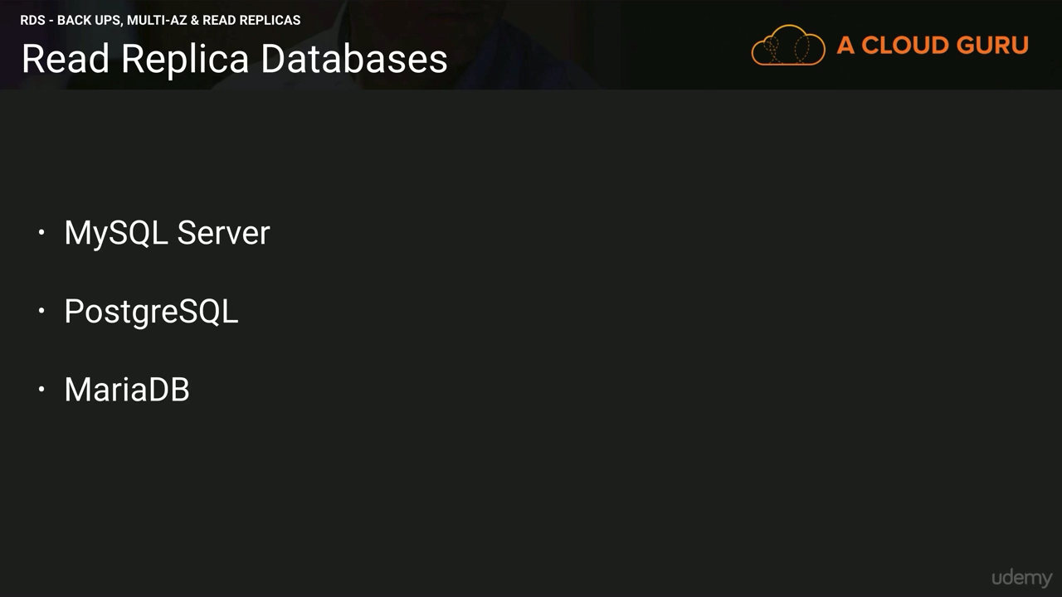**

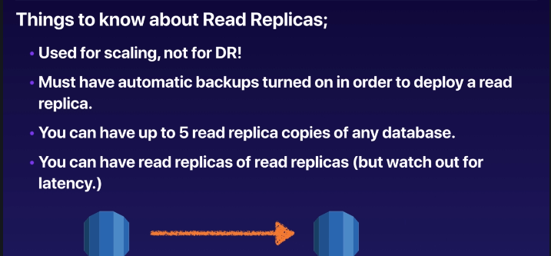

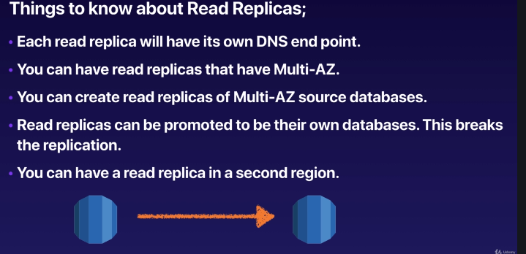

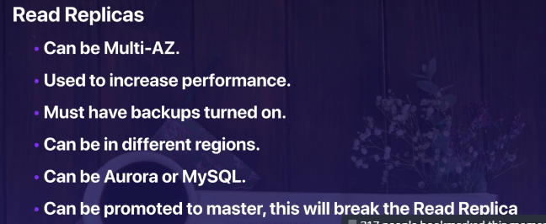

**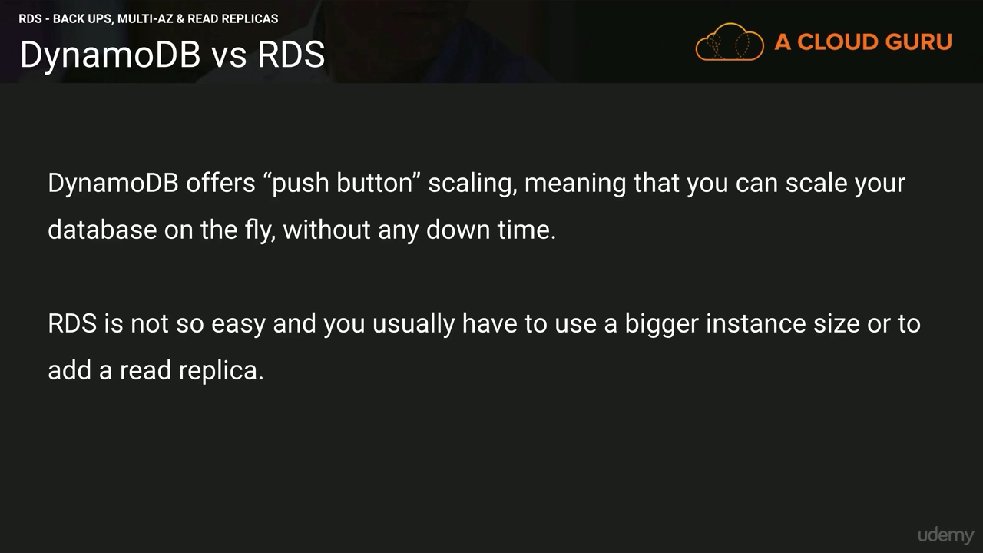**

**RDS for Solutions Architects**

* Read replicas are used for SELECT (=read) only kind of statements (not INSERT, UPDATE, DELETE)
* Amazon RDS supports Transparent Data Encryption for DB encryption:
  + Oracle or SQL Server DB instance only
  + TDE can be used on top of KMS – may affect performance

• IAM Authentication (versus traditional username / password): Works for MySQL, PostgreSQL

* + Lifespan of an authentication token is 15 minutes (short-lived)
  + Tokens are generated by AWS credentials
  + SSL must be used when connecting to the database
  + Easy to use EC2 Instance Roles to connect to the RDS database

### Amazon DynamoDB

Amazon DynamoDB is a fully managed NoSQL database service

DynamoDB allows for the storage of large text and binary objects, but there is a limit of 400 KB.

To help maintain consistent, fast performance levels, all table data is stored on high performance SSD disk drives. Performance metrics, including transactions rates, can be monitored using Amazon CloudWatch. In addition to providing high-performance levels, Amazon DynamoDB also provides automatic high-availability and durability protections by replicating data across multiple Availability Zones within an AWS Region.

Item -🡪 Column

Attribute 🡪 Rows

In a relational database, a table has a predefined schema such as the table name, primary key, list of its column names, and their data types. All records stored in the table must have the same set of columns. In contrast, Amazon DynamoDB only requires that a table have a primary key, but it does not require you to define all of the attribute names and data types in advance.

Applications can connect to the Amazon DynamoDB service endpoint and submit requests over HTTP/S to read and write items to a table or even to create and delete tables.

DynamoDB provides a web service API that accepts requests in JSON format. While you could program directly against the web service API endpoints, most developers choose to use the AWS Software Development Kit (SDK) to interact with their items and tables.

**Amazon DynamoDB Accelerator (DAX)**

Fully managed, in-memory cache for DynamoDB.  
Reduces DynamoDB response times from milliseconds to microseconds.

Amazon DynamoDB Accelerator (DAX) is a fully managed, highly available, in-memory [cache](https://aws.amazon.com/caching/) for [DynamoDB](https://aws.amazon.com/dynamodb/) that delivers up to a 10x performance improvement – from milliseconds to microseconds – even at millions of requests per second. DAX does all the heavy lifting required to add in-memory acceleration to your DynamoDB tables, without requiring developers to manage cache invalidation, data population, or cluster management. Now you can focus on building great applications for your customers without worrying about performance at scale. You do not need to modify application logic, since DAX is compatible with existing DynamoDB API calls. You can enable DAX with just a few clicks in the AWS Management Console or using the AWS SDK. Just as with DynamoDB, you only pay for the capacity you provision

**Data Types**

1. Scalar Data Types

A scalar type represents exactly one value. Amazon DynamoDB supports the following five scalar types:

-String Text and variable length characters up to 400KB. Supports Unicode with UTF8 encoding

-Number Positive or negative number with up to 38 digits of precision

-Binary Binary data, images, compressed objects up to 400KB in size

-Boolean Binary flag representing a true or false value

- Null Represents a blank, empty, or unknown state. String, Number, Binary, Boolean cannot be empty.

1. Set Data Types

Sets are useful to represent a unique list of one or more scalar values. Each value in a set needs to be unique and must be the same data type. Sets do not guarantee order. Amazon DynamoDB supports three set types:

-String Set Unique list of String attributes

-Number Set Unique list of Number attributes

- Binary Set Unique list of Binary attributes

1. Document Data Types

Document type is useful to represent multiple nested attributes, similar to the structure of a JSON file. Amazon DynamoDB supports two document types: List and Map. Multiple Lists and Maps can be combined and nested to create complex structures.

-List Each List can be used to store an ordered list of attributes of different data types.

-Map Each Map can be used to store an unordered list of key/value pairs. Maps can be used to represent the structure of any JSON object.

**Provisioned Capacity**

You can use Amazon CloudWatch to monitor your Amazon DynamoDB capacity and make scaling decisions. There is a rich set of metrics, including ConsumedReadCapacityUnits and ConsumedWriteCapacityUnits. If you do exceed your provisioned capacity for a period of time, requests will be throttled and can be retried later. You can monitor and alert on the ThrottledRequests metric using Amazon CloudWatch to notify you of changing usage patterns.

**Read And Write Items**

API actions

1. Putitem
2. Updateitem
3. Deleteitem
4. getitem

**Batch Operations**

1. BatchGetItem
2. BatchWriteItem(25Items)

**Searching Items**

For most operations, performing a Query operation instead of a Scan operation will be the most efficient option. Performing a Scan operation will result in a full scan of the entire table or secondary index, then it filters out values to provide the desired result. Use a Query operation when possible and avoid a Scan on a large table or index for only a small number of items.

**Scaling and Partitioning**

You can create tables that can scale up to hold a virtually unlimited number of items with consistent low-latency performance. An Amazon DynamoDB table can scale horizontally through the use of partitions to meet the storage and performance requirements of your application.

To maximize Amazon DynamoDB throughput, create tables with a partition key that has a large number of distinct values and ensure that the values are requested fairly uniformly. Adding a random element that can be calculated or hashed is one common technique to improve partition distribution.

**Security**

1. IAM
2. For mobile applications, a best practice is to use a combination of web identity federation with the AWS Security Token Service (AWS STS) to issue temporary keys that expire after a short period.

**Amazon DynamoDB Streams**

keep track of recent changes to synchronize two tables or update a dashboard

**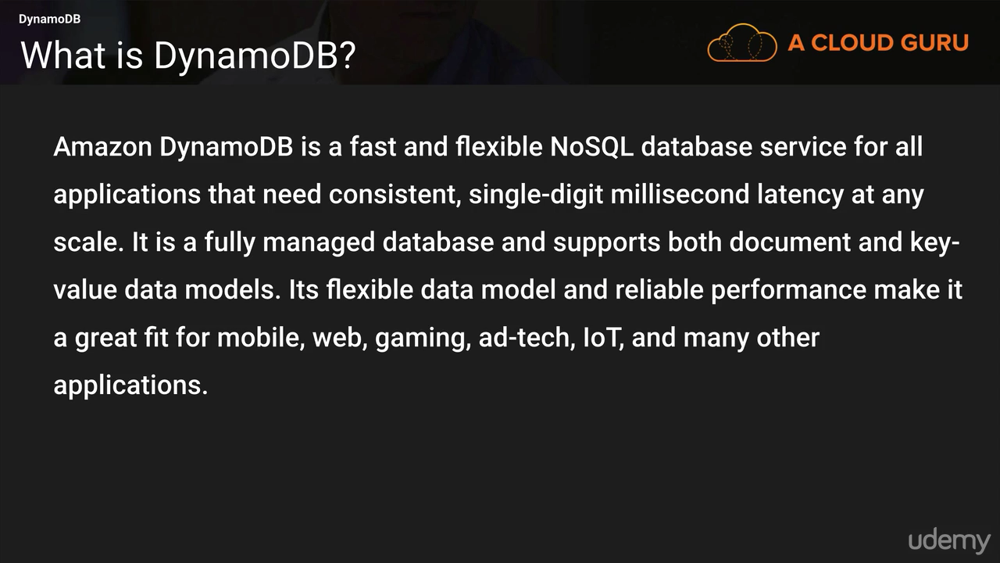**

**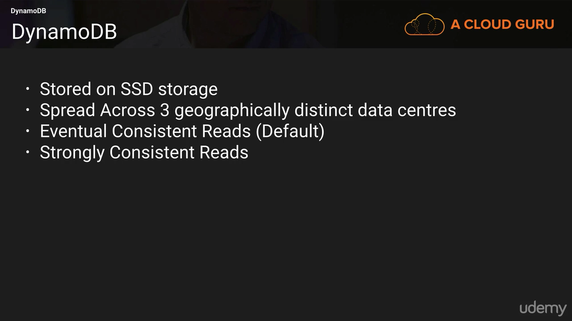**

Stored on SDD storage

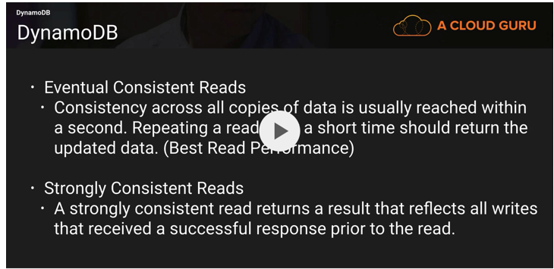

**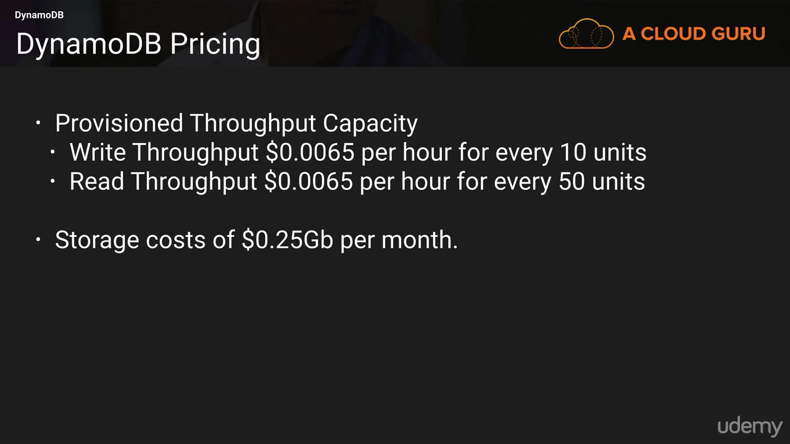**

**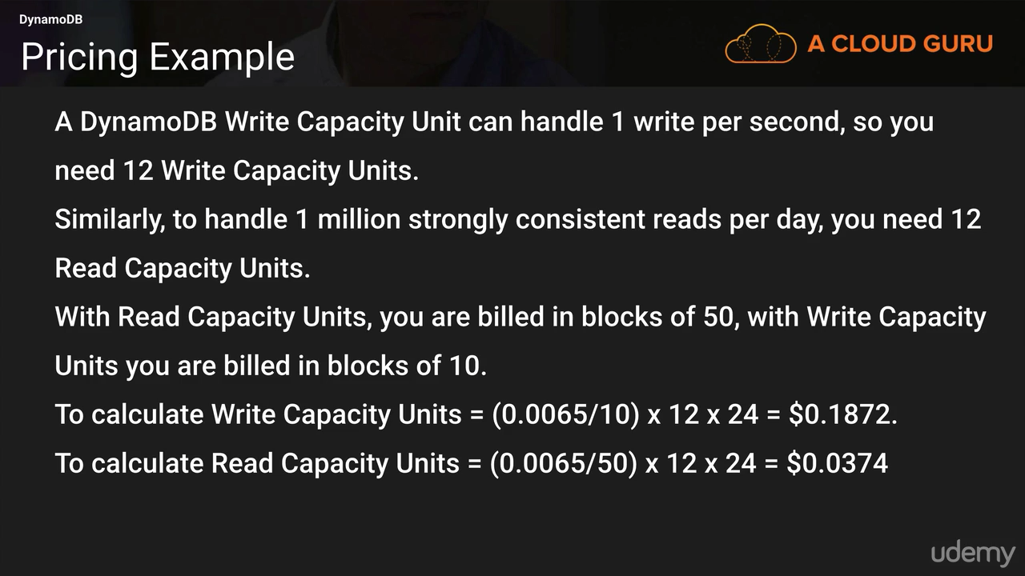**

### Redshift

**Enhanced VPC Routing** supports the use of standard **VPC** features such as **VPC** Endpoints, security groups, network ACLs, managed NAT and internet gateways, enabling you to tightly manage the flow of data between your Amazon **Redshift** cluster and all of your data sources.

The key component of an Amazon Redshift data warehouse is a cluster. A cluster is composed of a leader node and one or more compute nodes. The client application interacts directly only with the leader node, and the compute nodes are transparent to external applications.

Amazon Redshift currently has support for six different node types and each has a different mix of CPU, memory, and storage. The six node types are grouped into two categories: Dense Compute and Dense Storage. The Dense Compute node types support clusters up to 326TB using fast SSDs, while the Dense Storage nodes support clusters up to 2PB using large magnetic disks. Each cluster consists of one leader node and one or more compute nodes. Figure 7.2 shows the internal components of an Amazon Redshift data warehouse cluster.

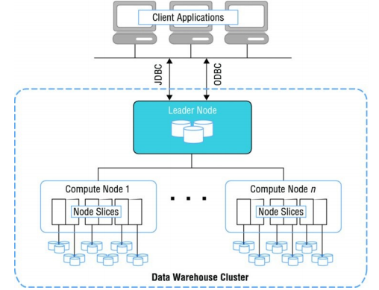

Each cluster contains one or more databases. User data for each table is distributed across the compute nodes. Your application or SQL client communicates with Amazon Redshift using standard JDBC or ODBC connections with the leader node, which in turn coordinates query execution with the compute nodes. Your application does not interact directly with the compute nodes. The disk storage for a compute node is divided into a number of slices. The number of slices per node depends on the node size of the cluster and typically varies between 2 and 16. The nodes all participate in parallel query execution, working on data that is distributed as evenly as possible across the slices. You can increase query performance by adding multiple nodes to a cluster. When you submit a query, Amazon Redshift distributes and executes the query in parallel across all of a cluster’s compute nodes. Amazon Redshift also spreads your table data across all compute nodes in a cluster based on a distribution strategy that you specify. This partitioning of data across multiple compute resources allows you to achieve high levels of performance. Amazon Redshift allows you to resize a cluster to add storage and compute capacity over time as your needs evolve. You can also change the node type of a cluster and keep the overall size the same. Whenever you perform a resize operation, Amazon Redshift will create a new cluster and migrate data from the old cluster to the new one. During a resize operation, the database will become read-only until the operation is finished.

**Compression Encoding**

One of the key performance optimizations used by Amazon Redshift is data compression. When loading data for the first time into an empty table, Amazon Redshift will automatically sample your data and select the best compression scheme for each column. Alternatively, you can specify compression encoding on a per-column basis as part of the CREATE TABLE command.

**Distribution Strategy**

One of the primary decisions when creating a table in Amazon Redshift is how to distribute the records across the nodes and slices in a cluster.

you can choose between one of three distribution styles: EVEN, KEY, or ALL.

1. EVEN distribution

This is the default option and results in the data being distributed across the slices in a uniform fashion regardless of the data.

1. KEY distribution

With KEY distribution, the rows are distributed according to the values in one column. The leader node will store matching values close together and increase query performance for joins.

1. ALL distribution

With ALL, a full copy of the entire table is distributed to every node. This is useful for lookup tables and other large tables that are not updated frequently.

**Loading Data**

A COPY command can load data into a table in the most efficient manner, and it supports multiple types of input data sources. The fastest way to load data into Amazon Redshift is doing bulk data loads from flat files stored in an Amazon Simple Storage Service (Amazon S3) bucket or from an Amazon DynamoDB table.

Data can also be exported out of Amazon Redshift using the UNLOAD command. This command can be used to generate delimited text files and store them in Amazon S3.

**Snapshots**

Similar to Amazon RDS, you can create point-in-time snapshots of your Amazon Redshift cluster. A snapshot can then be used to restore a copy or create a clone of your original Amazon Redshift cluster. Snapshots are durably stored internally in Amazon S3 by Amazon Redshift. Amazon Redshift supports both automated snapshots and manual snapshots. With automated snapshots, Amazon Redshift will periodically take snapshots of your cluster and keep a copy for a configurable retention period. You can also perform manual snapshots and share them across regions or even with other AWS accounts. Manual snapshots are retained until you explicitly delete them.

**Security**

Perform security using

1. IAM
2. Network Level

deployed within the private IP address space of your Amazon VPC to restrict overall network connectivity. Fine-grained network access can be further restricted using security groups and network ACLs at the subnet level.

1. infrastructure level

you must protect access at the database level. create a master user account and password.

1. Amazon Redshift supports encryption of data

in transit using SSL-encrypted connections, and also encryption of data at rest using multiple techniques.

To encrypt data at rest, Amazon Redshift integrates with KMS and AWS CloudHSM for encryption key management services.

Encryption at rest and in transit assists in meeting compliance requirements, such as for the Health Insurance Portability and Accountability Act (HIPAA) or the Payment Card Industry Data Security Standard (PCI DSS), and provides additional protections for your data.

**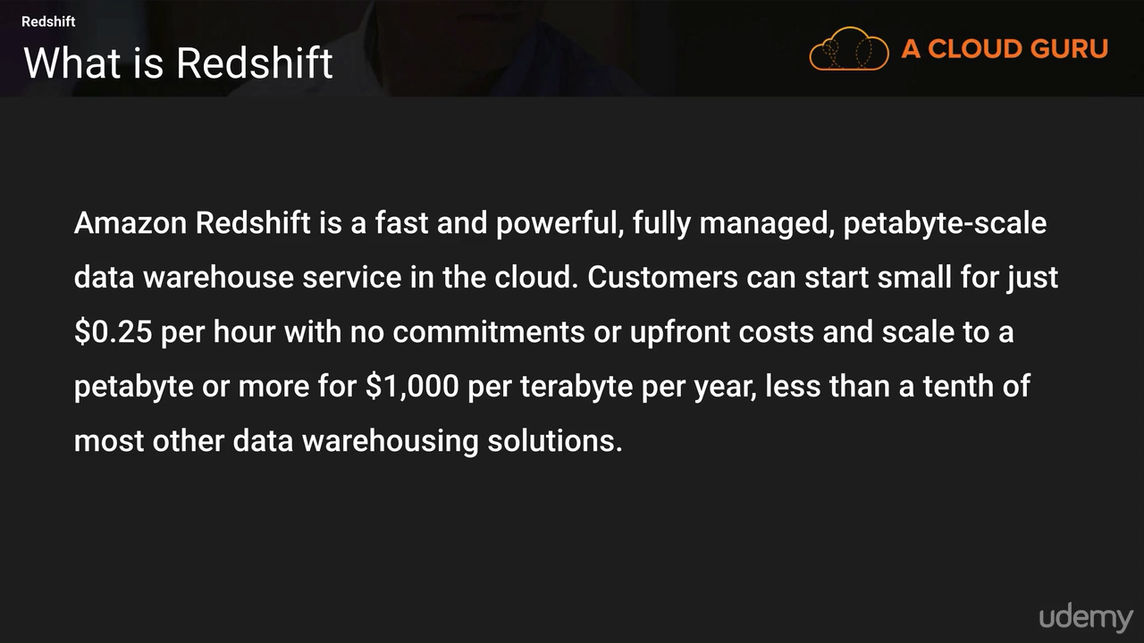**

Column base storage so analytical queries run fast and save data upto 1.5 PB.

BI works well with Redshift. Not spread across Multiple AZ zones but you can create the snapshot and copy it to the other servers.

**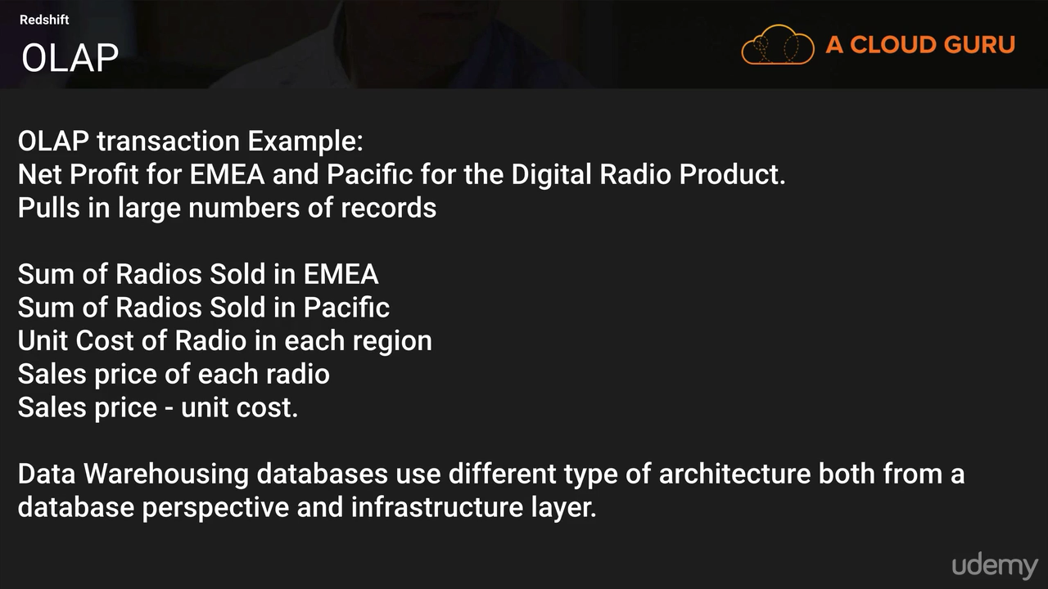**

**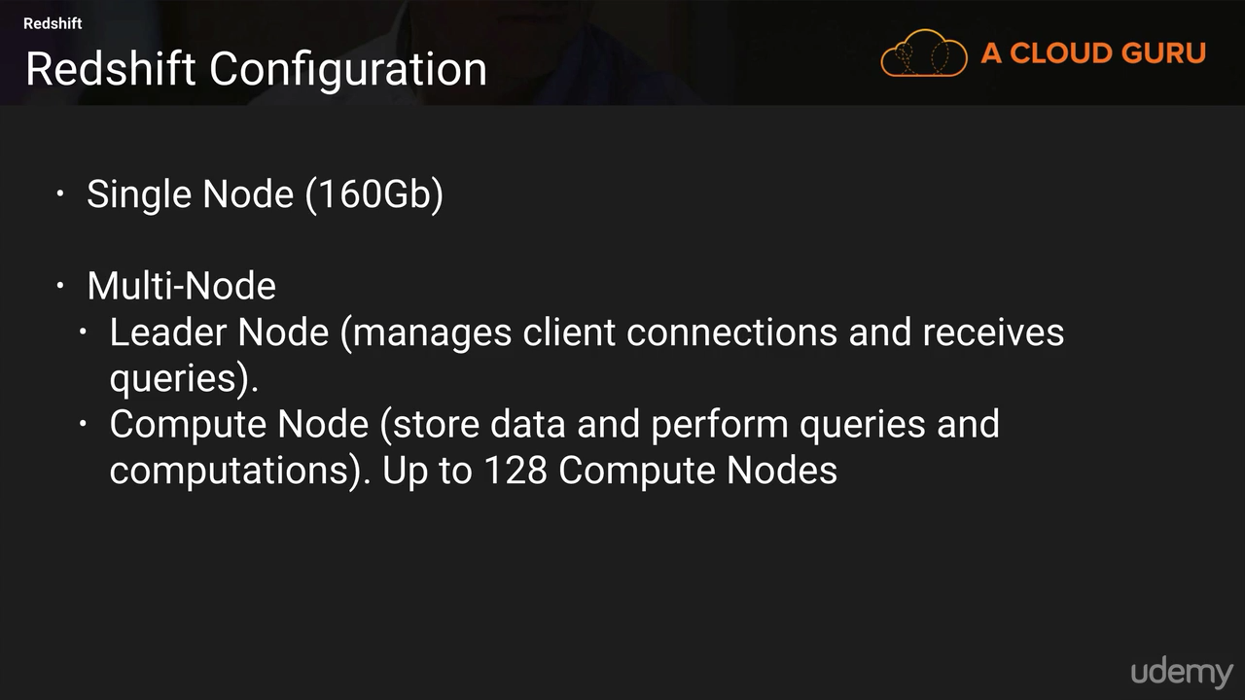**

**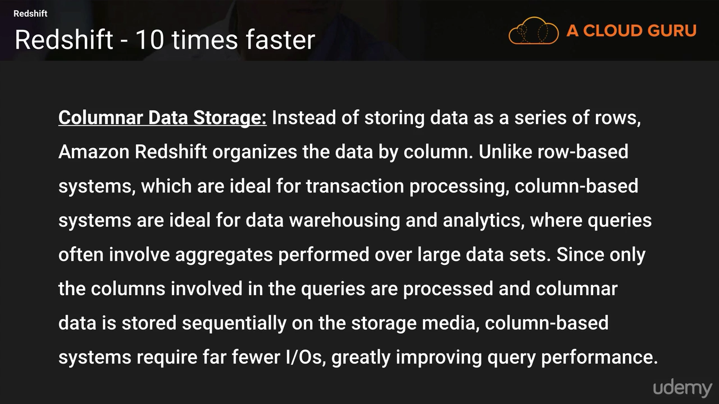**

**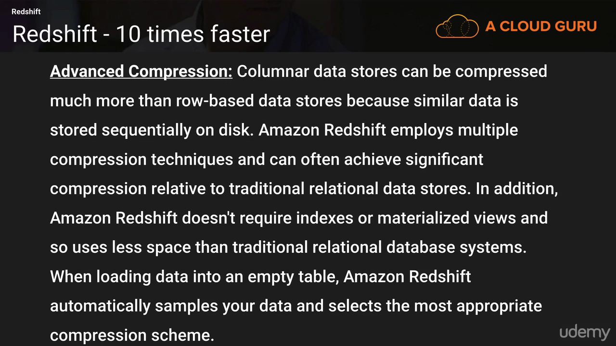**

**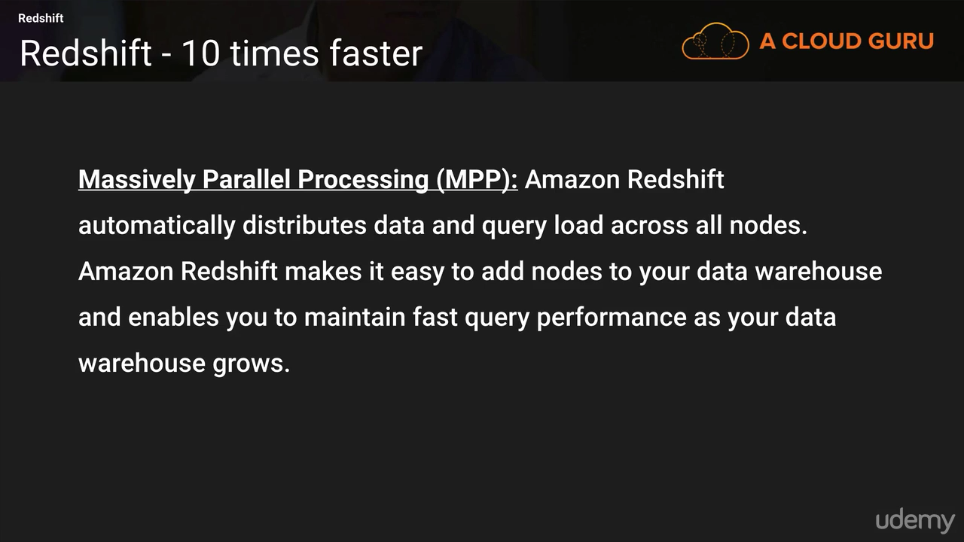**

**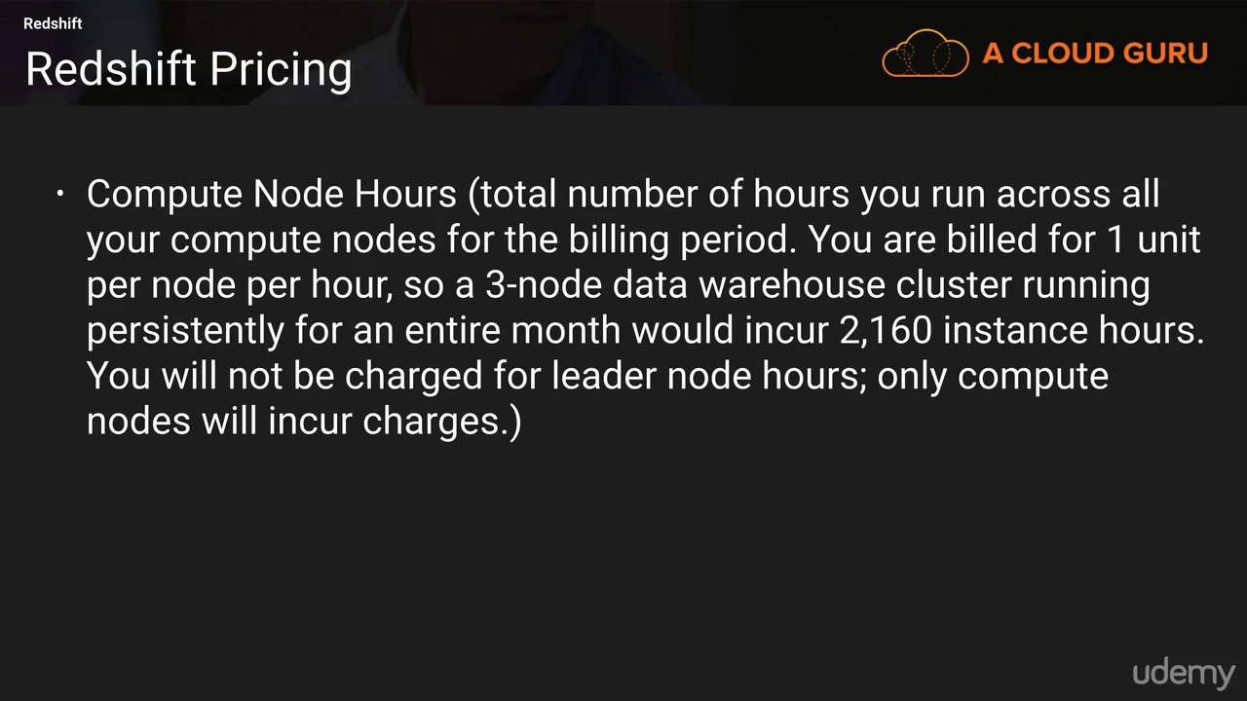**

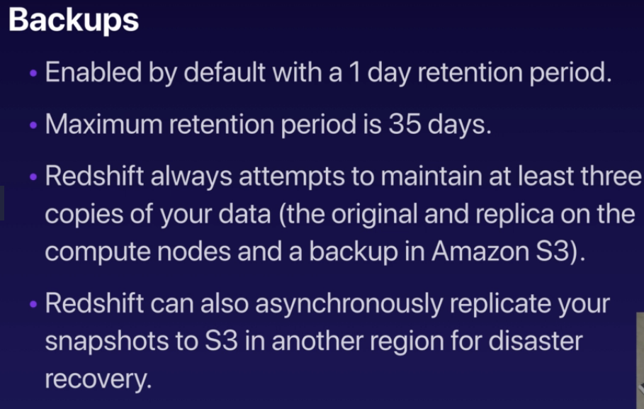

**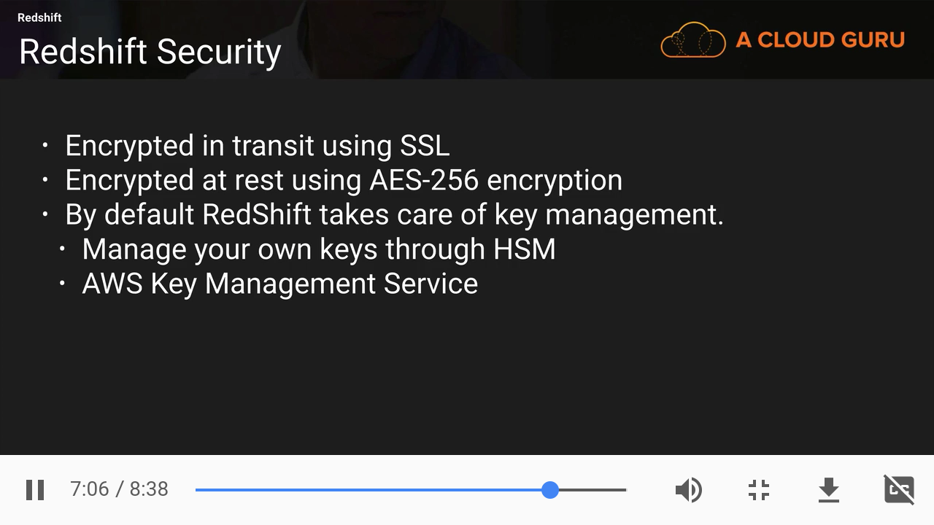**

**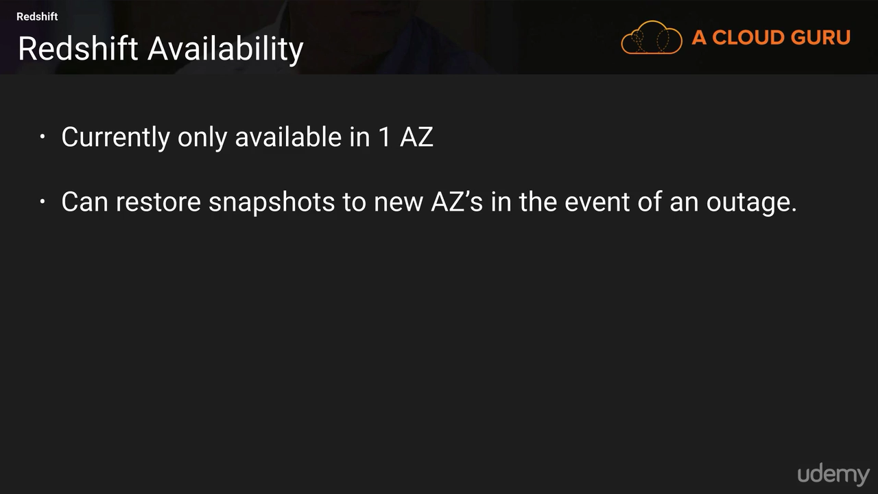**

### Elasticache

**Cache Engines**

* The same way RDS is to get managed Relational Databases…
* ElastiCache is to get managed Redis or Memcached
* Caches are in-memory databases with really high performance, low latency
* Helps reduce load off of databases for read intensive workloads
* Helps make your application stateless
* Write Scaling using sharding
* Read Scaling using Read Replicas
* Multi AZ with Failover Capability
* AWS takes care of OS maintenance / patching, optimizations, setup, configuration, monitoring, failure recovery and backups

**ElastiCache Solution Architecture - DB Cache**

* Applications queries ElastiCache, if not available, get from RDS and store in ElastiCache.
* Helps relieve load in RDS
* Cache must have an invalidation strategy to make sure only the most current data is used in there.

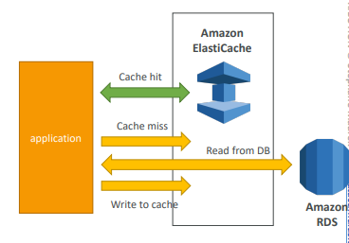

**ElastiCache Solution Architecture – User Session Store**

* User logs into any of the application
* The application writes the session data into ElastiCache
* The user hits another instance of our application
* The instance retrieves the data and the user is already logged in

1. **Memcached**

* Memcached is an in-memory object store
* Cache doesn’t survive reboots
* Use cases:
  + Quick retrieval of objects from memory
  + Cache often accessed objects
* Overall, Redis has largely grown in popularity and has better feature sets than Memcached.
* I would personally only use Redis for caching needs. • AWS exam wouldn’t ask if Redis or Memcached is better. Just “ElastiCache” in general

Memcached provides a very simple interface that allows you to write and read objects into in-memory key/value data stores. With Amazon ElastiCache, you can elastically grow and shrink a cluster of Memcached nodes to meet your demands. You can partition your cluster into shards and support parallelized operations for very high performance throughput. Memcached deals with objects as blobs that can be retrieved using a unique key. What you put into the object is up to you, and it is typically the serialized results from a database query. This could be simple string values or binary data

1. **Redis**

* Redis is an in-memory key-value store
* Super low latency (sub ms)
* Cache survive reboots by default (it’s called persistence)
* Great to host
  + User sessions
  + Leaderboard (for gaming)
  + Distributed states
  + Relieve pressure on databases (such as RDS)
  + Pub / Sub capability for messaging
* Multi AZ with Automatic Failover for disaster recovery if you don’t want to lose your cache data
* Support for Read Replicas

Unlike Memcached, Redis supports the ability to persist the in-memory data onto disk. This allows you to create snapshots that back up your data and then recover or replicate from the backups. Redis clusters also can support up to five read replicas to offload read requests. In the event of failure of the primary node, a read replica can be promoted and become the new master using Multi-AZ replication groups

**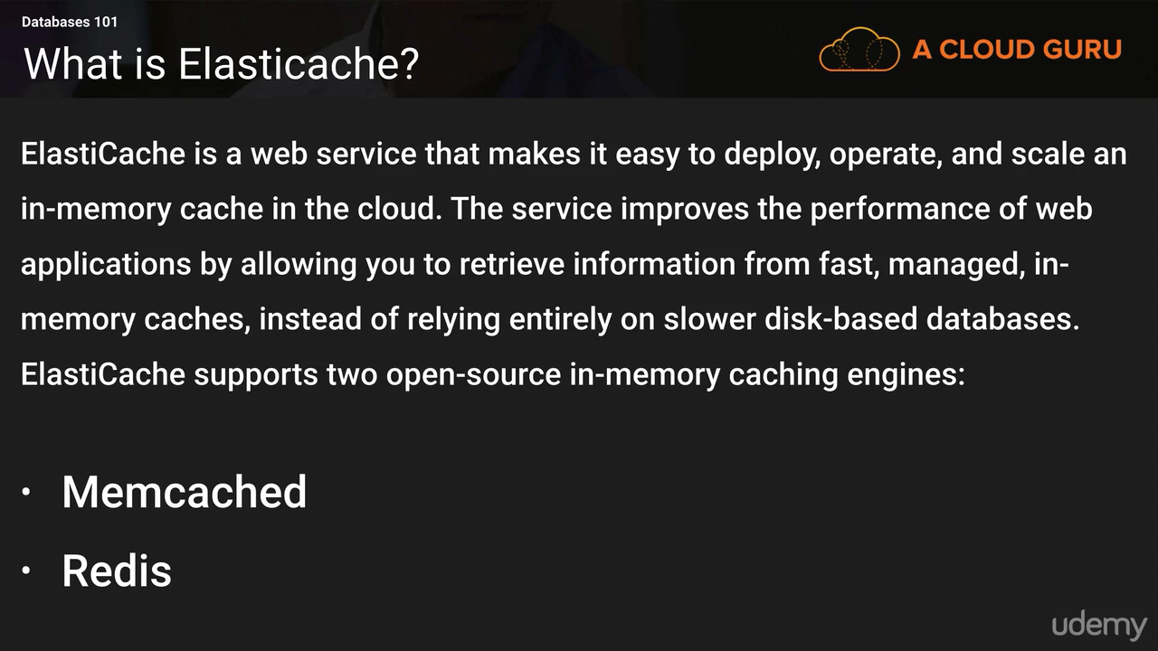**

**Redshift is used for BI or Data Warehousing and Elastic cache is used to speed up performance of existing databases(Frequent Identical Queris)**

**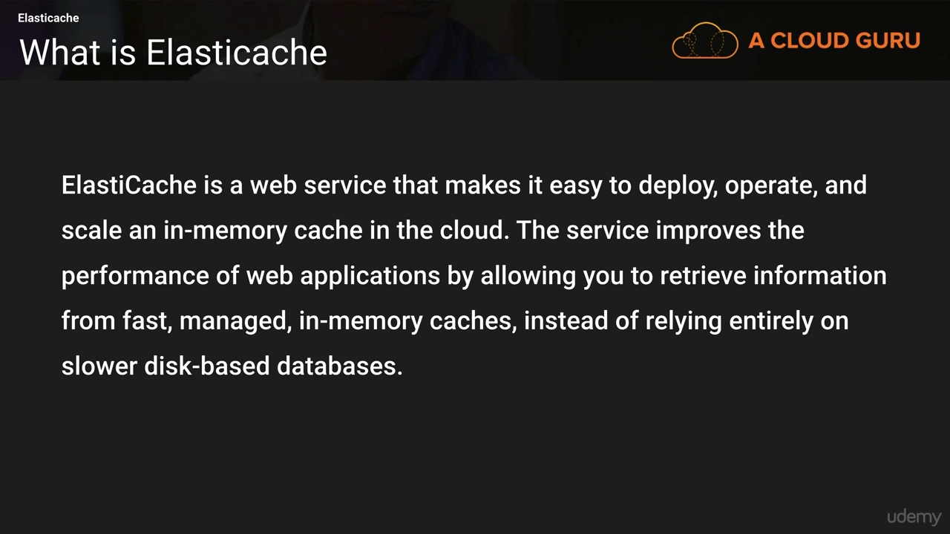**

**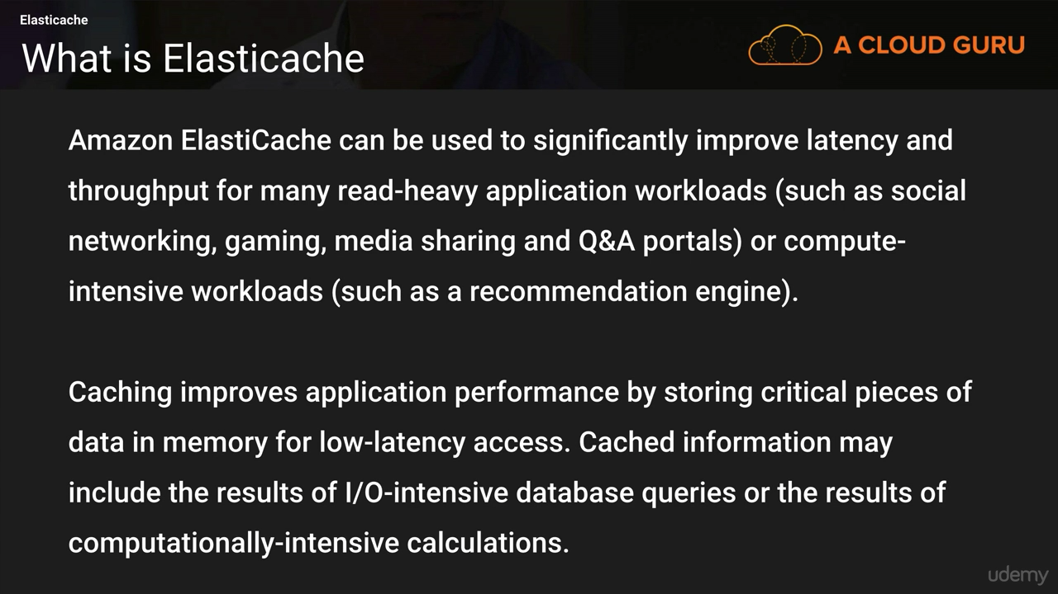**

**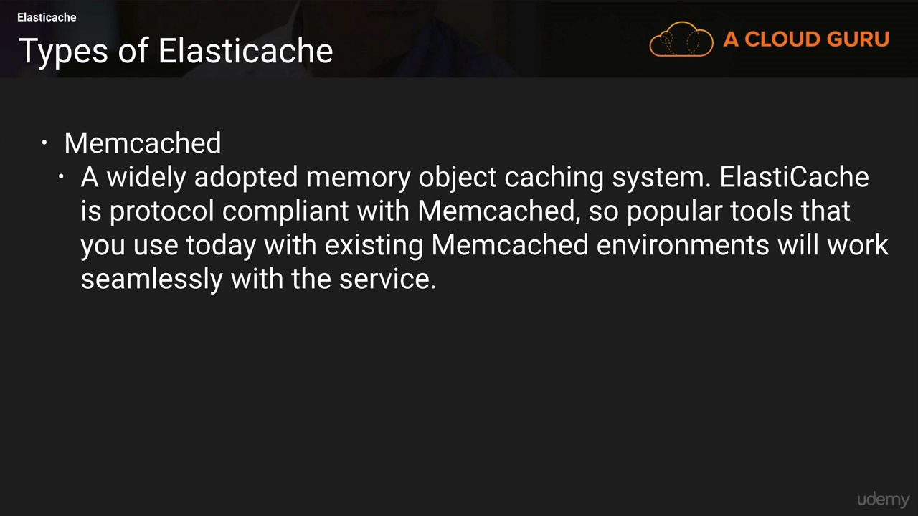**

**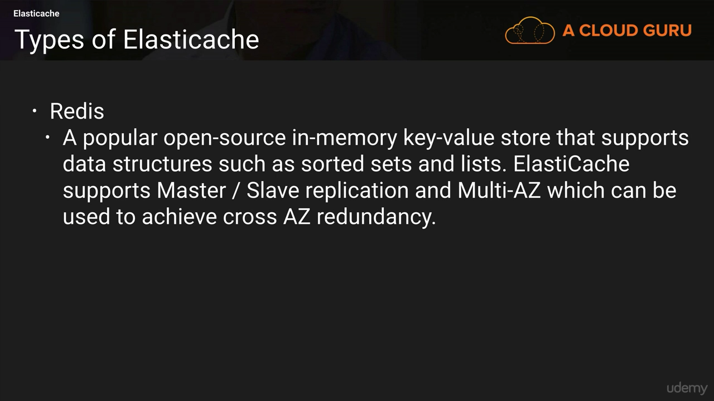**

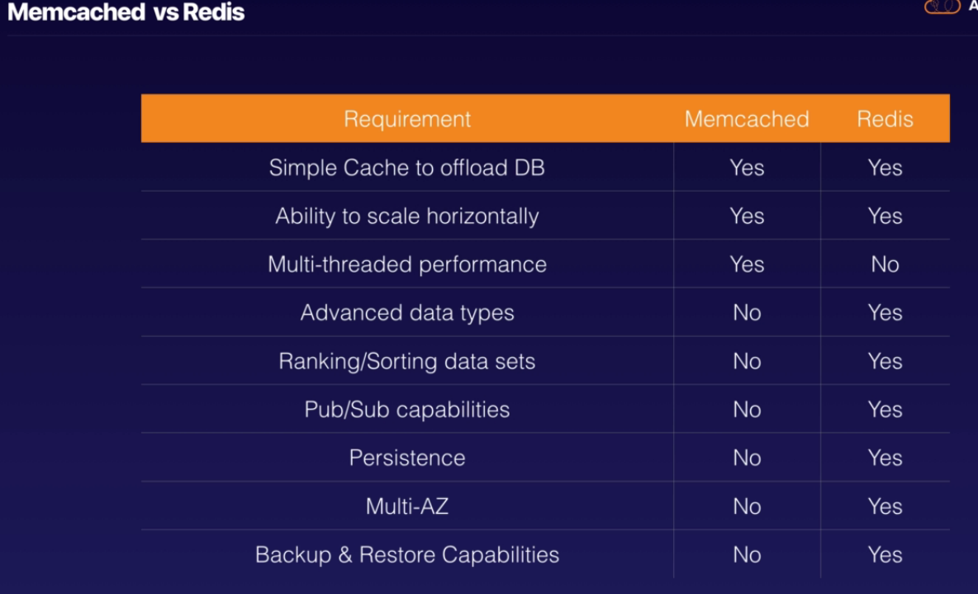

**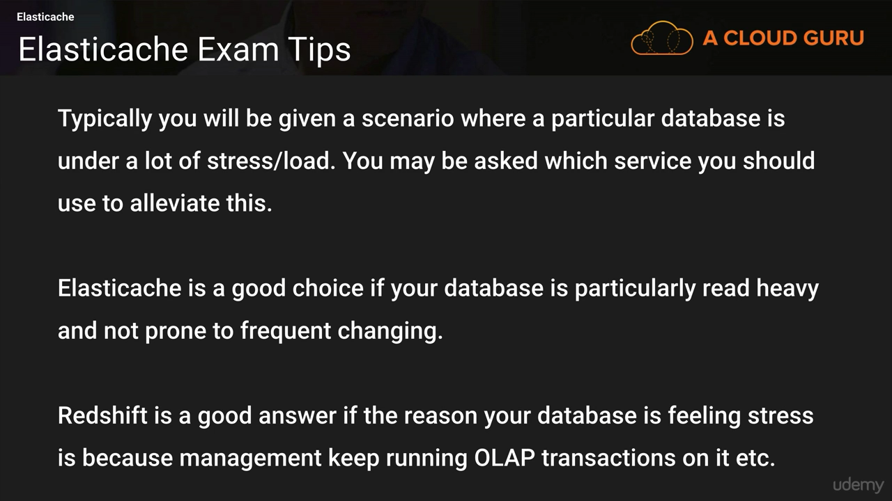**

**ElastiCache for Solutions Architects**

* Security:
  + Redis support Redis AUTH (username / password)
  + SSL in-flight encryption must be enabled and used
  + Memcached support SASL authentication (advanced)
  + **None of the caches support IAM authentication**
  + IAM policies on ElastiCache are only used for AWS API-level security
* Patterns for ElastiCache:
  + Lazy Loading: all the read data is cached, data can become stale in cache
  + Write Through: Adds or update data in the cache when written to a DB (no stale data)
  + Session Store: store temporary session data in a cache (using TTL features)
* Quote: There are only two hard things in Computer Science: cache invalidation and naming things

**Nodes and Clusters**

Each deployment of Amazon ElastiCache consists of one or more nodes in a cluster.

A single Memcached cluster can contain up to 20 nodes. Redis clusters are always made up of a single node; however, multiple clusters can be grouped into a Redis replication group.

**Design for Failure**

While it is unlikely, you should plan for the potential failure of an individual cache node. For Memcached clusters, you can decrease the impact of the failure of a cache node by using a larger number of nodes with a smaller capacity, instead of a few large nodes

**Scaling**

Amazon ElastiCache allows you to adjust the size of your environment to meet the needs of workloads as they evolve over time

Horizontal Scaling

Amazon ElastiCache also adds additional functionality that allows you to scale horizontally the size of your cache environment. This functionality differs depending on the cache engine you have selected.

With Memcached, you can partition your data and scale horizontally to 20 nodes or more.

A Redis cluster consists of a single cache node that is handling read and write transactions. Additional clusters can be created and grouped into a Redis replication group. While you can only have one node handling write commands, you can have up to five read replicas handling read-only requests.

Vertical Scaling

Support for vertical scaling is more limited with Amazon ElastiCache. If you like to change the cache node type and scale the compute resources vertically, the service does not directly allow you to resize your cluster in this manner. You can, however, quickly spin up a new cluster with the desired cache node types and start redirecting traffic to the new cluster. It’s important to understand that a new Memcached cluster always starts empty, while a Redis cluster can be initialized from a backup.

**Replication and Multi-AZ**

It’s important to keep in mind that replication between the clusters is performed asynchronously and there will be a small delay before data is available on all cluster nodes.

**Backup and Recovery**

Use a combination of automatic and manual snapshots to meet your recovery objectives for your Redis cluster. Memcached is purely in-memory and does not have native backup capabilities.

Whether the snapshot was created automatically or manually, the snapshot can then be used to create a new cluster at any time. By default, the new cluster will have the same configuration as the source cluster, but you can override these settings. You can also restore from an RDB file generated from any other compatible Redis cluster.

**Access Control**

Inbound network traffic is restricted through the use of security groups

You can further restrict network ingress at the subnet level by modifying the network Access Control Lists (ACLs).

### Amazon Aurora

Amazon Aurora can deliver up to five times the performance of MySQL without requiring changes to most of your existing web applications

When you first create an Amazon Aurora instance, you create a DB cluster. A DB cluster has one or more instances and includes a cluster volume that manages the data for those instances. An Amazon Aurora cluster volume is a virtual database storage volume that spans multiple Availability Zones, with each Availability Zone having a copy of the cluster data.

An Amazon Aurora DB cluster consists of two different types of instances:

1. Primary Instance This is the main instance, which supports both read and write workloads. When you modify your data, you are modifying the primary instance. Each Amazon Aurora DB cluster has one primary instance.
2. Amazon Aurora Replica This is a secondary instance that supports only read operations. Each DB cluster can have up to 15 Amazon Aurora Replicas in addition to the primary instance. By using multiple Amazon Aurora Replicas, you can distribute the read workload among various instances, increasing performance. You can also locate your Amazon Aurora Replicas in multiple Availability Zones to increase your database availability

* Postgres and MySQL are both supported as Aurora DB (that means your drivers will work as if Aurora was a Postgres or MySQL database)
* Aurora is “AWS cloud optimized” and claims 5x performance improvement over MySQL on RDS, over 3x the performance of Postgres on RDS
* Aurora storage automatically grows in increments of 10GB, up to 64 TB.
* Aurora can have 15 replicas while MySQL has 5, and the replication process is faster (sub 10 ms replica lag)
* Failover in Aurora is instantaneous. It’s HA native.
* Aurora costs more than RDS (20% more) – but is more efficient

**Aurora High Availability and Read Scaling**

* 6 copies of your data across 3 AZ:
  + 4 copies out of 6 needed for writes
  + 3 copies out of 6 need for reads
  + Self healing with peer-to-peer replication
  + Storage is striped across 100s of volumes
* One Aurora Instance takes writes (master)
* Automated failover for master in less than 30 seconds
* Master + up to 15 Aurora Read Replicas serve reads
* Support for Cross Region Replication

**Aurora Security**

* Encryption at rest using KMS
* Automated backups, snapshots and replicas are also encrypted
* Encryption in flight using SSL (same process as MySQL or Postgres)
* Authentication using IAM
* You are responsible for protecting the instance with security groups
* You can’t SSH

**Aurora Serverless**

* • No need to choose an instance size
* • Only supports MySQL 5.6 (as of Jan 2019) & Postgres (beta)
* • Helpful when you can’t predict the workload
* • DB cluster starts, shutdown and scales automatically based on CPU / connections
* • Can migrate from Aurora Cluster to Aurora Serverless and vice versa
* • Aurora Serverless usage is measured in ACU (Aurora Capacity Units)
* • Billed in 5 minutes increment of ACU
* • Note: some features of Aurora aren’t supported in Serverless mode, be sure to check the documentation if you plan on using it

**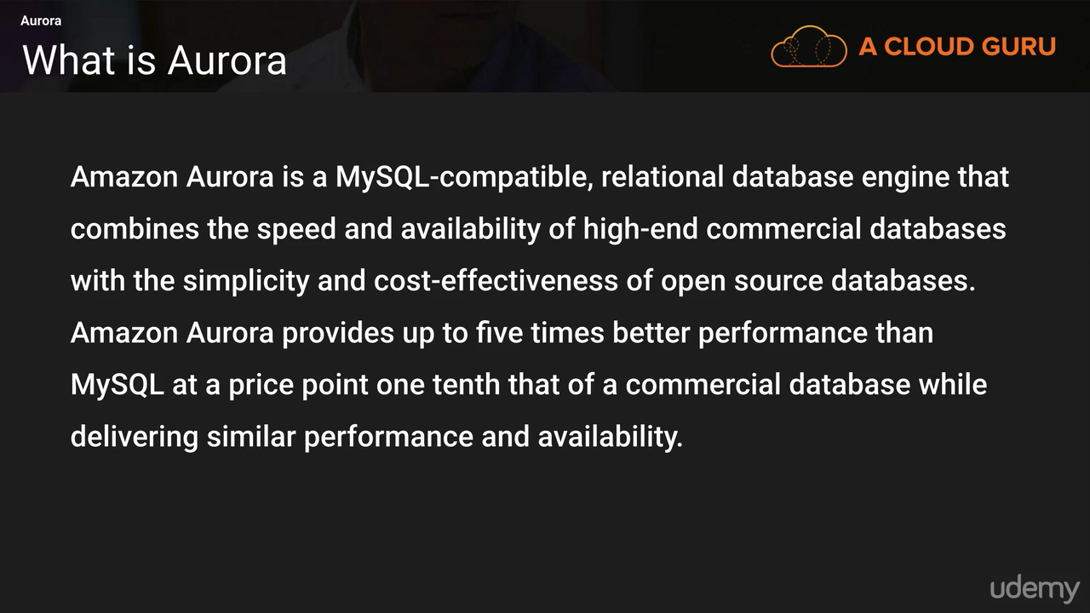**

**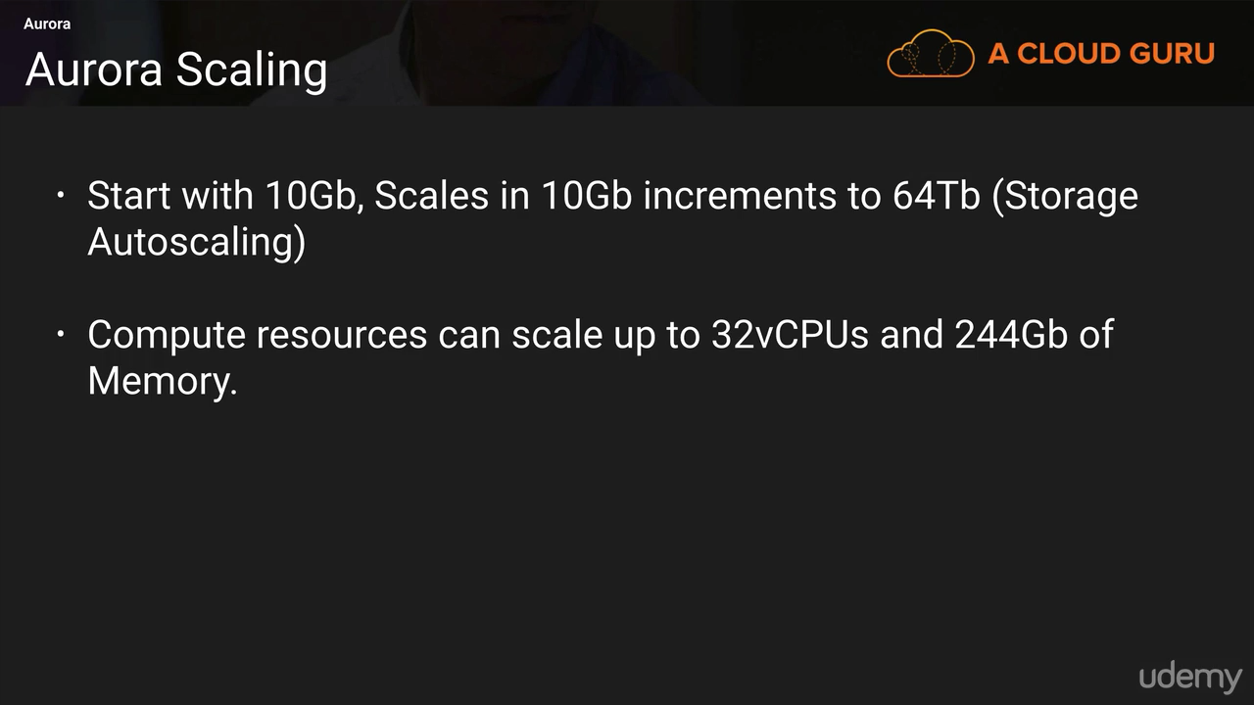**

**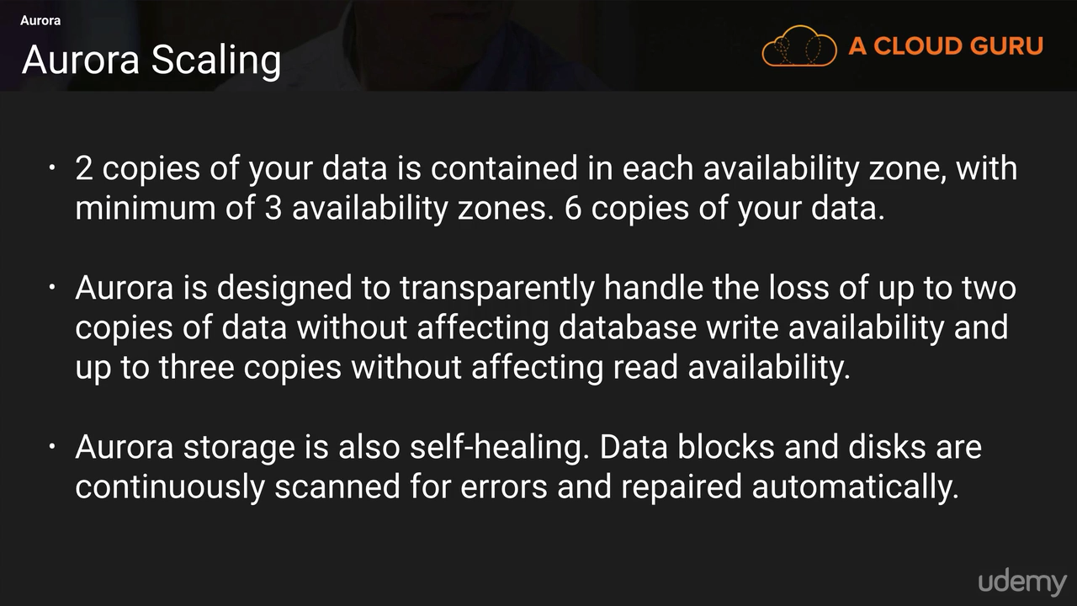**

**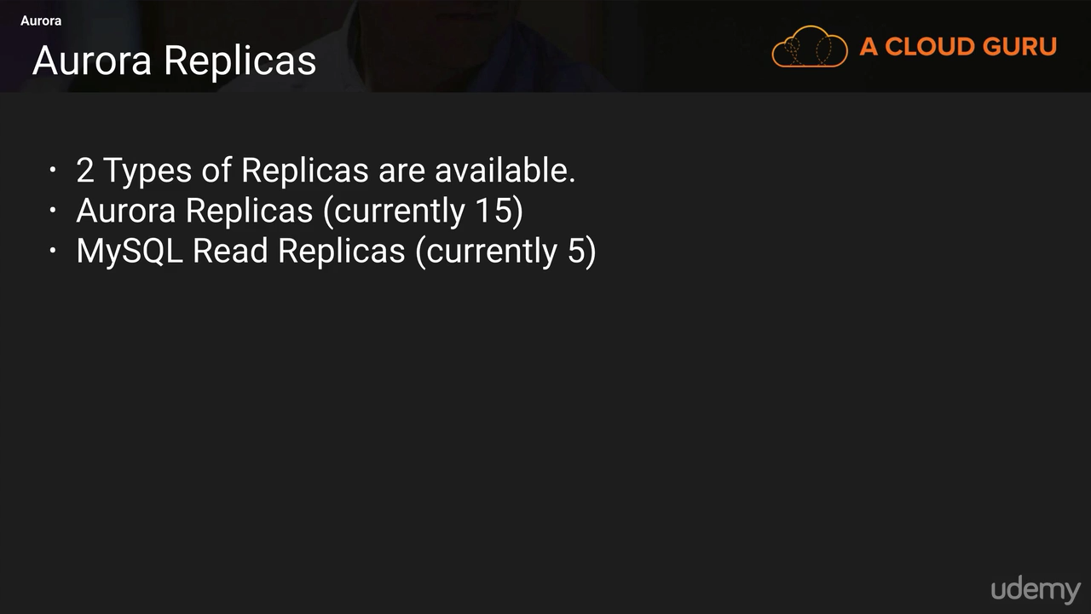**

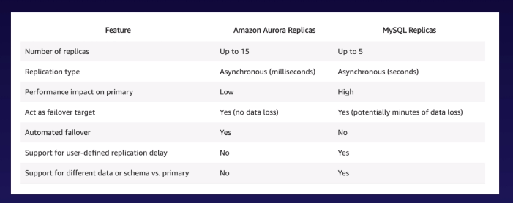

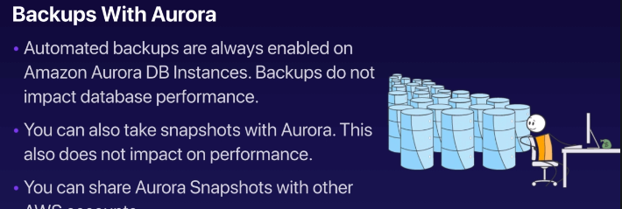

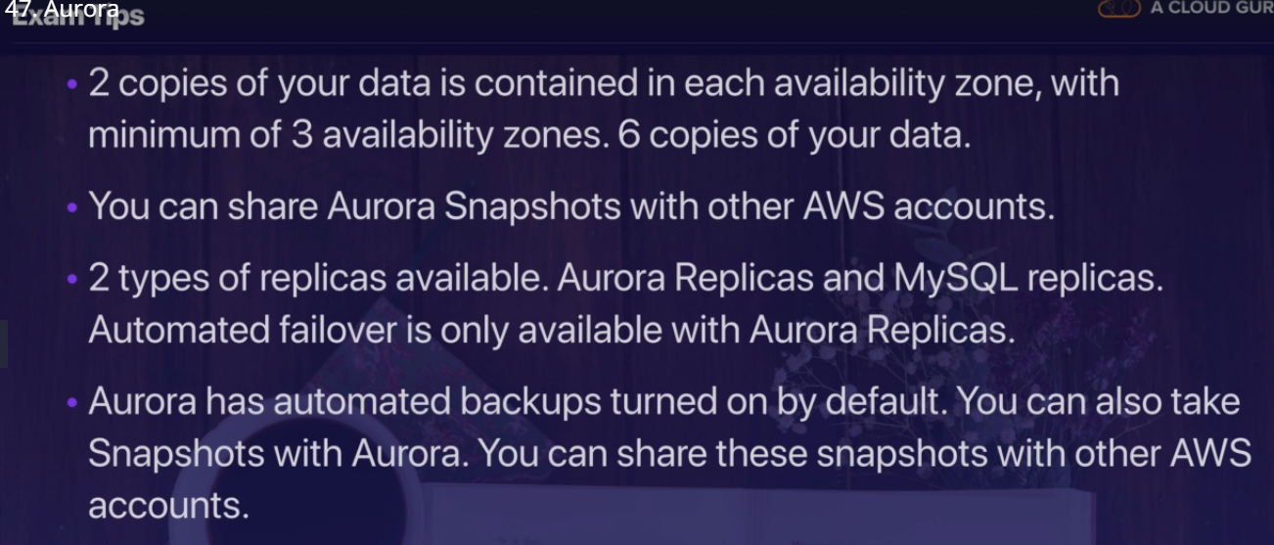

**Aurora for Solutions Architects**

* Can use IAM authentication for Aurora MySQL and Postgres
* Aurora Global databases span multiple regions and enable DR
  + One Primary Region
  + One DR Region
  + The DR region can be used for lower latency reads
  + < 1 second replica lag on average

# **VPC (Virtual Private Cloud)**

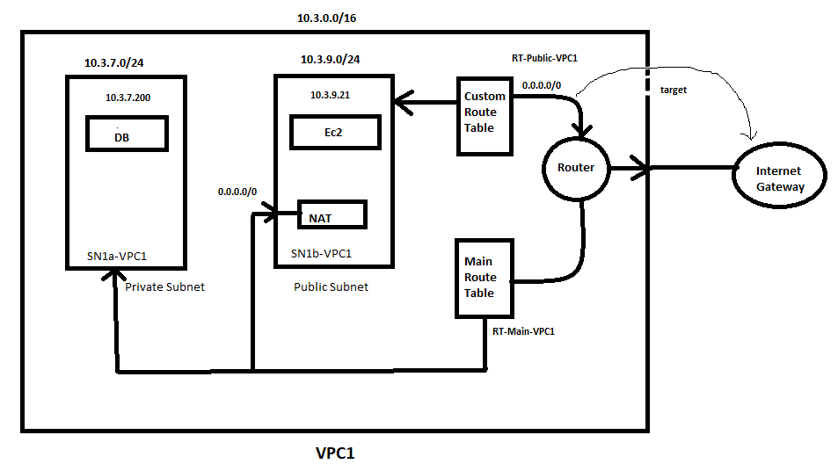

Virtual Datacentre in cloud

<http://cidr.xyz/> ---go to this website for more range for your VPC

ip ranges -10.4.9.0/24 ----means first 24 bit are fixed last 8 byte can vary

10.2.0.0/**16** ----first 16 byte fixed

e.g

10.2.1.1

10.2.1.2

10.2.2.1

VPC in AWS – IPv4

• You can have multiple VPCs in a region (max 5 per region – soft limit)

• Max CIDR per VPC is 5. For each CIDR:

• Min size is /28 = 16 IP Addresses

• Max size is /16 = 65536 IP Addresses

• Because VPC is private, only the Private IP ranges are allowed:

• 10.0.0.0 – 10.255.255.255 (10.0.0.0/8)

• 172.16.0.0 – 172.31.255.255 (172.16.0.0/12)

• 192.168.0.0 – 192.168.255.255 (192.168.0.0/16)

• Your VPC CIDR should not overlap with your other networks (ex: corporate)

1)VPC name-

2)Associated with region (Available for that region only)

3)when u create the vpc then it create the ip’s so when u create the VM’s in VPC then VPC assign that private ip’s to VM

Amazon Virtual Private Cloud (Amazon VPC) lets you provision a logically isolated section of the AWS Cloud where you can launch AWS resources in a virtual network that you define. You have complete control over your virtual networking environment, including selection of your own IP address range, creation of subnets, and configuration of route tables and network gateways. You can use both IPv4 and IPv6 in your VPC for secure and easy access to resources and applications.

You can easily customize the network configuration for your VPC. For example, you can create a public facing subnet for your web servers that has access to the Internet, and place your backend systems, such as databases or application servers, in a private-facing subnet with no Internet access. You can leverage multiple layers of security (including security groups and network access control lists) to help control access to EC2 instances in each subnet.

Additionally, you can create a hardware virtual private network (VPN) connection between your corporate data centre and your VPC and leverage the AWS Cloud as an extension of your corporate data centre.

C:\Users\pawar_ka\Desktop\Image001.tif

**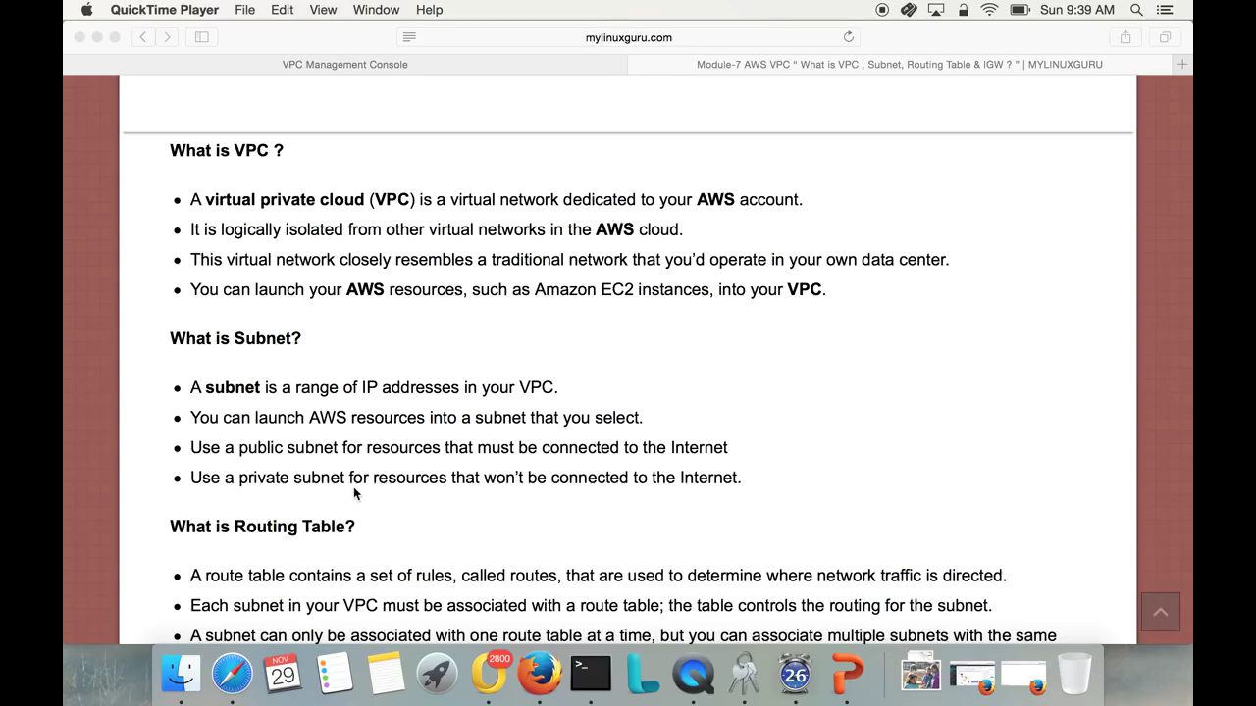**

**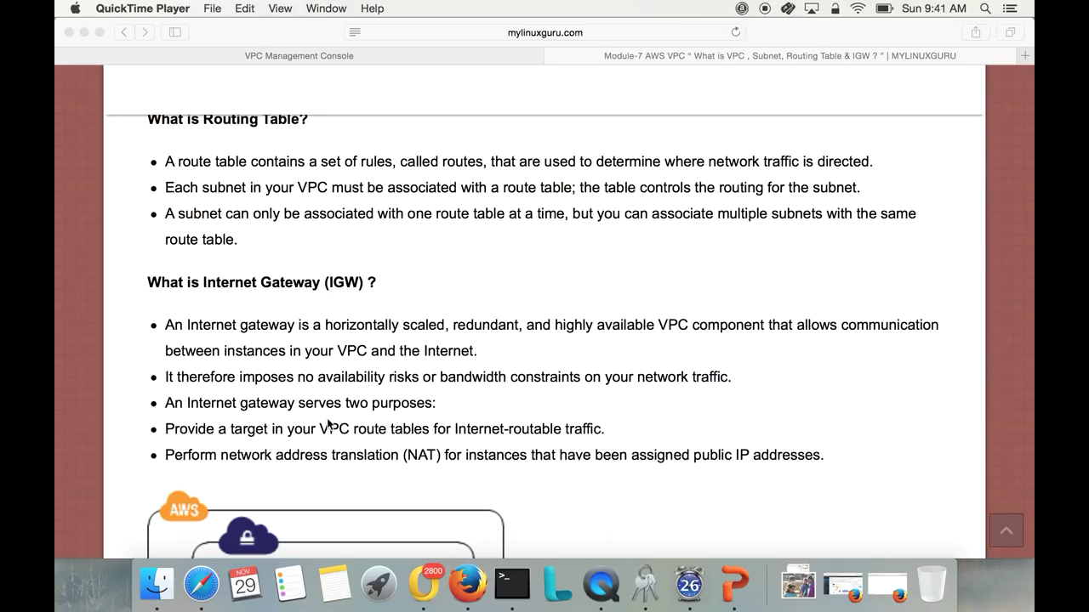**

**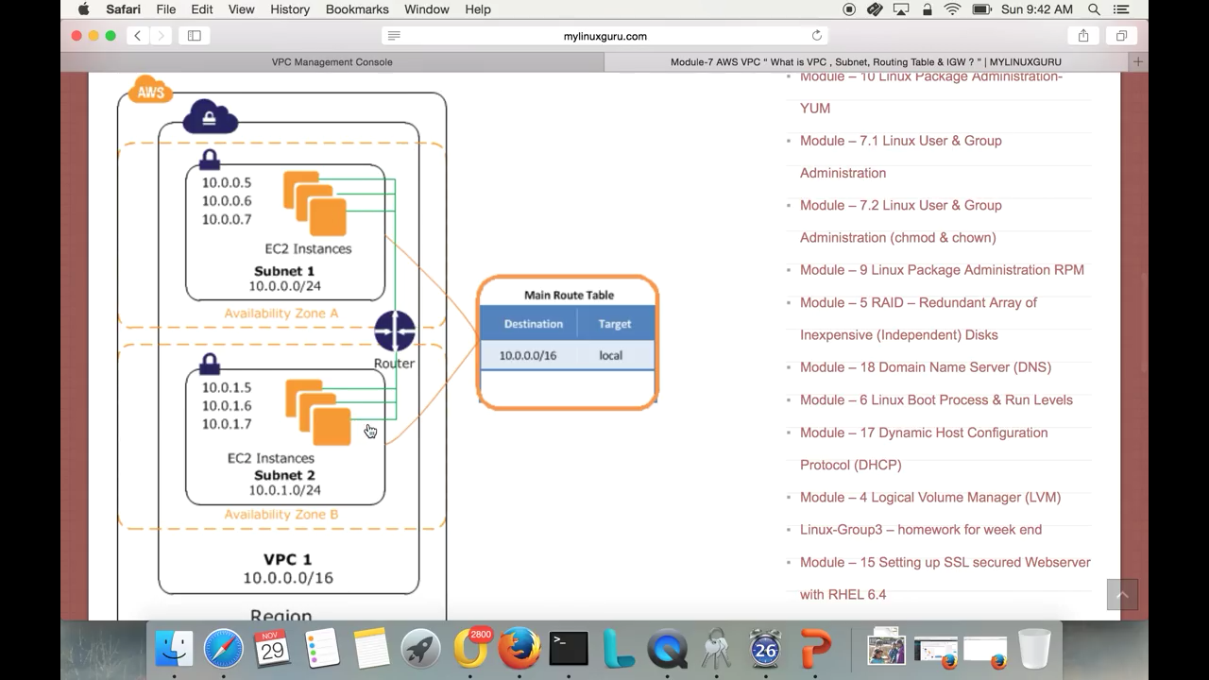**

**public ip address Range**-

Class A-0-127

Class B-128-191

Class C-192-223

Class D-224

**Private ip address Range**

Class A:10.0.0.0

Class B-172.16.0.0

Class C-192.168.0.0

================

An Amazon VPC address range may be as large as /16 (65,536 available addresses) or as small as /28 (16 available addresses) and should not overlap any other network with which they are to be connected.

**Subnets**

It is Similar To u r country---People from other countries not allowed to come .country is divided to multiple state so for different state u can apply different rules(e.g language)

So split our country multiple state so the picture of subnet comes ahead.you can associate different rules using subnet for accessing the particular things…i.e in VPC u have webserver and DB server … you can give the access of webserver to outside word or allow them to access the webserver and not to the DB server .

U can give the range of subnet…ie particular range of subnet can have access only the webserver and other range of subnet should not have access.

**Subnet is associated with Availability Zone**

Ip address=subnet(Network+ host)

**Subnet(Network Number)**-Sub Network or smaller network within a large network

**Subnet mask**-subnet mask is a 32-bit number that divides the IP address into **network address(**street address**)** and **host address** (House address)

If there are more than 50 computers are connected and if you don’t want to communicate each computer with the another one the in that case subnet mask is created (Segment network logically)

If two computers are in different subnet(Network) then they cant talk with each other it can be possible only via router between them to connect

Subnet mask=Subnet+Net+Mask

Public Subnet-Use a public subnet for resources that must be connected to the internet (use For Webserver)

Private Subnet- Use a private subnet for resources that won’t be connected to the internet

(For use for backend Databases,Application servers)

C:\Users\pawar_ka\Desktop\Image002.tif

Diagram 1

* AWS accounts that support EC2-VPC will have a default VPC created in each region with a default subnet created in each Availability Zone. The assigned CIDR block of the default VPC will be 172.31.0.0/16.
* Subnets reside within one Availability Zone and cannot span zones. **one subnet equals one Availability Zone**. You can, however, have multiple subnets in one Availability Zone.
* Default Amazon VPCs contain one public subnet in every Availability Zone within the region, with a netmask of /20.
* **When you create the subnet the auto assign public ip is disable** so when u create the instance using the VPC and subnet then that EC2 instance will not have the public ip, only private ip you can see after creation ..in that case while creating the subnet u have to enable the auto assign public ip from subnet actions

**Route Tables**

* A route table is a logical construct within an Amazon VPC that contains a set of rules (called routes)that are applied to the subnet and used to determine where network traffic is directed.
* You can modify route tables and add your own custom routes. You can also use route tables to specify which subnets are public (by directing Internet traffic to the IGW) and which subnets are private (by not having a route that directs traffic to the IGW)
* Each route table contains a default route called the local route, which enables communication within the Amazon VPC, and this route cannot be modified or removed.
* Additional routes can be added to direct traffic to exit the Amazon VPC via the IGW (discussed later), the VPG (discussed later), or the NAT instance (discussed later).

You should remember the following points about route tables:

* Your VPC has an implicit router.
* Your VPC automatically comes with a main route table that you can modify.
* You can create additional custom route tables for your VPC.
* Each subnet must be associated with a route table, which controls the routing for the subnet. If you don’t explicitly associate a subnet with a particular route table, the subnet uses the main route table.
* You can replace the main route table with a custom table that you’ve created so that each new subnet is automatically associated with it.
* Each route in a table specifies a destination CIDR and a target; for example, traffic destined for 172.16.0.0/12 is targeted for the VPG. AWS uses the most specific route that matches the traffic to determine how to route the traffic.

**Elastic IP Addresses (EIPs)**

* You must first allocate an EIP for use within a VPC and then assign it to an instance.
* EIPs are specific to a region (that is, an EIP in one region cannot be assigned to an instance within an Amazon VPC in a different region).
* There is a one-to-one relationship between network interfaces and EIPs.
* You can move EIPs from one instance to another, either in the same Amazon VPC or a different Amazon VPC within the same region.
* EIPs remain associated with your AWS account until you explicitly release them.
* There are charges for EIPs allocated to your account, even when they are not associated with a resource.

**Elastic Network Interfaces (ENIs)**

* An Elastic Network Interface (ENI) is a virtual network interface that you can attach to an instance in an Amazon VPC.
* ENIs are only available within an Amazon VPC, and they are associated with a subnet upon creation.
* They can have one public IP address and multiple private IP addresses. If there are multiple private IP addresses, one of them is primary.
* Assigning a second network interface to an instance via an ENI allows it to be *dual-homed* (have network presence in different subnets).
* ENIs allow you to create a management network, use network and security appliances in your Amazon VPC, create dual-homed instances with workloads/roles on distinct subnets, or create a low-budget, high-availability solution.

**When you create the subnet the auto assign public ip is disable** so when u create the instance using the VPC and subnet then that EC2 instance will not have the public ip, only private ip you can see after creation ..in that case while creating the subnet u have to enable the auto assign public ip from subnet actions

After creation of instance in VPC and that instance have RDP enable in security group and having public ip.. so in that can you access that RDP instance from outside world? ………………no because VPC does not allowed access to outside world (you need visa for u r country for accessing the RDP)..

The Option is internet gateway to connect with outside world (need to create the internet gateway)

Create the internet gateway and associate with VPC

**Default Gateway**-It is the router for the subnet ,If you looking for website then it first looks in the locally, if don’t find then go to default gateway via router to find over the internet

This also will not work again you can connect to the RDP because subnet is allowed to internet connection so we need to create the route table. Route table is associated with the subnet.

Create the route table and make it public and associate with subnet and internet gateway so now u can have incoming and outgoing internet access on public subnet

**Route Tables**

Router -Which path to take for connecting to site

Each router consist of TCP/IP information i.e stored in the database and this database is called routing table

C:\Users\pawar_ka\Desktop\Image002.tif

Diagram 2

Suppose if you want outgoing internet connection on private server(private subnet) then you cannot add it in rout table which is connecting with gateway because it is having both incoming and outgoing internet connections(Refer Diagram 3)

So for that you can use NAT gateway

How to do that

1)create the NAT gateway in public subnet

2)in the private route table put the rule for NAT

C:\Users\pawar_ka\Desktop\Image002.tif

Diagram 3

NAT gateway has the static ip’s ie. Elastic ip

**NAT**-Network Address Translation(It has elastic IP)

Every single computer connected to the internet would needs its unique ip address and NAT concept comes ahead (this fixes the issue)

Every router(NAT installed on it) connect to internet, needs its own dedicated ip address (This is your external ip address,internet does not consider internal ip address (home ips)

Home pc -🡪router (NAT installed) --🡪internet

======

When u create the VPC then aws automatically create the security group and the route table with VPC

**DHCP**-Dynamic host control protocol

Static Ip Adreess-need to put it manually but t it creates the pain (Ip conflict)

Why you can do use DHCP .(This server gives ip addresses,subnet,default gateway automatically)

**Network ACL-Access control List (Refer Diagram 4)**

It is similar to security group

* A network ACL is a numbered list of rules that AWS evaluates in order, starting with the lowest numbered rule, to determine whether traffic is allowed in or out of any subnet associated with the network ACL
* Amazon VPCs are created with a *“default network ACL”* associated with every subnet that allows all inbound and outbound traffic
* When you create a *“custom network ACL”*, its initial configuration will deny all inbound and outbound traffic until you create rules that allow otherwise
* every subnet must be associated with a network ACL.

1. Security group sits on top of VM (all the incoming request go through Security group and reaches to VM and all the outgoing request go through security group and then go out)
2. Whereas ACL sits over subnet (subnet level)

(It has also inbound and outbound rules. the traffic is passed through as below ACL🡪Subnet🡪Security group-🡪VM and vice versa

ACL is a set of rules which allow or deny the specific traffic moving through the router

It is a layer 3 security which controls the flow of traffic from one router to another

It is also called packet filtering firewall

When you create the ACL then by default inbound and outbound rules are allow (

ACL has stateless nature whereas security group has stateful nature.

In Security group it allows rules whereas ACL you can allow and deny rules.

C:\Users\pawar_ka\Desktop\Image003.tif

Diagram 4

C:\Users\pawar_ka\Desktop\Image002.tif

Internetgateway is only one per VPC

**VPN-Virtual private network**

Using VPN no one can track and stole u r data

**VPC peering**-If two VPC’s are in same region then you can configure VPC peering so that VM from on VPC can connect to other VPC via private ip’s

Public Ip address always change when you start /stop the EC2 instance. If you want to make it static public Ip then first create the **elastic Ip** and associate it with the EC2 instance.

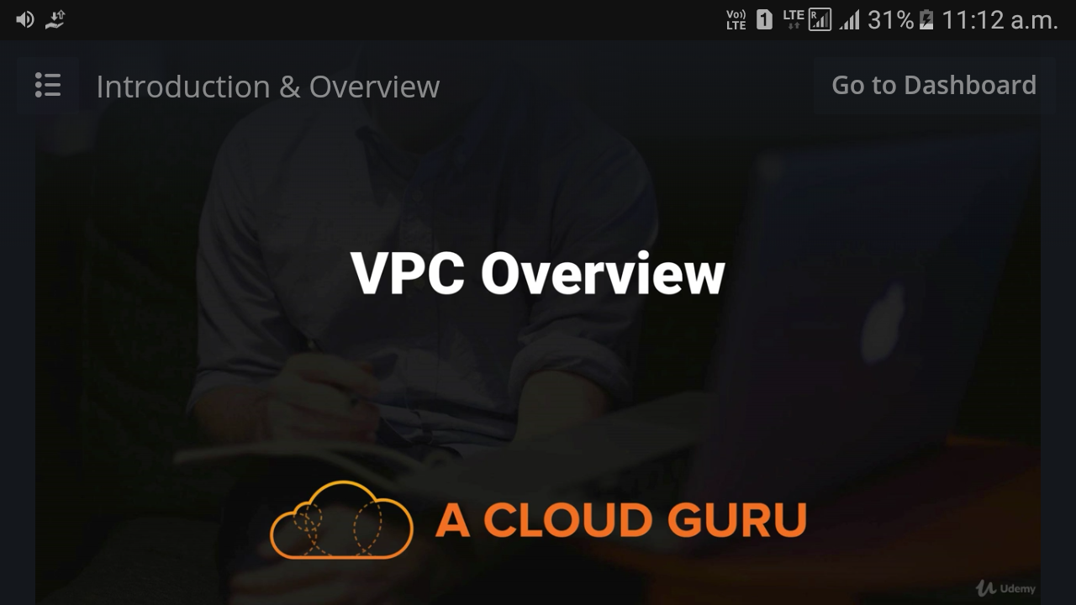

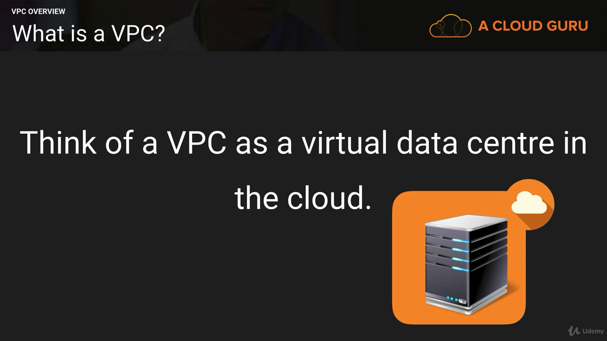

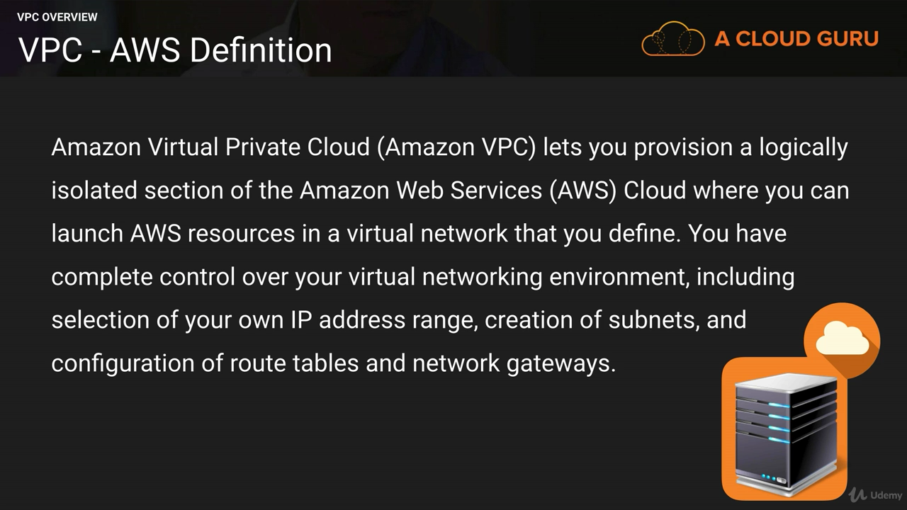

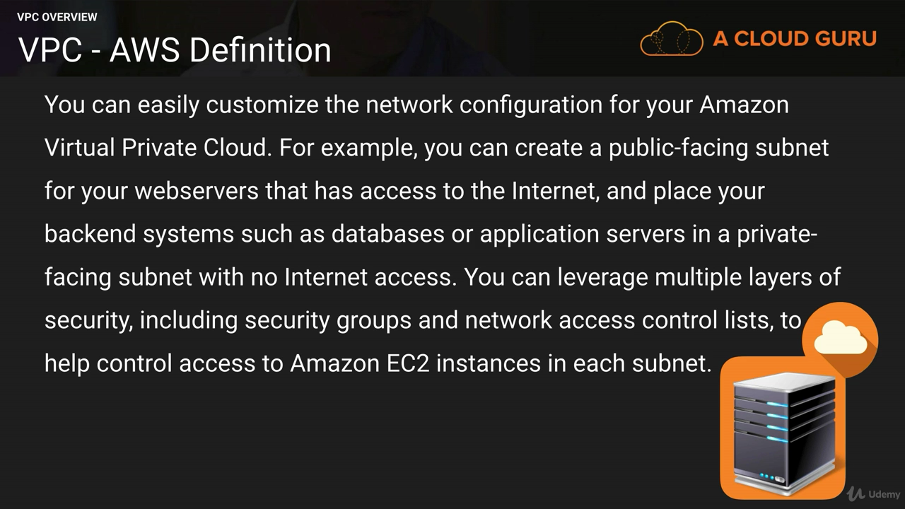

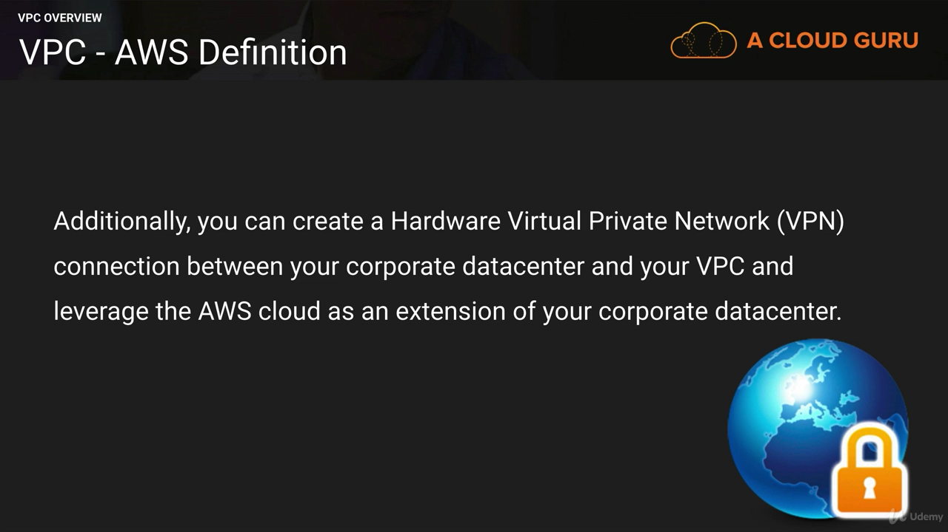

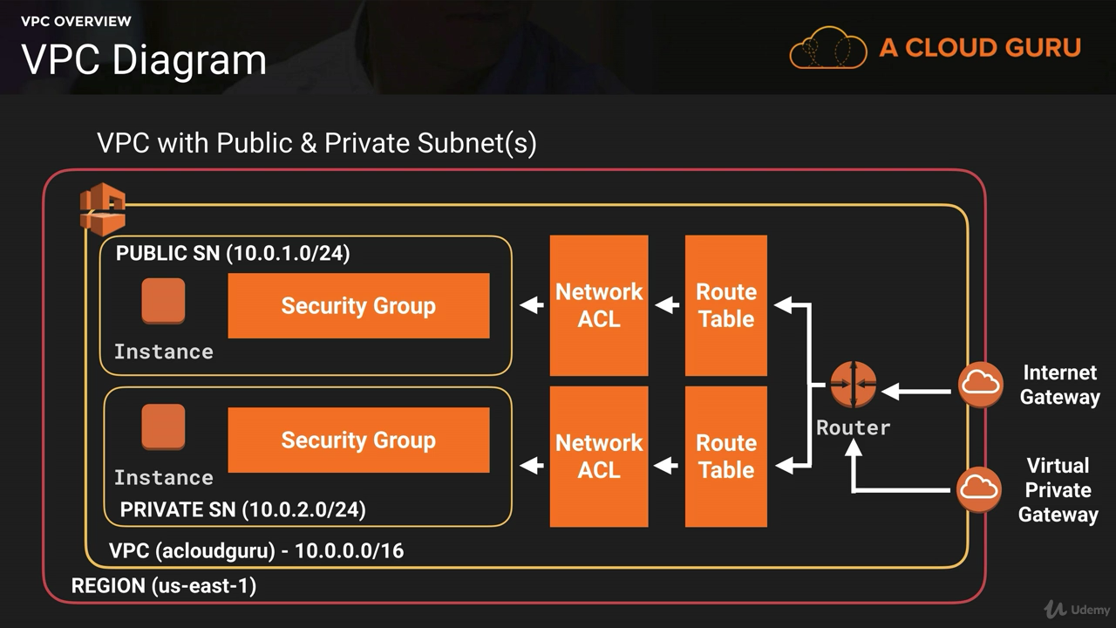

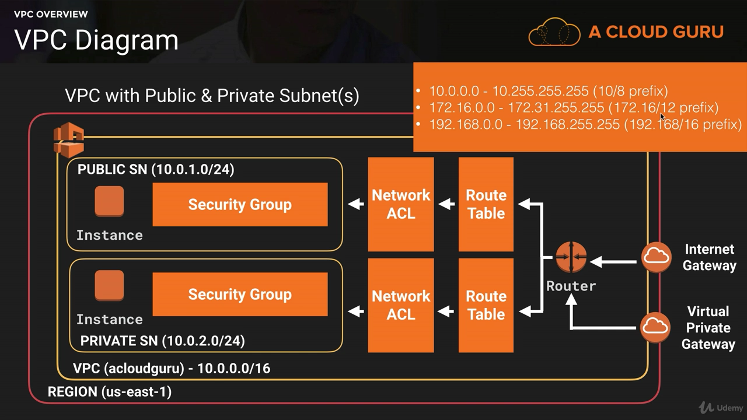

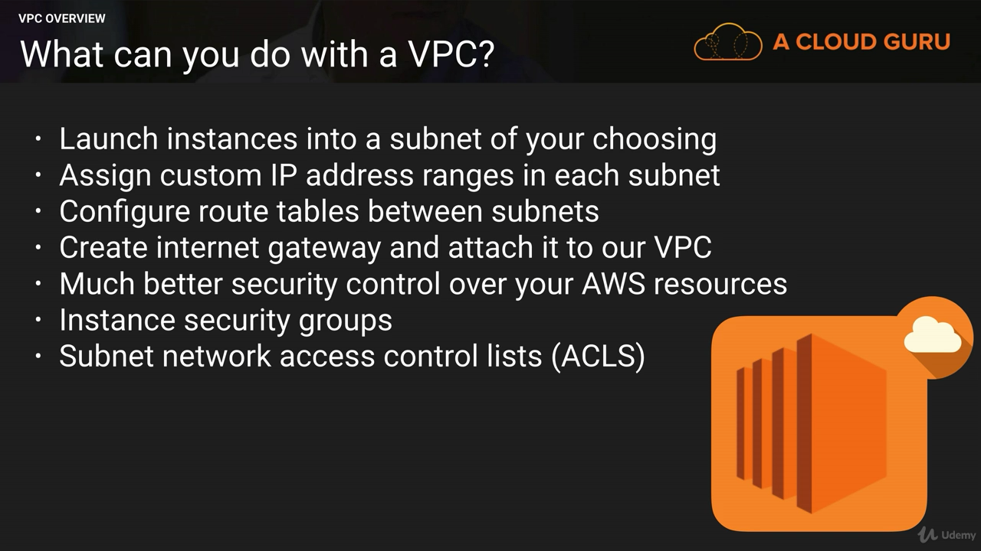

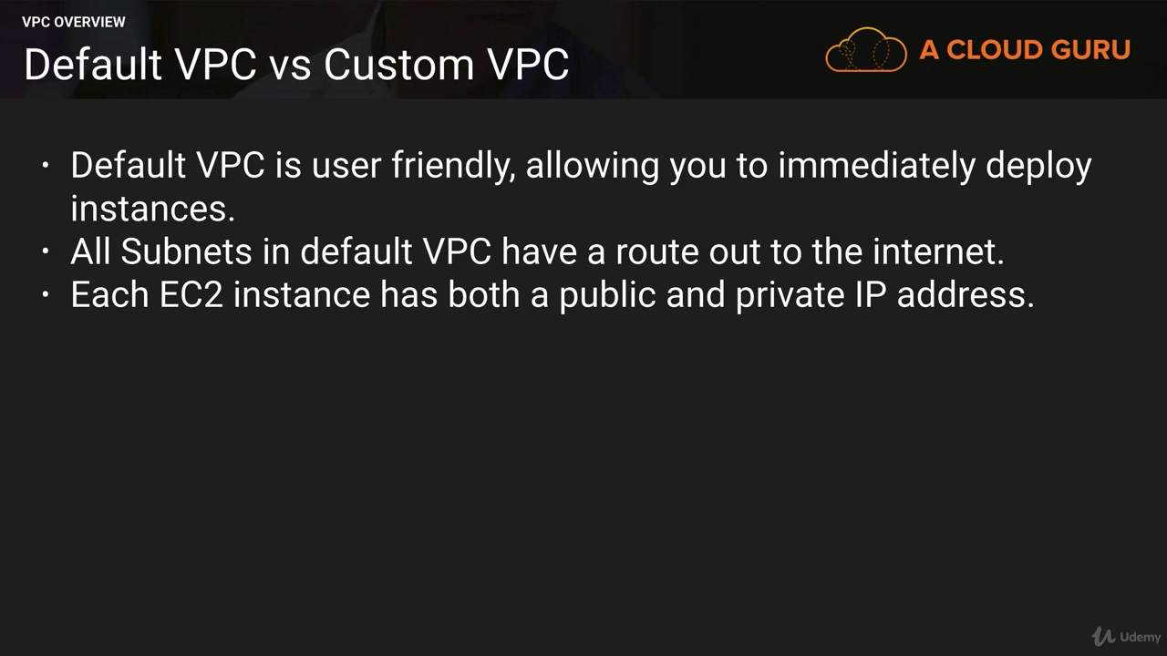

### VPC Peering

* You can create an Amazon VPC peering connection between your own Amazon VPCs or with an Amazon VPC in another AWS account within a single region
* A peering connection is neither a gateway nor an Amazon VPN connection and does not introduce a single point of failure for communication.
* peering is a one-to-one relationship between Amazon VPCs, meaning two Amazon VPCs cannot have two peering agreements between them
* You cannot create a peering connection between Amazon VPCs that have matching or overlapping CIDR blocks.
* You cannot create a peering connection between Amazon VPCs in different regions.
* Amazon VPC peering connections do not support transitive routing.
* You cannot have more than one peering connection between the same two Amazon VPCs at the same time.

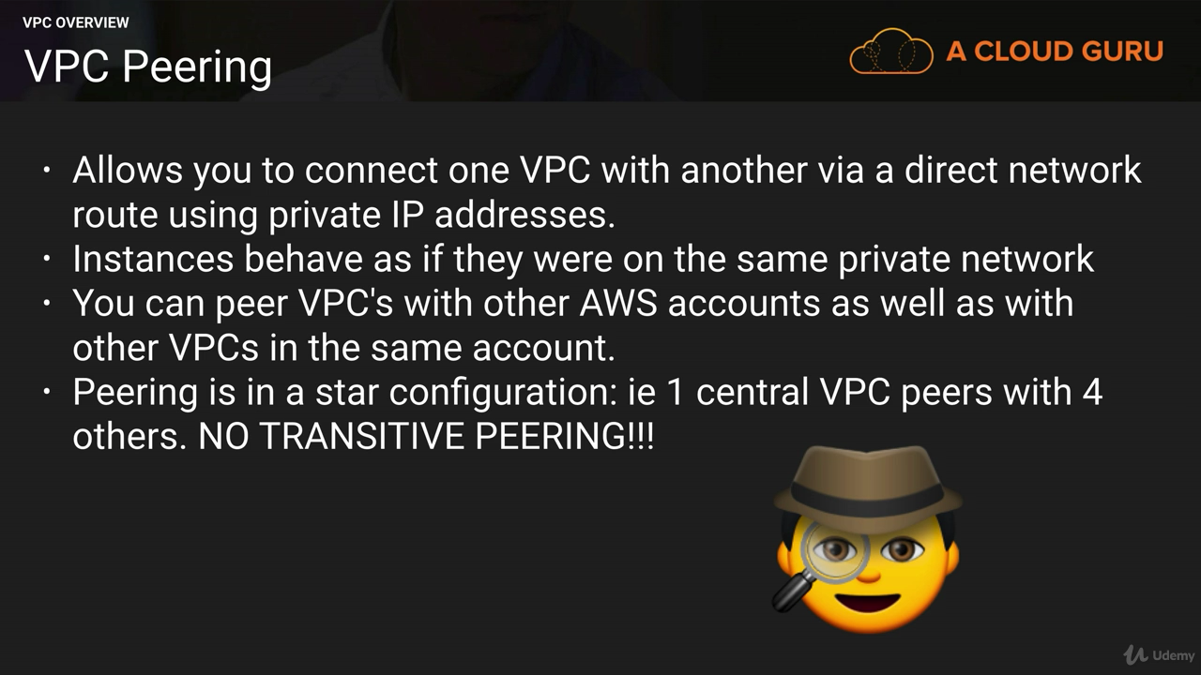

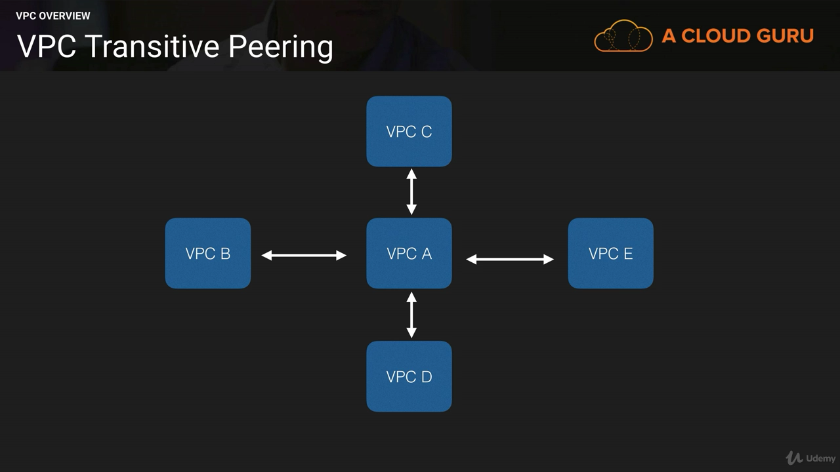

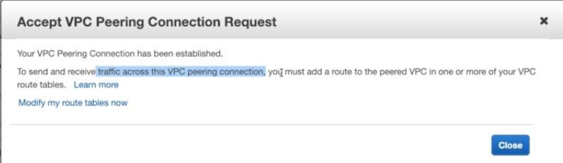

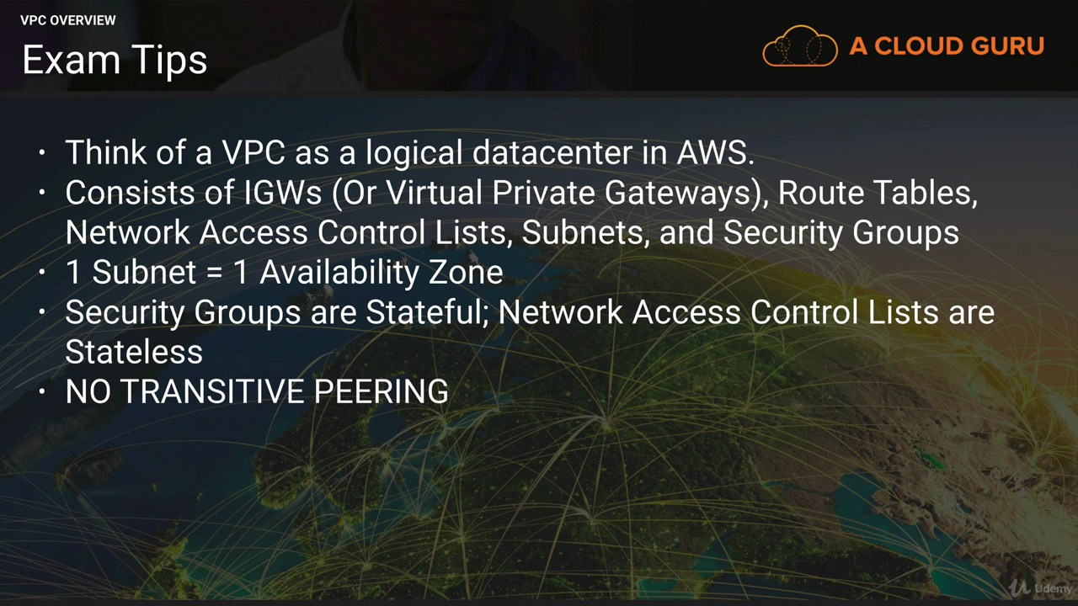

1 subnet=1 availability zone

By default its 5 VPC in one region,

200 subnet per VPC

200 route tables per VPC

500 Security groups per VPC

50 in/outbound rules per VPC

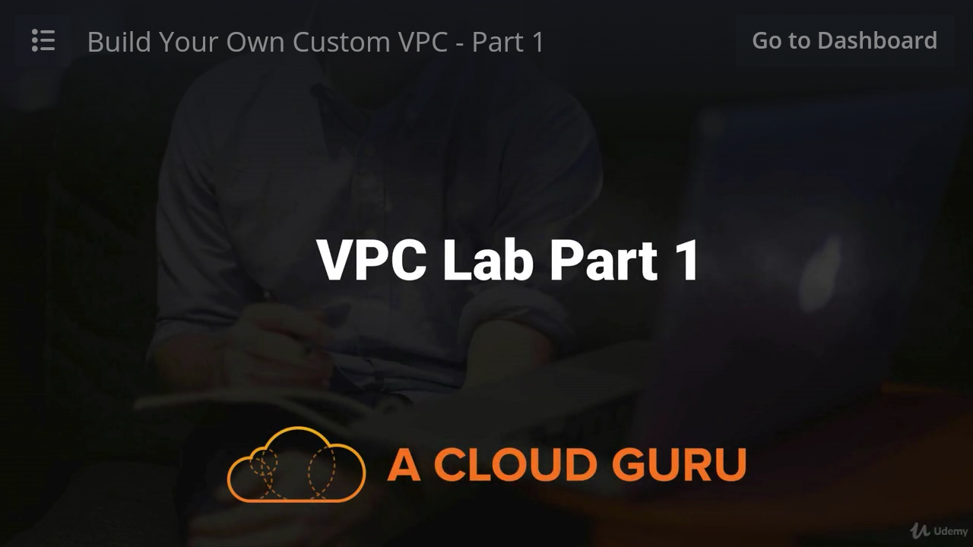

1) **When you create the VPC below things automatically created**

1. Route tables --- id/acloudguruvpc (This is default one and accessible to internet,Allow all inbound and outbound traffic)
2. Networok ACL -- id/acloudguruvpc
3. Security Goup ---Default VPC security greoup

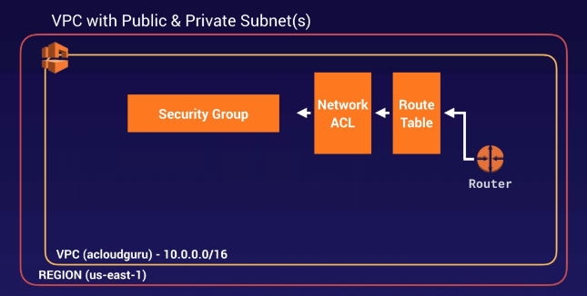

2) **Create 2 Subnet in one VPC (name-id/ acloudguruvpc ) when u create subnet then that time both are private**

1. id/ acloudguruvpc --10.0.**1**.0/24 us-east-1a
2. id/ acloudguruvpc --10.0.**2**.0/24 us-east-1b

“*Auto assign public ip*” is **no** for the subnet we created and for the default subnet it is **yes**

for making public subnet we need to change to “yes “ from action i.e enable it from subnet actions for 10.0.**1**.0

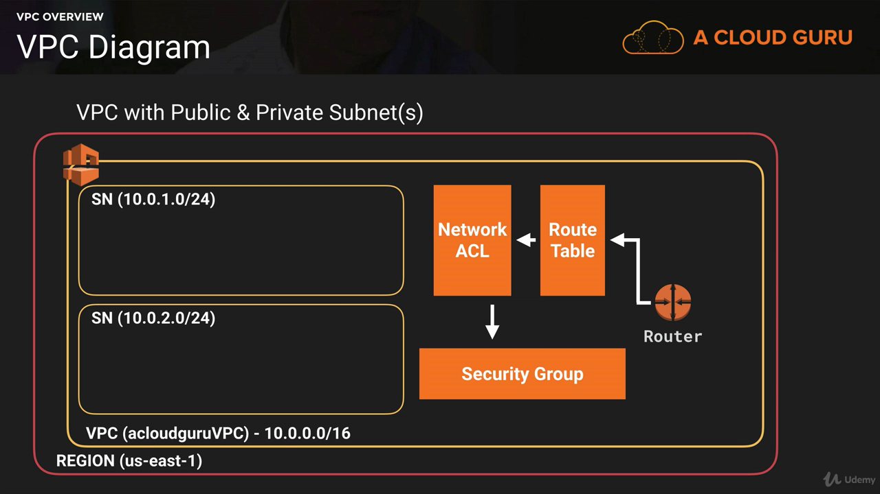

**3) Create internet gateway and attached it to VPC -MyIGW**

When “internet gateway” is attached to the VPC then you cannot attach other “internet gateway “ to same VPC again.

1 vpc=1 internet gateway

**4) Now again create new route table other than the default one and attached VPC to it .**

**Reason**-for security purpose Always keep main route table as Private and create separate route table for public Subnet. We can not add public route to main route table otherwise all the subnet will be publicly accessible hence creating the new route

**Name-MyPublicRoute** This is essential for subnet associative with new route table ,will then be able to talk to internet



* 1. 1st one is default route table which one is main and private (Using this subnet in the VPC can talk to each other using SSH).
  2. Second one we created and attached to VPC to access it publicly (With this we can route out to internet)

Click on **MyPublicRoute** route table perform below steps

**IPV4**-For internet access go to route(Edit Routes) and add new route i.e 0.0.0.0/0 and give target as u r internet gateway i.e **MyIGW**

**IPV6** -add destination ::/0 and give target as u r internet gateway i.e MyIGW and save the route

**Follow Below Diagram**

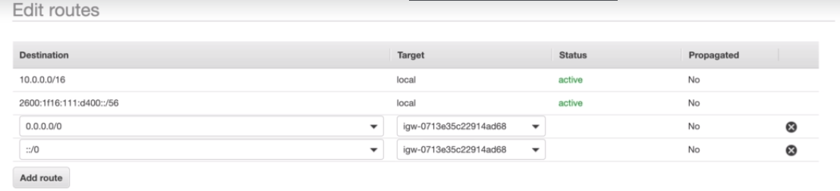

* For making the public subnet then go to “subnet association” and select the subnet “**10.0.1.0/24”** which you wanna make public and save it

Now **public subnet is 10.0.1.0**

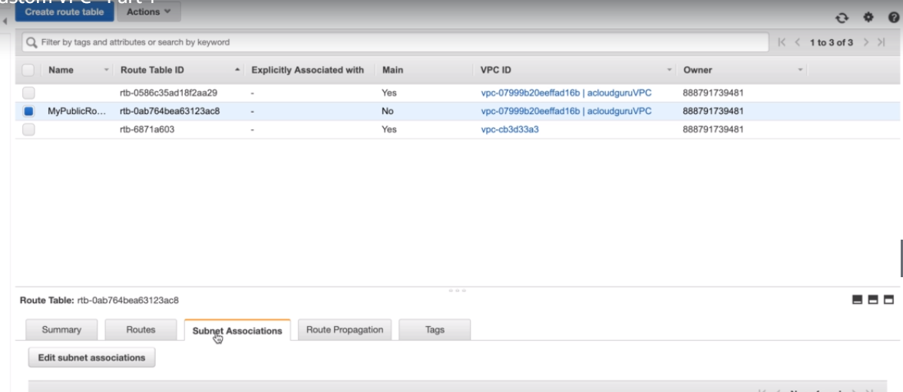

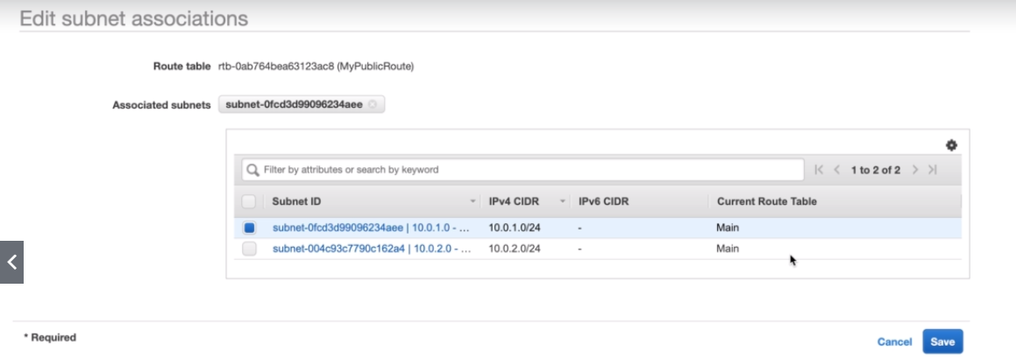

**5) Create two instance**

1)public -WebServer01 (use WebDMzSecurity group)

Do following things while creating the instance

* Select VPC
* Select public Subnet
* Auto assign public IP is by default enable
* Use WebDMZ security group which is open to world ie. Ssh and http

2) Private-MyMySql (Use Default Security group)

* Select VPC
* Select Private Subnet
* Auto assign public IP is disable for this
* Use default security group

**What we learn till now**

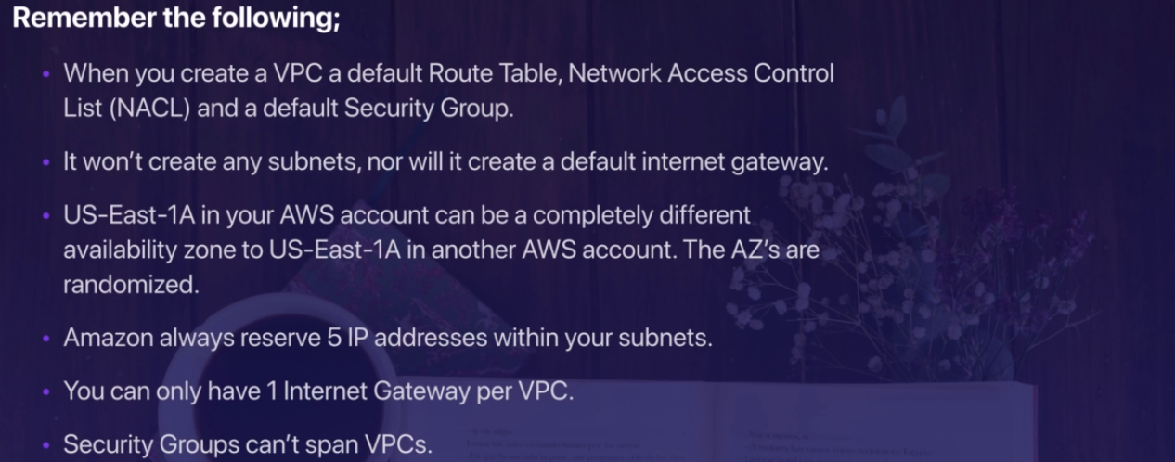



Till now we are here

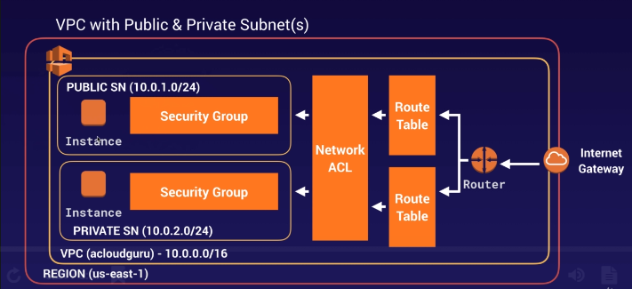

1. **How to connect to Private subnet**

Private subnet does not have the public ip,it has private ip so we can not directly access it.

Now follow below steps

1. Create new security group

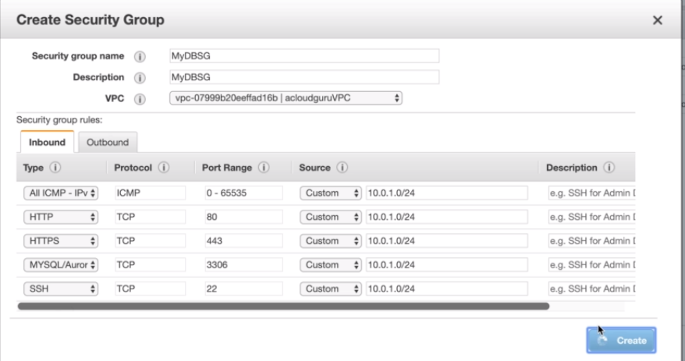

1. Then attach this security group to your private server i.e to MyMySql

Previously it was default and now it is attached to new security group

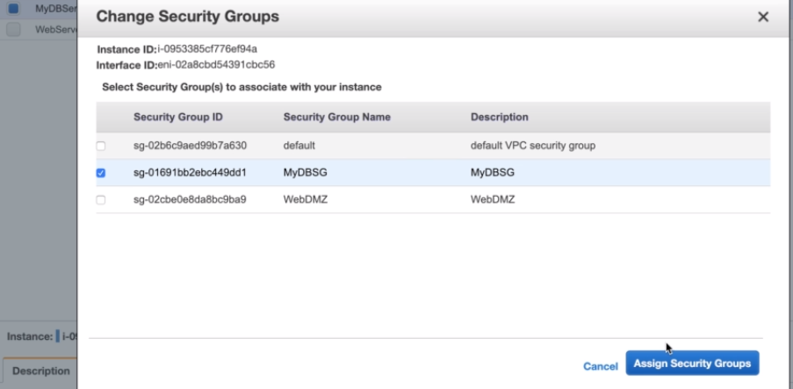

* Now you can ping from public webserver to private webserver.
* To do ssh from public webserver to private webserver then copy private key and copy it to public webserver (This is actually you can do it on the bastion server only)
* You can not do “yum update -y” on private webserver.This can be done using NAT instance and NAT Gateway

### NAT Instances and NAT Gateways (Network Access Translaction)

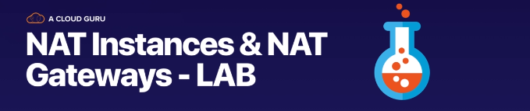

To Download the software on the private webserver, we can achieve this with NAT instance and NAT Gateway.

NAT gateway are more preferred than the NAT instance

**7 ) NAT instance**

* AWS provides NAT instances and NAT gateways to allow instances deployed in private subnets to gain Internet access(NAT should be in Public Subnet)
* **NAT Instance**

To allow instances within a private subnet to access Internet resources through the IGW via a NAT instance, you must do the following:

1. Create a security group for the NAT with outbound rules that specify the needed Internet resources by port, protocol, and IP address.
2. Launch an Amazon Linux NAT AMI as an instance in a public subnet and associate it with the NAT security group.
3. Disable the Source/Destination Check attribute of the NAT.
4. Configure the route table associated with a private subnet to direct Internet-bound traffic to the NAT instance (for example, i-1a2b3c4d).
5. Allocate an EIP and associate it with the NAT instance

* “NAT instance” literally single EC2 instance
* “NAT gateway” is highly available gateway that allow you to get “private subnet communicate out to with the internet to become public
* Create the “NAT instance” (choose AMI nat) in “Public subnet”
* Disable Source/destination check on the NAT instance

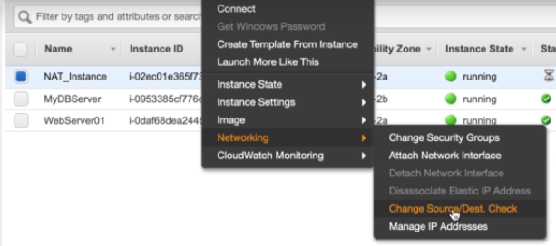

-In order to get my “private instance” (MyMysql) talk to “NAT instance”then create the route(0.0.0.0/0) in default route table and target it to NAT insatnce

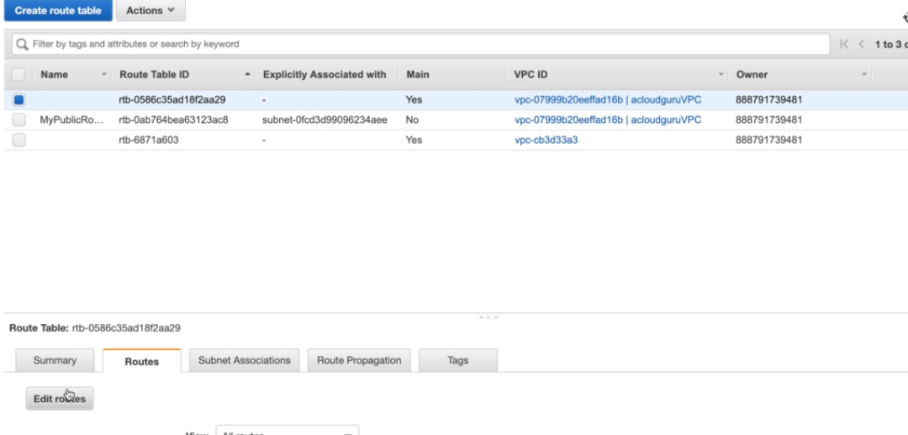

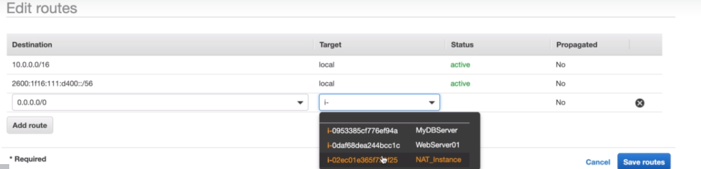

-Now connect to private server from public server by doing ssh

- And install the software

- The main problem is that suppose we have 1000’s of private Ec2 server and all of them are downloading so much data through single “NAT server” then its bottleneck. Because its small instance.

- If you stop or terminate “NAT instance” then all of the private Ec2 instance which is connected with it will not be able to download anything, means its single point of failure.

- This can be avoid using the NAT Gateway and make it highly available

**NAT Gateways**

* **NAT Gateway**
  1. Configure the route table associated with the private subnet to direct Internet-bound traffic to the NAT gateway (for example, nat-1a2b3c4d).
  2. Allocate an EIP and associate it with the NAT gateway.
  3. To create an Availability Zone-independent architecture, create a NAT gateway in each Availability Zone and configure your routing to ensure that resources use the NAT gateway in the same Availability Zone.

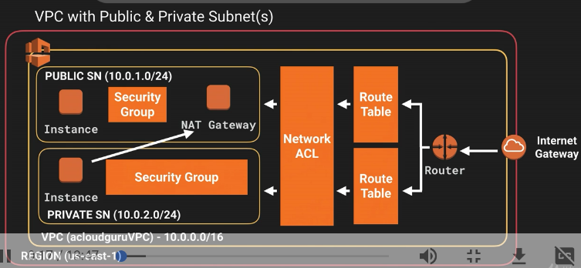

-Create NAT gateway and select public subnet

-create new elastic ip and create gateway

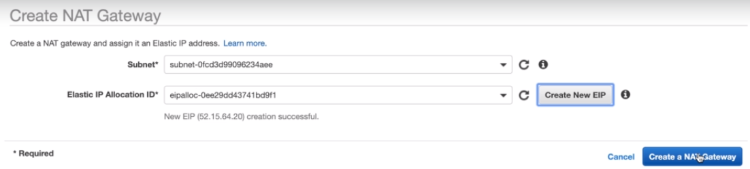

- then create the route(0.0.0.0/0) in default route table and target it to NAT Gateway

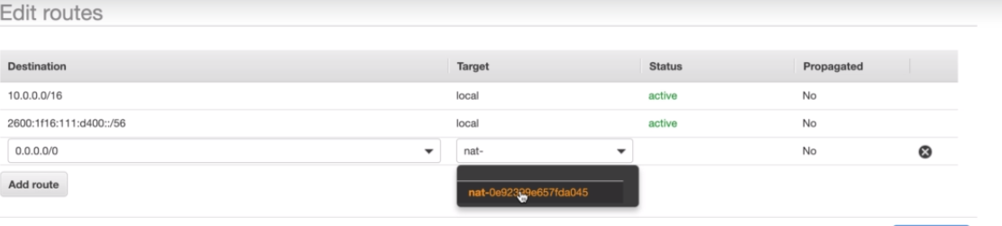

-Now connect to private server from public server by doing ssh

- And install the software

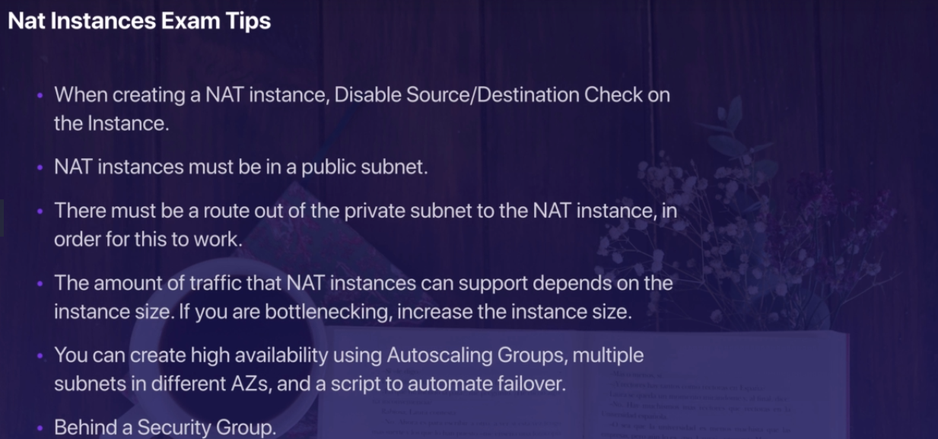

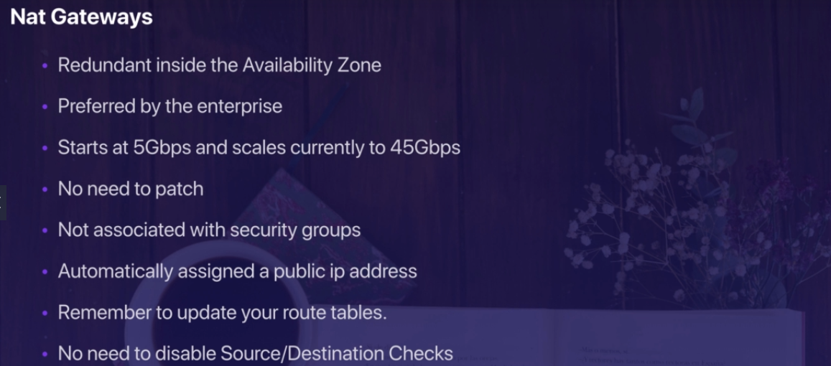

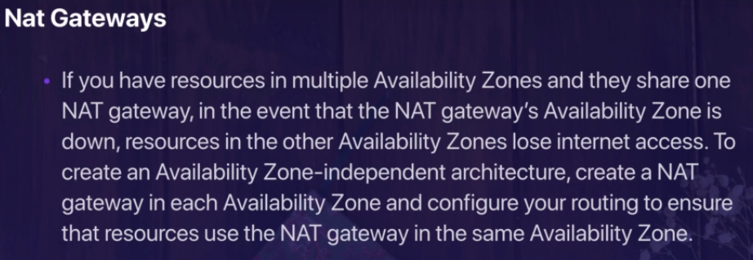

NAT gateway are more preferred than the NAT insatcnce

|  |  |  |
| --- | --- | --- |
| **Attribute** | **NAT gateway** | **NAT instance** |
| Availability | Highly available. NAT gateways in each Availability Zone are implemented with redundancy. Create a NAT gateway in each Availability Zone to ensure zone-independent architecture. | Use a script to manage failover between instances. |
| Bandwidth | Supports bursts of up to 10Gbps. | Depends on the bandwidth of the instance type. |
| Maintenance | Managed by AWS.You do not need to perform any maintenance. | Managed by you, for example, by installing software updates or operating system patches on the instance. |
| Performance | Software is optimized for handling NAT traffic. | A generic Amazon Linux AMI that's configured to perform NAT. |
| Cost | Charged depending on the number of NAT gateways you use, duration of usage, and amount of data that you send through the NAT gateways. | Charged depending on the number of NAT instances that you use, duration of usage, and instance type and size. |
| Type and size | Uniform offering; you don’t need to decide on the type or size. | Choose a suitable instance type and size, according to your predicted workload. |
| Public IP addresses | Choose the Elastic IP address to associate with a NAT gateway at creation. | Use an Elastic IP address or a public IP address with a NAT instance. You can change the public IP address at any time by associating a new Elastic IP address with the instance. |
| Private IP addresses | Automatically selected from the subnet's IP address range when you create the gateway. | Assign a specific private IP address from the subnet's IP address range when you launch the instance. |
| Security groups | Cannot be associated with a NAT gateway. You can associate security groups with your resources behind the NAT gateway to control inbound and outbound traffic. | Associate with your NAT instance and the resources behind your NAT instance to control inbound and outbound traffic. |
| Network ACLs | Use a network ACL to control the traffic to and from the subnet in which your NAT gateway resides. | Use a network ACL to control the traffic to and from the subnet in which your NAT instance resides. |
| Flow logs | Use flow logs to capture the traffic. | Use flow logs to capture the traffic. |
| Port forwarding | Not supported. | Manually customize the configuration to support port forwarding. |
| Bastion servers | Not supported. | Use as a bastion server. |
| Traffic metrics | View [CloudWatch metrics for the NAT gateway](https://docs.aws.amazon.com/AmazonVPC/latest/UserGuide/vpc-nat-gateway-cloudwatch.html). | View CloudWatch metrics for the instance. |
| Timeout behaviour | When a connection times out, a NAT gateway returns an RST packet to any resources behind the NAT gateway that attempt to continue the connection (it does not send a FIN packet). | When a connection times out, a NAT instance sends a FIN packet to resources behind the NAT instance to close the connection. |
| IP fragmentation | Supports forwarding of IP fragmented packets for the UDP protocol.  Does not support fragmentation for the TCP and ICMP protocols. Fragmented packets for these protocols will get dropped. | Supports reassembly of IP fragmented packets for the UDP, TCP, and ICMP protocols. |

### NACL Vs Security Group

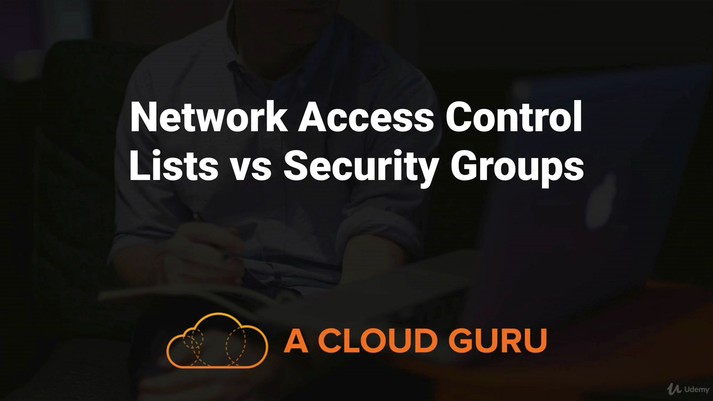

**8 ) Network ACL and Security Group**

**Security Group**

* The default security group allows communication between all resources within the security group, allows all outbound traffic, and denies all other traffic.
* You may change the rules for the default security group, but you may not delete the default security group.
* You can create up to 500 security groups for each Amazon VPC.
* You can add up to 50 inbound and 50 outbound rules to each security group.
* If you need to apply more than 100 rules to an instance, you can associate up to five security groups with each network interface.
* You can specify allow rules, but not deny rules. This is an important difference between security groups and ACLs.
* You can specify separate rules for inbound and outbound traffic.
* By default, no inbound traffic is allowed until you add inbound rules to the security group.
* By default, new security groups have an outbound rule that allows all outbound traffic. You can remove the rule and add outbound rules that allow specific outbound traffic only.
* Security groups are stateful. This means that responses to allowed inbound traffic are allowed to flow outbound regardless of outbound rules and vice versa. This is an important difference between security groups and network ACLs.
* Instances associated with the same security group can’t talk to each other unless you add rules allowing it (with the exception being the default security group).
* You can change the security groups with which an instance is associated after launch, and the changes will take effect immediately.
* If your application is not accessible (time out), then it’s a security group issue

If your application gives a “connection refused“ error, then it’s an application error or it’s not launched

**NACL**

NACL by default allow all the traffic so deny the traffic create new NACL and provide your allow or deny rules for specific subnet.

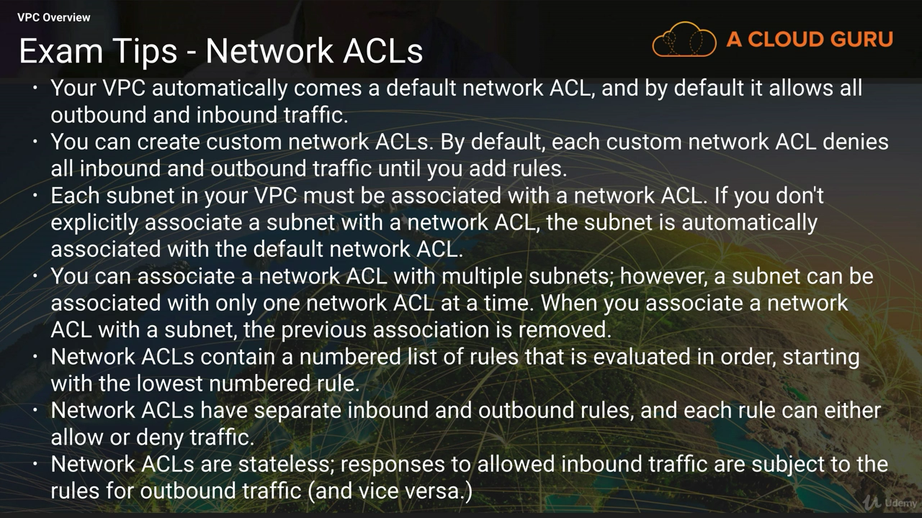

* Network ACL act before security group

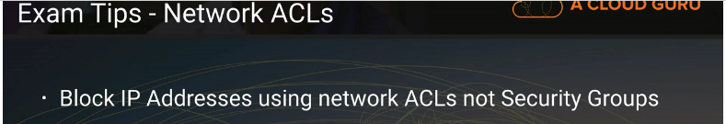

### VPC FLOW LOG

* + 1. VPC Flow Logs is a feature that enables you to capture information about the IP traffic going to and from network interfaces in your VPC. Flow log data can be published to Amazon CloudWatch Logs and Amazon S3. After you've created a flow log, you can retrieve and view its data in the chosen destination.
    2. Flow logs can help you with a number of tasks; for example, to troubleshoot why specific traffic is not reaching an instance, which in turn helps you diagnose overly restrictive security group rules. You can also use flow logs as a security tool to monitor the traffic that is reaching your instance.

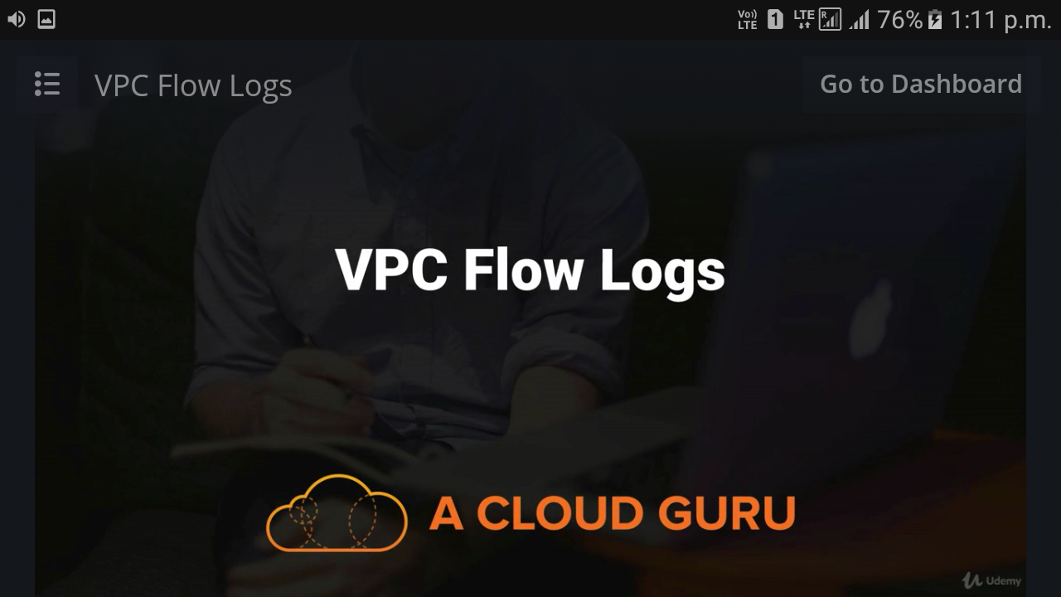

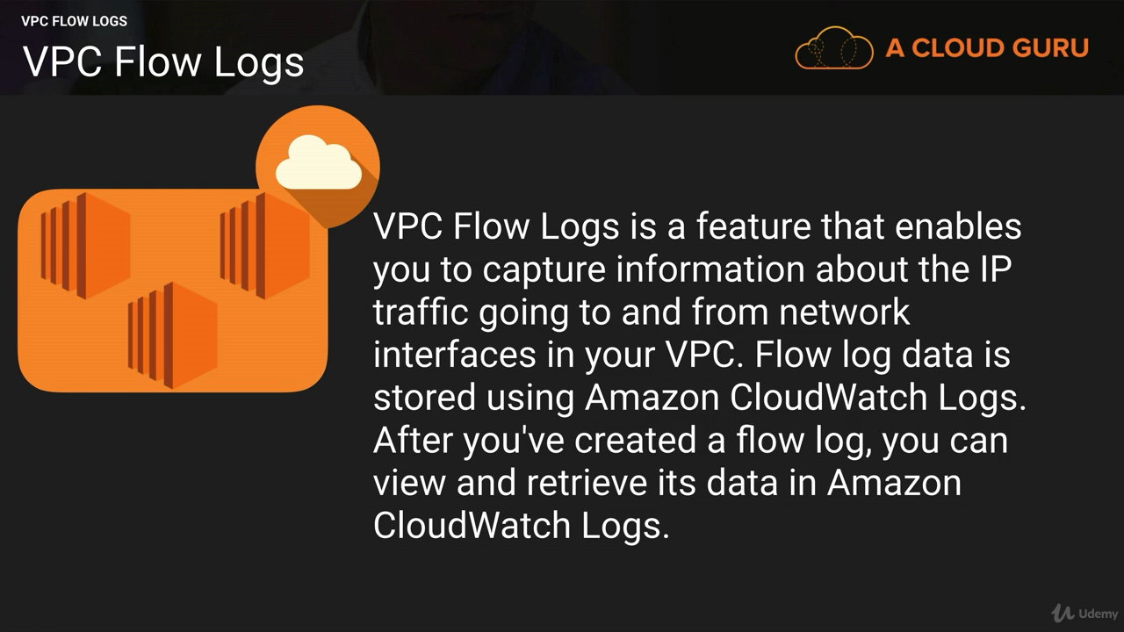

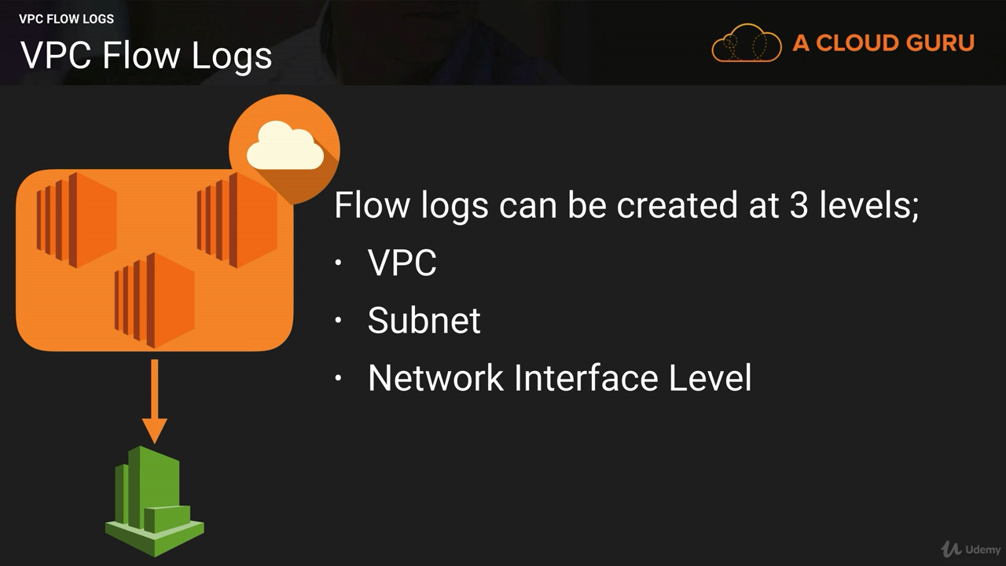

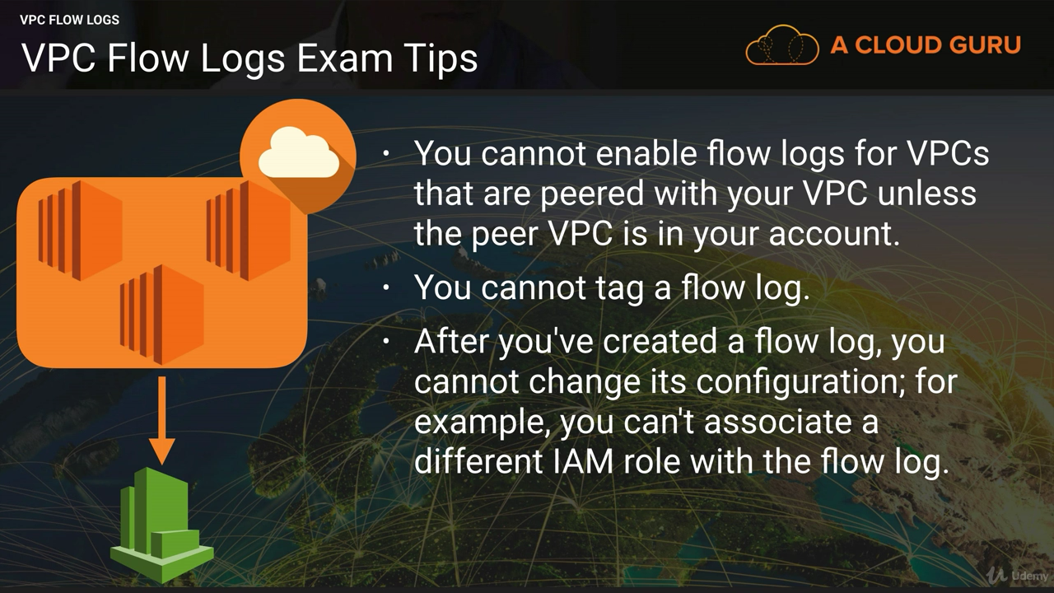

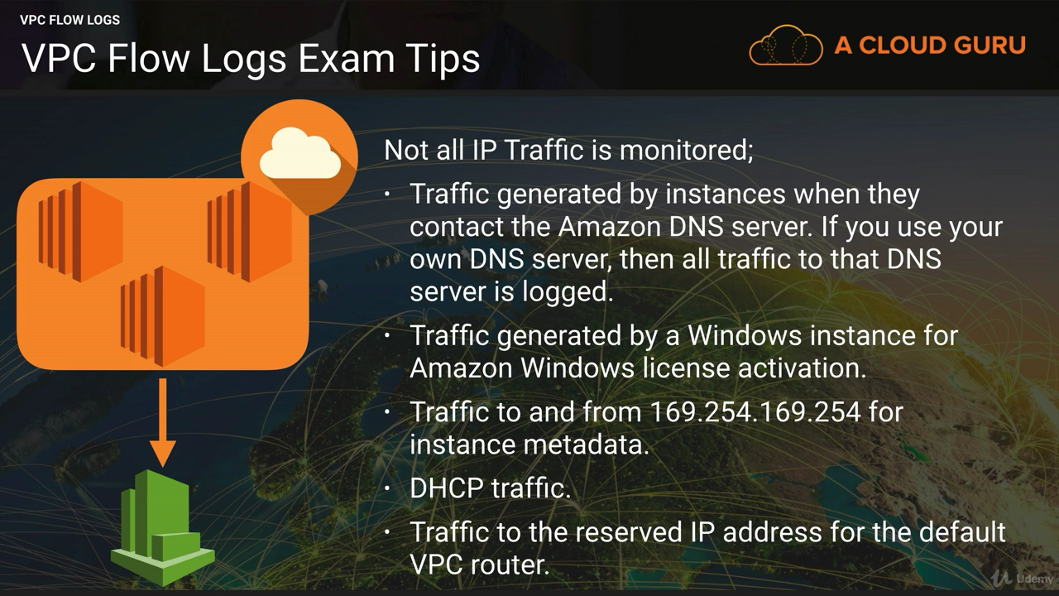

### NAT VS Bastion

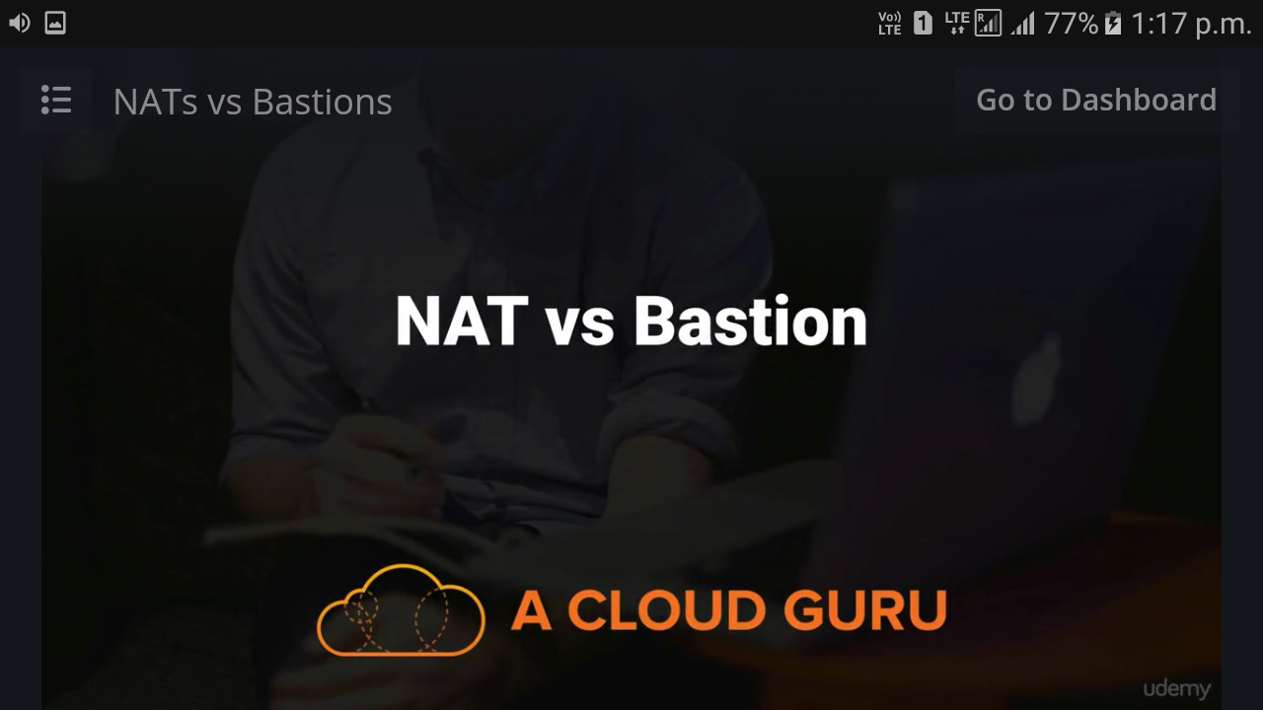

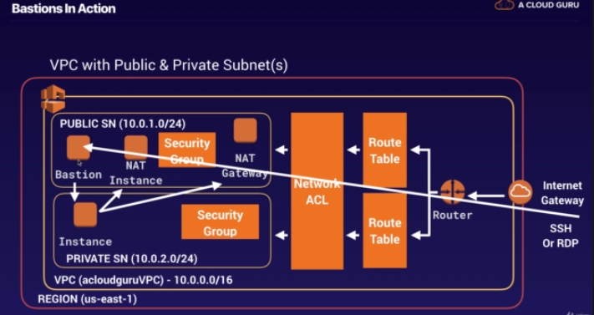

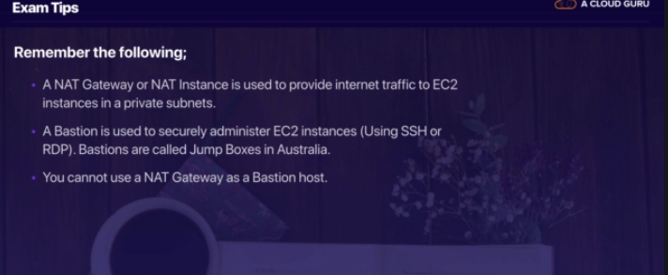

### Direct Connect

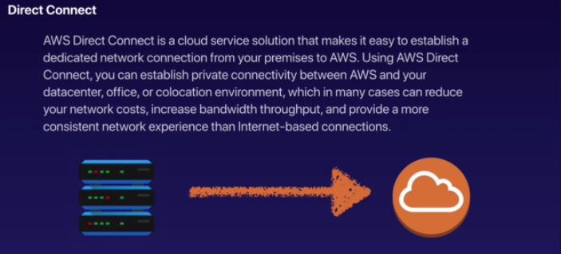

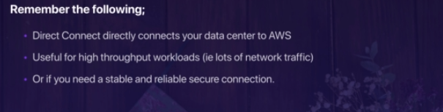

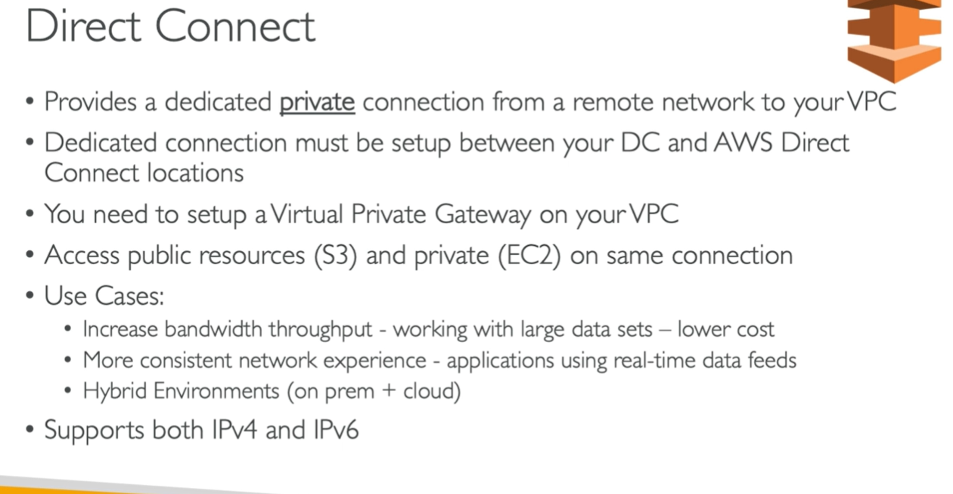

### VPC ENDPOINT

* An Amazon VPC endpoint enables you to create a private connection between your Amazon VPC and another AWS service without requiring access over the Internet or through a NAT instance, VPN connection, or AWS Direct Connect.
* You can create multiple endpoints for a single service, and you can use different route tables to enforce different access policies from different subnets to the same service.
* Amazon VPC endpoints currently support communication with Amazon Simple Storage Service (Amazon S3), and other services are expected to be added in the future.

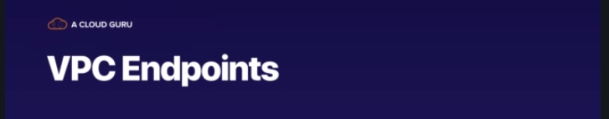

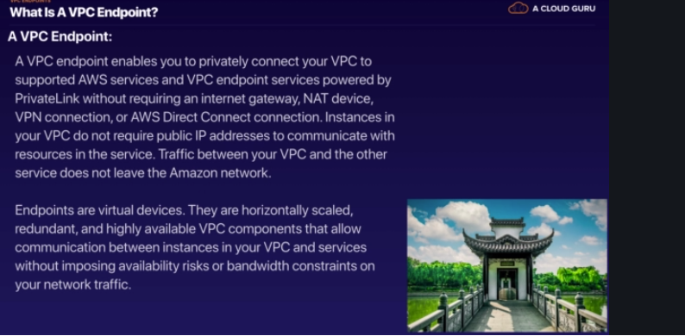

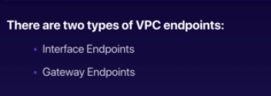

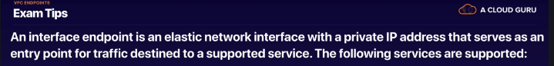

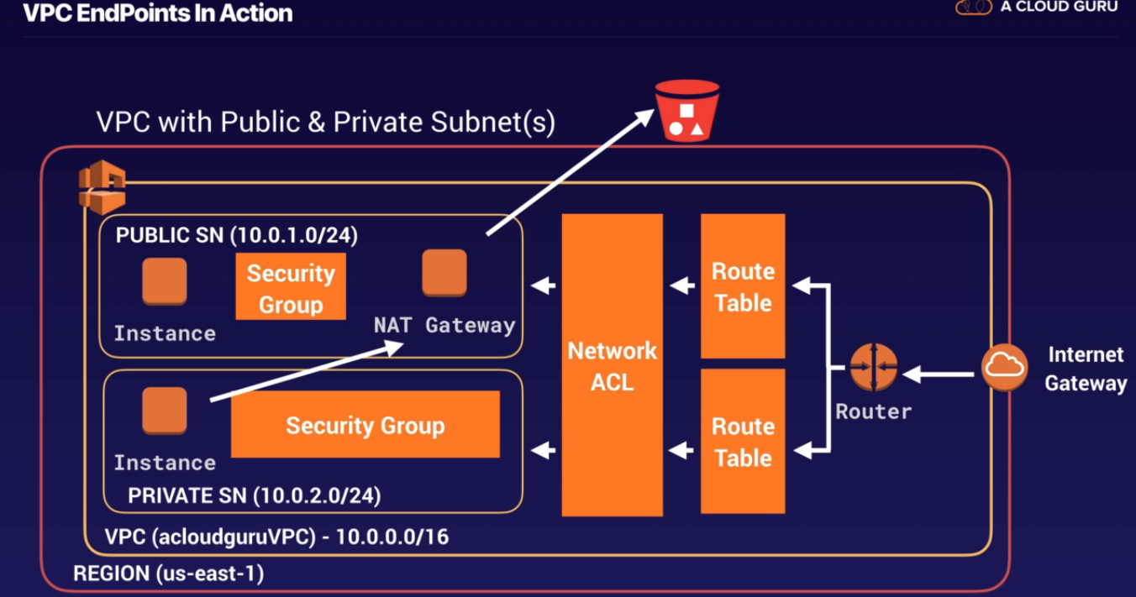

**Egress Only Internet Gateway**

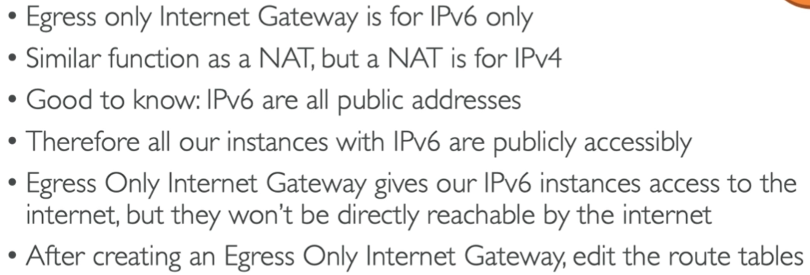

**How to create VPC Explained in below example**



1. Create VPC (VPC1)
2. When you create VPC,below things will automatically created

* Security Group
* NACL(By Default allow All traffic, hence not added in diagram)
* Route Table(Main Route Table-RT-Main-VPC1)

1. Now create two Subnet

* Private Subnet

SN1a-VPC1(10.3.7.0/24) and

create the Ec2 instance associated with this subnet having private ip 10.3.7.200)

* Public Subnet

Sn1b-VPC1 (10.3.9.0/24) and

Create the Ec2 instance associated with this instance and enable auto assign public ip.

1. Create internet gateway and associate with VPC
2. Create the custom route table

There is default route table already created i.e main route table (By default Main route table is associated with all subnet in VPC so if we make any changes in routes then will reflect in all subnet).So it is good to create the custom route table with the subnet and after that create rules

Create Custom route table (RT-Public-VPC1) 🡪associate with subnet🡪SN1b-VPC1-🡪remove the route of main

Now route should be towards internet gateway

0.0.0.0/0 -🡪Target intern et gateway

6) Now you do RDP/SSH to instance in private subnet from the public subnet

7) Create NAT Gateway

Now in private subnet you need outgoing connection to install the software’s so create the NAT gateway in public subnet and add route (0.0.0.0/0) in main route table and target should be NAT gateway

RT-Main-VPC1 -🡪add route

0.0.0.0/0 -🡪 target NAT gateway

**How to Connect with the On premise network with VPC**

**Virtual Private Gateways (VPGs), Customer Gateways (CGWs), and Virtual Private Networks (VPNs)**

You can connect an existing data center to Amazon VPC using either hardware or software VPN connections,

1. The VPG is the AWS end of the VPN tunnel.
2. The CGW is a hardware or software application on the customer’s side of the VPN tunnel.
3. You must initiate the VPN tunnel from the CGW to the VPG.
4. VPGs support both dynamic routing with BGP and static routing.
5. The VPN connection consists of two tunnels for higher availability to the VPC.

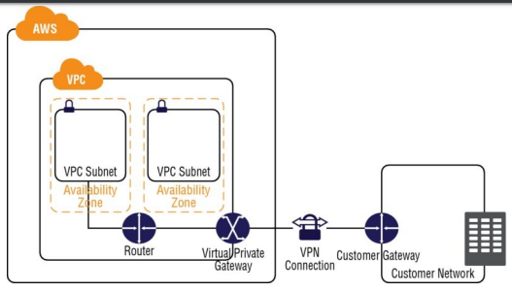

**VPC Section Summary**

* **CIDR**: IP Range
* **VPC**: Virtual Private Cloud => we define a list of IPv4 & IPv6 CIDR
* **Subnets**:Tied to an AZ, we define a CIDR
* **Internet Gateway**: at the VPC level, provide IPv4 & IPv6 Internet Access
* **Route Tables**: must be edited to add routes from subnets to the IGW, VPC Peering Connections, VPC Endpoints, etc…
* **NAT Instances**: gives internet access to instances in private subnets. Old, must be setup in a public subnet, disable Source / Destination check flag
* **NAT Gateway**: managed by AWS, provides scalable internet access to private instances, IPv4 only
* **Private DNS + Route 53**: enable DNS Resolution + DNS hostnames (VPC)
* **NACL**: Stateless, subnet rules for inbound and outbound, don’t forget ephemeral ports
* **Security Groups**: Stateful, operate at the EC2 instance level
* **VPC Peering**: Connect two VPC with non overlapping CIDR, non transitive
* **VPC Endpoints**: Provide private access to AWS Services (S3, DynamoDB, CloudFormation, SSM) within VPC
* **VPC Flow Logs**: Can be setup at the VPC / Subnet / ENI Level, for ACCEPT and REJECT traffic, helps identifying attacks, analyze using Athena or CloudWatch Log Insights
* **Bastion Host**: Public instance to SSH into, that has SSH connectivity to instances in private subnets
* **Site to Site VPN**: setup a Customer Gateway on DC, a Virtual Private Gateway on VPC, and site-to-site VPN over public internet
* **Direct Connect**: setup a Virtual Private Gateway on VPC, and establish a direct private connection to an AWS Direct Connect Location
* **Direct Connect Gateway**: setup a Direct Connect to many VPC in different regions
* **Internet Gateway Egress**: like a NAT Gateway, but for IPv6

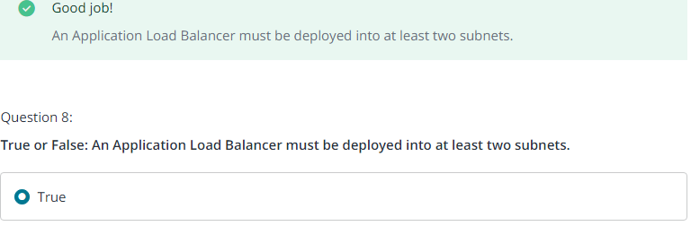

* SecurityProtocol used by amazon VPC Is ipsec
* Which of the following Amazon VPC resources would you use in order for EC2-VPC instances to send traffic directly to Amazon S3?

🡪 An Amazon **VPC endpoint** enables you to create a private connection between your Amazon VPC and another AWS service without requiring access over the Internet or through a NAT device, VPN connection, or AWS Direct Connect

* Which Amazon VPC feature allows you to create a dual-homed instance?

🡪 ENI (Elastic Network Interface)

Asa

# **Application Services**

**SQS, SWF, and SNS**

SQS (Simple Queue Service)is pull based system

SNS(Simple Notification Service) is push based system

SWF(Simple Workflow Service)

**SQS**

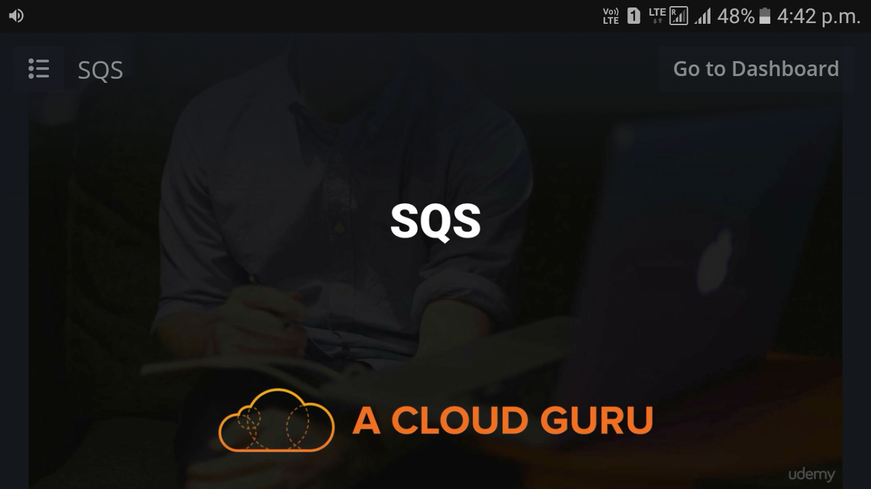

* Amazon SQS is a fast, reliable, scalable, and fully managed message queuing service.
* Amazon SQS ensures delivery of each message at least once and supports multiple readers and writers interacting with the same queue.
* A single queue can be used simultaneously by many distributed application components
* Although most of the time each message will be delivered to your application exactly once
* however, the service does not guarantee First In, First Out (FIFO) delivery of messages.

For many distributed applications, each message can stand on its own and, if all messages are delivered, the order is not important. If your system requires that order be preserved, you can place sequencing information in each message so that you can reorder the messages when they are retrieved from the queue.

**Message Lifecycle**

Visibility timeout is there unless and until the message get consumed. Once it is consumed then it’s deleted by receiver

**Delay Queues and Visibility Timeouts**

Delay queues allow you to postpone the delivery of new messages in a queue for a specific number of seconds. If you create a delay queue, any message that you send to that queue will be invisible to consumers for the duration of the delay period. To create a delay queue, use CreateQueue and set the DelaySeconds attribute to any value between 0 and 900 (15 minutes). You can also turn an existing queue into a delay queue by using SetQueueAttributes to set the queue’s DelaySeconds attribute. The default value for DelaySeconds is 0. Delay queues are similar to visibility timeouts in that both features make messages unavailable to consumers for a specific period of time. The difference is that a delay queue hides a message when it is first added to the queue, whereas a visibility timeout hides a message only after that message is retrieved from the queue. Figure 8.2 illustrates the functioning of a visibility timeout. When a message is in the queue but is neither delayed nor in a visibility timeout, it is considered to be “in flight.” You can have up to 120,000 messages in flight at any given time. *Amazon SQS supports up to 12 hours’ maximum visibility timeout.*

Like many other AWS Cloud services, Amazon SQS is accessed through HTTP request

**Queue Operations, Unique IDs, and Metadata The defined operations for Amazon SQS queues are** CreateQueue, ListQueues, DeleteQueue, SendMessage, SendMessageBatch, ReceiveMessage, DeleteMessage, DeleteMessageBatch, PurgeQueue, ChangeMessageVisibility, ChangeMessageVisibilityBatch, SetQueueAttributes, GetQueueAttributes, GetQueueUrl, ListDeadLetterSourceQueues, AddPermission, and RemovePermission. Only the AWS account owner or an AWS identity that has been granted the proper permissions can perform operations

Your messages are identified via a globally unique ID that Amazon SQS returns when the message is delivered to the queue.

**Queue and Message Identifiers**

Amazon SQS uses three identifiers that you need to be familiar with:

1. queue URLs 🡪name
2. message IDs 🡪 unique ID
3. receipt handles. 🡪 you receive a receipt handle for that message. (to delete the message or to change the message visibility)

The maximum length of a receipt handle is 1,024 characters.

**Message Attributes**

Its message metadata(such as timestamps, geospatial data, signatures, and identifiers)

**Amazon SQS Short and Long Polling**

ReceiveMessage will check for the existence of a message in the queue and return immediately, either with or without a message

The process of consuming messages from a queue depends on whether you use short or long polling. By default, Amazon SQS uses *short polling,* querying only a subset of its servers (based on a weighted random distribution) to determine whether any messages are available for a response.

**Consuming Messages Using Short Polling**

When you consume messages from a queue using short polling, Amazon SQS samples a subset of its servers (based on a weighted random distribution) and returns messages from only those servers

**Consuming Message Using Long Polling**

When the wait time for the ReceiveMessage API action is greater than 0, long polling is in effect.

**Dead Letter Queues**

Amazon SQS provides support for dead letter queues. A dead letter queue is a queue that other queues can target to send messages that for some reason could not be successfully processed. A primary benefit of using a dead letter queue is the ability to sideline and isolate the unsuccessfully processed messages. You can then analyze any messages sent to the dead letter queue to try to determine the cause of failure

**Access Control**

these types of actions through the use of IAM roles

* You want to grant another AWS account a particular type of access to your queue (for example, SendMessage).
* You want to grant another AWS account access to your queue for a specific period of time.
* You want to grant another AWS account access to your queue only if the requests come from your Amazon EC2 instances.
* You want to deny another AWS account axccess to your queue.

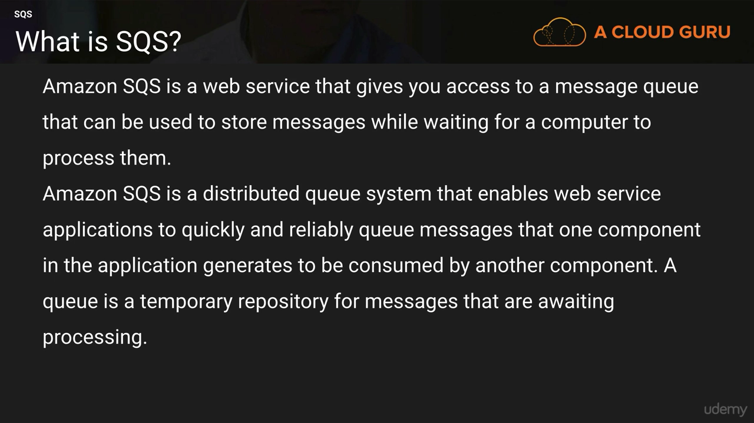

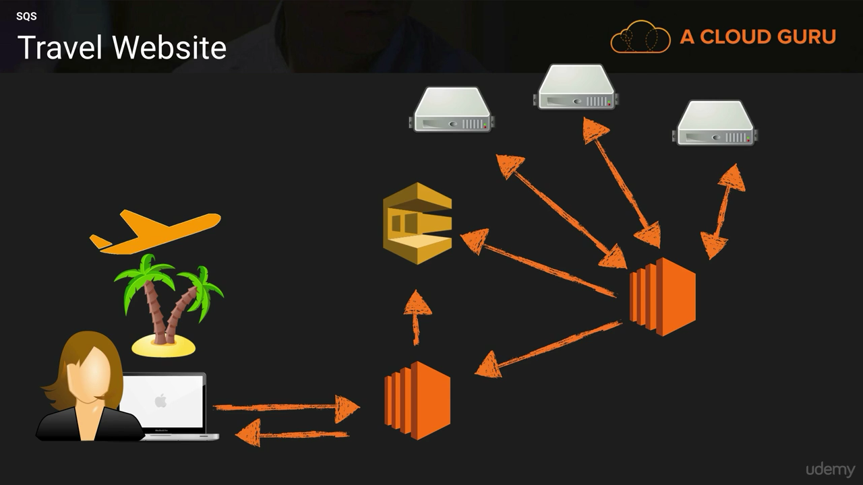

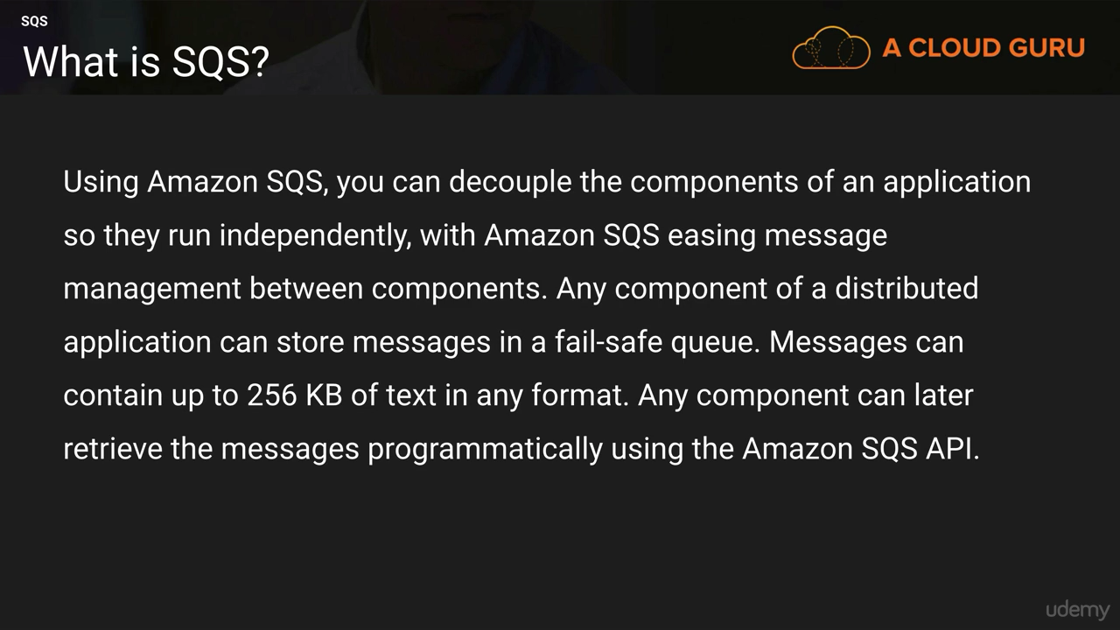

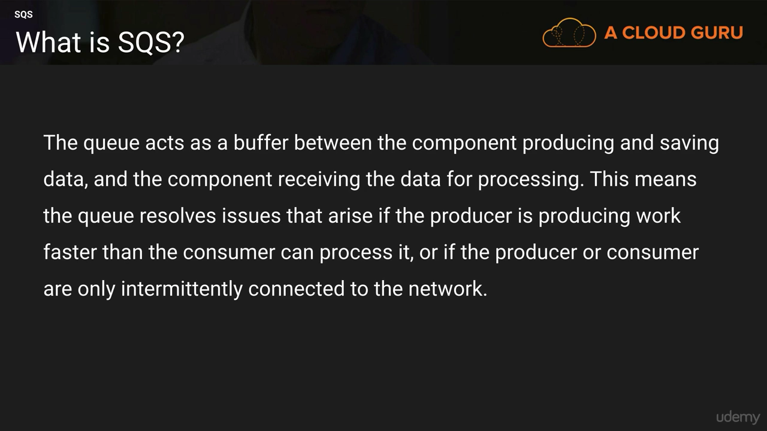

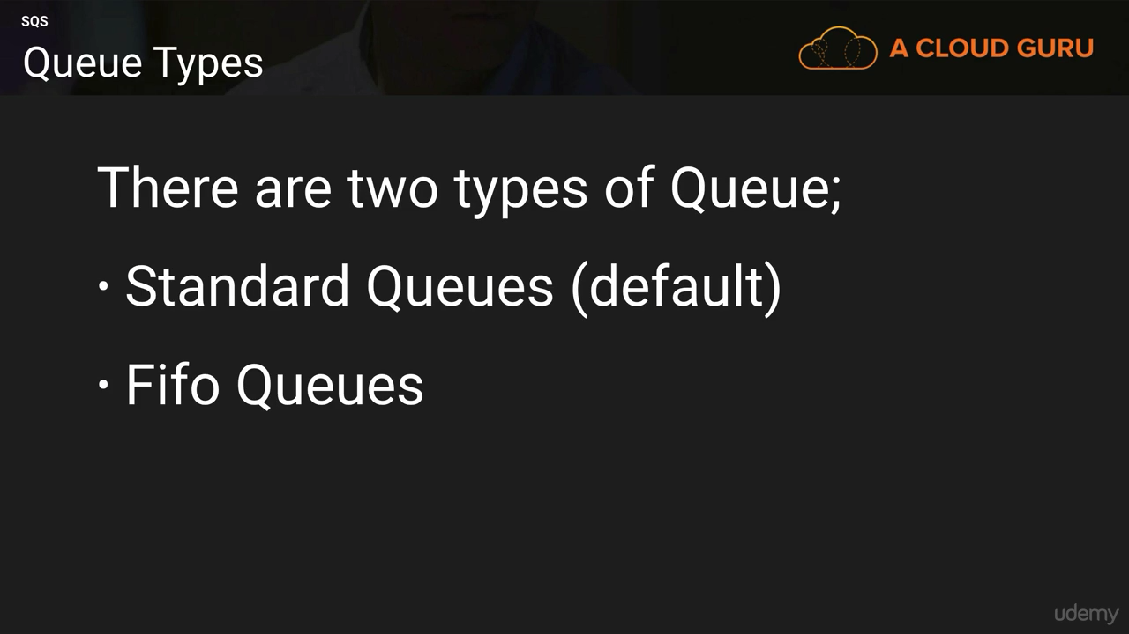

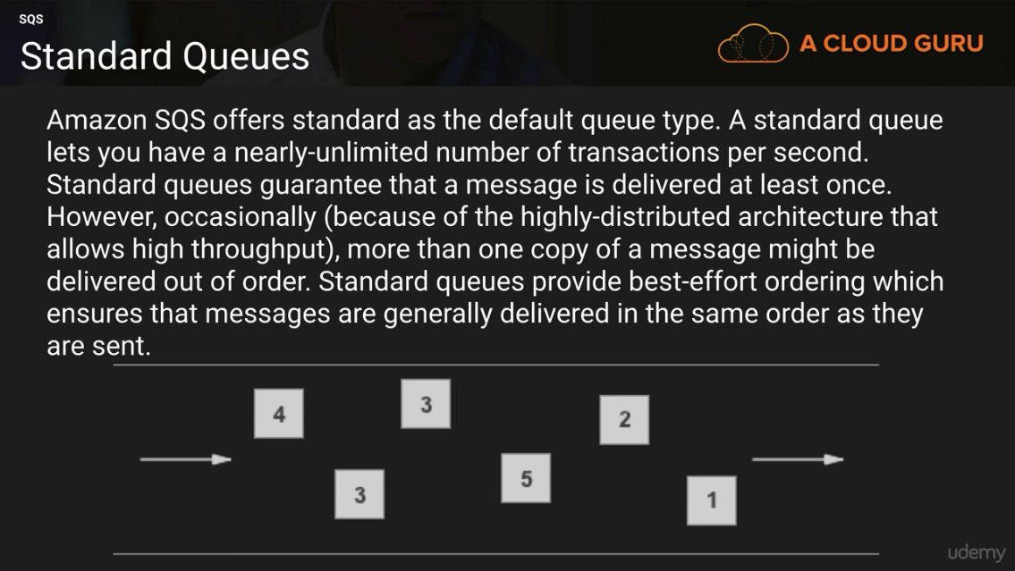

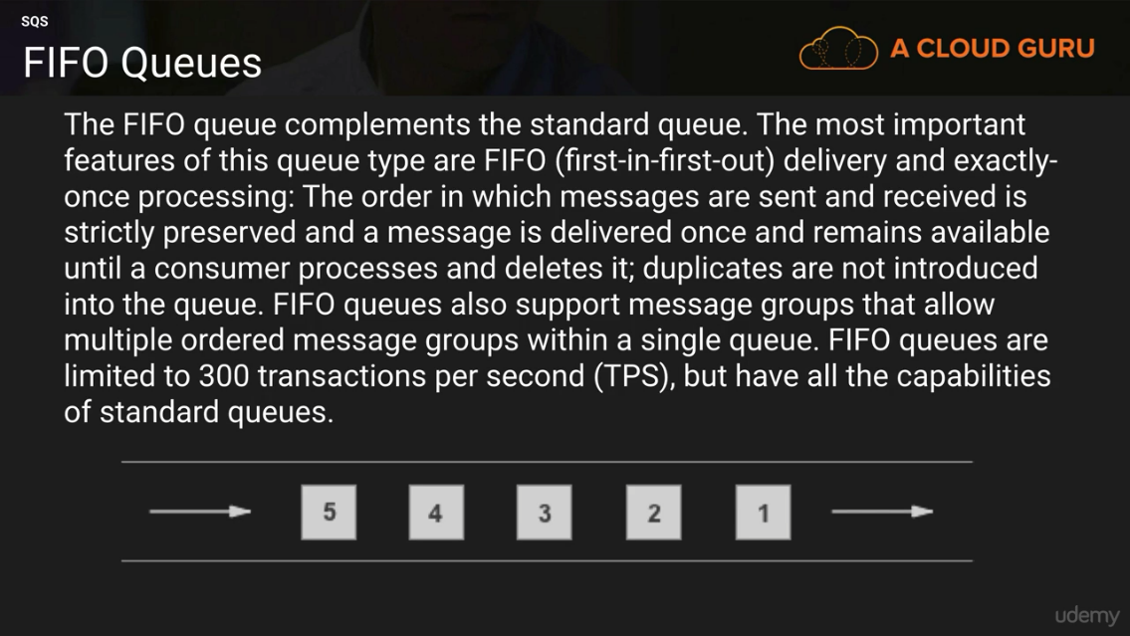

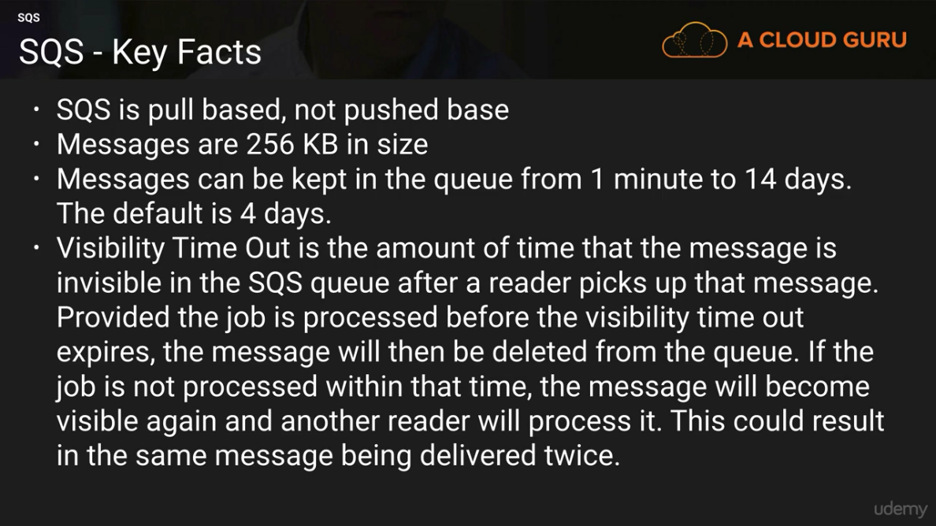

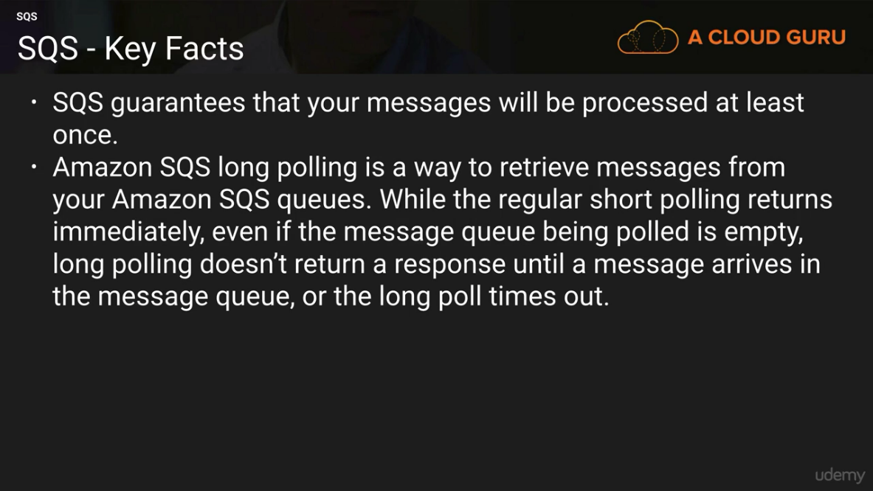

**Amazon SQS Short and Long Polling**

The process of consuming messages from a queue depends on whether you use short or long polling. By default, Amazon SQS uses short polling, querying only a subset of its servers (based on a weighted random distribution) to determine whether any messages are available for a response.

**Consuming Messages Using Short Polling**

When you consume messages from a queue using short polling, Amazon SQS samples a subset of its servers (based on a weighted random distribution) and returns messages from only those servers

**Consuming Message Using Long Polling**

When the wait time for the ReceiveMessage API action is greater than 0, long polling is in effect.

**Simple Workflow Service**

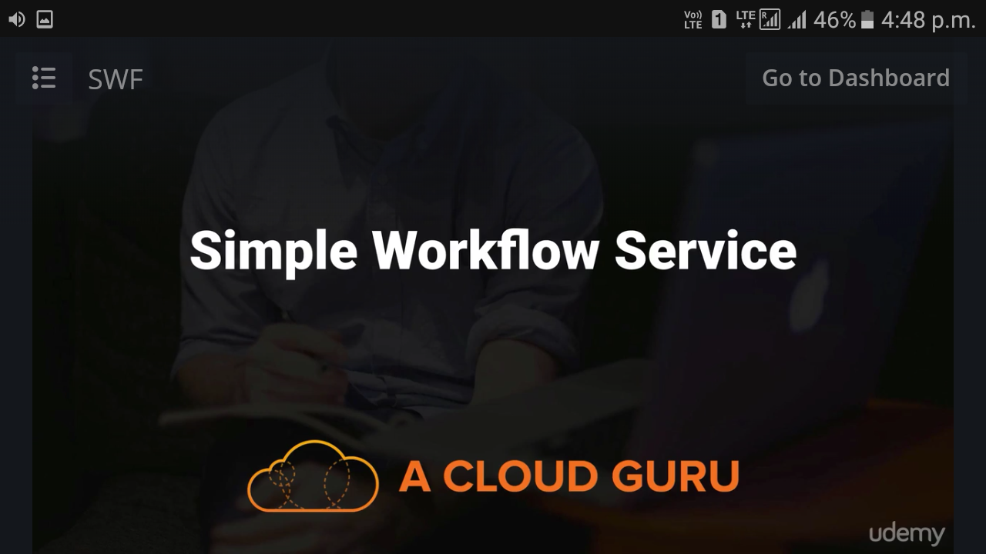

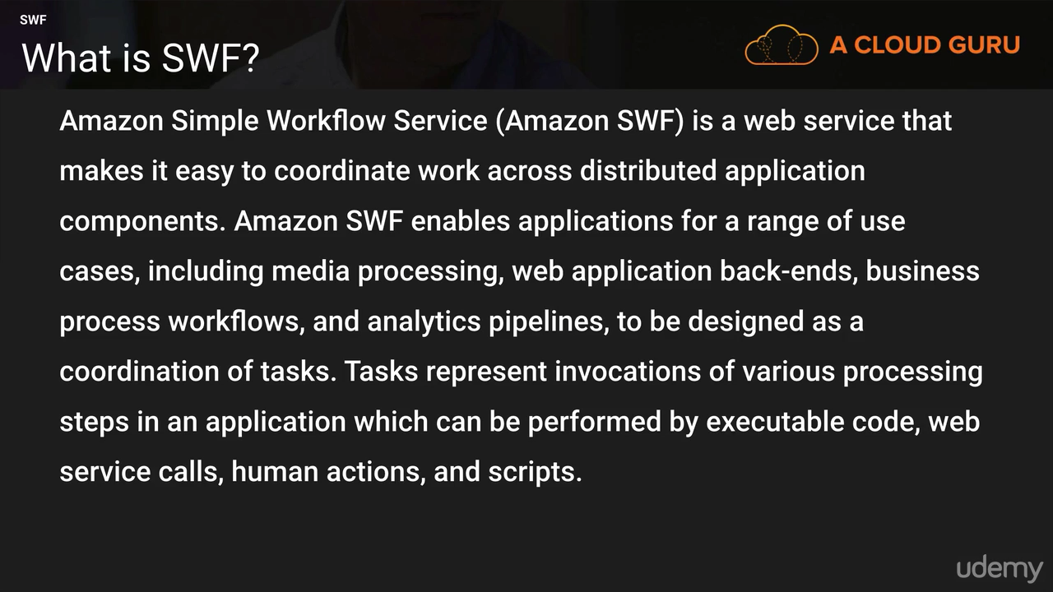

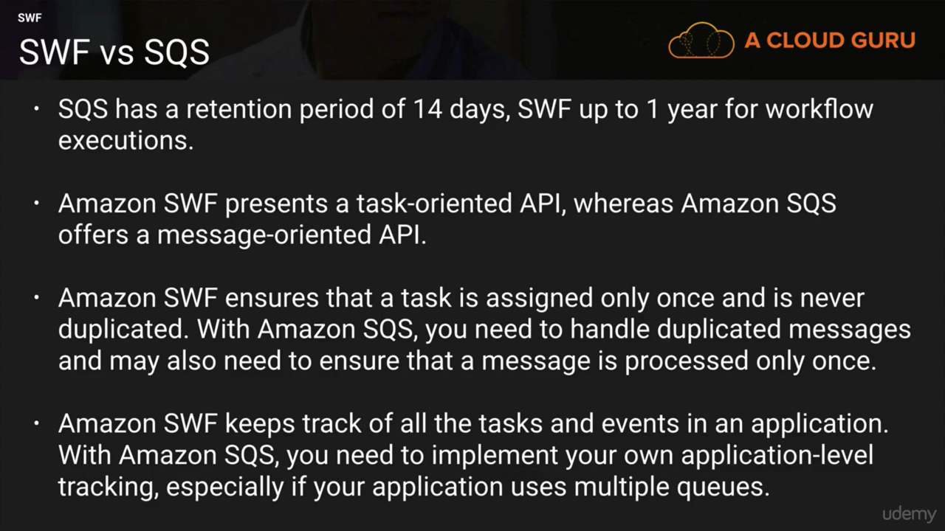

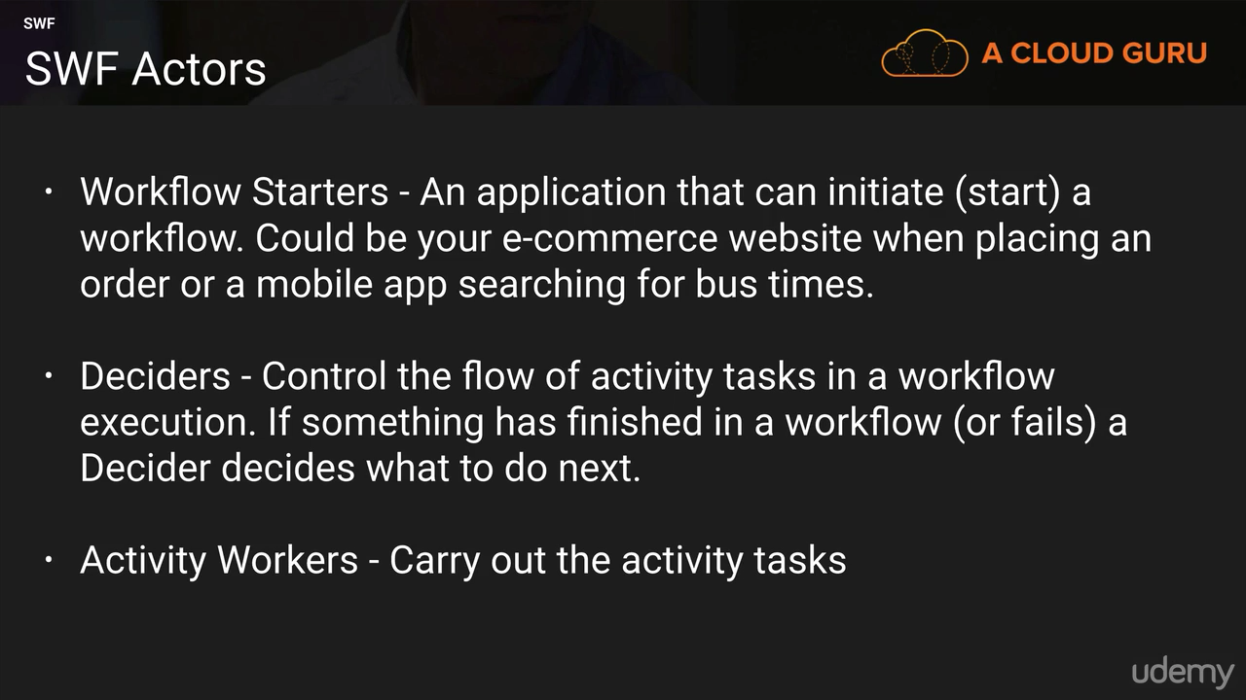

**SIMPLE NOTIFICATION SERVICE**

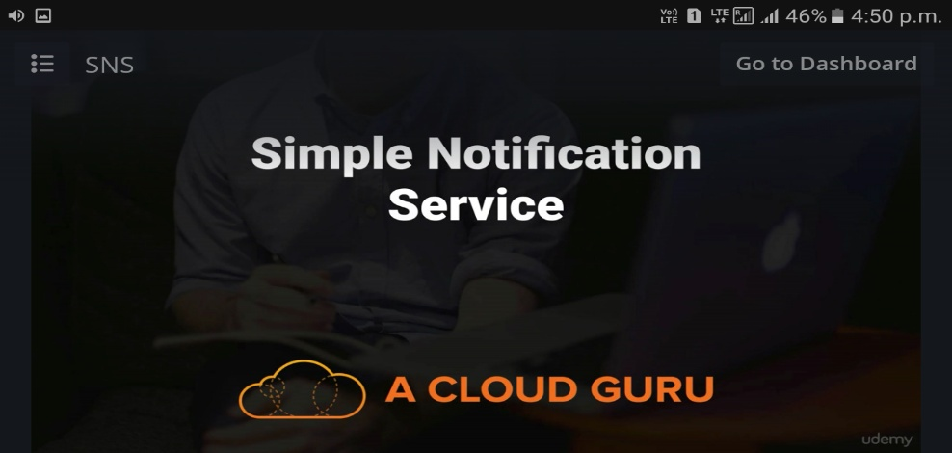

Amazon SNS is a web service for mobile and enterprise messaging that enables you to set up, operate, and send notifications.

Amazon SNS consists of two types of clients:

1. Publisher (Producer)
2. Subscriber (Consumer)

The message is then delivered to the subscribers of that topic using different methods, such as - -

* Amazon SQS,
* HTTP,
* HTTPS,
* email,
* SMS,
* AWS Lambda.

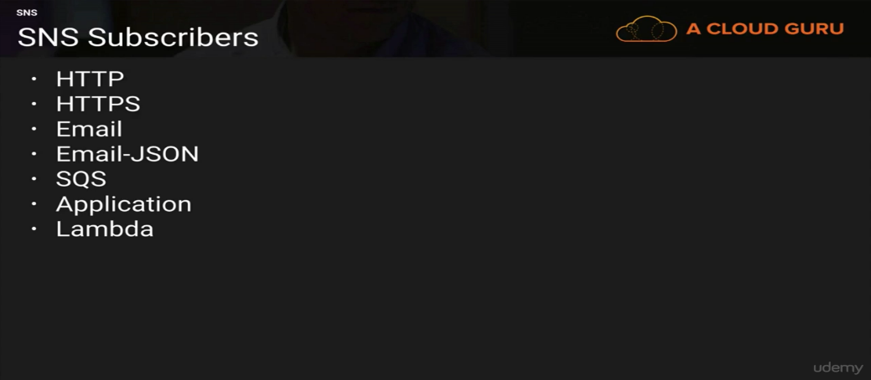

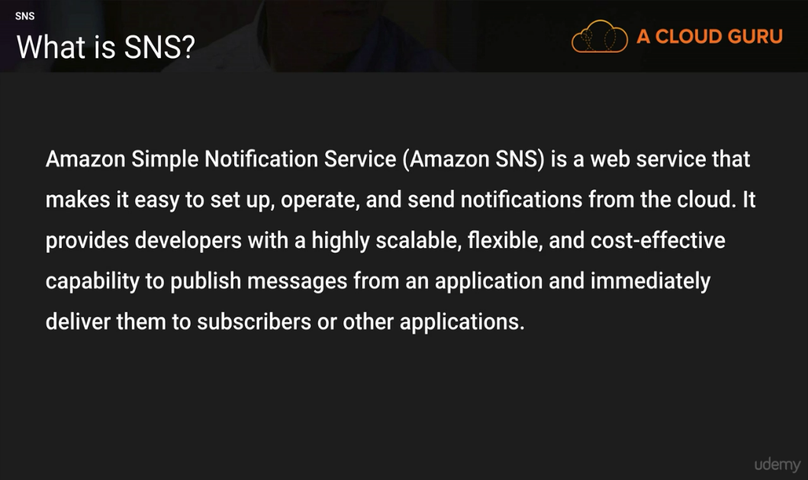

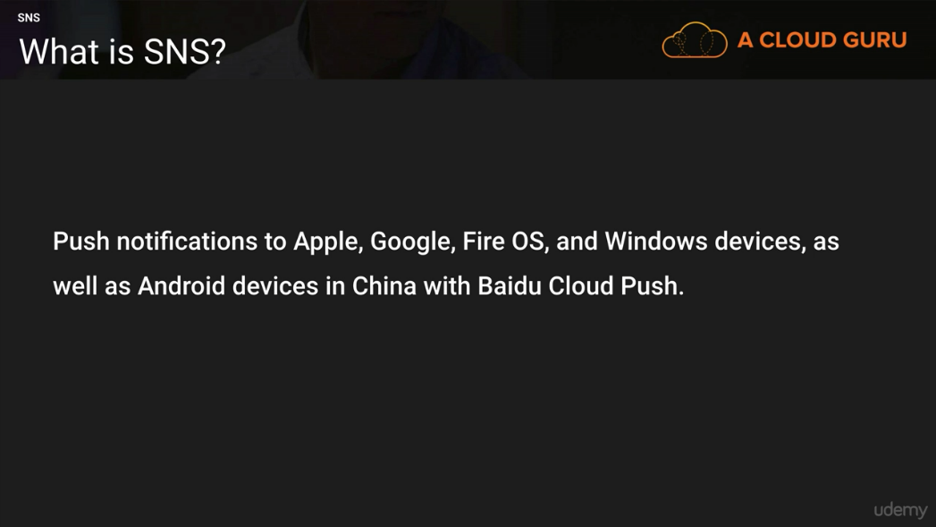

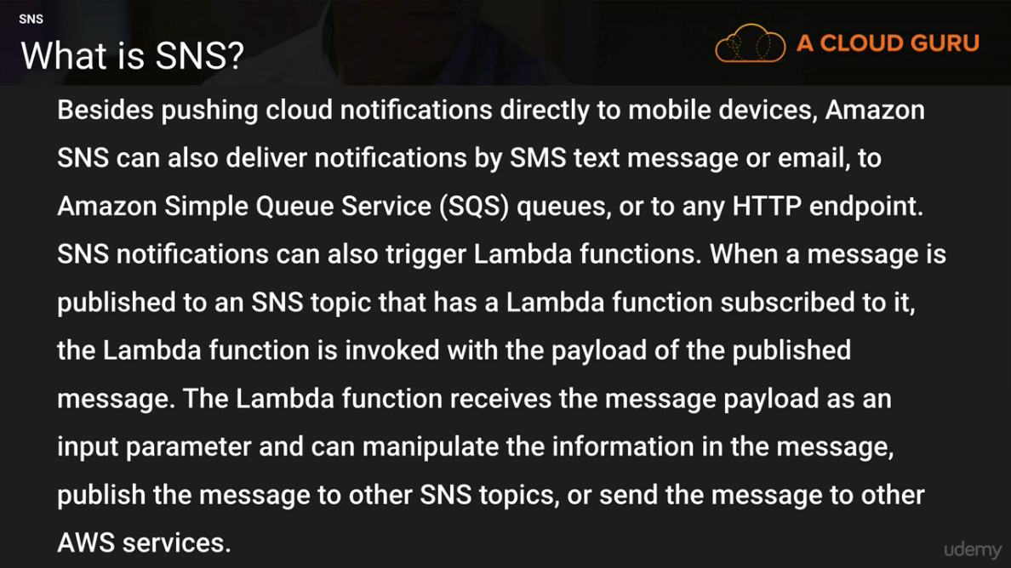

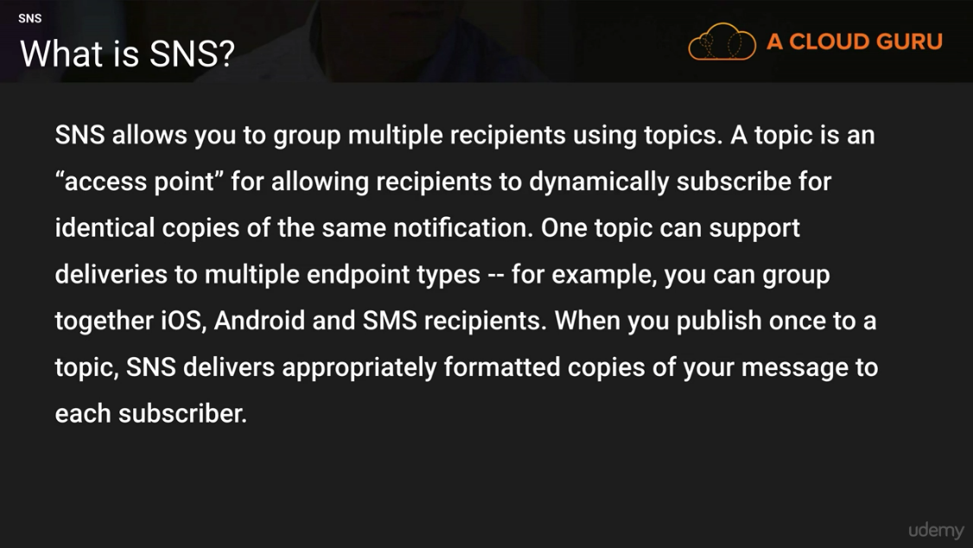

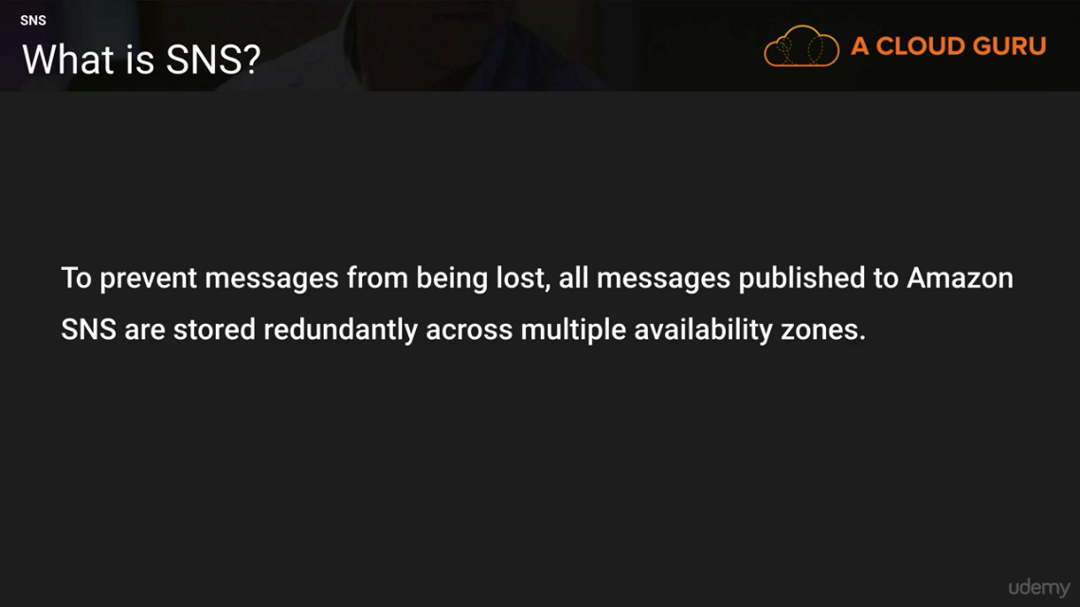

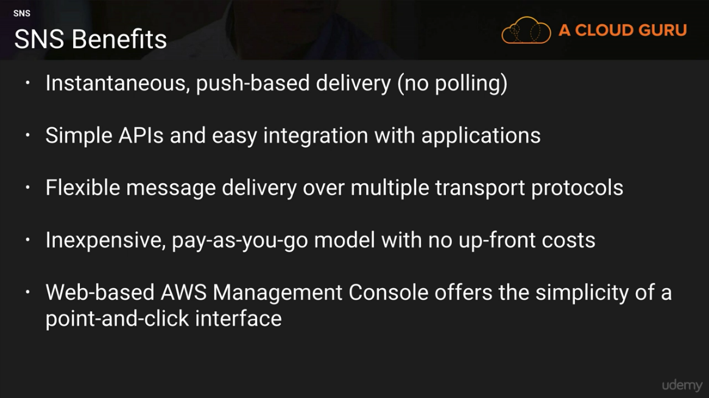

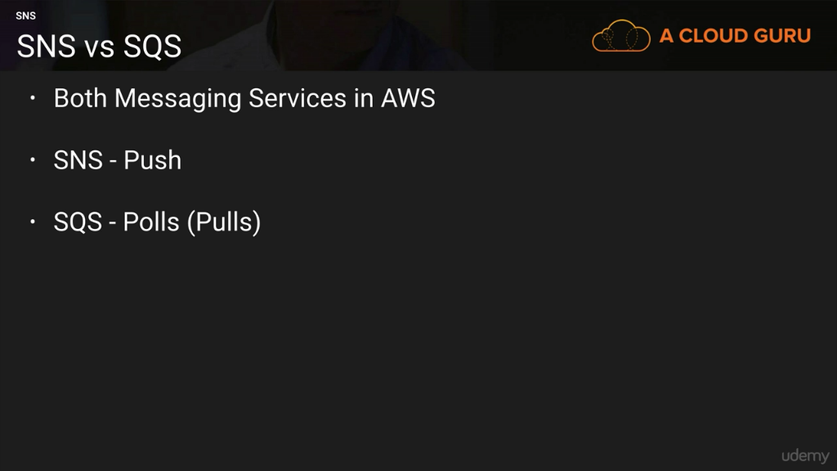

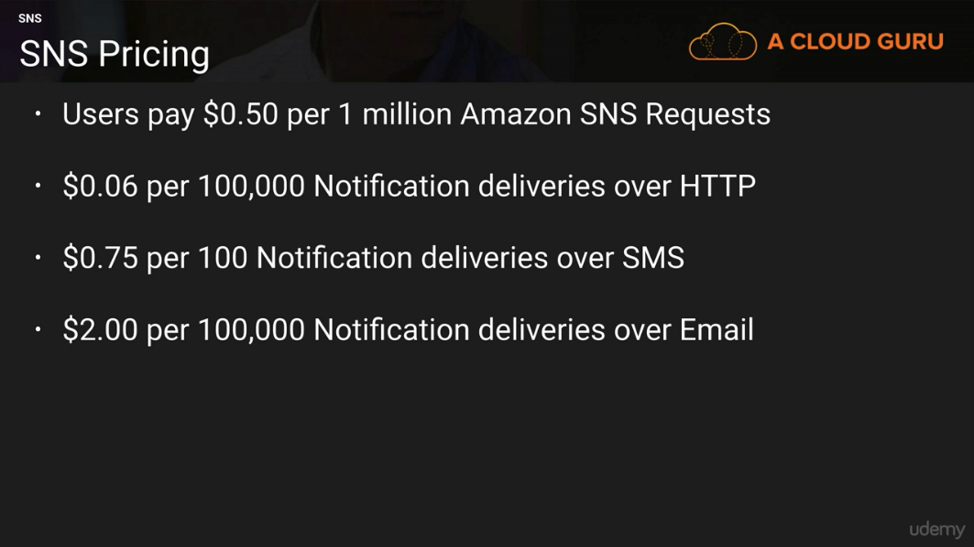

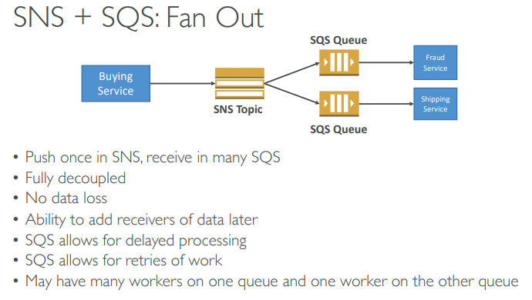

**ELASTIC TRANSCODER**

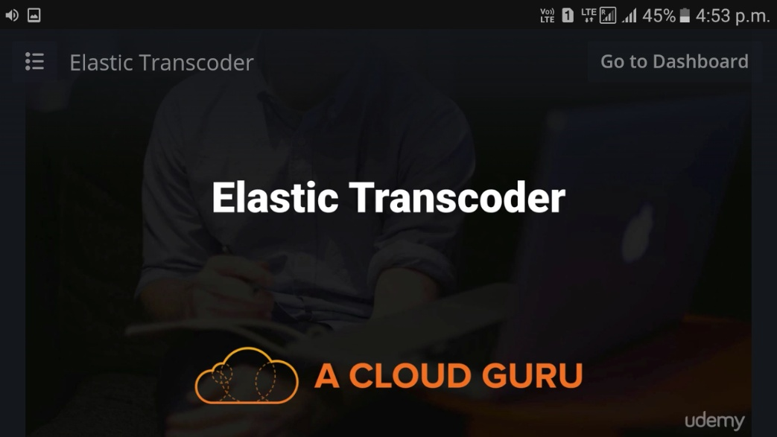

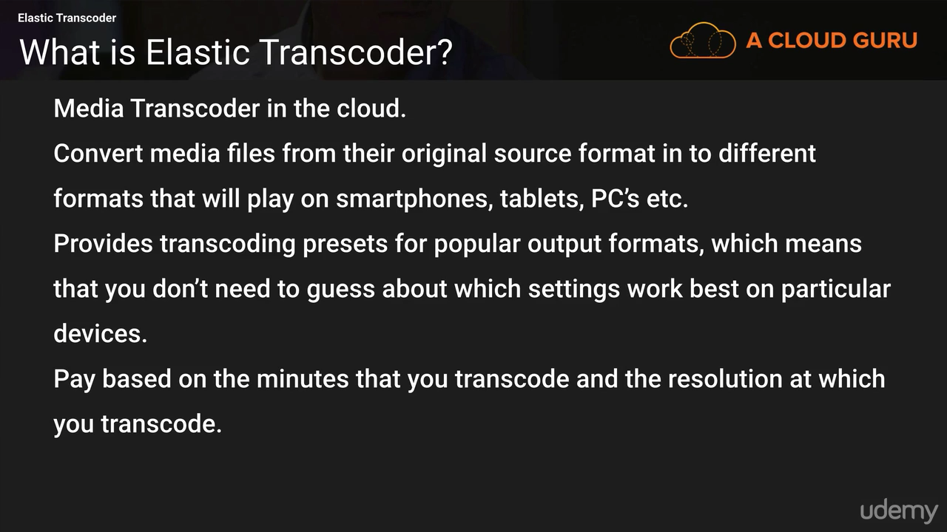

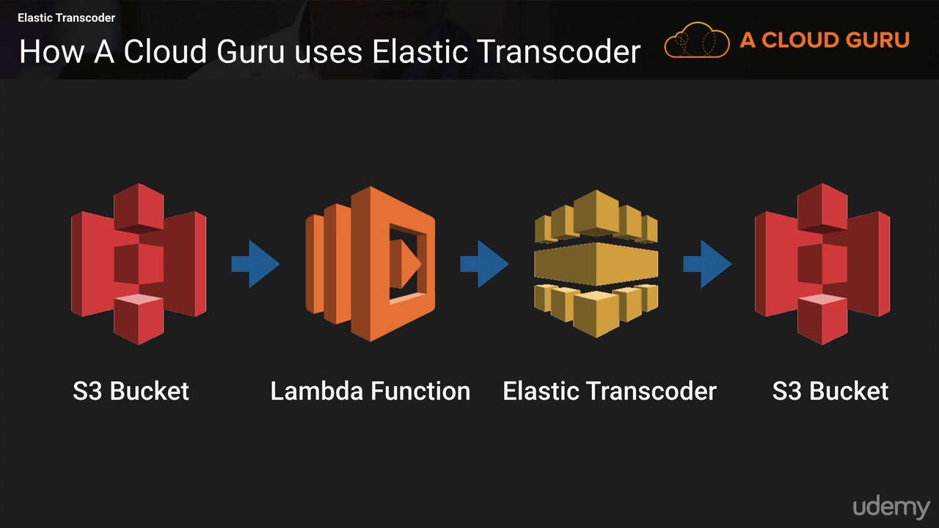

# **KINESIS**

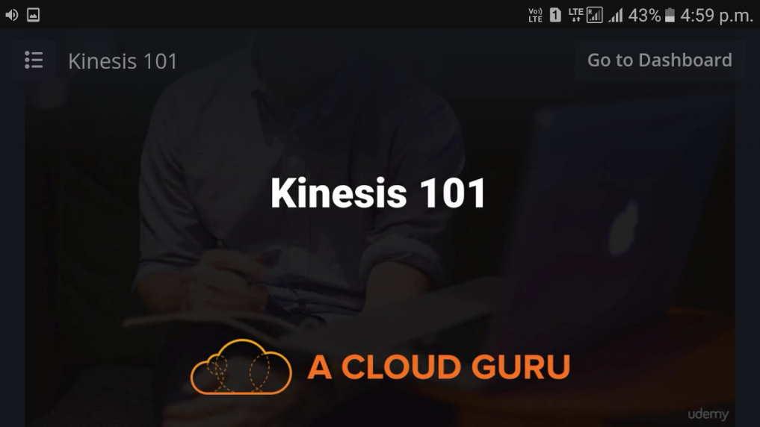

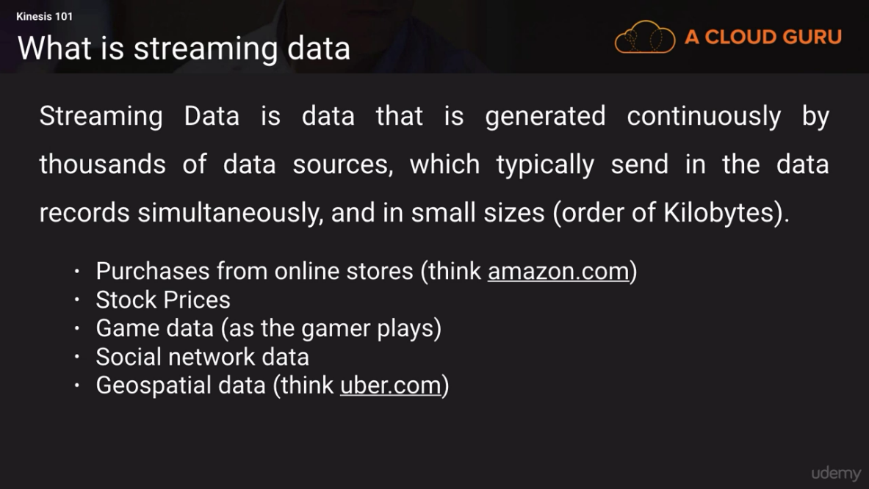

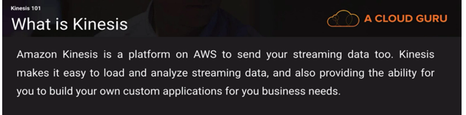

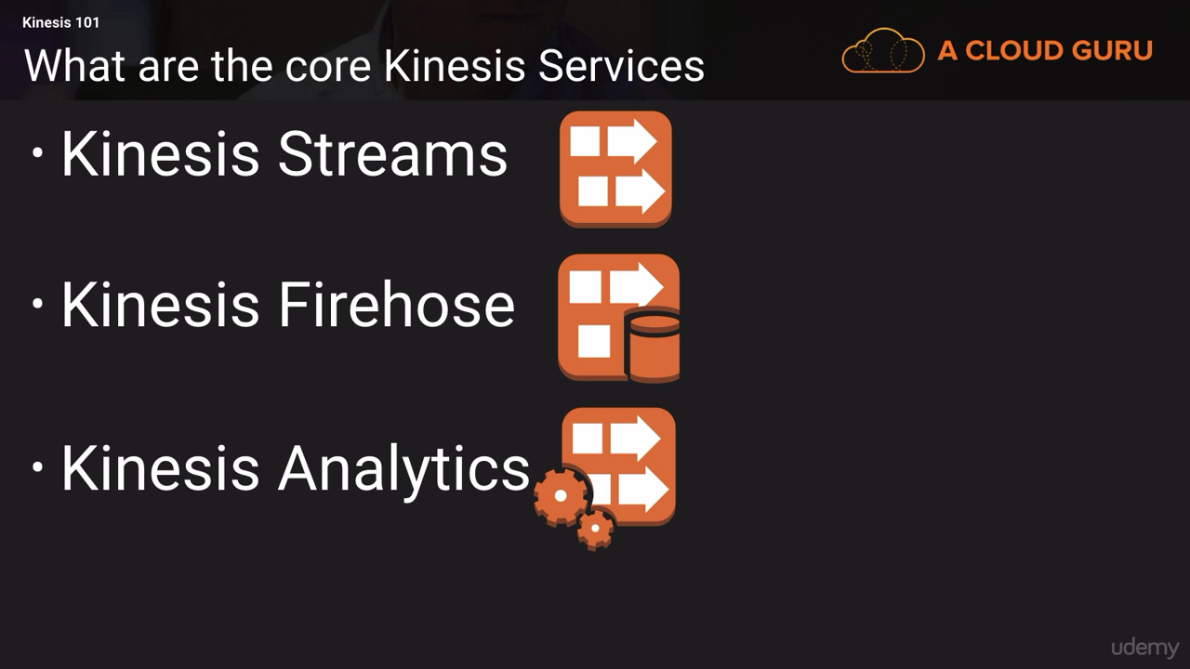

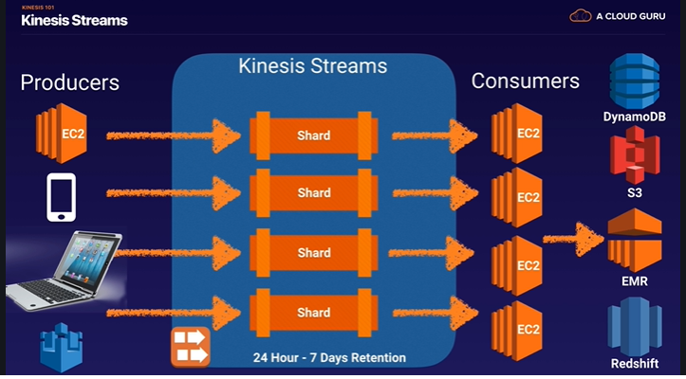

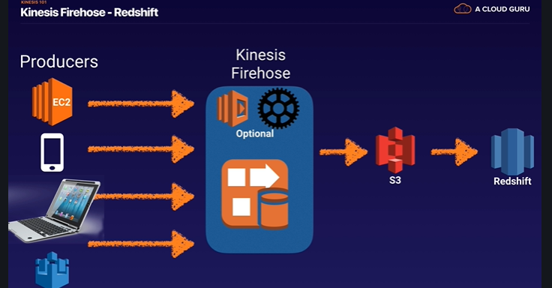

1. Amazon Kinesis Firehose: A service enabling you to load massive volumes of streaming data into AWS
2. Amazon Kinesis Analytics: A service enabling you to easily analyze streaming data real time with standard SQL
3. Amazon Kinesis Streams: : low latency streaming ingest at scale .A service enabling you to build custom applications for more complex analysis of streaming data in real time (Consist of shards)

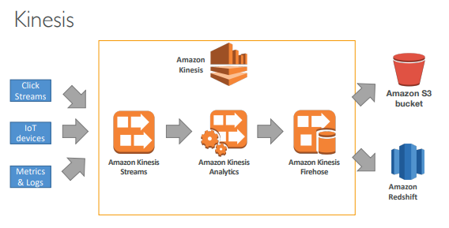

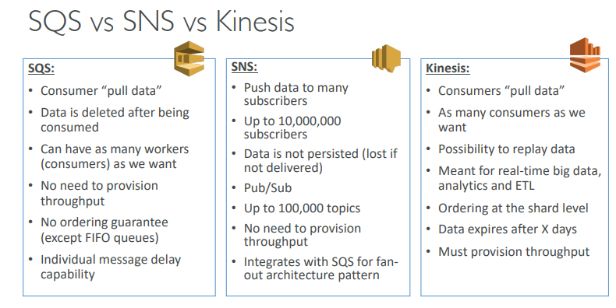

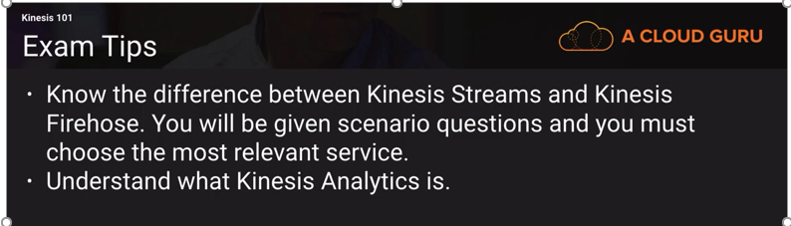

# **Serverless**

Serverless in AWS

• AWS Lambda & Step Functions

• DynamoDB

• AWS Cognito

• AWS API Gateway

• Amazon S3

• AWS SNS & SQS

• AWS Kinesis

• Aurora Serverless



**Lambda**

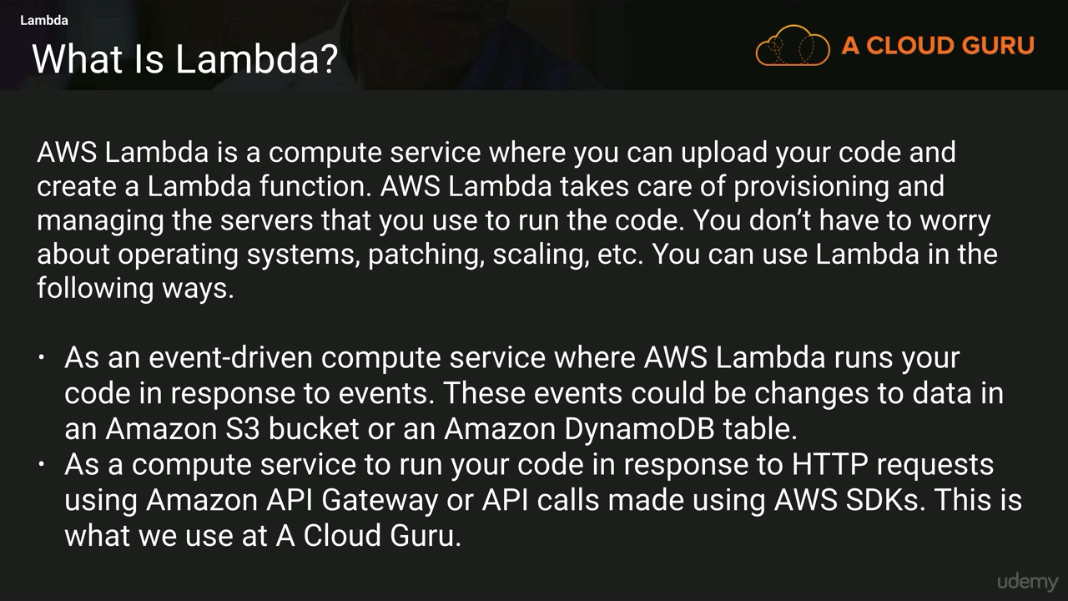

**Benefits of AWS Lambda**

• Easy Pricing:

• Pay per request and compute time

• Free tier of 1,000,000 AWS Lambda requests and 400,000 GBs of compute time

• Integrated with the whole AWS Stack

• Integrated with many programming languages

• Easy monitoring through AWS CloudWatch

• Easy to get more resources per functions (up to 3GB of RAM!)

• Increasing RAM will also improve CPU and network!

**AWS Lambda language support**

• Node.js (JavaScript)

• Python

• Java (Java 8 compatible)

• C# (.NET Core)

• Golang

• C# / Powershell

**AWS Lambda Configuration**

• Timeout: default 3 seconds, max of 300s (Note: new limit 15 minutes)

• Environment variables

• Allocated memory (128M to 3G)

• Ability to deploy within a VPC + assign security groups

• IAM execution role must be attached to the Lambda function

**AWS Lambda Limits to Know**

• Execution:

• Memory allocation: 128 MB – 3008 MB (64 MB increments)

• Maximum execution time: 300 seconds (5 minutes), now 15 minutes but 5 for exam

• Disk capacity in the “function container” (in /tmp): 512 MB

• Concurrency limits: 1000

• Deployment:

• Lambda function deployment size (compressed .zip): 50 MB

• Size of uncompressed deployment (code + dependencies): 250 MB

• Can use the /tmp directory to load other files at startup

• Size of environment variables: 4 KB

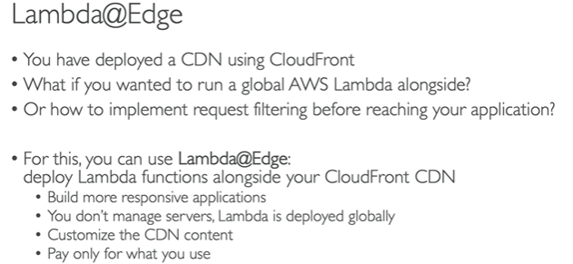

**Example: Serverless Thumbnail creation**

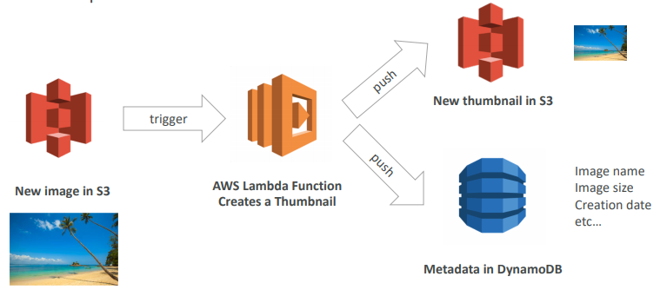

**Serverless architecture**



* + 1. **Myblog.com site**

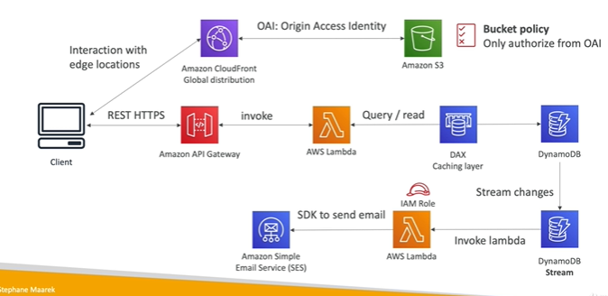

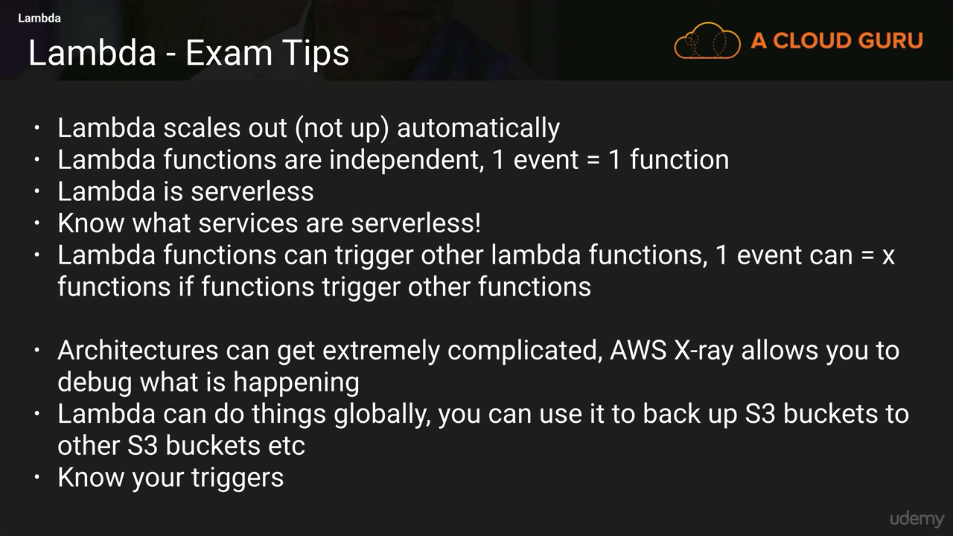

**API GATEWAY**

**API Gateway**-Front Door For the application

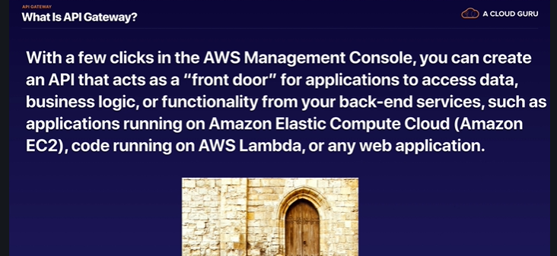

**API Gateway Integrations**

• Outside of VPC:

• AWS Lambda (most popular / powerful)

• Endpoints on EC2

• Load Balancers

• Any AWS Service

• External and publicly accessible HTTP endpoints

• Inside of VPC:

• AWS Lambda in your VPC

• EC2 endpoints in your VPC

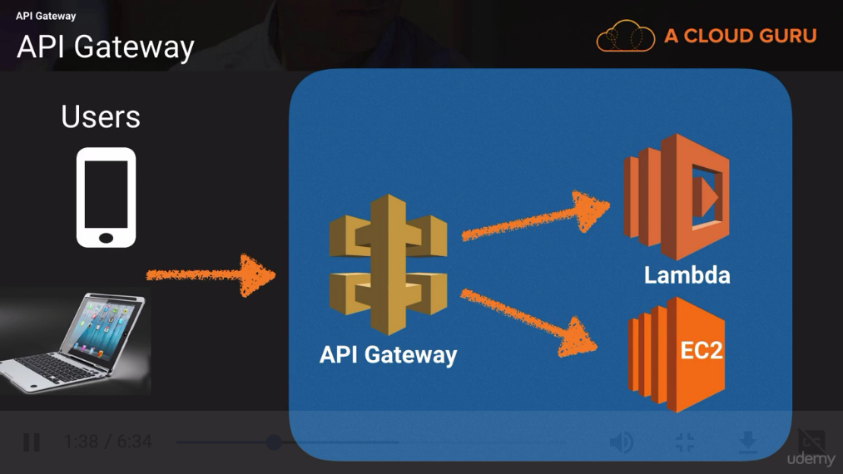



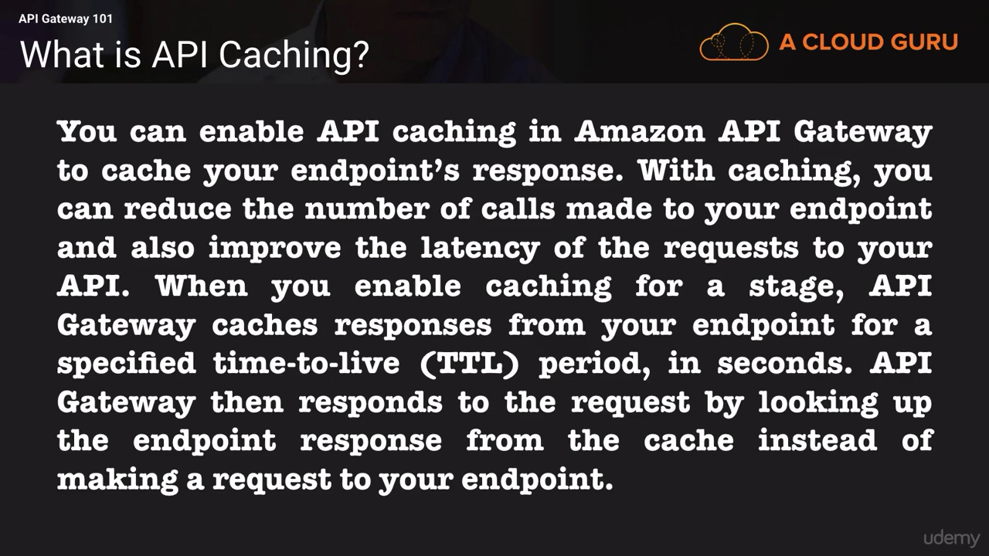





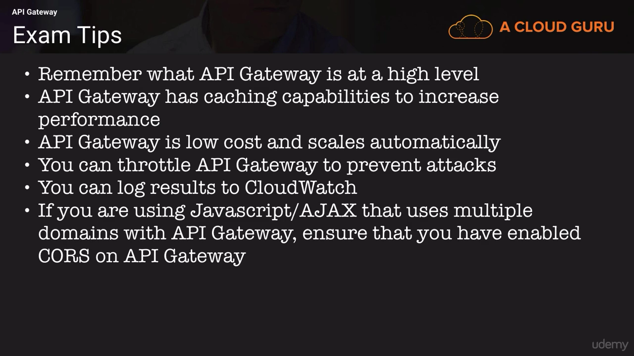

# **Disaster Recovery Overview**

• Backup and Restore • Pilot Light • Warm Standby • Hot Site / Multi Site Approach

1. **Backup and Restore (High RPO)**
2. **Pilot Light**

• A small version of the app is always running in the cloud

• Useful for the critical core (pilot light)

• Very similar to Backup and Restore

• Faster than Backup and Restore as critical systems are already up

1. **Warm Standby**

• Full system is up and running, but at minimum size

• Upon disaster, we can scale to production load

1. **Multi Site / Hot Site Approach**

• Very low RTO (minutes or seconds) – very expensive

• Full Production Scale is running AWS and On Premise

**Aws shared responsibility model**

customers migrate their IT environments to AWS, they create a model of shared responsibility between themselves and AWS. This shared responsibility model can help lessen a customer’s IT operational burden, as it is AWS responsibility to manage the components from the host operating system and virtualization layer down to the physical security of the data centers in which these services operate. The customer is responsible for the components from the guest operating system upward (including updates, security patches, and antivirus software). The customer is also responsible for any other application software, as well as the configuration of security groups, Virtual Private Clouds (VPCs), and so on.

While AWS manages the security of the cloud, security in the cloud is the responsibility of the customer. Customers retain control of what security they choose to implement to protect their own content, platform, applications, systems, and networks, no differently than they would for applications in an on-site data center.

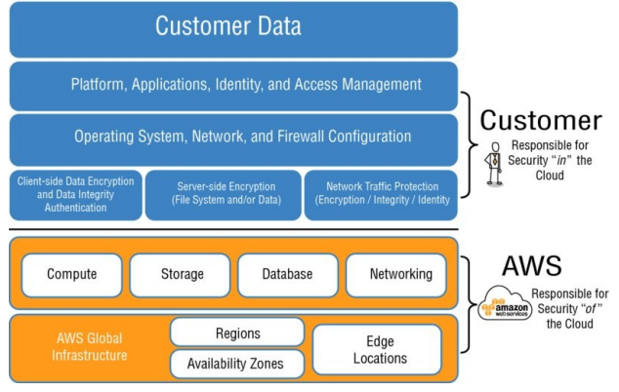

**What is the difference between horizontal & vertical scaling?**

**Vertical Scaling –**

To increase the capacity if we increase resources in same logical unit/server then it is vertical scaling.  E.g. Add more CPUs in existing sever. If system is not handled by one CPU then increase the CPU to 3 or 4. Another example is server is having 8 GB RAM then scale it to 16 GB. Same applicable to storages also.

**Horizontal Scaling**

As mentioned in above website example, when your business grows at the same time hits also grows so the responsibility of your server/node grows.  So to reduce this responsibility what we can do is we can add one more server with same capacity along with existing server. Now these two servers can handle the traffic effectively. This is what called horizontal scaling. We have not changed capacity of individual server but we decreased the load on server.

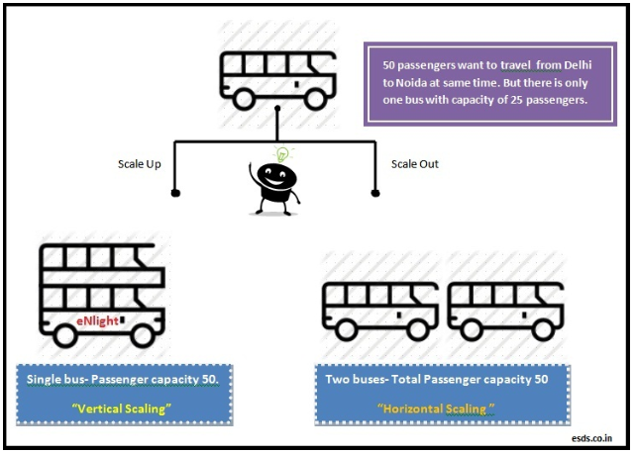

**Stateless Applications**

When users or services interact with an application, they will often perform a series of interactions that form a session. A stateless application needs no knowledge of the previous interactions and stores no session information. A stateless application can scale horizontally, because any request can be serviced by any of the available system compute resources. Because no session data needs to be shared between system resources, compute resources can be added as needed. When excess capacity is no longer required, any individual resource can be safely terminated. Those resources do not need to be aware of the presence of their peers; all that is required is a way to distribute the workload to them.

**Stateless/Stateful Components**

A stateful web service will keep track of the "state" of a client's connection and data over several requests. So for example, the client might login, select a users account data, update their address, attach a photo, and change the status flag, then disconnect.

In a stateless web service, the server doesn't keep any information from one request to the next. The client needs to do it's work in a series of simple transactions, and the client has to keep track of what happens between requests. So in the above example, the client needs to do each operation separately: connect and update the address, disconnect. Connect and attach the photo, disconnect. Connect and change the status flag, disconnect.

A stateless web service is much simpler to implement, and can handle greater volume of clients.

**Storage Options**

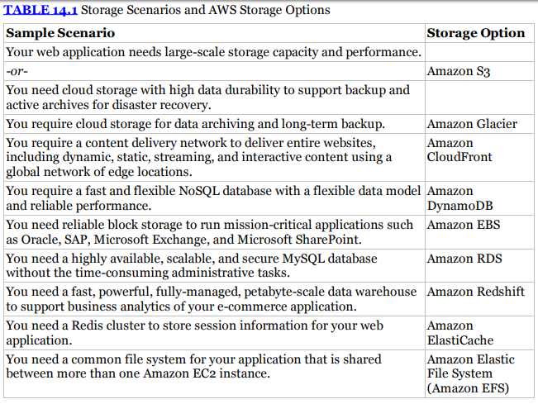

Serverless in AWS

• AWS Lambda & Step Functions

• DynamoDB

• AWS Cognito

• AWS API Gateway

• Amazon S3

• AWS SNS & SQS

• AWS Kinesis

• Aurora Serverless